**Team: Absolute-tech**

Rabble-WarnYou-Feature!



IDEA : To warn user about potential rug pulls/coinscams.   
  
The Problem/Solution: Potential fraudents tries to rugpull, (i.e fake fund their volume), hence we will be introducing a warning/detection feature on Rabble to identify prone to pulls Chain , memecoins etc.  
  
Docs:   
1) Addition of one more feature i.e warnYou feature , which can be a rugpull identifier/gives warning by analyzing the chains.  
  
2)A thorough walkthrough by the last/recent transactions by the chain/coin/token , if found following sybil, report the check matrics of legitimate chain and reduced the **percentage.**3)Consider Squid Game Token: 🡪 Created a fake volume (by going by the name of a popular webseries) 🡪 created fake user base by the community 🡪 generating fake volume 🡪 hence all these will be considered as aspects that reduces/diminify the metrics **percentage.**

Summary🡪 **Hey devs, we wanted you to implement with a rug pull identifying project as an additional feature that goes on with the other 3 main features of rabble.**

Feature Overview:  
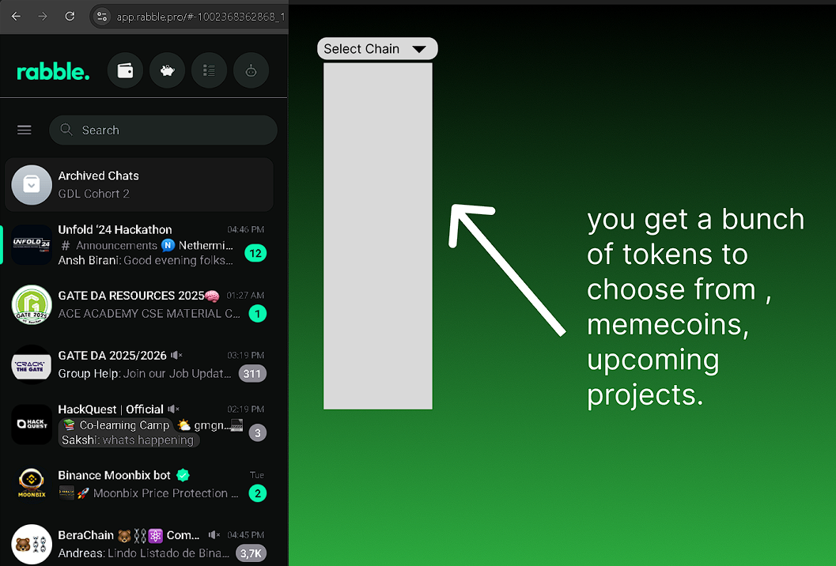

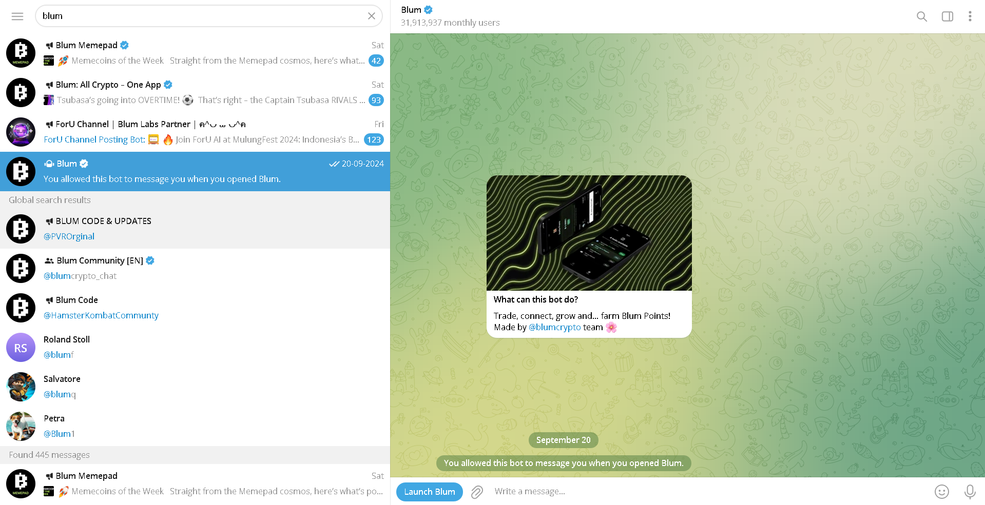

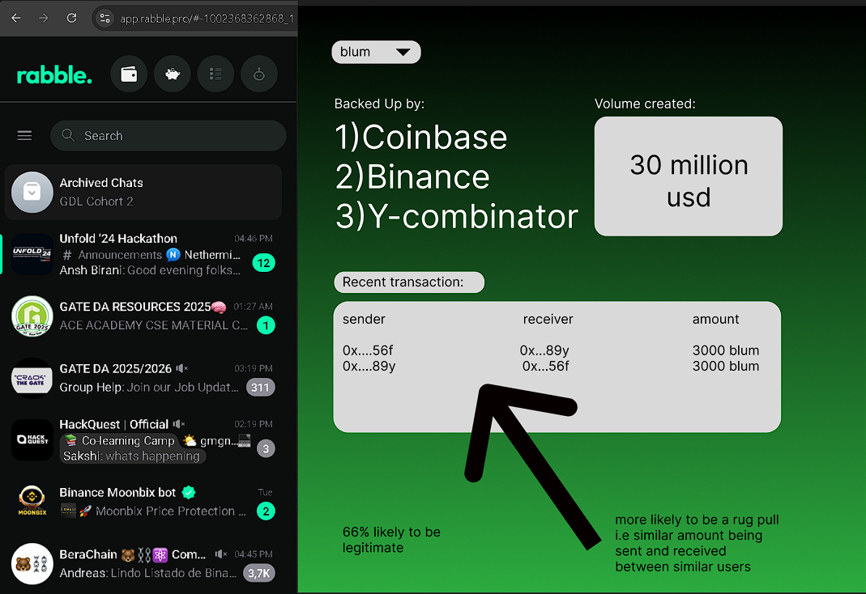

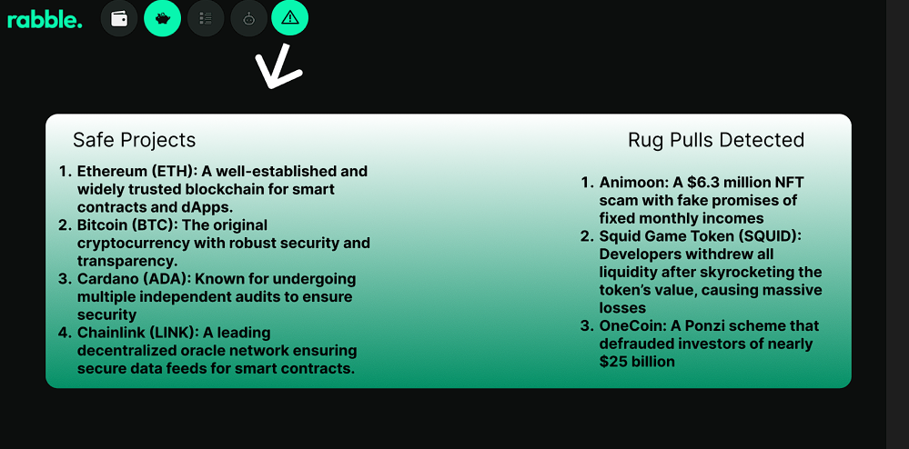

Flowchart:  
  
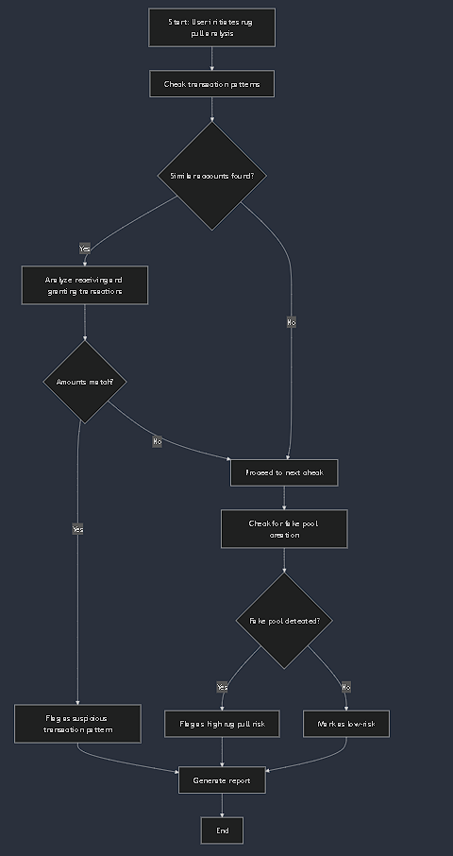

2)Bonus Idea: Rabble Token Drop unlike traditional dropping 

@Additionally for further updates, we can have rabble chain , launched which is a good idea , hence it seems blending with the idea of incentivizing user with every valid submission of civic issue(garbage related photos) being verified by our deep learning model , and then actually tokenizing them with rabble tokens, (which further promotes your chain and maintains a good face , while solving social issue, via creating a user-cycle).

-------------------------------------------------------------  
  
Overall Summary: Consider this as you as a user are also able to tag certain projects/chain by your end whether a given chain/memecoin is a potential rug pull or not, another one being an automated system that flags via the above mentioned points.  
 -----x—x—x-----