TEAM: ABSOLUTE-TECH

Comprising :Tanmay Sayare  
Shrujan Kharwadey  
Ayush Agrawal  
Prakhar Pande

Solution on increasing user-activity/traction on diamante blockchain.

**DIAMIFY**

What we observed..there is a limited amount of transaction/traction as still there is need of the token to get to multiple users! Or to increase its traction.

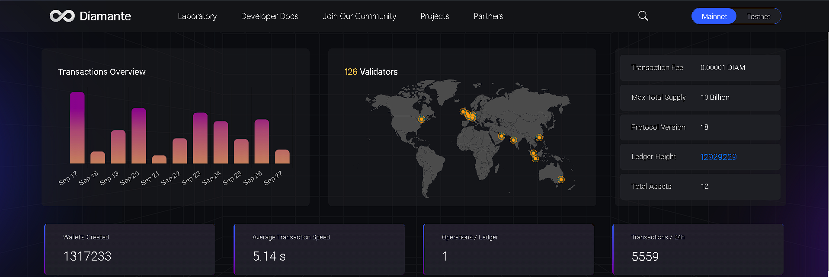

**Hence we came up with an idea!** 🡪

1)We will tokenize users who are actively participating in social tasks (as mentioned on ploggify)

2)By watching the current scenarios in airdropping 🡪 we came with a fair predictable pricing of 0.008$ to 0.01$ per diam coin.(EX hamster being able to hit 0.01 on the listing day itself, blum with a predicted price of 0.0067)

3)Unlike traditional Airdropping, where users need to do tasks with no meaning or no impact to the real world/society Our Solution redirect them through a healthy way i.e (if user takes part in a drive/

3)As always mining is limited hence we will provide every users with a 2 minute window for them to claim as many tokens as they want via a simple rockpaperscissor game/clicker game.  
  
4)Hence larger audience will be attracted to such campaigns with worthy meanings/ fruitful outcome to the society as well as the user itself.

5)Hence they can claim token after the listing date.

6)We ensure that the number of tokens that needs to be distributed does not fall into a sybil attacker userbase, (simply to maintain the total pool of diam tokens all over the network).

**TO PUT IN SIMPLE WORDS 🡪 INORDER TO INCREASE YOUR USERBASE ONE NEEDS TO MARKETIZE, HENCE MARKETIZE THE WAY NEVER BEFORE WITH A SOCIAL TOUCH.**

FLOWCHART:

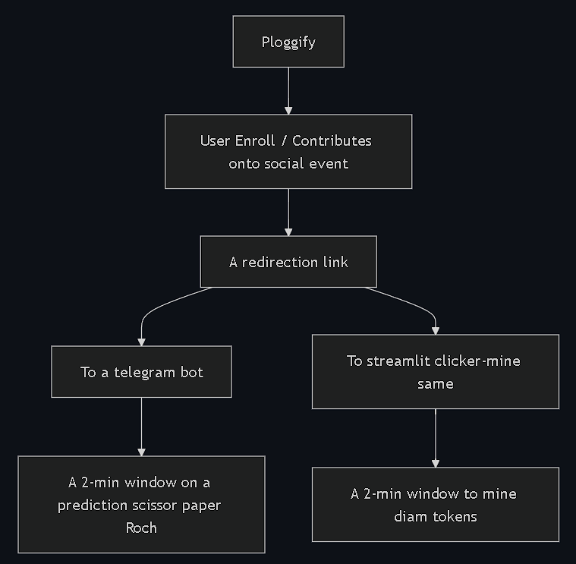

Conclusion: You Also look for the society while keeping your efforts worth count, getting incentivized (more like a social airdropping).