CHAPTER FOUR: RESULTS AND ANALYSIS OF FINDINGS

IBRAHIM KASSOUM Habibou

2024-06-12

# Demographic dynamics

## Population Dynamics analysis

### Spatial distribution relationship fertility rate and mortality

#### **Global Moran Index**

* *Descriptive statistics*

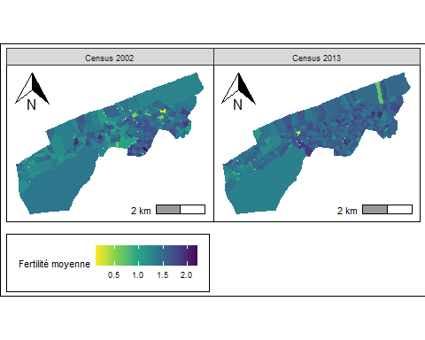

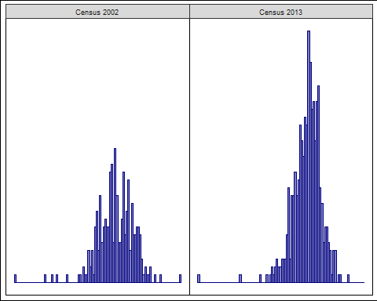

* *Global moran test*

##   
## Moran I test under randomisation  
##   
## data: MPI_data_dr_2013 %>% as.data.frame() %>% select(!!as.name(outcome)) %>%   
## weights: weights_2013   
## pull()   
## weights: weights_2013   
##   
## Moran I statistic standard deviate = 5.6649, p-value = 7.358e-09  
## alternative hypothesis: greater  
## sample estimates:  
## Moran I statistic Expectation Variance   
## 0.1585300059 -0.0023041475 0.0008060828

##   
## Moran I test under randomisation  
##   
## data: MPI_data_dr_2002 %>% as.data.frame() %>% select(!!as.name(outcome)) %>%   
## weights: weights_2002   
## pull()   
## weights: weights_2002   
##   
## Moran I statistic standard deviate = 5.9911, p-value = 1.042e-09  
## alternative hypothesis: greater  
## sample estimates:  
## Moran I statistic Expectation Variance   
## 0.216526035 -0.003745318 0.001351755

#### **Local indicators of spatial association (LISA)**

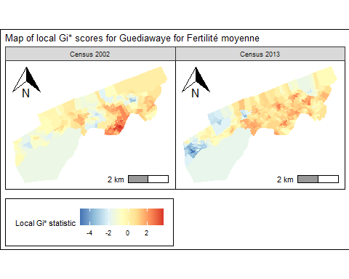

* *LISA quadrant scatterplot*

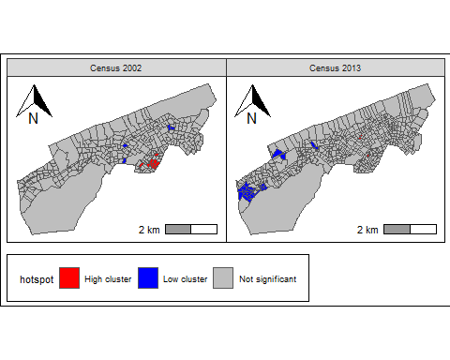

* *LISA quadrant scatterplot point*

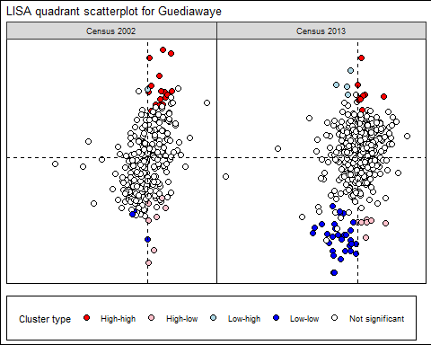

#### **Ordinary Least Square (OLS)**

|  | **Census 2002** | | | | **Census 2013** | | | |
| --- | --- | --- | --- | --- | --- | --- | --- | --- |
| **Covariates** | **Estimate***1* | **Std. Error***2* | **z value** | **Pr(>|z|)** | **Estimate***1* | **Std. Error***2* | **z value** | **Pr(>|z|)** |
| Migration: (ref. Visiteur) | | | | | | | | |
| - Proportion de Résident Absent | 1.6 | 1.70 | 0.958 | 0.3 | -1.3* | 0.501 | -2.51 | 0.012 |
| - Proportion de repas sauté | -0.20 | 1.51 | -0.134 | 0.9 | -0.09 | 0.500 | -0.174 | 0.9 |
| Langues parlées: (ref. Français) | | | | | | | | |
| - Wolof | -0.16 | 0.701 | -0.234 | 0.8 | -0.22 | 0.190 | -1.17 | 0.2 |
| - Pulaar | 3.1 | 2.30 | 1.37 | 0.2 | 0.99 | 0.961 | 1.03 | 0.3 |
| - Sereer | 5.0 | 10.5 | 0.473 | 0.6 | 5.3 | 5.57 | 0.949 | 0.3 |
| - Mandingo | -21 | 28.2 | -0.746 | 0.5 | -1.1 | 4.38 | -0.252 | 0.8 |
| - Diola | -24 | 15.3 | -1.56 | 0.12 | 0.32 | 3.66 | 0.087 | >0.9 |
| - Proportion de résident permanent | -0.57 | 0.427 | -1.32 | 0.2 | -0.17 | 0.135 | -1.28 | 0.2 |
| Niveau d'instruction du CM: (ref. Primaire) | | | | | | | | |
| - Moyen | -0.09 | 0.490 | -0.191 | 0.8 | -0.11 | 0.228 | -0.481 | 0.6 |
| - Secondaire | -0.48 | 0.543 | -0.876 | 0.4 | -0.05 | 0.253 | -0.185 | 0.9 |
| - Supérieur | -0.77 | 0.536 | -1.44 | 0.2 | -0.18 | 0.241 | -0.758 | 0.4 |
| - Arabic | 0.18 | 0.122 | 1.51 | 0.13 | 0.09 | 0.141 | 0.646 | 0.5 |
| Niveau d'instruction: (ref. Primaire) | | | | | | | | |
| - Moyen | 0.24 | 0.924 | 0.258 | 0.8 | 0.37 | 0.417 | 0.877 | 0.4 |
| - Secondaire | 0.95 | 1.24 | 0.766 | 0.4 | -0.77 | 0.639 | -1.20 | 0.2 |
| - Supérieur | 1.0 | 1.39 | 0.722 | 0.5 | 0.09 | 0.572 | 0.161 | 0.9 |
| - Aucun | -0.24 | 0.347 | -0.704 | 0.5 |  |  |  |  |
| Caractéristiques du ménage: | | | | | | | | |
| - Proportion de femme | 0.44 | 0.771 | 0.574 | 0.6 | 0.43 | 0.373 | 1.16 | 0.2 |
| - Aucun | 0.21 | 0.331 | 0.620 | 0.5 |  |  |  |  |
| - Proportion de soins médicaux | 0.43 | 1.39 | 0.309 | 0.8 | 0.61 | 0.469 | 1.29 | 0.2 |
| - Proportion d'individus qui sont au chômage ou à la recherche d'un premier emploi | -1.0* | 0.426 | -2.46 | 0.015 | -0.18 | 0.185 | -0.955 | 0.3 |
| - Age médian du CM | -0.01 | 0.013 | -0.969 | 0.3 | 0.00 | 0.006 | -0.384 | 0.7 |
| - Age moyen du CM | 0.01 | 0.016 | 0.855 | 0.4 | 0.01 | 0.008 | 0.774 | 0.4 |
| - Proportion de CM de sexe féminin | 0.19 | 0.285 | 0.669 | 0.5 | 0.19 | 0.107 | 1.76 | 0.079 |
| - Moyenne de l'indice de peoplement | -0.01 | 0.031 | -0.174 | 0.9 | 0.00 | 0.048 | -0.026 | >0.9 |
| Caractéristiques de la population: | | | | | | | | |
| - Médiane de l'indice de peoplement | 0.01 | 0.037 | 0.255 | 0.8 | 0.04 | 0.053 | 0.820 | 0.4 |
| - Densité de la population | 0.00 | 0.001 | 1.20 | 0.2 | 0.00 | 0.000 | -0.026 | >0.9 |
| Groupe d'age: (réf. 60 ans et plus) | | | | | | | | |
| - entre 15 et 29 ans | -4.6* | 2.31 | -1.98 | 0.048 | -1.7 | 0.961 | -1.80 | 0.073 |
| - entre 30 et 44 ans | -5.5* | 2.45 | -2.23 | 0.027 | -1.8 | 1.05 | -1.75 | 0.081 |
| - entre 45 et 59 ans | -2.5 | 2.48 | -1.02 | 0.3 | -0.82 | 0.973 | -0.842 | 0.4 |
| - Proportion de ménage | 0.00 | 0.000 | 0.181 | 0.9 | 0.00 | 0.000 | -0.179 | 0.9 |
| Occupation: (réf. occupés) | | | | | | | | |
| - Proportion d'individus qui sont occupés au foyer | -0.04 | 0.490 | -0.086 | >0.9 | 0.02 | 0.255 | 0.070 | >0.9 |
| - Proportion d'individus qui sont étudiants/élèves | -1.2** | 0.381 | -3.08 | 0.002 | 0.15 | 0.201 | 0.731 | 0.5 |
| - Proportion d'individus qui sont rentiers | 1.3 | 1.81 | 0.736 | 0.5 | 1.4* | 0.684 | 2.04 | 0.042 |
| - Proportion d'individus qui ont d'autres situations | -1.3*** | 0.325 | -3.90 | <0.001 | -0.03 | 0.146 | -0.199 | 0.8 |
| - moins de 14 ans | -2.4 | 2.23 | -1.05 | 0.3 | -1.3 | 0.921 | -1.45 | 0.15 |
|  | | | | | | | | |
| (Intercept) | 3.8 | 2.40 | 1.60 | 0.11 | 1.3 | 0.999 | 1.26 | 0.2 |
| R² | 0.270 |  |  |  | 0.186 |  |  |  |
| Adjusted R² | 0.160 |  |  |  | 0.119 |  |  |  |
| No. Obs. | 268 |  |  |  | 435 |  |  |  |
| *1*\*p<0.05; **p<0.01; ***p<0.001 | | | | | | | | |
| *2*SE = Standard Error | | | | | | | | |

#### **Geographically weighted regression (GWR)**

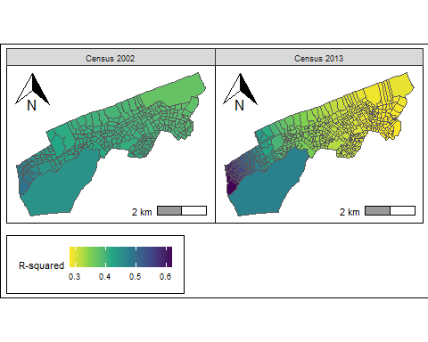

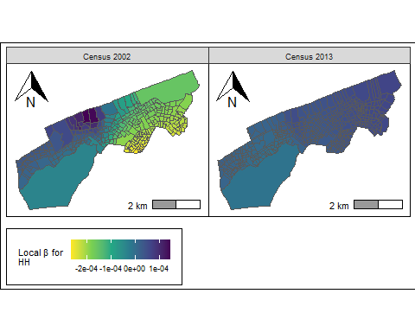

#### **K-means algorithm**

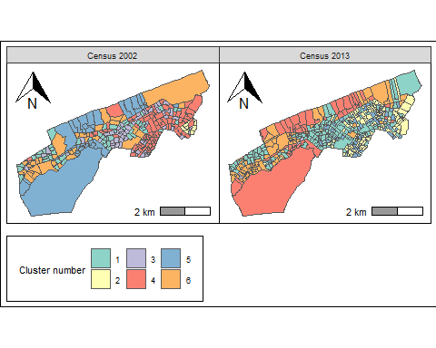

#### **K-Medoids Clustering Methods**

#### SKATER Algorithm

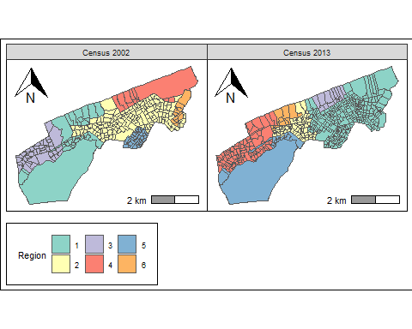

## Analysis of household changes

### Analysis of the situation of the head of household

#### Employment situation of the head of household

#### Marital status of the head of household

### Analysis of the household situation

#### Quality of housing and household Facilities

#### Household size and poverty