Forced Displacement Survey - South Sudan

Data4Decision team - data source : Forced Displacement Survey - South Sudan

04 May 2025

# Legal status and displacement history

| Covariates | **Refugees**, N = 2,0681 | **Host community North**, N = 9901 | **p-value**2 |
| --- | --- | --- | --- |
| Of which country [are you/is name] a citizen? |  |  | <0.001 |
| National of host country | 0.9 | 99 |  |
| National of other country | 88 | 1.0 |  |
| Stateless | 11 | 0 |  |
| Don't know | 0.1 | 0 |  |
| Refuse to answer | 0 | 0 |  |
| Do you have a passport? |  |  | 0.4 |
| yes | 3.4 | 4.3 |  |
| no | 96 | 96 |  |
| refuse to answer | 0.2 | 0.1 |  |
| Has [name]'s birth been registered with the [civil authorities]? |  |  | 0.5 |
| yes | 0 | 0 |  |
| no | 50 | 100 |  |
| don't know | 50 | 0 |  |
| refuse to answer | 0 | 0 |  |
| How long you have been living in SSD? Years |  |  | >0.9 |
| 15 | 67 | NA |  |
| 18 | 33 | NA |  |
| Did some household members stayed behind in [COUNTRY OF FORCED DISPLACEMENT]? |  |  | >0.9 |
| all household members moved together | 63 | 100 |  |
| some household members stayed behind | 33 | 0 |  |
| v.r.: i moved alone, all my household members stayed behind | 3.9 | 0 |  |
| refuse to answer | 0.4 | 0 |  |
| Do you intend to return to [COUNTRY OF F. DISPLACEMENT] within the next 6 months |  |  | >0.9 |
| definitely yes | 16 | NA |  |
| probably yes | 5.9 | NA |  |
| probably no | 15 | NA |  |
| definitely no | 31 | NA |  |
| I cannot predict the situation, my return depends on the evolution of the situation | 31 | NA |  |
| What about returning to [COUNTRY OF F. DISPLACEMENT] within a year? |  |  | >0.9 |
| definitely yes | 1.1 | NA |  |
| probably yes | 4.2 | NA |  |
| probably no | 31 | NA |  |
| definitely no | 61 | NA |  |
| I cannot predict the situation, my return depends on the evolution of the situation | 2.6 | NA |  |
| What about returning to [COUNTRY OF F. DISPLACEMENT] within next 5 years? |  |  | >0.9 |
| definitely yes | 1.1 | NA |  |
| probably yes | 9.1 | NA |  |
| probably no | 23 | NA |  |
| definitely no | 56 | NA |  |
| I cannot predict the situation, my return depends on the evolution of the situation | 11 | NA |  |
| 1% | | | |
| 2Fisher's exact test | | | |

# Demographics

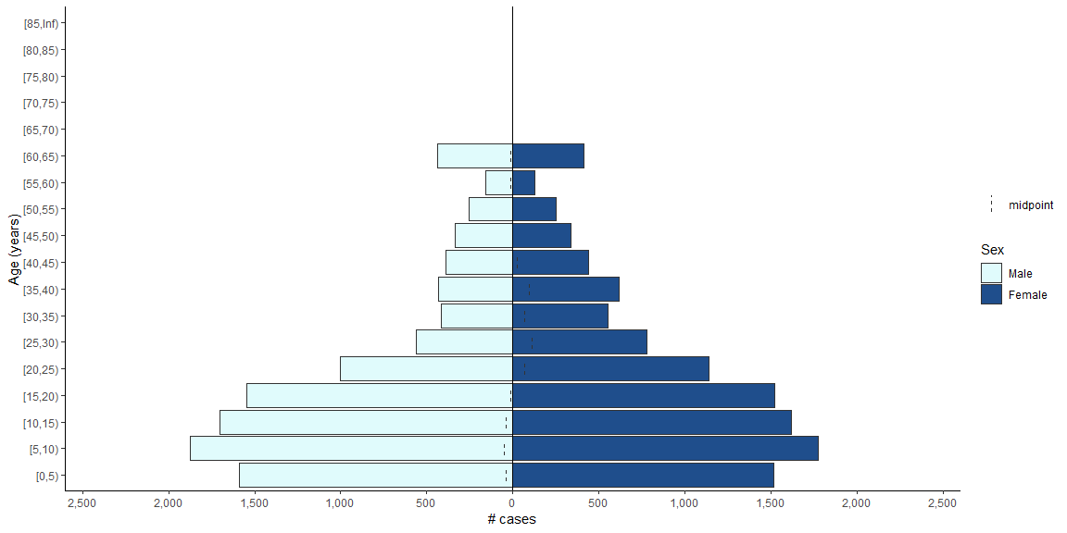

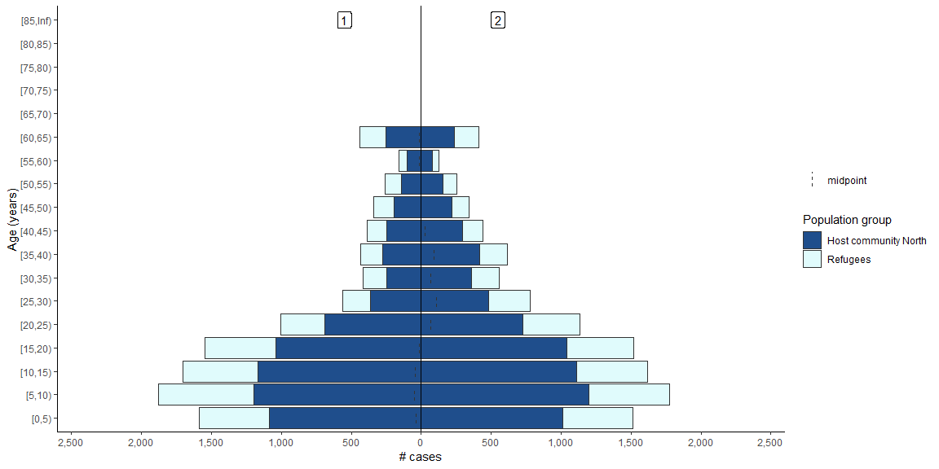

| Household head characteristics | **Refugees**, N = 2,0681 | **Host community North**, N = 9901 | **p-value**2 |
| --- | --- | --- | --- |
| ageYears | 42(17,61) | 42(19,61) | >0.9 |
| Sex |  |  | <0.001 |
| Male | 54 | 63 |  |
| Female | 46 | 37 |  |
| What is [your/name's] present marital status? |  |  |  |
| monogamous/married | 63 | 72 |  |
| polygamous/married | 14 | 19 |  |
| non-formal union | 0.6 | 0.3 |  |
| separated | 5.4 | 1.5 |  |
| divorced | 3.3 | 0.9 |  |
| widow or widower | 7.4 | 5.2 |  |
| never married | 6.9 | 1.1 |  |
| Age of first married/formed a non-formal union | 21.8(10.0,55.0) | 21.4(12.0,59.0) | 0.5 |
| [Is/was] [your/name' s] biological mother a refugee or asylum seeker? |  |  | <0.001 |
| yes | 33 | 2.1 |  |
| no | 66 | 97 |  |
| don't know | 0.3 | 0.6 |  |
| refuse to answer | 0.1 | 0 |  |
| [Is/was] [your/name' s] biological father a refugee or asylum seeker? |  |  | <0.001 |
| yes | 23 | 0.9 |  |
| no | 76 | 99 |  |
| don't know | 0.4 | 0.5 |  |
| refuse to answer | 0.3 | 0 |  |
| 1Mean(Minimum,Maximum); % | | | |
| 2Wilcoxon rank sum test; Pearson's Chi-squared test; Fisher's exact test | | | |

# Social environment

| Covariates | **Refugees**, N = 2,0681 | **Host community North**, N = 9901 | **p-value**2 |
| --- | --- | --- | --- |
| Do you have the legal right to move freely in SSD? |  |  | >0.9 |
| yes | 46 | 100 |  |
| no | 39 | 0 |  |
| don't know | 14 | 0 |  |
| How safe does your family feel living in this shelter? |  |  | <0.001 |
| always feel safe | 44 | 38 |  |
| sometimes feel safe | 34 | 41 |  |
| never feel safe | 22 | 20 |  |
| GBV available services: Health services |  |  | <0.001 |
| yes | 68 | 54 |  |
| no | 25 | 42 |  |
| don't know | 7.2 | 4.1 |  |
| GBV available services: psychological services |  |  | <0.001 |
| yes | 41 | 26 |  |
| no | 48 | 62 |  |
| don't know | 11 | 12 |  |
| GBV available services: Safety services as safe shelters |  |  | 0.5 |
| yes | 40 | 38 |  |
| no | 49 | 50 |  |
| don't know | 11 | 11 |  |
| GBV available services: Security services i.e. police |  |  | <0.001 |
| yes | 65 | 59 |  |
| no | 28 | 37 |  |
| don't know | 7.3 | 4.2 |  |
| GBV available services: Legal assistance |  |  | <0.001 |
| yes | 43 | 33 |  |
| no | 45 | 58 |  |
| don't know | 12 | 8.9 |  |
| GBV available services: Any other services |  |  | <0.001 |
| yes | 1.1 | 1.0 |  |
| no | 75 | 86 |  |
| don't know | 24 | 13 |  |
| 1% | | | |
| 2Fisher's exact test; Pearson's Chi-squared test | | | |

# Basic needs

## Water, sanitation, and hygiene (WASH)

| Covariates | **Refugees**, N = 2,0681 | **Host community North**, N = 9901 | **p-value**2 |
| --- | --- | --- | --- |
| HH didn't have sufficient quantities of drinking water (Past 30 days) |  |  | <0.001 |
| yes | 42 | 57 |  |
| no | 57 | 42 |  |
| don't know | 0.4 | 0.3 |  |
| (OBS) Sanitation pipes(sewage pipes) functional |  |  | <0.001 |
| yes | 1.7 | 0.3 |  |
| no | 51 | 44 |  |
| not possible to observe | 1.3 | 5.9 |  |
| (vol response) do not exist | 46 | 50 |  |
| Has any soap/detergent/ash/mud/sand in your house for washing hands | 60 | 34 | <0.001 |
| 1% | | | |
| 2Fisher's exact test; Pearson's Chi-squared test | | | |

## Clean energy

| Covariates | **Refugees**, N = 2,0681 | **Host community North**, N = 9901 | **p-value** |
| --- | --- | --- | --- |
| What type of fuel or energy source does this HH use most of the time? |  |  |  |
| alcohol / ethanol | 0 | 0 |  |
| gasoline / diesel (not in generator) | 0 | 0 |  |
| kerosene / paraffin | <0.1 | 0 |  |
| coal / lignite unprocessed | 9.4 | 11 |  |
| coal / lignite briquettes / pellets | <0.1 | 0 |  |
| charcoal unprocessed | 4.9 | 6.3 |  |
| charcoal briquettes / pellets | 1.0 | 0.2 |  |
| wood | 69 | 80 |  |
| agricultural or crop residue / grass / straw / shrubs / corn cobs | 8.8 | 0.5 |  |
| animal waste / dung | 0 | 0 |  |
| processed biomass pellets / briquettes | <0.1 | 0 |  |
| woodchips | 6.1 | 1.9 |  |
| garbage / plastic | 0 | 0 |  |
| sawdust | <0.1 | 0 |  |
| other: specify | 0.4 | 0.4 |  |
| What does this HH use for cooking most of the time? |  |  |  |
| solar cooker (thermal energy, not solar panels) | 0 | 0 |  |
| electric stove | 0 | 0 |  |
| piped natural gas stove | <0.1 | 0 |  |
| biogas stove | 0 | 0 |  |
| liquefied petroleum has (lpg) / cooking gas stove | 0 | 0.1 |  |
| manufactured solid fuel stove | 0.2 | 0.3 |  |
| traditional solid fuel stove (non-manufactured) | 1.8 | 0.4 |  |
| liguid fuel stove | 0.1 | 0.1 |  |
| Moveable firepan | 7.4 | 7.6 |  |
| three stone stove / open fire | 74 | 80 |  |
| Build stove with bricks and/or mud | 15 | 9.0 |  |
| other: specify | 0.7 | 2.6 |  |
| 1% | | | |

## Shelter

| Covariates | **Refugees**, N = 2,0681 | **Host community North**, N = 9901 | **p-value**2 |
| --- | --- | --- | --- |
| (OBS) Type of dwelling does the household live in |  |  |  |
| apartment | <0.1 | 0 |  |
| house | 34 | 36 |  |
| traditional house such as tukul | 46 | 39 |  |
| tents | 20 | 24 |  |
| caravan | 0.2 | 0.2 |  |
| collective center | <0.1 | 0.2 |  |
| worksite / unfinished home / abandoned building | 0 | 0.1 |  |
| school, mosque, church, or other religious building | 0.1 | 0 |  |
| garage, shop, workshop, or other structure not intended for habitation | 0 | 0 |  |
| other: specify | 0.3 | 0.5 |  |
| (OBS) Main material of the exterior walls of the dwelling |  |  |  |
| no walls | 9.3 | 31 |  |
| cane / palm / trunks | 12 | 3.0 |  |
| dirt | 5.3 | 0 |  |
| bamboo with mud | 3.5 | 45 |  |
| stone with mud | 1.3 | 3.0 |  |
| uncovered adobe | 3.2 | 0.8 |  |
| plywood | 1.0 | 0 |  |
| cardboard | 0.7 | 0 |  |
| reused wood | 0.4 | 0.8 |  |
| cement | 2.1 | 2.7 |  |
| stone with lime / cement | 0.4 | 0.3 |  |
| bricks | 14 | 3.0 |  |
| cement blocks | 0 | 0 |  |
| covered adobe | 3.3 | 0.5 |  |
| wood planks / shingles | 0.3 | 0.5 |  |
| mud bricks | 43 | 7.8 |  |
| other: specify | 0.8 | 1.9 |  |
| (OBS) Main material of the dwelling's floor |  |  | 0.006 |
| earth / sand | 92 | 96 |  |
| dung | 1.0 | 0.5 |  |
| wood planks | 0.6 | 0.3 |  |
| palm / bamboo | 0.1 | 0.3 |  |
| parquet or polished wood | 0 | 0 |  |
| vinyl or asphalt strips | 0 | 1.1 |  |
| ceramic tiles | 0.7 | 0 |  |
| cement | 4.3 | 1.4 |  |
| carpet | 0.3 | 0 |  |
| plastic sheeting or canvas | 0.8 | 0.3 |  |
| other: specify | 0.3 | 0.3 |  |
| 1% | | | |
| 2Fisher's exact test | | | |

## Health

| Covariates | **Refugees**, N = 2,0681 | **Host community North**, N = 9901 | **p-value**2 |
| --- | --- | --- | --- |
| Admitted to hospital/health facility (Past 12 months, no traditional healing) | 18 | 20 | 0.2 |
| Does your household have bednets/mosquito nets that can be used while sleeping? | 33 | 40 | <0.001 |
| How many of these bednets/mosquito nets does your household have? | 2.35(1.00,12.00) | 3.40(1.00,55.00) | <0.001 |
| Does anybody in your hh have difficulty seeing, even if wearing glasses? |  |  | 0.089 |
| 1 | 22 | 19 |  |
| 2 | 78 | 81 |  |
| 98 | 0 | 0.1 |  |
| 99 | <0.1 | 0 |  |
| Does anybody in your hh have difficulty hearing, even if using hearing aids? |  |  | <0.001 |
| 1 | 14 | 9.0 |  |
| 2 | 86 | 91 |  |
| 98 | 0 | 0.2 |  |
| Does anybody in hh have difficulty difficulty walking/climbing stairs? |  |  | 0.5 |
| 1 | 14 | 13 |  |
| 2 | 86 | 87 |  |
| 98 | <0.1 | 0 |  |
| Does anybody in hh have difficulty difficulty remembering/concentrating? |  |  | 0.002 |
| 1 | 7.5 | 4.5 |  |
| 2 | 92 | 95 |  |
| 99 | <0.1 | 0.1 |  |
| Anybody in hh have difficulty with self-care, as washing all over/dressing |  |  | 0.4 |
| 1 | 4.4 | 4.5 |  |
| 2 | 96 | 95 |  |
| 98 | 0 | 0.1 |  |
| Anybody in hh have difficulty communicating, understanding/being understood |  |  | <0.001 |
| 1 | 4.5 | 1.5 |  |
| 2 | 96 | 98 |  |
| 98 | 0 | 0.1 |  |
| 1%; Mean(Minimum,Maximum) | | | |
| 2Pearson's Chi-squared test; Wilcoxon rank sum test; Fisher's exact test | | | |

## Maternal and child health

| Covariates | **Refugees**, N = 2,0681 | **Host community North**, N = 9901 | **p-value**2 |
| --- | --- | --- | --- |
| Delivery assistance :: Doctor | 22 | 11 | <0.001 |
| Delivery assistance :: nurse / midwife | 82 | 58 | <0.001 |
| Delivery assistance :: traditional birth attendant | 12 | 18 | 0.003 |
| Delivery assistance :: community health worker | 0.2 | 0.4 | 0.6 |
| Delivery assistance :: relative / friend | 0.7 | 13 | <0.001 |
| Delivery assistance :: No one | 0.1 | 5.5 | <0.001 |
| Delivery assistance :: Other: specify | 0.5 | 0.2 | 0.7 |
| during pregnancy - times you had a follow-up visit w/health profesional | 5.05(0.00,10.00) | 5.10(0.00,9.00) | 0.8 |
| Was the child issued with a birth certificate? |  |  | <0.001 |
| yes | 90 | 41 |  |
| no | 9.5 | 59 |  |
| don't know | 0.1 | 0.4 |  |
| Does [child's name] have an immunization card? |  |  | <0.001 |
| yes | 94 | 75 |  |
| no | 5.3 | 24 |  |
| don't know | 0.2 | 0.8 |  |
| Can I see the card? | 81 | 68 | <0.001 |
| [Child's name] ever received a measles containing vaccine - MMR/MR vaccin |  |  | <0.001 |
| yes, with card | 75 | 51 |  |
| yes, without card | 16 | 20 |  |
| no | 8.4 | 28 |  |
| don't know | 0.2 | 1.1 |  |
| How many times did [child's name] receive the measles or MMR/MR vaccine? |  |  | 0.6 |
| 0 | 0.9 | 1.5 |  |
| 1 | 55 | 53 |  |
| 2 | 41 | 43 |  |
| 98 | 3.0 | 2.8 |  |
| Did [child's name] receive LAST measles vaccine in ? |  |  | 0.11 |
| In SSD | 99 | 98 |  |
| other country | 1.3 | 2.4 |  |
| main reason why [child's name] didn't receive a measles or MMR injection |  |  |  |
| service is not available | 13 | 22 |  |
| service provider refused to provide me with service | 0.9 | 1.1 |  |
| too far / transportation issue | 2.6 | 28 |  |
| no time as i had to work / care for children | 3.5 | 5.4 |  |
| language barrier | 0 | 0 |  |
| couldn't afford service fees | 0 | 0 |  |
| no information about immunization schedules | 6.1 | 5.9 |  |
| didn't know where to go | 0.9 | 1.6 |  |
| do not trust vaccine | 0.9 | 0.5 |  |
| staff were rude | 0.9 | 0 |  |
| other: specify | 71 | 35 |  |
| Has [child's name] received Pentavalent vaccine (DPT + Hep B + Hib)? |  |  | <0.001 |
| yes, card | 78 | 53 |  |
| yes, no card | 17 | 19 |  |
| no | 4.3 | 24 |  |
| don't know | 0.7 | 4.2 |  |
| How many times did [child's name] receive the Pentavalent vaccine? |  |  |  |
| 0 | 0.4 | 0 |  |
| 1 | 29 | 26 |  |
| 2 | 15 | 25 |  |
| 3 | 46 | 31 |  |
| 4 | 7.2 | 15 |  |
| 98 | 2.7 | 3.0 |  |
| Has [child's name] received a vitamin A capsule in the past six months? |  |  | <0.001 |
| yes, card | 66 | 35 |  |
| yes, no card | 19 | 17 |  |
| no | 12 | 44 |  |
| don't know | 4.0 | 4.0 |  |
| [Child's name] was given any drug for intestinal worms in the past 6 months |  |  | <0.001 |
| yes | 68 | 37 |  |
| no | 26 | 58 |  |
| not applicable | 1.0 | 1.2 |  |
| don't know | 5.2 | 4.0 |  |
| Has [child's name] had diarrhea in the past 2 weeks? |  |  | 0.003 |
| yes | 35 | 29 |  |
| no | 65 | 70 |  |
| don't know | 0.2 | 0.8 |  |
| Child's diarrhoea treament :: nothing | 8.6 | 29 | <0.001 |
| Child's diarrhoea treament :: ors | 57 | 32 | <0.001 |
| Child's diarrhoea treament :: zinc tablet or syrup | 60 | 55 | 0.2 |
| Child's diarrhoea treament :: home-made fluid | 11 | 21 | <0.001 |
| Child's diarrhoea treament :: injection | 2.7 | 9.6 | <0.001 |
| Child's diarrhoea treament :: intravenous | 0.4 | 5.3 | <0.001 |
| Child's diarrhoea treament :: other | 3.7 | 3.7 | >0.9 |
| Child's diarrhoea treament :: don't know | 0.6 | 0.5 | >0.9 |
| 1%; Mean(Minimum,Maximum) | | | |
| 2Pearson's Chi-squared test; Fisher's exact test; Wilcoxon rank sum test | | | |

## Education

## Food and Nutrition

| Covariates | **Refugees**, N = 2,0681 | **Host community North**, N = 9901 | **p-value**2 |
| --- | --- | --- | --- |
| There was not enough food or money for food in your HH (Past 7 days) | 82 | 89 | <0.001 |
| Anyone ate a limited variety of foods [Past 30/7 days] | 88 | 70 | <0.001 |
| No food to eat of any kind in your household [Past 30/7 days] | 78 | 72 | <0.001 |
| Any member slept at night hungry [Past 30/7 days] | 74 | 75 | 0.4 |
| Any member went a whole day and night without eating [Past 30/7 days] | 65 | 69 | 0.048 |
| 1% | | | |
| 2Pearson's Chi-squared test | | | |

## Social protection

| Covariates | **Refugees**, N = 2,0681 | **Host community North**, N = 9901 | **p-value**2 |
| --- | --- | --- | --- |
| You/anyone in HH received support from assistance programme (Past 12 months) |  |  | <0.001 |
| 1 | 58 | 11 |  |
| 2 | 42 | 89 |  |
| 98 | 0.2 | 0.2 |  |
| 1% | | | |
| 2Fisher's exact test | | | |

# Livelihoods

## Child Labour

| Covariates | **Refugees**, N = 2,0681 | **Host community North**, N = 9901 | **p-value**2 |
| --- | --- | --- | --- |
| child_labour | 15 | 9.5 | <0.001 |
| [Child] worked/helped in farm, food garden, looked after animals (Past 7 days) |  |  | 0.005 |
| yes | 12 | 8.1 |  |
| no | 88 | 92 |  |
| don't know | <0.1 | 0 |  |
| [Child] helped in family/relative business, or run own business? (past 7 days) |  |  | 0.002 |
| yes | 4.2 | 1.8 |  |
| no | 96 | 98 |  |
| don't know | <0.1 | 0 |  |
| [Child] produced or sold articles, handicrafts, clothes, food…? (Past 7 days) |  |  | 0.025 |
| yes | 2.8 | 1.7 |  |
| no | 97 | 98 |  |
| don't know | 0.5 | 0 |  |
| [Child] engaged in any other activity (Past 7 days) |  |  | 0.041 |
| yes | 2.9 | 1.5 |  |
| no | 97 | 98 |  |
| don't know | <0.1 | 0.3 |  |
| Total of hours [Child] engaged in these [his/her] activity(ies) (Past 7 days) | 7(0,168) | 18(0,70) | <0.001 |
| 1%; Mean(Minimum,Maximum) | | | |
| 2Pearson's Chi-squared test; Fisher's exact test; Wilcoxon rank sum test | | | |

## Financial services

| Covariates | **Refugees**, N = 2,0681 | **Host community North**, N = 9901 | **p-value**2 |
| --- | --- | --- | --- |
| Has a bank/other formal financial institution (FFI) account in SSD |  |  | 0.042 |
| 1 | 0.6 | 1.3 |  |
| 2 | 99 | 99 |  |
| 98 | 0.5 | 0.1 |  |
| Assistance provider :: remittances from family, friends, or any relatives | NA(Inf,-Inf) | NA(Inf,-Inf) |  |
| 1%; Mean(Minimum,Maximum) | | | |
| 2Fisher's exact test | | | |

## Land and property

| Covariates | **Refugees**, N = 2,0681 | **Host community North**, N = 9901 | **p-value**2 |
| --- | --- | --- | --- |
| You or any HH member own any plot of land in SSD |  |  | <0.001 |
| yes | 15 | 75 |  |
| no | 85 | 25 |  |
| don't know | 0.3 | 0.3 |  |
| refuse to answer | 0 | 0 |  |
| You or any HH member owns the plot you live on |  |  | <0.001 |
| yes | 29 | 79 |  |
| no | 70 | 21 |  |
| don't know | 0.5 | 0.1 |  |
| refuse to answer | <0.1 | 0.1 |  |
| 1% | | | |
| 2Fisher's exact test | | | |

## Shocks

| Covariates | **Refugees**, N = 2,0681 | **Host community North**, N = 9901 | **p-value**2 |
| --- | --- | --- | --- |
| In the past 12 months, has your household experienced any shock? |  |  | 0.3 |
| 1 | 52 | 48 |  |
| 2 | 48 | 52 |  |
| 98 | 0.2 | 0.2 |  |
| 99 | <0.1 | 0 |  |
| 1% | | | |
| 2Fisher's exact test | | | |

## Changes to household income

| Covariates | **Refugees**, N = 2,0681 | **Host community North**, N = 9901 | **p-value**2 |
| --- | --- | --- | --- |
| Compared to this time last year, would you say your HH income...? |  |  | <0.001 |
| increased | 21 | 7.9 |  |
| remained the same | 26 | 36 |  |
| decreased | 43 | 47 |  |
| my household does not have any income | 9.2 | 8.5 |  |
| don't know | 1.2 | 0.9 |  |
| 1% | | | |
| 2Pearson's Chi-squared test | | | |

## Subjective well-being

| Covariates | **Refugees**, N = 2,0681 | **Host community North**, N = 9901 | **p-value**2 |
| --- | --- | --- | --- |
| (1=not at all satisfied, 5= very satisf.): Your standard of living |  |  | <0.001 |
| 1 | 26 | 45 |  |
| 2 | 26 | 18 |  |
| 3 | 33 | 21 |  |
| 4 | 9.4 | 5.5 |  |
| 5 | 5.8 | 11 |  |
| Catril Scale - Where you feel you personally stand at PRESENT TIME | 2.95(0.00,10.00) | 2.01(0.00,10.00) | <0.001 |
| Catril Scale - Where you feel you will personally stand in 1 YEAR FROM NOW | 3.85(0.00,10.00) | 2.85(0.00,10.00) | <0.001 |
| 1%; Mean(Minimum,Maximum) | | | |
| 2Pearson's Chi-squared test; Wilcoxon rank sum test | | | |

# Assistance programme

| Covariates | **Refugees**, N = 2,0681 | **Host community North**, N = 9901 | **p-value**2 |
| --- | --- | --- | --- |
| SProg1: Type of assistance |  |  | <0.001 |
| food assistance programme | 68 | 65 |  |
| non-food items assistance programme | 9.1 | 22 |  |
| cash transfer programme, other than food cash grants | 22 | 5.5 |  |
| other: specify | 0.8 | 4.6 |  |
| don't know | 0.4 | 2.8 |  |
| refuse to answer | 0 | 0 |  |
| SProg1: Program type |  |  | <0.001 |
| government | 0.2 | 16 |  |
| community organization or cooperative | 3.3 | 1.8 |  |
| ngo & international organization | 95 | 73 |  |
| religious group | <0.1 | 2.8 |  |
| other | 0.2 | 0.9 |  |
| don't know | 1.0 | 5.5 |  |
| refuse to answer | 0 | 0 |  |
| SProg1: in-kind food distrib, cash grant or food voucher |  |  |  |
| in-kind | 18 | 62 |  |
| cash grant | 9.7 | 2.8 |  |
| food voucher | 13 | 21 |  |
| v.r.: a combination of in-kind and cash | 53 | 0 |  |
| v.r.: a combination of cash and food voucher | 6.2 | 0 |  |
| v.r.: a combination of in-kind and food voucher | 0.9 | 0 |  |
| v.r.: a combination of the 3 modalities | 0.4 | 13 |  |
| don't know | 0 | 1.4 |  |
| refuse to answer | 0 | 0 |  |
| Sprog1 :: HH member that receives money in the form of a cash transfer |  |  | 0.11 |
| 1 | 78 | 67 |  |
| 2 | 15 | 17 |  |
| 3 | 3.9 | 0 |  |
| 4 | 1.2 | 0 |  |
| 5 | 0.8 | 0 |  |
| 6 | 0.4 | 0 |  |
| 9 | 0.8 | 0 |  |
| 10 | 0.4 | 0 |  |
| 15 | 0 | 17 |  |
| SProg1: N times, past 12 months | 8.9(1.0,81.0) | 1.9(1.0,12.0) | <0.001 |
| 1%; Mean(Minimum,Maximum) | | | |
| 2Fisher's exact test; Wilcoxon rank sum test | | | |