**REPUBLIQUE DU SENEGAL**

**\*\*\*\*\*\*\*\*\*\*\*\*\***

**Un Peuple-Un But-Une Foi**

**\*\*\*\*\*\*\*\*\*\*\*\*\***

**Chargé du cours :**

**M. Aboubacar HEMA**

**Analyse de recherche à l’IFPRI**

**Ministère de l’Economie, du Plan et de la Coopération**

**\*\*\*\*\*\*\*\*\*\*\*\*\*\*\*\*\*\*\*\*\*\*\*\*\***

**Ecole nationale de la Statistique et de l’Analyse économique Pierre Ndiaye (ENSAE)**

**(ENSAE)**

**Projet-statistique-sous-R**

**Par :**

**Djerakeï MISTALENGAR**

**Élève Ingénieur Statisticien Economiste (ISE)**

Table of Contents

I. Analyse de consistance des bases de données 2

I.1 Analyse préliminaire des bases de données 3

I.2 Nettoyage des bases de données avec janitor 3

I.3 Suppression des colonnes et lignes inutiles 4

I.4 Traitement des doublons 5

I.5 Cohérence entre les bases de données 5

I.6 Traitement des valeurs aberrantes 5

I.7 Résumé du nettoyage 5

I.8 Finalisation des bases de données nettoyées 6

Exploration des données 6

I.9 Structure des bases de données 6

I.10 Variables catégorielles importantes 23

I.11 Statistiques descriptives des variables numériques 25

Analyse des données socio-démographiques 26

I.12 Répartition par âge et sexe 26

I.13 Analyse du niveau d’éducation 28

30

Calcul et analyse du Crowding Index (Indice d’affluence) 30

I.14 Calcul du nombre d’individus par ménage 30

I.15 Statistiques descriptives sur le nombre de pièces 31

I.16 Calcul de l’indice d’affluence (Crowding Index) 32

I.17 Analyse de la distribution de l’indice d’affluence 32

I.18 Comparaison entre réfugiés et communautés d’accueil 33

Analyse de la sécurité alimentaire des déplacés internes 34

I.19 Score de Consommation Alimentaire (SCA) 34

I.2.1 Analyse descriptive des variables composant le SCA 35

I.2.2 Calcul du Score de Consommation Alimentaire 37

I.2.3 Catégorisation du SCA selon différents seuils 38

I.2.4 Représentation spatiale du SCA par région et département 39

I.2.5 Analyse du SCA selon le statut de déplacement 42

L’indice réduit des stratégies de survie (rCSI) 44

I.20 Analyse descriptive des variables qui composent le rCSI 44

I.21 Création et analyse de nouvelles variables numériques pour le rCSI 47

I.22 Calcul de l’indice réduit des stratégies de survie (rCSI) 48

I.23 Représentation spatiale du rCSI selon le milieu de résidence 50

I.24 Analyse croisée du rCSI avec d’autres variables socio-démographiques 52

# 

# I. Analyse de consistance des bases de données

Cette section vise à vérifier la qualité des données importées et à appliquer les transformations nécessaires pour assurer leur cohérence avant l’analyse. Nous utiliserons principalement les packages janitor et tidyverse pour cette tâche.

## Analyse préliminaire des bases de données

Commençons par examiner les dimensions et les caractéristiques générales de nos bases de données.

## Dimensions de la base Ind: 22092 144

## Dimensions de la base Prin: 3058 1312

##   
## Nombre de valeurs manquantes par colonne (top 10) - Base Ind:

## HH_00b_month HH_00b_year HH_11b Dis_18 Dis_15 Dis_12   
## 22089 22077 22025 21978 21954 21879   
## ID_04 HH_16 ID_06 Dis_06   
## 21852 21760 21710 21692

##   
## Nombre de valeurs manquantes par colonne (top 10) - Base Prin:

## HH_31b16 HH_31b17 HH_31b18 HH_31b19 HH_31b20 HH_31b21 HH_31b22 HH_31b23   
## 3058 3058 3058 3058 3058 3058 3058 3058   
## HH_31b24 HH_31b25   
## 3058 3058

##   
## Pourcentage global de valeurs manquantes - Base Ind: 64.64 %

## Pourcentage global de valeurs manquantes - Base Prin: 65.55 %

## Nettoyage des bases de données avec janitor

Le package janitor offre des fonctions utiles pour nettoyer les bases de données. Appliquons quelques-unes de ces fonctions à nos bases.

## Colonnes presque vides (>90% NA) dans la base Ind: 36

## [1] "HH_00a_year" "HH_00a_month" "HH_00b_year" "HH_00b_month" "HH_11b"   
## [6] "ID_04" "ID_06" "HH_07b" "HH_10name16" "HH_10name17"

##   
## Colonnes presque vides (>90% NA) dans la base Prin: 589

## [1] "HH_31b1" "HH_31b2" "HH_31b3" "HH_31b4" "HH_31b5" "HH_31b6"   
## [7] "HH_31b7" "HH_31b8" "HH_31b9" "HH_31b10"

##   
## Lignes presque vides (>90% NA) dans la base Ind: 0

## Lignes presque vides (>90% NA) dans la base Prin: 0

##   
## Exemple de noms de colonnes avant/après nettoyage - Base Ind:

## original nettoyé  
## 1 Intro_07_1 Intro_07_1  
## 2 start start  
## 3 end end  
## 4 admin0 admin0  
## 5 admin1 admin1

##   
## Exemple de noms de colonnes avant/après nettoyage - Base Prin:

## original nettoyé  
## 1 Intro_07_1 Intro_07_1  
## 2 start start  
## 3 end end  
## 4 admin0 admin0  
## 5 admin1 admin1

## Suppression des colonnes et lignes inutiles

Sur la base de l’analyse ci-dessus, nous pouvons décider de supprimer certaines colonnes ou lignes qui contiennent principalement des valeurs manquantes. Cependant, il est important de ne pas supprimer des données qui pourraient être pertinentes pour l’analyse.

## Dimensions de la base Ind avant: 22092 144

## Dimensions de la base Ind après: 22092 116

## Dimensions de la base Prin avant: 3058 1312

## Dimensions de la base Prin après: 3058 873

##   
## Dimensions de la base Ind après suppression des lignes: 22092 116

## Dimensions de la base Prin après suppression des lignes: 3058 873

## Traitement des doublons

Vérifions s’il existe des doublons dans les bases de données.

## Nombre de lignes avec des IDs dupliqués dans la base Ind: 2971

## Nombre de lignes dupliquées dans la base Prin: 0

## Cohérence entre les bases de données

Vérifions la cohérence entre les bases de données Ind et Prin, notamment la correspondance des identifiants.

## Nombre d'IDs dans Ind qui n'existent pas dans Prin: 0

## Nombre d'IDs dans Prin qui n'existent pas dans Ind: 0

## Traitement des valeurs aberrantes

Examinons certaines variables numériques clés pour détecter d’éventuelles valeurs aberrantes.

## Nombre de valeurs aberrantes pour l'âge: 0

## Résumé du nettoyage

## Résumé des modifications apportées:

## 1. Colonnes supprimées (>95% NA) - Base Ind: 28

## 2. Colonnes supprimées (>95% NA) - Base Prin: 439

## 3. Lignes supprimées (>95% NA) - Base Ind: 0

## 4. Lignes supprimées (>95% NA) - Base Prin: 0

##   
## Pourcentage final de valeurs manquantes - Base Ind: 56.8 %

## Pourcentage final de valeurs manquantes - Base Prin: 48.97 %

## Finalisation des bases de données nettoyées

Remplaçons les bases de données originales par les versions nettoyées pour la suite de l’analyse.

## used (Mb) gc trigger (Mb) max used (Mb)  
## Ncells 1236541 66.1 2288362 122.3 2288362 122.3  
## Vcells 6482159 49.5 24630400 188.0 21401687 163.3

# Exploration des données

## Structure des bases de données

Pour mieux comprendre les données, examinons la structure des deux bases et les principales variables disponibles.

## [1] 22092 116

## [1] 3058 873

## tibble [22,092 × 116] (S3: tbl_df/tbl/data.frame)  
## $ Intro_07_1 : dbl+lbl [1:22092] 1, 1, 1, 1, 1, 1, 1, 1, 1, 1, 1, 1, 1, 1, 1, 1, 1, 1...  
## ..@ label : chr "Population group"  
## ..@ format.stata: chr "%10.0g"  
## ..@ labels : Named num [1:4] 1 2 3 4  
## .. ..- attr(*, "names")= chr [1:4] "Refugees" "Asylum-seekers" "Host community North" "Returnees"  
## $ start : Date[1:22092], format: "2023-04-29" "2023-04-29" ...  
## $ end : Date[1:22092], format: "2023-04-29" "2023-04-29" ...  
## $ admin0 : chr [1:22092] "SSD" "SSD" "SSD" "SSD" ...  
## ..- attr(*, "label")= chr "Host country"  
## ..- attr(*, "format.stata")= chr "%-9s"  
## $ admin1 : dbl+lbl [1:22092] 3, 3, 3, 3, 3, 3, 3, 3, 3, 3, 3, 3, 3, 3, 3, 2, 2, 2...  
## ..@ label : chr "State"  
## ..@ format.stata: chr "%10.0g"  
## ..@ labels : Named num [1:6] 1 2 3 4 5 6  
## .. ..- attr(*, "names")= chr [1:6] "Unity" "Upper Nile" "Central Equatoria" "Jonglei" ...  
## $ admin2 : dbl+lbl [1:22092] 3, 3, 3, 3, 3, 3, 3, 3, 3, 3, 3, 3, 3, 3, 3, 2, 2, 2...  
## ..@ label : chr "County"  
## ..@ format.stata: chr "%10.0g"  
## ..@ labels : Named num [1:12] 1 2 3 4 5 6 7 8 9 10 ...  
## .. ..- attr(*, "names")= chr [1:12] "Pariang" "Maban" "Juba" "Morobo" ...  
## $ admin3 : dbl+lbl [1:22092] 1, 1, 1, 1, 1, 1, 1, 1, 1, 1, 1, 1, 1, 1, 1, 5, 5, 5...  
## ..@ label : chr "Payam"  
## ..@ format.stata: chr "%10.0g"  
## ..@ labels : Named num [1:19] 1 2 3 4 5 6 7 8 9 10 ...  
## .. ..- attr(*, "names")= chr [1:19] "Not applicable" "Jamjang" "Werthen" "Boung" ...  
## $ Final_01 : dbl+lbl [1:22092] 1, 1, 1, 1, 1, 1, 1, 1, 1, 1, 1, 1, 1, 1, 1, 1, 1, 1...  
## ..@ label : chr "Final outcome of the interview"  
## ..@ format.stata: chr "%49.0g"  
## ..@ labels : Named num [1:15] 1 2 21 22 23 24 25 31 32 33 ...  
## .. ..- attr(*, "names")= chr [1:15] "Complete Interview" "Partially complete interview" "Refused to be interviewed - hard" "Break-off, refusal" ...  
## $ ID : num [1:22092] 1 1 1 1 1 1 1 1 1 1 ...  
## ..- attr(*, "label")= chr "Household ID"  
## ..- attr(*, "format.stata")= chr "%12.0g"  
## $ rosterposition : num [1:22092] 1 2 3 4 5 6 7 8 9 10 ...  
## ..- attr(*, "label")= chr "Position in HH Roster"  
## ..- attr(*, "format.stata")= chr "%12.0g"  
## $ HH_03 : int [1:22092] 1 2 3 3 3 3 3 3 4 4 ...  
## $ HH_02 : int [1:22092] 1 1 2 2 1 1 2 2 1 1 ...  
## $ ageYears : num [1:22092] 31 44 19 16 12 10 4 2 19 13 ...  
## $ Intro_camp_label : chr [1:22092] "GOROM" "GOROM" "GOROM" "GOROM" ...  
## ..- attr(*, "label")= chr "Intro_camp_label"  
## ..- attr(*, "format.stata")= chr "%11s"  
## $ HH_00 : int [1:22092] 1 1 1 1 1 1 1 1 1 1 ...  
## $ HH_00a_year : int [1:22092] NA NA NA NA NA NA NA NA NA NA ...  
## $ HH_00a_month : int [1:22092] NA NA NA NA NA NA NA NA NA NA ...  
## $ HH_11a : int [1:22092] 0 0 0 0 0 0 NA NA 0 0 ...  
## $ HH_13 : int [1:22092] 1 1 1 1 1 1 1 1 1 1 ...  
## $ ID_00 : dbl+lbl [1:22092] 2, 2, 2, 2, NA, NA, NA, NA, 2, NA, NA, NA, NA, ...  
## ..@ label : chr "Of which country [are you/is name] a citizen?"  
## ..@ format.stata: chr "%10.0g"  
## ..@ labels : Named num [1:5] 1 2 3 98 99  
## .. ..- attr(*, "names")= chr [1:5] "National of host country" "National of other country" "Stateless" "Don't know" ...  
## $ ID_01a : dbl+lbl [1:22092] NA, NA, NA, NA, NA, NA, NA, NA, NA, NA, NA, NA, NA, ...  
## ..@ label : chr "While living in this country, have you ever had to flee home?"  
## ..@ format.stata: chr "%10.0g"  
## ..@ labels : Named num [1:3] 1 2 99  
## .. ..- attr(*, "names")= chr [1:3] "yes" "no" "refused to answer"  
## $ ID_01b : dbl+lbl [1:22092] 1, 1, 1, 1, NA, NA, NA, NA, 1, NA, NA, NA, NA, ...  
## ..@ label : chr "While living abroad, have you ever had to flee home?"  
## ..@ format.stata: chr "%10.0g"  
## ..@ labels : Named num [1:3] 1 2 99  
## .. ..- attr(*, "names")= chr [1:3] "yes" "no" "refused to answer"  
## $ ID_02 : dbl+lbl [1:22092] 1, 1, 1, 1, NA, NA, NA, NA, 1, NA, NA, NA, NA, ...  
## ..@ label : chr "What is the main reason why had to flee home?"  
## ..@ format.stata: chr "%10.0g"  
## ..@ labels : Named num [1:8] 1 2 3 4 5 6 98 99  
## .. ..- attr(*, "names")= chr [1:8] "security reasons, armed conflicts & generalized violence" "fear of persecution" "human rights violation" "natural or man-made disaster" ...  
## $ ID_03 : dbl+lbl [1:22092] 1, 1, 1, 1, NA, NA, NA, NA, 1, NA, NA, NA, NA, ...  
## ..@ label : chr "After forced to leave home, did you/name have to cross an international border?"  
## ..@ format.stata: chr "%10.0g"  
## ..@ labels : Named num [1:4] 1 2 3 99  
## .. ..- attr(*, "names")= chr [1:4] "yes" "no" "v.r.: I just went to another location in" "refused to answer"  
## $ ID_05 : dbl+lbl [1:22092] 1, 1, 1, 1, NA, NA, NA, NA, 3, NA, NA, NA, NA, ...  
## ..@ label : chr "While abroad/in SSD, applied for international protection (government/UNHCR)"  
## ..@ format.stata: chr "%10.0g"  
## ..@ labels : Named num [1:3] 1 2 3  
## .. ..- attr(*, "names")= chr [1:3] "Applied for protection" "Did not apply for protection" "Did not apply for protection because of prima facie recognition"  
## $ ID_06b : dbl+lbl [1:22092] 1, 1, 1, 1, NA, NA, NA, NA, NA, NA, NA, NA, NA, ...  
## ..@ label : chr "What is the outcome of your application for international protection?"  
## ..@ format.stata: chr "%10.0g"  
## ..@ labels : Named num [1:6] 1 2 3 4 96 98  
## .. ..- attr(*, "names")= chr [1:6] "refugee status granted" "refugee status denied" "still waiting for response" "v.r.: I have not checked for a while" ...  
## $ ID_07 : dbl+lbl [1:22092] 2, 2, 2, 2, NA, NA, NA, NA, 2, NA, NA, NA, NA, ...  
## ..@ label : chr "If want to, can return home?"  
## ..@ format.stata: chr "%10.0g"  
## ..@ labels : Named num [1:3] 1 2 99  
## .. ..- attr(*, "names")= chr [1:3] "yes" "no" "Refused to answer"  
## $ ID_08 : dbl+lbl [1:22092] 1, 1, 1, 1, NA, NA, NA, NA, 1, NA, NA, NA, NA, ...  
## ..@ label : chr "What is the main reason why cannot return home?"  
## ..@ format.stata: chr "%56.0g"  
## ..@ labels : Named num [1:14] 1 2 3 4 51 52 53 54 55 56 ...  
## .. ..- attr(*, "names")= chr [1:14] "security reasons, armed conflicts & generalized violence" "fear of persecution" "human rights violation" "natural or man-made disaster" ...  
## $ ID_09 : dbl+lbl [1:22092] 9, 9, 9, 9, NA, NA, NA, NA, 9, NA, NA, NA, NA, ...  
## ..@ label : chr "Legal document"  
## ..@ format.stata: chr "%52.0g"  
## ..@ labels : Named num [1:14] 1 2 3 5 6 7 8 9 10 11 ...  
## .. ..- attr(*, "names")= chr [1:14] "No documents" "Student visa" "Work visa" "Humanitarian visa" ...  
## $ ID_10 : dbl+lbl [1:22092] 1, 1, 1, 1, NA, NA, NA, NA, 1, NA, NA, NA, NA, ...  
## ..@ label : chr "Can I see the document?"  
## ..@ format.stata: chr "%10.0g"  
## ..@ labels : Named num [1:5] 1 2 3 96 99  
## .. ..- attr(*, "names")= chr [1:5] "Yes: Doc seen" "No: Doc not seen" "v.r.: Doc not seen because the household member is not present and he/she has the document" "Don't know" ...  
## $ ID_11 : dbl+lbl [1:22092] 1, 1, 1, 1, NA, NA, NA, NA, 1, NA, NA, NA, NA, ...  
## ..@ label : chr "Can I take a picture of the document?"  
## ..@ format.stata: chr "%10.0g"  
## ..@ labels : Named num [1:4] 1 2 96 99  
## .. ..- attr(*, "names")= chr [1:4] "Yes" "No" "Don't know" "refuse to answer"  
## $ ID_VAR : chr [1:22092] "8" "8" "8" "8" ...  
## ..- attr(*, "label")= chr "ID_VAR"  
## ..- attr(*, "format.stata")= chr "%9s"  
## $ HH_06 : int [1:22092] 2 2 2 2 2 2 1 1 2 2 ...  
## $ HH_06_specify : chr [1:22092] "ETH" "ETH" "ETH" "ETH" ...  
## ..- attr(*, "label")= chr "In which country [were you/was name] born? If C. of origin, please specify"  
## ..- attr(*, "format.stata")= chr "%9s"  
## $ HH_07a : int [1:22092] NA NA NA NA NA NA 2 1 NA NA ...  
## $ HH_08 : int [1:22092] 1 1 1 7 7 NA NA NA 7 7 ...  
## $ HH_09 : chr [1:22092] "17" "20" "17" "" ...  
## ..- attr(*, "label")= chr "How old [were you/was name] when first [married/formed a non-formal union] ?"  
## ..- attr(*, "format.stata")= chr "%-9s"  
## $ HH_10 : chr [1:22092] "" "name1" "hhmemberother" "" ...  
## ..- attr(*, "label")= chr "Could you tell me who is [your/name's] spouse/partner?"  
## ..- attr(*, "format.stata")= chr "%35s"  
## $ HH_10hhmemberother : int [1:22092] NA 0 1 NA NA NA NA NA NA NA ...  
## $ HH_10name1 : int [1:22092] NA 1 0 NA NA NA NA NA NA NA ...  
## $ HH_10name2 : int [1:22092] NA 0 0 NA NA NA NA NA NA NA ...  
## $ HH_10name3 : int [1:22092] NA 0 0 NA NA NA NA NA NA NA ...  
## $ HH_10name4 : int [1:22092] NA 0 0 NA NA NA NA NA NA NA ...  
## $ HH_10name5 : int [1:22092] NA 0 0 NA NA NA NA NA NA NA ...  
## $ HH_10name6 : int [1:22092] NA 0 0 NA NA NA NA NA NA NA ...  
## $ HH_10name7 : int [1:22092] NA 0 0 NA NA NA NA NA NA NA ...  
## $ HH_10name8 : int [1:22092] NA 0 0 NA NA NA NA NA NA NA ...  
## $ HH_10name9 : int [1:22092] NA 0 0 NA NA NA NA NA NA NA ...  
## $ HH_10name10 : int [1:22092] NA 0 0 NA NA NA NA NA NA NA ...  
## $ HH_10name11 : int [1:22092] NA 0 0 NA NA NA NA NA NA NA ...  
## $ HH_10name12 : int [1:22092] NA 0 0 NA NA NA NA NA NA NA ...  
## $ HH_10name13 : int [1:22092] NA 0 0 NA NA NA NA NA NA NA ...  
## $ HH_10name14 : int [1:22092] NA 0 0 NA NA NA NA NA NA NA ...  
## $ HH_10name15 : int [1:22092] NA 0 0 NA NA NA NA NA NA NA ...  
## $ HH_17 : int [1:22092] NA NA 5 NA NA NA NA NA NA NA ...  
## $ HH_18 : int [1:22092] 2 2 1 1 1 1 1 1 1 1 ...  
## $ HH_19 : chr [1:22092] "" "" "name1" "name1" ...  
## ..- attr(*, "label")= chr "Who is [your/name' s] biological mother?"  
## ..- attr(*, "format.stata")= chr "%13s"  
## $ HH_21 : int [1:22092] 2 2 1 1 1 1 1 1 1 1 ...  
## $ HH_22 : int [1:22092] 2 2 NA NA NA NA NA NA 2 2 ...  
## $ HH_23 : int [1:22092] NA NA NA NA NA NA NA NA NA NA ...  
## $ HH_25 : int [1:22092] 2 2 1 1 1 1 1 1 1 1 ...  
## $ HH_26 : int [1:22092] NA NA NA NA NA NA 2 4 NA NA ...  
## $ HH_27 : int [1:22092] NA NA 1 2 NA NA NA NA NA NA ...  
## $ HH_28 : int [1:22092] NA NA 1 NA NA NA NA NA NA NA ...  
## $ HH_29 : int [1:22092] NA NA 2 NA NA NA NA NA NA NA ...  
## $ HH_Educ00 : int [1:22092] NA NA NA NA NA NA 1 2 NA NA ...  
## $ HH_Educ01 : int [1:22092] NA NA NA NA NA NA 2 NA NA NA ...  
## $ HH_Educ02a : int [1:22092] 2 2 1 1 1 1 NA NA 1 1 ...  
## $ HH_Educ02b : int [1:22092] NA NA 1 1 1 1 NA NA 1 1 ...  
## $ HH_Educ02c : int [1:22092] NA NA 1 1 1 1 NA NA 1 1 ...  
## $ HH_Educ03 : int [1:22092] NA NA 6 4 4 1 NA NA 4 3 ...  
## $ HH_Educ04a : int [1:22092] NA NA 2 2 2 2 NA NA 2 2 ...  
## $ HH_Educ04b : int [1:22092] NA NA 1 1 1 1 NA NA 1 1 ...  
## $ HH_Educ05 : chr [1:22092] "" "" "name1 name2" "name1 name2" ...  
## ..- attr(*, "label")= chr "Who decides whether [you go/name goes] to school?"  
## ..- attr(*, "format.stata")= chr "%30s"  
## $ HH_Educ05hhmemberother: int [1:22092] NA NA 0 0 0 0 NA NA 0 0 ...  
## $ HH_Educ05name1 : int [1:22092] NA NA 1 1 1 1 NA NA 0 0 ...  
## $ HH_Educ05name2 : int [1:22092] NA NA 1 1 1 1 NA NA 0 0 ...  
## $ HH_Educ05name3 : int [1:22092] NA NA 0 0 0 0 NA NA 0 0 ...  
## $ HH_Educ05name4 : int [1:22092] NA NA 0 0 0 0 NA NA 0 0 ...  
## $ HH_Educ05name5 : int [1:22092] NA NA 0 0 0 0 NA NA 0 0 ...  
## $ HH_Educ05name6 : int [1:22092] NA NA 0 0 0 0 NA NA 0 0 ...  
## $ HH_Educ05name7 : int [1:22092] NA NA 0 0 0 0 NA NA 0 0 ...  
## $ HH_Educ05name8 : int [1:22092] NA NA 0 0 0 0 NA NA 0 0 ...  
## $ HH_Educ05name9 : int [1:22092] NA NA 0 0 0 0 NA NA 0 0 ...  
## $ HH_Educ05name10 : int [1:22092] NA NA 0 0 0 0 NA NA 0 0 ...  
## $ HH_Educ05name11 : int [1:22092] NA NA 0 0 0 0 NA NA 0 0 ...  
## $ HH_Educ05name12 : int [1:22092] NA NA 0 0 0 0 NA NA 0 0 ...  
## $ HH_Educ05name13 : int [1:22092] NA NA 0 0 0 0 NA NA 0 0 ...  
## $ HH_Educ05name14 : int [1:22092] NA NA 0 0 0 0 NA NA 0 0 ...  
## $ HH_Educ05name15 : int [1:22092] NA NA 0 0 0 0 NA NA 1 1 ...  
## $ HH_Educ05name16 : int [1:22092] NA NA NA NA NA NA NA NA NA NA ...  
## $ HH_Educ05name17 : int [1:22092] NA NA NA NA NA NA NA NA NA NA ...  
## $ HH_Educ05name18 : int [1:22092] NA NA NA NA NA NA NA NA NA NA ...  
## $ HH_Educ05name19 : int [1:22092] NA NA NA NA NA NA NA NA NA NA ...  
## $ HH_Educ05name20 : int [1:22092] NA NA NA NA NA NA NA NA NA NA ...  
## $ HH_Educ05name21 : int [1:22092] NA NA NA NA NA NA NA NA NA NA ...  
## $ HH_Educ05name22 : int [1:22092] NA NA NA NA NA NA NA NA NA NA ...  
## $ HH_Educ05name23 : int [1:22092] NA NA NA NA NA NA NA NA NA NA ...  
## $ HH_Educ05name24 : int [1:22092] NA NA NA NA NA NA NA NA NA NA ...  
## [list output truncated]

## # A tibble: 6 × 116  
## Intro_07_1 start end admin0 admin1 admin2 admin3 Final_01 ID  
## <dbl+lbl> <date> <date> <chr> <dbl+l> <dbl+l> <dbl+l> <dbl+lb> <dbl>  
## 1 1 [Refuge… 2023-04-29 2023-04-29 SSD 3 [Cen… 3 [Jub… 1 [Not… 1 [Comp… 1  
## 2 1 [Refuge… 2023-04-29 2023-04-29 SSD 3 [Cen… 3 [Jub… 1 [Not… 1 [Comp… 1  
## 3 1 [Refuge… 2023-04-29 2023-04-29 SSD 3 [Cen… 3 [Jub… 1 [Not… 1 [Comp… 1  
## 4 1 [Refuge… 2023-04-29 2023-04-29 SSD 3 [Cen… 3 [Jub… 1 [Not… 1 [Comp… 1  
## 5 1 [Refuge… 2023-04-29 2023-04-29 SSD 3 [Cen… 3 [Jub… 1 [Not… 1 [Comp… 1  
## 6 1 [Refuge… 2023-04-29 2023-04-29 SSD 3 [Cen… 3 [Jub… 1 [Not… 1 [Comp… 1  
## # ℹ 107 more variables: rosterposition <dbl>, HH_03 <int>, HH_02 <int>,  
## # ageYears <dbl>, Intro_camp_label <chr>, HH_00 <int>, HH_00a_year <int>,  
## # HH_00a_month <int>, HH_11a <int>, HH_13 <int>, ID_00 <dbl+lbl>,  
## # ID_01a <dbl+lbl>, ID_01b <dbl+lbl>, ID_02 <dbl+lbl>, ID_03 <dbl+lbl>,  
## # ID_05 <dbl+lbl>, ID_06b <dbl+lbl>, ID_07 <dbl+lbl>, ID_08 <dbl+lbl>,  
## # ID_09 <dbl+lbl>, ID_10 <dbl+lbl>, ID_11 <dbl+lbl>, ID_VAR <chr>,  
## # HH_06 <int>, HH_06_specify <chr>, HH_07a <int>, HH_08 <int>, HH_09 <chr>, …

## tibble [3,058 × 873] (S3: tbl_df/tbl/data.frame)  
## $ Intro_07_1 : dbl+lbl [1:3058] 1, 1, 3, 3, 3, 3, 1, 1, 1, 3, 1, 1, 1, 1, 3, 1, 3, 3,...  
## ..@ label : chr "Population group"  
## ..@ format.stata: chr "%10.0g"  
## ..@ labels : Named num [1:4] 1 2 3 4  
## .. ..- attr(*, "names")= chr [1:4] "Refugees" "Asylum-seekers" "Host community North" "Returnees"  
## $ start : Date[1:3058], format: "2023-04-29" "2023-07-21" ...  
## $ end : Date[1:3058], format: "2023-04-29" "2023-07-21" ...  
## $ admin0 : chr [1:3058] "SSD" "SSD" "SSD" "SSD" ...  
## ..- attr(*, "label")= chr "Host country"  
## ..- attr(*, "format.stata")= chr "%-9s"  
## $ admin1 : dbl+lbl [1:3058] 3, 2, 2, 2, 1, 2, 2, 1, 1, 2, 1, 2, 2, ...  
## ..@ label : chr "State"  
## ..@ format.stata: chr "%10.0g"  
## ..@ labels : Named num [1:6] 1 2 3 4 5 6  
## .. ..- attr(*, "names")= chr [1:6] "Unity" "Upper Nile" "Central Equatoria" "Jonglei" ...  
## $ admin2 : dbl+lbl [1:3058] 3, 2, 2, 2, 1, 2, 2, 1, 1, 2, 1, 2, 2, ...  
## ..@ label : chr "County"  
## ..@ format.stata: chr "%10.0g"  
## ..@ labels : Named num [1:12] 1 2 3 4 5 6 7 8 9 10 ...  
## .. ..- attr(*, "names")= chr [1:12] "Pariang" "Maban" "Juba" "Morobo" ...  
## $ admin3 : dbl+lbl [1:3058] 1, 5, 4, 4, 6, 11, 12, 2, 2, 4, 2, 4, 5, ...  
## ..@ label : chr "Payam"  
## ..@ format.stata: chr "%10.0g"  
## ..@ labels : Named num [1:19] 1 2 3 4 5 6 7 8 9 10 ...  
## .. ..- attr(*, "names")= chr [1:19] "Not applicable" "Jamjang" "Werthen" "Boung" ...  
## $ Final_01 : dbl+lbl [1:3058] 1, 1, 1, 1, 1, 1, 1, 1, 1, 1, 1, 1, 1, 1, 1, 1, 1, 1,...  
## ..@ label : chr "Final outcome of the interview"  
## ..@ format.stata: chr "%49.0g"  
## ..@ labels : Named num [1:15] 1 2 21 22 23 24 25 31 32 33 ...  
## .. ..- attr(*, "names")= chr [1:15] "Complete Interview" "Partially complete interview" "Refused to be interviewed - hard" "Break-off, refusal" ...  
## $ ID : num [1:3058] 1 2 3 4 5 6 7 8 9 10 ...  
## ..- attr(*, "label")= chr "Household ID"  
## ..- attr(*, "format.stata")= chr "%12.0g"  
## $ positionofHH : chr [1:3058] "1" "1" "1" "2" ...  
## ..- attr(*, "label")= chr "Hoh position in roster"  
## ..- attr(*, "format.stata")= chr "%9s"  
## $ Intro_camp_label : dbl+lbl [1:3058] 5, 11, 2, 2, 10, 11, 6, 9, 1, 2, 9, 2, 11, ...  
## ..@ label : chr "Intro_camp_label"  
## ..@ format.stata: chr "%12.0g"  
## ..@ labels : Named num [1:11] 1 2 3 4 5 6 7 8 9 10 ...  
## .. ..- attr(*, "names")= chr [1:11] "Ajuong Thok" "Doro" "EZO" "Gendrassa" ...  
## $ Intro_02 : chr [1:3058] "rb_easthornafrica" "rb_easthornafrica" "rb_easthornafrica" "rb_easthornafrica" ...  
## ..- attr(*, "label")= chr "UNHCR RB"  
## ..- attr(*, "format.stata")= chr "%17s"  
## $ Intro_08 : dbl+lbl [1:3058] 1, 1, 2, 2, 2, 2, 1, 1, 1, 2, 1, 1, 1, 1, 3, 1, 2, 2,...  
## ..@ label : chr "Place of residence"  
## ..@ format.stata: chr "%10.0g"  
## ..@ labels : Named num [1:3] 1 2 3  
## .. ..- attr(*, "names")= chr [1:3] "Camp" "Settlement" "Neither camp nor settlement"  
## $ Intro_09 : dbl+lbl [1:3058] 1, 1, 1, 1, 1, 1, 1, 2, 2, 1, 2, 1, 1, 1, 1, 1, 1, 1,...  
## ..@ label : chr "Location type"  
## ..@ format.stata: chr "%10.0g"  
## ..@ labels : Named num [1:3] 1 2 3  
## .. ..- attr(*, "names")= chr [1:3] "rural" "peri-urban" "urban"  
## $ origincountry : dbl+lbl [1:3058] NA, 5, 6, 6, 6, 6, 5, 5, 5, 6, 5, 5, 5, ...  
## ..@ label : chr "Country of origin"  
## ..@ format.stata: chr "%12.0g"  
## ..@ labels : Named num [1:6] 1 2 3 4 5 6  
## .. ..- attr(*, "names")= chr [1:6] "CAF" "COD" "ETH" "OT" ...  
## $ Intro_15 : dbl+lbl [1:3058] 1, 1, 1, 1, 1, 1, 1, 1, 1, 1, 1, 1, 1, 1, 1, 1, 1, 1,...  
## ..@ label : chr "Interview Consent"  
## ..@ format.stata: chr "%10.0g"  
## ..@ labels : Named num [1:2] 1 2  
## .. ..- attr(*, "names")= chr [1:2] "yes" "no"  
## $ HH_Lang01 : dbl+lbl [1:3058] 9, 8, 19, NA, 98, 19, NA, 3, 3, 19, 3, 1, 8, ...  
## ..@ label : chr "What is [your/ name's] mother tongue(s)?"  
## ..@ format.stata: chr "%14.0g"  
## ..@ labels : Named num [1:24] 1 2 3 4 5 6 7 8 9 10 ...  
## .. ..- attr(*, "names")= chr [1:24] "Arabic" "English" "Nuba" "Uduk" ...  
## $ HH_Lang02a : dbl+lbl [1:3058] 2, 1, 1, 1, 2, 1, NA, 1, 1, 1, 1, NA, 1, ...  
## ..@ label : chr "Can [you/name] understand any of the following languages? : Arabic"  
## ..@ format.stata: chr "%16.0g"  
## ..@ labels : Named num [1:4] 1 2 98 99  
## .. ..- attr(*, "names")= chr [1:4] "yes" "no" "don't know" "refuse to answer"  
## $ HH_Lang02b : dbl+lbl [1:3058] 2, 2, 2, 2, 2, 2, 2, 2, 1, 2, 2, 2, 2, 2, 2, 2, 2, 2,...  
## ..@ label : chr "Can [you/name] understand any of the following languages? : English"  
## ..@ format.stata: chr "%16.0g"  
## ..@ labels : Named num [1:4] 1 2 98 99  
## .. ..- attr(*, "names")= chr [1:4] "yes" "no" "don't know" "refuse to answer"  
## $ HH_Lang03a : dbl+lbl [1:3058] NA, 1, 1, 1, NA, 1, NA, 1, 1, 1, 1, NA, 1, ...  
## ..@ label : chr "Can [you/name] speak well enough to conduct a conversation? : Arabic"  
## ..@ format.stata: chr "%28.0g"  
## ..@ labels : Named num [1:5] 1 2 3 98 99  
## .. ..- attr(*, "names")= chr [1:5] "yes" "no" "v.r.: the child cannot speak" "don't know" ...  
## $ HH_Lang03b : dbl+lbl [1:3058] NA, NA, NA, NA, NA, NA, NA, NA, 1, NA, NA, NA, NA, N...  
## ..@ label : chr "Can [you/name] speak well enough to conduct a conversation? : English"  
## ..@ format.stata: chr "%28.0g"  
## ..@ labels : Named num [1:5] 1 2 3 98 99  
## .. ..- attr(*, "names")= chr [1:5] "yes" "no" "v.r.: the child cannot speak" "don't know" ...  
## $ HH_30a : num [1:3058] 2 2 2 2 2 2 2 2 2 2 ...  
## ..- attr(*, "label")= chr "Has a bank/other formal financial institution (FFI) account in SSD"  
## ..- attr(*, "format.stata")= chr "%10.0g"  
## $ HH_30b : num [1:3058] 2 2 2 2 2 2 2 2 2 2 ...  
## ..- attr(*, "label")= chr "Do you personally have a ATM/debit card in SSD?"  
## ..- attr(*, "format.stata")= chr "%10.0g"  
## $ HH_31a : num [1:3058] 2 2 2 2 2 2 2 2 2 2 ...  
## ..- attr(*, "label")= chr "Any other member (>15) has bank account in SSD"  
## ..- attr(*, "format.stata")= chr "%10.0g"  
## $ HH_31b : chr [1:3058] "" "" "" "" ...  
## ..- attr(*, "label")= chr "Hh members (>15) who have bank account in SSD"  
## ..- attr(*, "format.stata")= chr "%9s"  
## $ HH_31c : num [1:3058] 2 2 2 2 2 2 2 2 2 2 ...  
## ..- attr(*, "label")= chr "Any other member has ATM card"  
## ..- attr(*, "format.stata")= chr "%10.0g"  
## $ Dis_01 : num [1:3058] 2 2 1 1 2 1 2 2 2 2 ...  
## ..- attr(*, "label")= chr "Does anybody in your hh have difficulty seeing, even if wearing glasses?  "  
## ..- attr(*, "format.stata")= chr "%10.0g"  
## $ Dis_02 : chr [1:3058] "" "" "2" "2" ...  
## ..- attr(*, "label")= chr "HH members - Disability - Difficulty seeing"  
## ..- attr(*, "format.stata")= chr "%11s"  
## $ Dis_021 : num [1:3058] NA NA 0 0 NA 1 NA NA NA NA ...  
## ..- attr(*, "label")= chr "Member 1 has disability/difficulty seeing"  
## ..- attr(*, "format.stata")= chr "%10.0g"  
## $ Dis_022 : num [1:3058] NA NA 1 1 NA 0 NA NA NA NA ...  
## ..- attr(*, "label")= chr "Member 2 has disability/difficulty seeing"  
## ..- attr(*, "format.stata")= chr "%10.0g"  
## $ Dis_023 : num [1:3058] NA NA 0 0 NA 0 NA NA NA NA ...  
## ..- attr(*, "label")= chr "Member 3 has disability/difficulty seeing"  
## ..- attr(*, "format.stata")= chr "%10.0g"  
## $ Dis_024 : num [1:3058] NA NA 0 0 NA 0 NA NA NA NA ...  
## ..- attr(*, "label")= chr "Member 4 has disability/difficulty seeing"  
## ..- attr(*, "format.stata")= chr "%10.0g"  
## $ Dis_025 : num [1:3058] NA NA 0 0 NA 0 NA NA NA NA ...  
## ..- attr(*, "label")= chr "Member 5 has disability/difficulty seeing"  
## ..- attr(*, "format.stata")= chr "%10.0g"  
## $ Dis_026 : num [1:3058] NA NA 0 0 NA 0 NA NA NA NA ...  
## ..- attr(*, "label")= chr "Member 6 has disability/difficulty seeing"  
## ..- attr(*, "format.stata")= chr "%10.0g"  
## $ Dis_027 : num [1:3058] NA NA 0 0 NA 0 NA NA NA NA ...  
## ..- attr(*, "label")= chr "Member 7 has disability/difficulty seeing"  
## ..- attr(*, "format.stata")= chr "%10.0g"  
## $ Dis_028 : num [1:3058] NA NA 0 0 NA 0 NA NA NA NA ...  
## ..- attr(*, "label")= chr "Member 8 has disability/difficulty seeing"  
## ..- attr(*, "format.stata")= chr "%10.0g"  
## $ Dis_029 : num [1:3058] NA NA 0 0 NA 0 NA NA NA NA ...  
## ..- attr(*, "label")= chr "Member 9 has disability/difficulty seeing"  
## ..- attr(*, "format.stata")= chr "%10.0g"  
## $ Dis_0210 : num [1:3058] NA NA 0 0 NA 0 NA NA NA NA ...  
## ..- attr(*, "label")= chr "Member 10 has disability/difficulty seeing"  
## ..- attr(*, "format.stata")= chr "%10.0g"  
## $ Dis_0211 : num [1:3058] NA NA 0 0 NA 0 NA NA NA NA ...  
## ..- attr(*, "label")= chr "Member 11 has disability/difficulty seeing"  
## ..- attr(*, "format.stata")= chr "%10.0g"  
## $ Dis_0212 : num [1:3058] NA NA 0 0 NA 0 NA NA NA NA ...  
## ..- attr(*, "label")= chr "Member 12 has disability/difficulty seeing"  
## ..- attr(*, "format.stata")= chr "%10.0g"  
## $ Dis_0213 : num [1:3058] NA NA 0 0 NA 0 NA NA NA NA ...  
## ..- attr(*, "label")= chr "Member 13 has disability/difficulty seeing"  
## ..- attr(*, "format.stata")= chr "%10.0g"  
## $ Dis_0214 : num [1:3058] NA NA 0 0 NA 0 NA NA NA NA ...  
## ..- attr(*, "label")= chr "Member 14 has disability/difficulty seeing"  
## ..- attr(*, "format.stata")= chr "%10.0g"  
## $ Dis_0215 : num [1:3058] NA NA 0 0 NA 0 NA NA NA NA ...  
## ..- attr(*, "label")= chr "Member 15 has disability/difficulty seeing"  
## ..- attr(*, "format.stata")= chr "%10.0g"  
## $ Dis_0216 : num [1:3058] NA NA NA NA NA NA NA NA NA NA ...  
## ..- attr(*, "label")= chr "Member 16 has disability/difficulty seeing"  
## ..- attr(*, "format.stata")= chr "%10.0g"  
## $ Dis_0217 : num [1:3058] NA NA NA NA NA NA NA NA NA NA ...  
## ..- attr(*, "label")= chr "Member 17 has disability/difficulty seeing"  
## ..- attr(*, "format.stata")= chr "%10.0g"  
## $ Dis_0218 : num [1:3058] NA NA NA NA NA NA NA NA NA NA ...  
## ..- attr(*, "label")= chr "Member 18 has disability/difficulty seeing"  
## ..- attr(*, "format.stata")= chr "%10.0g"  
## $ Dis_0219 : num [1:3058] NA NA NA NA NA NA NA NA NA NA ...  
## ..- attr(*, "label")= chr "Member 19 has disability/difficulty seeing"  
## ..- attr(*, "format.stata")= chr "%10.0g"  
## $ Dis_0220 : num [1:3058] NA NA NA NA NA NA NA NA NA NA ...  
## ..- attr(*, "label")= chr "Member 20 has disability/difficulty seeing"  
## ..- attr(*, "format.stata")= chr "%10.0g"  
## $ Dis_0221 : num [1:3058] NA NA NA NA NA NA NA NA NA NA ...  
## ..- attr(*, "label")= chr "Member 21 has disability/difficulty seeing"  
## ..- attr(*, "format.stata")= chr "%10.0g"  
## $ Dis_0222 : num [1:3058] NA NA NA NA NA NA NA NA NA NA ...  
## ..- attr(*, "label")= chr "Member 22 has disability/difficulty seeing"  
## ..- attr(*, "format.stata")= chr "%10.0g"  
## $ Dis_0223 : num [1:3058] NA NA NA NA NA NA NA NA NA NA ...  
## ..- attr(*, "label")= chr "Member 23 has disability/difficulty seeing"  
## ..- attr(*, "format.stata")= chr "%10.0g"  
## $ Dis_0224 : num [1:3058] NA NA NA NA NA NA NA NA NA NA ...  
## ..- attr(*, "label")= chr "Member 24 has disability/difficulty seeing"  
## ..- attr(*, "format.stata")= chr "%10.0g"  
## $ Dis_0225 : num [1:3058] NA NA NA NA NA NA NA NA NA NA ...  
## ..- attr(*, "label")= chr "Member 25 has disability/difficulty seeing"  
## ..- attr(*, "format.stata")= chr "%10.0g"  
## $ Dis_0226 : num [1:3058] NA NA NA NA NA NA NA NA NA NA ...  
## ..- attr(*, "label")= chr "Member 26 has disability/difficulty seeing"  
## ..- attr(*, "format.stata")= chr "%10.0g"  
## $ Dis_0227 : num [1:3058] NA NA NA NA NA NA NA NA NA NA ...  
## ..- attr(*, "label")= chr "Member 27 has disability/difficulty seeing"  
## ..- attr(*, "format.stata")= chr "%10.0g"  
## $ Dis_0228 : num [1:3058] NA NA NA NA NA NA NA NA NA NA ...  
## ..- attr(*, "label")= chr "Member 28 has disability/difficulty seeing"  
## ..- attr(*, "format.stata")= chr "%10.0g"  
## $ Dis_0229 : num [1:3058] NA NA NA NA NA NA NA NA NA NA ...  
## ..- attr(*, "label")= chr "Member 29 has disability/difficulty seeing"  
## ..- attr(*, "format.stata")= chr "%10.0g"  
## $ Dis_0230 : num [1:3058] NA NA NA NA NA NA NA NA NA NA ...  
## ..- attr(*, "label")= chr "Member 30 has disability/difficulty seeing"  
## ..- attr(*, "format.stata")= chr "%10.0g"  
## $ Dis_04 : num [1:3058] 2 2 2 2 2 2 2 2 2 2 ...  
## ..- attr(*, "label")= chr "Does anybody in your hh have difficulty hearing, even if using hearing aids?  "  
## ..- attr(*, "format.stata")= chr "%10.0g"  
## $ Dis_05 : chr [1:3058] "" "" "" "" ...  
## ..- attr(*, "label")= chr "HH members - Disability - Difficulty hearing"  
## ..- attr(*, "format.stata")= chr "%9s"  
## $ Dis_051 : num [1:3058] NA NA NA NA NA NA NA NA NA NA ...  
## ..- attr(*, "label")= chr "Member 1 has disability/difficulty hearing"  
## ..- attr(*, "format.stata")= chr "%10.0g"  
## $ Dis_052 : num [1:3058] NA NA NA NA NA NA NA NA NA NA ...  
## ..- attr(*, "label")= chr "Member 2 has disability/difficulty hearing"  
## ..- attr(*, "format.stata")= chr "%10.0g"  
## $ Dis_053 : num [1:3058] NA NA NA NA NA NA NA NA NA NA ...  
## ..- attr(*, "label")= chr "Member 3 has disability/difficulty hearing"  
## ..- attr(*, "format.stata")= chr "%10.0g"  
## $ Dis_054 : num [1:3058] NA NA NA NA NA NA NA NA NA NA ...  
## ..- attr(*, "label")= chr "Member 4 has disability/difficulty hearing"  
## ..- attr(*, "format.stata")= chr "%10.0g"  
## $ Dis_055 : num [1:3058] NA NA NA NA NA NA NA NA NA NA ...  
## ..- attr(*, "label")= chr "Member 5 has disability/difficulty hearing"  
## ..- attr(*, "format.stata")= chr "%10.0g"  
## $ Dis_056 : num [1:3058] NA NA NA NA NA NA NA NA NA NA ...  
## ..- attr(*, "label")= chr "Member 6 has disability/difficulty hearing"  
## ..- attr(*, "format.stata")= chr "%10.0g"  
## $ Dis_057 : num [1:3058] NA NA NA NA NA NA NA NA NA NA ...  
## ..- attr(*, "label")= chr "Member 7 has disability/difficulty hearing"  
## ..- attr(*, "format.stata")= chr "%10.0g"  
## $ Dis_058 : num [1:3058] NA NA NA NA NA NA NA NA NA NA ...  
## ..- attr(*, "label")= chr "Member 8 has disability/difficulty hearing"  
## ..- attr(*, "format.stata")= chr "%10.0g"  
## $ Dis_059 : num [1:3058] NA NA NA NA NA NA NA NA NA NA ...  
## ..- attr(*, "label")= chr "Member 9 has disability/difficulty hearing"  
## ..- attr(*, "format.stata")= chr "%10.0g"  
## $ Dis_0510 : num [1:3058] NA NA NA NA NA NA NA NA NA NA ...  
## ..- attr(*, "label")= chr "Member 10 has disability/difficulty hearing"  
## ..- attr(*, "format.stata")= chr "%10.0g"  
## $ Dis_0511 : num [1:3058] NA NA NA NA NA NA NA NA NA NA ...  
## ..- attr(*, "label")= chr "Member 11 has disability/difficulty hearing"  
## ..- attr(*, "format.stata")= chr "%10.0g"  
## $ Dis_0512 : num [1:3058] NA NA NA NA NA NA NA NA NA NA ...  
## ..- attr(*, "label")= chr "Member 12 has disability/difficulty hearing"  
## ..- attr(*, "format.stata")= chr "%10.0g"  
## $ Dis_0513 : num [1:3058] NA NA NA NA NA NA NA NA NA NA ...  
## ..- attr(*, "label")= chr "Member 13 has disability/difficulty hearing"  
## ..- attr(*, "format.stata")= chr "%10.0g"  
## $ Dis_0514 : num [1:3058] NA NA NA NA NA NA NA NA NA NA ...  
## ..- attr(*, "label")= chr "Member 14 has disability/difficulty hearing"  
## ..- attr(*, "format.stata")= chr "%10.0g"  
## $ Dis_0515 : num [1:3058] NA NA NA NA NA NA NA NA NA NA ...  
## ..- attr(*, "label")= chr "Member 15 has disability/difficulty hearing"  
## ..- attr(*, "format.stata")= chr "%10.0g"  
## $ Dis_07 : num [1:3058] 2 2 2 2 2 2 2 2 1 2 ...  
## ..- attr(*, "label")= chr "Does anybody in hh have difficulty difficulty walking/climbing stairs?  "  
## ..- attr(*, "format.stata")= chr "%10.0g"  
## $ Dis_08 : chr [1:3058] "" "" "" "" ...  
## ..- attr(*, "label")= chr "HH members - Disability - Difficulty walking/climbing stairs"  
## ..- attr(*, "format.stata")= chr "%9s"  
## $ Dis_081 : num [1:3058] NA NA NA NA NA NA NA NA 0 NA ...  
## ..- attr(*, "label")= chr "Member 1 has disability/difficulty walking/climbing stairs"  
## ..- attr(*, "format.stata")= chr "%10.0g"  
## $ Dis_082 : num [1:3058] NA NA NA NA NA NA NA NA 0 NA ...  
## ..- attr(*, "label")= chr "Member 2 has disability/difficulty walking/climbing stairs"  
## ..- attr(*, "format.stata")= chr "%10.0g"  
## $ Dis_083 : num [1:3058] NA NA NA NA NA NA NA NA 1 NA ...  
## ..- attr(*, "label")= chr "Member 3 has disability/difficulty walking/climbing stairs"  
## ..- attr(*, "format.stata")= chr "%10.0g"  
## $ Dis_084 : num [1:3058] NA NA NA NA NA NA NA NA 0 NA ...  
## ..- attr(*, "label")= chr "Member 4 has disability/difficulty walking/climbing stairs"  
## ..- attr(*, "format.stata")= chr "%10.0g"  
## $ Dis_085 : num [1:3058] NA NA NA NA NA NA NA NA 0 NA ...  
## ..- attr(*, "label")= chr "Member 5 has disability/difficulty walking/climbing stairs"  
## ..- attr(*, "format.stata")= chr "%10.0g"  
## $ Dis_086 : num [1:3058] NA NA NA NA NA NA NA NA 0 NA ...  
## ..- attr(*, "label")= chr "Member 6 has disability/difficulty walking/climbing stairs"  
## ..- attr(*, "format.stata")= chr "%10.0g"  
## $ Dis_087 : num [1:3058] NA NA NA NA NA NA NA NA 0 NA ...  
## ..- attr(*, "label")= chr "Member 7 has disability/difficulty walking/climbing stairs"  
## ..- attr(*, "format.stata")= chr "%10.0g"  
## $ Dis_088 : num [1:3058] NA NA NA NA NA NA NA NA 0 NA ...  
## ..- attr(*, "label")= chr "Member 8 has disability/difficulty walking/climbing stairs"  
## ..- attr(*, "format.stata")= chr "%10.0g"  
## $ Dis_089 : num [1:3058] NA NA NA NA NA NA NA NA 0 NA ...  
## ..- attr(*, "label")= chr "Member 9 has disability/difficulty walking/climbing stairs"  
## ..- attr(*, "format.stata")= chr "%10.0g"  
## $ Dis_0810 : num [1:3058] NA NA NA NA NA NA NA NA 0 NA ...  
## ..- attr(*, "label")= chr "Member 10 has disability/difficulty walking/climbing stairs"  
## ..- attr(*, "format.stata")= chr "%10.0g"  
## $ Dis_0811 : num [1:3058] NA NA NA NA NA NA NA NA 0 NA ...  
## ..- attr(*, "label")= chr "Member 11 has disability/difficulty walking/climbing stairs"  
## ..- attr(*, "format.stata")= chr "%10.0g"  
## $ Dis_0812 : num [1:3058] NA NA NA NA NA NA NA NA 0 NA ...  
## ..- attr(*, "label")= chr "Member 12 has disability/difficulty walking/climbing stairs"  
## ..- attr(*, "format.stata")= chr "%10.0g"  
## $ Dis_0813 : num [1:3058] NA NA NA NA NA NA NA NA 0 NA ...  
## ..- attr(*, "label")= chr "Member 13 has disability/difficulty walking/climbing stairs"  
## ..- attr(*, "format.stata")= chr "%10.0g"  
## $ Dis_0814 : num [1:3058] NA NA NA NA NA NA NA NA 0 NA ...  
## ..- attr(*, "label")= chr "Member 14 has disability/difficulty walking/climbing stairs"  
## ..- attr(*, "format.stata")= chr "%10.0g"  
## $ Dis_0815 : num [1:3058] NA NA NA NA NA NA NA NA 0 NA ...  
## ..- attr(*, "label")= chr "Member 15 has disability/difficulty walking/climbing stairs"  
## ..- attr(*, "format.stata")= chr "%10.0g"  
## $ Dis_10 : num [1:3058] 2 2 2 2 2 2 2 2 2 2 ...  
## ..- attr(*, "label")= chr "Does anybody in hh have difficulty difficulty remembering/concentrating?  "  
## ..- attr(*, "format.stata")= chr "%10.0g"  
## $ Dis_11 : chr [1:3058] "" "" "" "" ...  
## ..- attr(*, "label")= chr "HH members - Disability - Difficulty remembering or concentrating"  
## ..- attr(*, "format.stata")= chr "%9s"  
## $ Dis_111 : num [1:3058] NA NA NA NA NA NA NA NA NA NA ...  
## ..- attr(*, "label")= chr "Member 1 has disability/difficulty remembering or concentrating"  
## ..- attr(*, "format.stata")= chr "%10.0g"  
## $ Dis_112 : num [1:3058] NA NA NA NA NA NA NA NA NA NA ...  
## ..- attr(*, "label")= chr "Member 2 has disability/difficulty remembering or concentrating"  
## ..- attr(*, "format.stata")= chr "%10.0g"  
## $ Dis_113 : num [1:3058] NA NA NA NA NA NA NA NA NA NA ...  
## ..- attr(*, "label")= chr "Member 3 has disability/difficulty remembering or concentrating"  
## ..- attr(*, "format.stata")= chr "%10.0g"  
## $ Dis_114 : num [1:3058] NA NA NA NA NA NA NA NA NA NA ...  
## ..- attr(*, "label")= chr "Member 4 has disability/difficulty remembering or concentrating"  
## ..- attr(*, "format.stata")= chr "%10.0g"  
## $ Dis_115 : num [1:3058] NA NA NA NA NA NA NA NA NA NA ...  
## ..- attr(*, "label")= chr "Member 5 has disability/difficulty remembering or concentrating"  
## ..- attr(*, "format.stata")= chr "%10.0g"  
## [list output truncated]

## # A tibble: 6 × 873  
## Intro_07_1 start end admin0 admin1 admin2 admin3 Final_01  
## <dbl+lbl> <date> <date> <chr> <dbl+l> <dbl+l> <dbl+lb> <dbl+lb>  
## 1 1 [Refugees] 2023-04-29 2023-04-29 SSD 3 [Cen… 3 [Jub… 1 [Not… 1 [Comp…  
## 2 1 [Refugees] 2023-07-21 2023-07-21 SSD 2 [Upp… 2 [Mab… 5 [Jin… 1 [Comp…  
## 3 3 [Host commun… 2023-05-22 2023-05-22 SSD 2 [Upp… 2 [Mab… 4 [Bou… 1 [Comp…  
## 4 3 [Host commun… 2023-07-26 2023-07-26 SSD 2 [Upp… 2 [Mab… 4 [Bou… 1 [Comp…  
## 5 3 [Host commun… 2023-05-29 2023-05-29 SSD 1 [Uni… 1 [Par… 6 [Ali… 1 [Comp…  
## 6 3 [Host commun… 2023-05-12 2023-05-12 SSD 2 [Upp… 2 [Mab… 11 [Ban… 1 [Comp…  
## # ℹ 865 more variables: ID <dbl>, positionofHH <chr>,  
## # Intro_camp_label <dbl+lbl>, Intro_02 <chr>, Intro_08 <dbl+lbl>,  
## # Intro_09 <dbl+lbl>, origincountry <dbl+lbl>, Intro_15 <dbl+lbl>,  
## # HH_Lang01 <dbl+lbl>, HH_Lang02a <dbl+lbl>, HH_Lang02b <dbl+lbl>,  
## # HH_Lang03a <dbl+lbl>, HH_Lang03b <dbl+lbl>, HH_30a <dbl>, HH_30b <dbl>,  
## # HH_31a <dbl>, HH_31b <chr>, HH_31c <dbl>, Dis_01 <dbl>, Dis_02 <chr>,  
## # Dis_021 <dbl>, Dis_022 <dbl>, Dis_023 <dbl>, Dis_024 <dbl>, …

## Variables catégorielles importantes

Examinons les variables catégorielles importantes comme le sexe, le statut marital, etc.

##   
## 1 2 <NA>   
## 10821 11251 20

##   
## 1 2 <NA>   
## 48.98153178 50.92793772 0.09053051

##   
## 1 2 3 4 5 6 7 <NA>   
## 5631 660 43 260 157 422 7339 7580

##   
## 1 2 3 4 5 6 7   
## 25.4888647 2.9875068 0.1946406 1.1768966 0.7106645 1.9101937 33.2201702   
## <NA>   
## 34.3110628

##   
## 1 2 98 99 <NA>   
## 7021 7956 12 2 7101

##   
## 1 2 98 99 <NA>   
## 31.780735108 36.013036393 0.054318305 0.009053051 32.142857143

##   
## 1 2 3 4 5 6 7 8 9 10 11 12 13   
## 1213 1098 950 869 641 506 369 370 220 221 180 198 5   
## 14 15 16 17 18 19 20 21 22 23 24 27 28   
## 3 9 12 5 4 2 1 10 15 2 1 1 52   
## 29 <NA>   
## 40 15095

##   
## 1 2 3 4 5 6   
## 5.490675358 4.970124932 4.300199167 3.933550607 2.901502806 2.290421872   
## 7 8 9 10 11 12   
## 1.670287887 1.674814412 0.995835597 1.000362122 0.814774579 0.896252037   
## 13 14 15 16 17 18   
## 0.022632627 0.013579576 0.040738729 0.054318305 0.022632627 0.018106102   
## 19 20 21 22 23 24   
## 0.009053051 0.004526525 0.045265254 0.067897882 0.009053051 0.004526525   
## 27 28 29 <NA>   
## 0.004526525 0.235379323 0.181061018 68.327901503

##   
## 1 2 3 4 5 96 98 <NA>   
## 1328 5212 167 17 282 5 10 15071

##   
## 1 2 3 4 5 96   
## 6.01122578 23.59225059 0.75592975 0.07695093 1.27648017 0.02263263   
## 98 <NA>   
## 0.04526525 68.21926489

## Statistiques descriptives des variables numériques

## ageYears   
## 295

## ageYears   
## Min. : 1.00   
## 1st Qu.: 8.00   
## Median :16.00   
## Mean :20.12   
## 3rd Qu.:28.00   
## Max. :61.00   
## NA's :295

|  |  |  |  |
| --- | --- | --- | --- |
|  | **Accueil et d'Intégration des Réfugiés** | |  |
| **Caractéristique du Chef de ménage** | **Host community North** N = 990*1* | **Refugees** N = 2,068*1* | **p-value***2* |
| **Age** | 42 (19, 61) | 42 (17, 61) | >0.9 |
| **Sexe** |  |  | <0.001 |
| Male | 624 (63.0%) | 1,119 (54.2%) |  |
| Female | 366 (37.0%) | 946 (45.8%) |  |
| **Situation matrimoniale** |  |  |  |
| monogamous/married | 713 (72.2%) | 1,290 (62.6%) |  |
| polygamous/married | 186 (18.8%) | 282 (13.7%) |  |
| non-formal union | 3 (0.3%) | 12 (0.6%) |  |
| separated | 15 (1.5%) | 112 (5.4%) |  |
| divorced | 9 (0.9%) | 68 (3.3%) |  |
| widow or widower | 51 (5.2%) | 153 (7.4%) |  |
| never married | 11 (1.1%) | 143 (6.9%) |  |
| *1*Mean (Min, Max); n (%) | | | |
| *2*Wilcoxon rank sum test; Pearson's Chi-squared test | | | |
| Source : Enquête sur les déplacements forcés au Sud-Soudan en 2023 | | | |

# Analyse des données socio-démographiques

## Répartition par âge et sexe

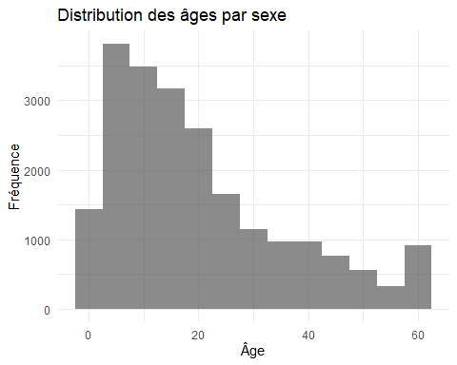

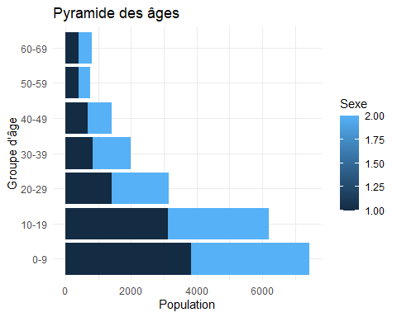

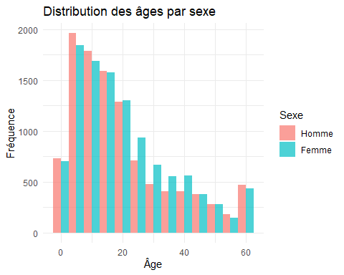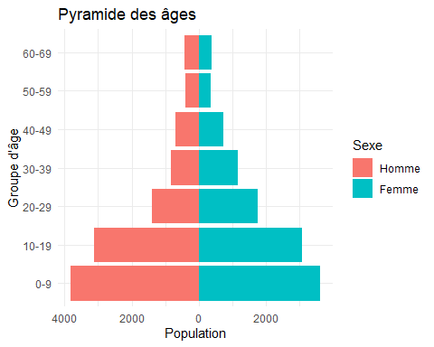

## Analyse du niveau d’éducation

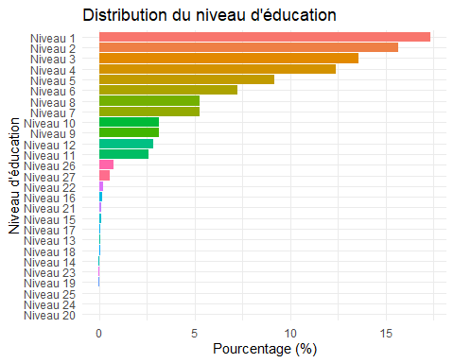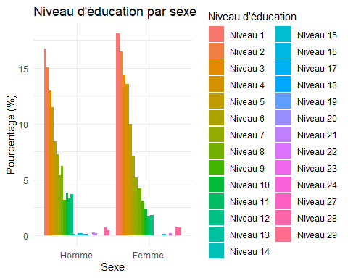

# 

# Calcul et analyse du Crowding Index (Indice d’affluence)

Le Crowding Index ou indice d’affluence est le rapport entre le nombre de personnes vivant dans un ménage et le nombre de pièces disponibles (à l’exclusion de la cuisine et des couloirs). Cet indice est un indicateur important des conditions de vie des ménages.

## Calcul du nombre d’individus par ménage

## Min. 1st Qu. Median Mean 3rd Qu. Max.   
## 1.000 5.000 7.000 7.224 9.000 17.000

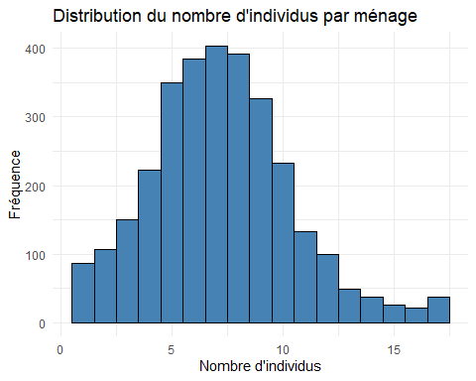

## Statistiques descriptives sur le nombre de pièces

## Min. 1st Qu. Median Mean 3rd Qu. Max. NA's   
## 1.000 2.000 2.000 2.388 3.000 21.000 6

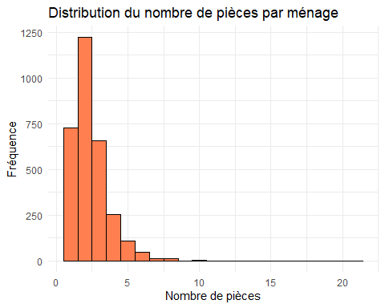

## Calcul de l’indice d’affluence (Crowding Index)

## Min. 1st Qu. Median Mean 3rd Qu. Max. NA's   
## 0.1905 2.0000 3.0000 3.5997 4.5000 15.0000 6

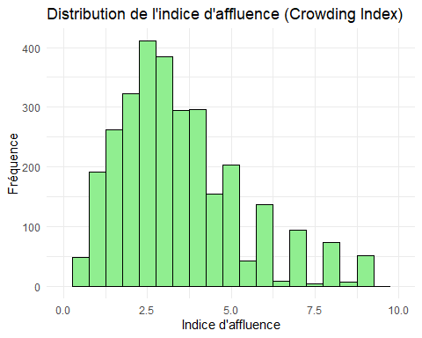

## Analyse de la distribution de l’indice d’affluence

## # A tibble: 5 × 3  
## categorie_crowding n proportion  
## <chr> <int> <dbl>  
## 1 1 - 2 466 15.2   
## 2 2 - 3 727 23.8   
## 3 < 1 61 1.99   
## 4 >= 3 1798 58.8   
## 5 <NA> 6 0.196

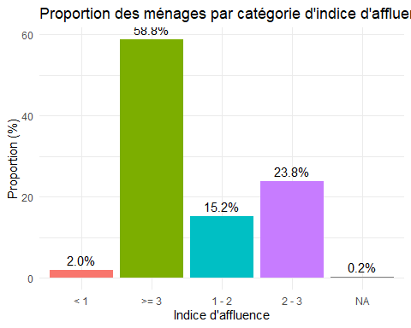

## Comparaison entre réfugiés et communautés d’accueil

## Labels pour la variable groupe de population:  
## Refugees Asylum-seekers Host community North   
## 1 2 3   
## Returnees   
## 4

## # A tibble: 2 × 7  
## Intro_07_1 n moyenne mediane ecart_type min max  
## <dbl+lbl> <int> <dbl> <dbl> <dbl> <dbl> <dbl>  
## 1 1 [Refugees] 2068 3.43 3 1.98 0.190 15  
## 2 3 [Host community North] 990 3.95 3.33 2.31 0.333 15

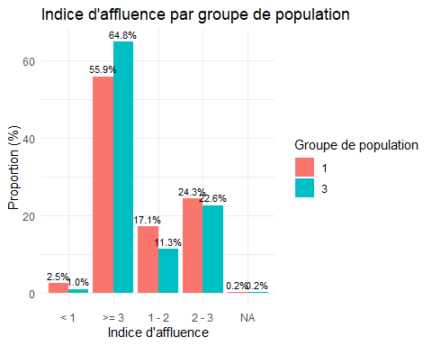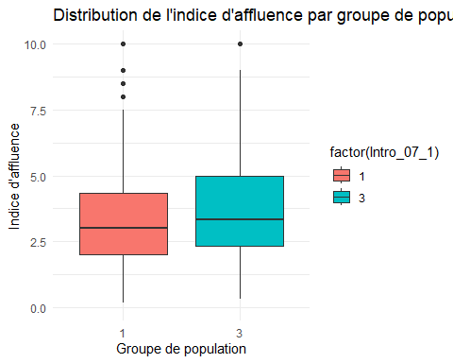

# Analyse de la sécurité alimentaire des déplacés internes

## Score de Consommation Alimentaire (SCA)

Le Score de Consommation Alimentaire (SCA) est un indicateur proxy développé par le Programme Alimentaire Mondial pour mesurer la sécurité alimentaire des ménages. C’est un score composite basé sur la diversité alimentaire, la fréquence de consommation et l’importance nutritionnelle relative des groupes d’aliments consommés.

### Analyse descriptive des variables composant le SCA

Statistiques descriptives des variables du SCA

| variable | moyenne | mediane | type | min | max | valides | manquants |
| --- | --- | --- | --- | --- | --- | --- | --- |
| Food_div1 | 3.2213491 | 3 | NA | 0 | 7 | NA | NA |
| Food_div1_ecart | NA | NA | 2.640259 | NA | NA | NA | NA |
| Food_div1_n | NA | NA | NA | NA | NA | 3054 | 4 |
| Food_div2 | 1.1100917 | 0 | NA | 0 | 7 | NA | NA |
| Food_div2_ecart | NA | NA | 1.843696 | NA | NA | NA | NA |
| Food_div2_n | NA | NA | NA | NA | NA | 3052 | 6 |
| Food_div3 | 0.5188463 | 0 | NA | 0 | 7 | NA | NA |
| Food_div3_ecart | NA | NA | 1.404870 | NA | NA | NA | NA |
| Food_div3_n | NA | NA | NA | NA | NA | 3051 | 7 |
| Food_div4 | 0.6148294 | 0 | NA | 0 | 7 | NA | NA |
| Food_div4_ecart | NA | NA | 1.280462 | NA | NA | NA | NA |
| Food_div4_n | NA | NA | NA | NA | NA | 3048 | 10 |
| Food_div5 | 0.9244167 | 0 | NA | 0 | 7 | NA | NA |
| Food_div5_ecart | NA | NA | 1.746097 | NA | NA | NA | NA |
| Food_div5_n | NA | NA | NA | NA | NA | 3043 | 15 |
| Food_div6 | 0.2994740 | 0 | NA | 0 | 7 | NA | NA |
| Food_div6_ecart | NA | NA | 1.139148 | NA | NA | NA | NA |
| Food_div6_n | NA | NA | NA | NA | NA | 3042 | 16 |
| Food_div7 | 1.0223170 | 0 | NA | 0 | 7 | NA | NA |
| Food_div7_ecart | NA | NA | 1.907796 | NA | NA | NA | NA |
| Food_div7_n | NA | NA | NA | NA | NA | 3047 | 11 |
| Food_div8 | 0.8103222 | 0 | NA | 0 | 7 | NA | NA |
| Food_div8_ecart | NA | NA | 1.739492 | NA | NA | NA | NA |
| Food_div8_n | NA | NA | NA | NA | NA | 3042 | 16 |

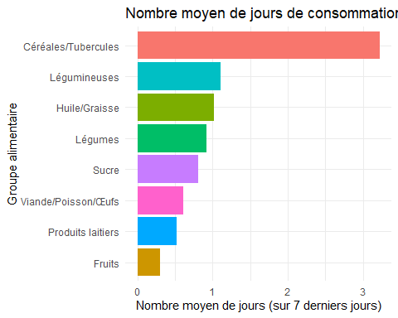

### Calcul du Score de Consommation Alimentaire

Poids attribués aux groupes alimentaires pour le calcul du SCA

| groupe_alimentaire | variable | poids |
| --- | --- | --- |
| Céréales/Tubercules | Food_div1 | 2.0 |
| Légumineuses | Food_div2 | 3.0 |
| Produits laitiers | Food_div3 | 4.0 |
| Viande/Poisson/Œufs | Food_div4 | 4.0 |
| Légumes | Food_div5 | 1.0 |
| Fruits | Food_div6 | 1.0 |
| Huile/Graisse | Food_div7 | 0.5 |
| Sucre | Food_div8 | 0.5 |

## Min. 1st Qu. Median Mean 3rd Qu. Max. NA's   
## 0.00 6.00 14.00 16.46 23.00 107.00 23

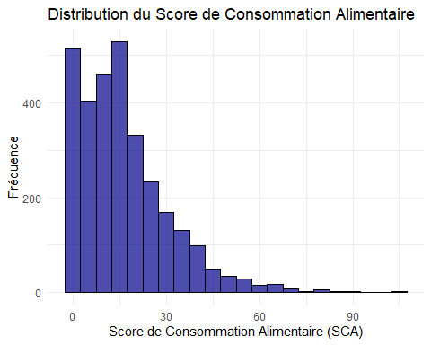

### Catégorisation du SCA selon différents seuils

Répartition des ménages selon les seuils SCA 21/35

| categorie_sca_21_35 | n | proportion |
| --- | --- | --- |
| Acceptable | 311 | 10.1700458 |
| Limite | 626 | 20.4708960 |
| Pauvre | 2098 | 68.6069326 |
| NA | 23 | 0.7521256 |

Répartition des ménages selon les seuils SCA 28/42

| categorie_sca_28_42 | n | proportion |
| --- | --- | --- |
| Acceptable | 169 | 5.5264879 |
| Limite | 393 | 12.8515370 |
| Pauvre | 2473 | 80.8698496 |
| NA | 23 | 0.7521256 |

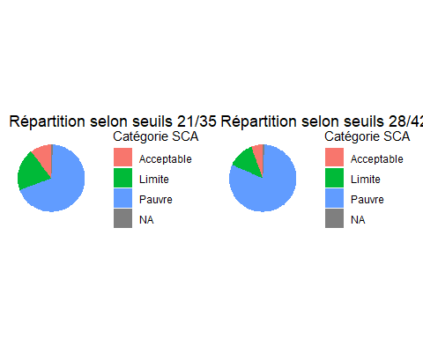

### Représentation spatiale du SCA par région et département

## Labels pour admin1 (Région):  
## Unity Upper Nile Central Equatoria Jonglei   
## 1 2 3 4   
## Western Equatoria Eastern Equatoria   
## 5 6

## Labels pour admin2 (Département):  
## Pariang Maban Juba Morobo Yei Pochalla Ezo Maridi   
## 1 2 3 4 5 6 7 8   
## Tambura Yambio Magwi Juba   
## 9 10 11 12

Score de Consommation Alimentaire par région

| admin1 | sca_moyen | sca_median | n | pct_pauvre_21_35 | pct_limite_21_35 | pct_acceptable_21_35 |
| --- | --- | --- | --- | --- | --- | --- |
| 1 | 16.8 | 14.0 | 1064 | 69.9 | 22.6 | 7.5 |
| 2 | 14.5 | 10.2 | 1466 | 74.5 | 15.1 | 10.5 |
| 3 | 27.3 | 25.0 | 114 | 34.5 | 36.3 | 29.2 |
| 4 | 8.0 | 7.0 | 35 | 96.4 | 3.6 | 0.0 |
| 5 | 21.4 | 20.5 | 285 | 50.2 | 36.8 | 13.0 |
| NA | 18.0 | 14.5 | 94 | 68.5 | 21.7 | 9.8 |

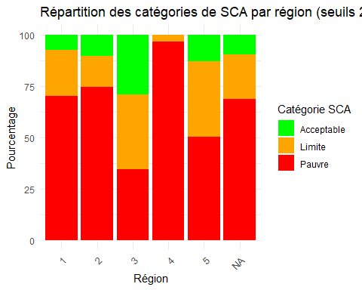

### Analyse du SCA selon le statut de déplacement

Score de Consommation Alimentaire par statut de déplacement

| Intro_07_1 | sca_moyen | sca_median | sca_ecart_type | n | pct_pauvre_21_35 | pct_limite_21_35 | pct_acceptable_21_35 |
| --- | --- | --- | --- | --- | --- | --- | --- |
| 1 | 16.4 | 14 | 14.2 | 2068 | 67.5 | 22.5 | 10.0 |
| 3 | 16.6 | 14 | 14.6 | 990 | 72.4 | 16.8 | 10.8 |

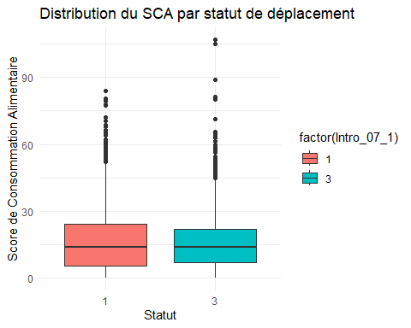

## Test ANOVA pour comparer les moyennes du SCA entre les groupes:  
## Df Sum Sq Mean Sq F value Pr(>F)  
## factor(Intro_07_1) 1 19 18.53 0.091 0.764  
## Residuals 3033 620829 204.69   
## 23 observations effacées parce que manquantes

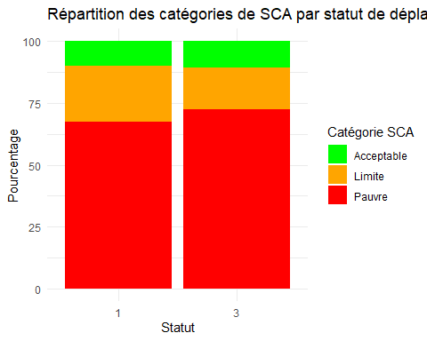

# L’indice réduit des stratégies de survie (rCSI)

L’indice réduit des stratégies de survie (rCSI) est un indicateur qui mesure les comportements d’adaptation que les ménages adoptent lorsqu’ils n’ont pas accès à suffisamment de nourriture. Il est basé sur un ensemble de cinq stratégies de survie communes liées à la consommation alimentaire. Un score plus élevé indique une plus grande insécurité alimentaire.

## Analyse descriptive des variables qui composent le rCSI

Les cinq stratégies d’adaptation communes utilisées pour calculer le rCSI sont:

1. Consommer des aliments moins préférés et moins chers (Food02a)
2. Emprunter de la nourriture ou compter sur l’aide de proches (Food05a)
3. Limiter la taille des portions au moment des repas (Food06a)
4. Réduire le nombre de repas par jour (Food08a)
5. Réduire la consommation des adultes pour nourrir les enfants (Food07a)

## tibble [3,058 × 5] (S3: tbl_df/tbl/data.frame)  
## $ Food02a: dbl+lbl [1:3058] 1, 2, 1, 1, 1, 1, 1, 1, 1, 1, 1, 1, 1, 1, 1, 1, 1, 1,...  
## ..@ label : chr "A member ate less preferred food and less expensive food [Past 30/7 days]"  
## ..@ format.stata: chr "%10.0g"  
## ..@ labels : Named num [1:2] 1 2  
## .. ..- attr(*, "names")= chr [1:2] "yes" "no"  
## $ Food05a: dbl+lbl [1:3058] 1, 2, 2, 1, 2, 2, 1, 1, 2, 2, 2, 1, 1, 1, 1, 1, 2, 2,...  
## ..@ label : chr "Any member borrowed food/relied on help to get more food...[Past 30/7 days]"  
## ..@ format.stata: chr "%10.0g"  
## ..@ labels : Named num [1:2] 1 2  
## .. ..- attr(*, "names")= chr [1:2] "yes" "no"  
## $ Food06a: dbl+lbl [1:3058] 1, 2, 1, 1, 1, 1, 1, 1, 2, 2, 1, 1, 1, 1, 1, 1, 1, 1,...  
## ..@ label : chr "Any member ate a smaller meal than you felt you needed [Past 30/7 days]"  
## ..@ format.stata: chr "%10.0g"  
## ..@ labels : Named num [1:2] 1 2  
## .. ..- attr(*, "names")= chr [1:2] "yes" "no"  
## $ Food08a: dbl+lbl [1:3058] 1, 2, 1, 1, 1, 1, 1, 1, 1, 2, 1, 1, 1, 1, 1, 1, 1, 1,...  
## ..@ label : chr "Any member ate fewer meals in a day [Past 30/7 days]"  
## ..@ format.stata: chr "%10.0g"  
## ..@ labels : Named num [1:2] 1 2  
## .. ..- attr(*, "names")= chr [1:2] "yes" "no"  
## $ Food07a: dbl+lbl [1:3058] 1, 2, 1, 1, 1, 1, 2, 2, 1, 2, 1, 1, 1, 1, 1, 1, 2, 1,...  
## ..@ label : chr "Adults ate less to have more food for children under 5? [Past 30/7 days]"  
## ..@ format.stata: chr "%10.0g"  
## ..@ labels : Named num [1:2] 1 2  
## .. ..- attr(*, "names")= chr [1:2] "yes" "no"

## Variable: Food02a   
##   
## 1 2 <NA>   
## 2493 563 2   
##   
## Variable: Food05a   
##   
## 1 2 <NA>   
## 1831 1222 5   
##   
## Variable: Food06a   
##   
## 1 2 <NA>   
## 2600 454 4   
##   
## Variable: Food08a   
##   
## 1 2 <NA>   
## 2547 510 1   
##   
## Variable: Food07a   
##   
## 1 2 <NA>   
## 2145 906 7

Statistiques descriptives des variables du rCSI

| variable | oui | non | manquants |
| --- | --- | --- | --- |
| Food02a_n | 2493.00000 | 0 | 2 |
| Food02a_pct | 81.57723 | NA | NA |
| Food05a_n | 1831.00000 | 0 | 5 |
| Food05a_pct | 59.97380 | NA | NA |
| Food06a_n | 2600.00000 | 0 | 4 |
| Food06a_pct | 85.13425 | NA | NA |
| Food08a_n | 2547.00000 | 0 | 1 |
| Food08a_pct | 83.31698 | NA | NA |
| Food07a_n | 2145.00000 | 0 | 7 |
| Food07a_pct | 70.30482 | NA | NA |

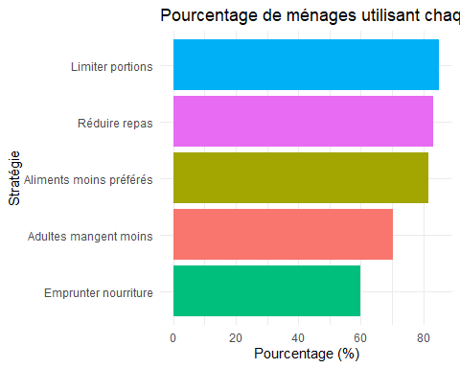

## Création et analyse de nouvelles variables numériques pour le rCSI

Statistiques descriptives des nouvelles variables numériques du rCSI

| variable | moyenne | mediane | type | min | max |
| --- | --- | --- | --- | --- | --- |
| Food02a_num | 3.267997 | 3 | NA | 0 | 7 |
| Food02a_num_ecart | NA | NA | 2.388702 | NA | NA |
| Food05a_num | 2.334753 | 2 | NA | 0 | 7 |
| Food05a_num_ecart | NA | NA | 2.446136 | NA | NA |
| Food06a_num | 3.442698 | 3 | NA | 0 | 7 |
| Food06a_num_ecart | NA | NA | 2.348695 | NA | NA |
| Food08a_num | 3.283611 | 3 | NA | 0 | 7 |
| Food08a_num_ecart | NA | NA | 2.360722 | NA | NA |
| Food07a_num | 2.798099 | 2 | NA | 0 | 7 |
| Food07a_num_ecart | NA | NA | 2.479796 | NA | NA |

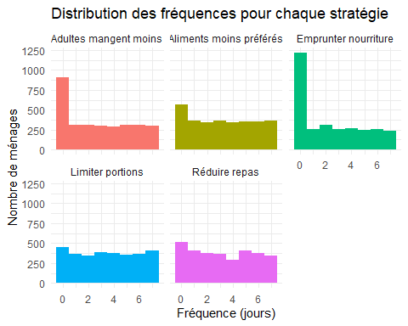

## Calcul de l’indice réduit des stratégies de survie (rCSI)

## [1] 21

Poids attribués aux stratégies pour le calcul du rCSI

| strategie | variable | poids |
| --- | --- | --- |
| Aliments moins préférés | Food02a_num | 2 |
| Emprunter nourriture | Food05a_num | 2 |
| Limiter portions | Food06a_num | 3 |
| Réduire repas | Food08a_num | 7 |
| Adultes mangent moins | Food07a_num | 7 |

## Min. 1st Qu. Median Mean 3rd Qu. Max. NA's   
## 0.00 43.00 67.00 64.15 87.00 136.00 15

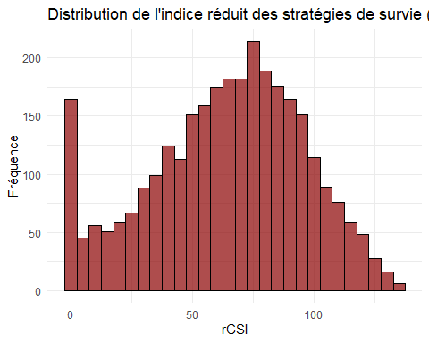

Répartition des ménages par niveau de stress alimentaire

| categorie_rcsi | n | proportion |
| --- | --- | --- |
| Faible | 183 | 5.9843035 |
| Moyen-faible | 47 | 1.5369523 |
| Moyen-élevé | 109 | 3.5644212 |
| Élevé | 2704 | 88.4238064 |
| NA | 15 | 0.4905167 |

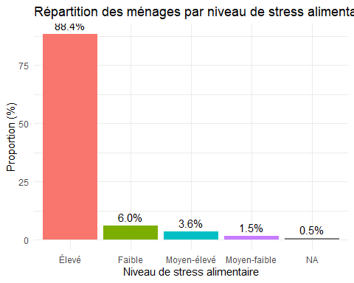

## Représentation spatiale du rCSI selon le milieu de résidence

## Labels pour Intro_09 (milieu de résidence):  
## rural peri-urban urban   
## 1 2 3

rCSI moyen par milieu de résidence

| Intro_09 | rcsi_moyen | rcsi_median | rcsi_ecart_type | n |
| --- | --- | --- | --- | --- |
| 1 | 64.8 | 68.0 | 31.4 | 2058 |
| 2 | 60.4 | 63.0 | 32.0 | 740 |
| 3 | 69.6 | 77.0 | 32.1 | 258 |
| NA | 46.5 | 46.5 | 34.6 | 2 |

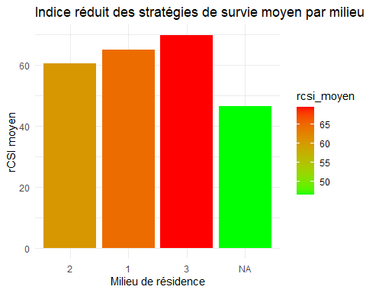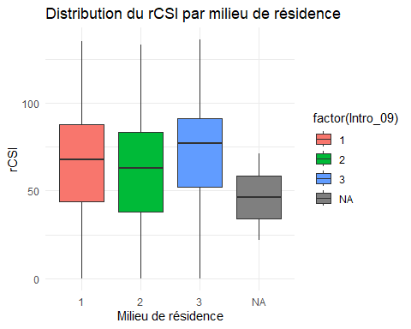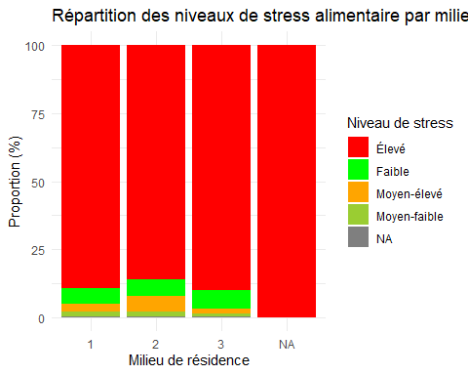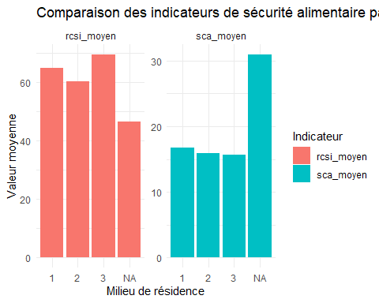

## Analyse croisée du rCSI avec d’autres variables socio-démographiques

rCSI moyen par groupe de population

| Intro_07_1 | rcsi_moyen | rcsi_median | n | pct_eleve |
| --- | --- | --- | --- | --- |
| 1 | 66.3 | 70 | 2068 | 89.8 |
| 3 | 59.6 | 62 | 990 | 87.0 |

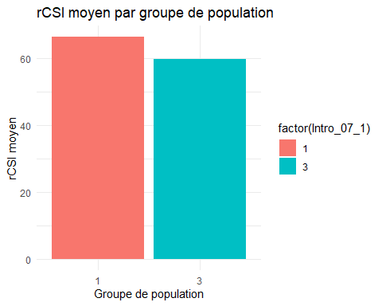

## Test ANOVA pour comparer les moyennes du rCSI entre les groupes:  
## Df Sum Sq Mean Sq F value Pr(>F)   
## factor(Intro_07_1) 1 30332 30332 30.53 3.57e-08 ***  
## Residuals 3041 3021305 994   
## ---  
## Signif. codes: 0 '***' 0.001 '**' 0.01 '*' 0.05 '.' 0.1 ' ' 1  
## 15 observations effacées parce que manquantes

Les résultats de l’ANOVA indiquent une différence statistiquement significative entre les moyennes du rCSI des réfugiés et des communautés d’accueil (F(1, 3041) = 30.53, p < 0.0001), avec une valeur-p extrêmement faible (3.57e-08) qui permet de rejeter fortement l’hypothèse nulle. Bien que la variance expliquée par l’appartenance au groupe soit relativement faible (environ 1% de la variabilité totale), la taille importante de l’échantillon (n = 3043 après exclusion de 15 observations manquantes) confère une puissance statistique élevée à cette analyse. Ces résultats suggèrent que les réfugiés présentent des niveaux d’insécurité alimentaire significativement plus sévères que les communautés d’accueil, tel que mesuré par le rCSI. Cependant, l’ampleur limitée de la variance expliquée souligne la nécessité d’étudier d’autres facteurs susceptibles d’influencer les stratégies d’adaptation alimentaire, comme l’accès aux ressources économiques ou aux aides humanitaires.