TP8

FRANCIS_ENSAE

2025-03-09

#Importation des bases de données des pays de L'UEMOA   
library(haven)  
library(sf)

## Warning: package 'sf' was built under R version 4.4.3

## Linking to GEOS 3.13.0, GDAL 3.10.1, PROJ 9.5.1; sf_use_s2() is TRUE

library(ggplot2)  
library(tidyr)  
library(dplyr)

##   
## Attaching package: 'dplyr'

## The following objects are masked from 'package:stats':  
##   
## filter, lag

## The following objects are masked from 'package:base':  
##   
## intersect, setdiff, setequal, union

# Charger le shapefile des pays  
pays1 <- st_read("C:/Users/Hp/Desktop/DATABASES/sen_admbnda_adm3_anat_20240520.shp")

## Reading layer `sen_admbnda_adm3_anat_20240520' from data source   
## `C:\Users\Hp\Desktop\DATABASES\sen_admbnda_adm3_anat_20240520.shp'   
## using driver `ESRI Shapefile'  
## Simple feature collection with 125 features and 15 fields  
## Geometry type: MULTIPOLYGON  
## Dimension: XY  
## Bounding box: xmin: -17.53115 ymin: 12.30813 xmax: -11.34522 ymax: 16.6928  
## Geodetic CRS: WGS 84

pays2 <- st_read("C:/Users/Hp/Desktop/DATABASES/ben_admbnda_adm2_1m_salb_20190816.shp")

## Reading layer `ben_admbnda_adm2_1m_salb_20190816' from data source   
## `C:\Users\Hp\Desktop\DATABASES\ben_admbnda_adm2_1m_salb_20190816.shp'   
## using driver `ESRI Shapefile'  
## Simple feature collection with 77 features and 12 fields  
## Geometry type: MULTIPOLYGON  
## Dimension: XY  
## Bounding box: xmin: 0.77457 ymin: 6.234181 xmax: 3.8517 ymax: 12.40861  
## Geodetic CRS: WGS 84

#les regions/le 1er decoupage administratif du pays  
#Les cartes en affichant des variables/indicateurs suivant:  
region<-pays1%>%select(ADM1_FR)  
ggplot(region) +  
 aes(fill = ADM1_FR) +  
 geom_sf() +  
 scale_fill_hue(direction = 1) +  
 theme_minimal()

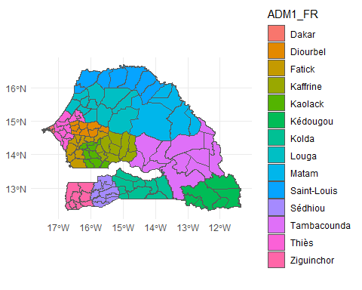

#les departements/le 2e decoupage administratif du pays  
#Les cartes en affichant des variables/indicateurs suivant:  
departement<-pays1%>%select(ADM2_FR)  
ggplot(departement) +  
 aes(fill = ADM2_FR) +  
 geom_sf() +  
 scale_fill_hue(direction = 1) +  
 theme_minimal()

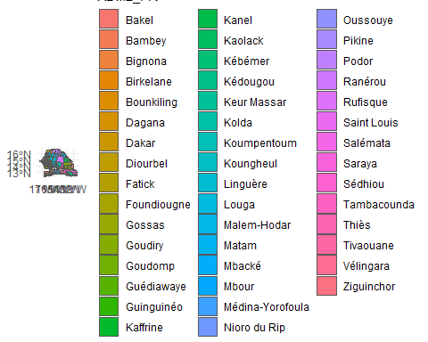

#les communes/le 3e decoupage administratif du pays  
#Les cartes en affichant des variables/indicateurs suivant:  
communes<-pays1%>%select(ADM3_FR)  
ggplot(communes) +  
 aes(fill = ADM3_FR) +  
 geom_sf() +  
 scale_fill_hue(direction = 1) +  
 theme_minimal()

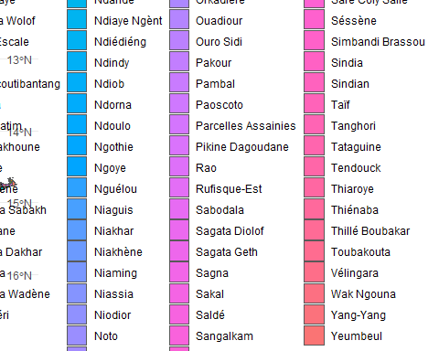

#les regions/le 1er decoupage administratif du pays  
#Les cartes en affichant des variables/indicateurs suivant:  
Region<-pays2%>%select(adm1_name)  
ggplot(Region) +  
 aes(fill = adm1_name) +  
 geom_sf() +  
 scale_fill_hue(direction = 1) +  
 theme_minimal()

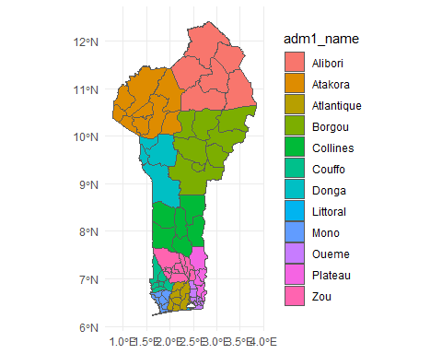

#les departements/le 2e decoupage administratif du pays  
#Les cartes en affichant des variables/indicateurs suivant:  
Departement<-pays2%>%select(adm2_name)  
ggplot(Departement) +  
 aes(fill = adm2_name) +  
 geom_sf() +  
 scale_fill_hue(direction = 1) +  
 theme_minimal()

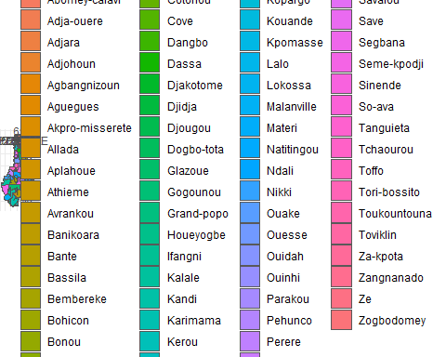

{r setup, include=FALSE}  
knitr::opts_chunk$set(echo = TRUE)

## R Markdown  
  
This is an R Markdown document. Markdown is a simple formatting syntax for authoring HTML, PDF, and MS Word documents. For more details on using R Markdown see <http://rmarkdown.rstudio.com>.  
  
When you click the **Knit** button a document will be generated that includes both content as well as the output of any embedded R code chunks within the document. You can embed an R code chunk like this:  
  
  
``` r  
summary(cars)

## speed dist   
## Min. : 4.0 Min. : 2.00   
## 1st Qu.:12.0 1st Qu.: 26.00   
## Median :15.0 Median : 36.00   
## Mean :15.4 Mean : 42.98   
## 3rd Qu.:19.0 3rd Qu.: 56.00   
## Max. :25.0 Max. :120.00

## Including Plots

You can also embed plots, for example:



Note that the echo = FALSE parameter was added to the code chunk to prevent printing of the R code that generated the plot.