Analyses factorielles et Modelisation

Aboubacar HEMA,ITS4

Mars-Juin 2020

## OGR data source with driver: ESRI Shapefile   
## Source: "C:\Users\Hp\OneDrive\Memoire_ITS4\shpzones\variables topographiques", layer: "topo"  
## with 69 features  
## It has 20 fields  
## Integer64 fields read as strings: OBJECTID GRIDCODE Subbasin HydroID OutletID

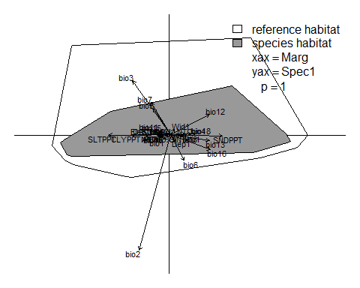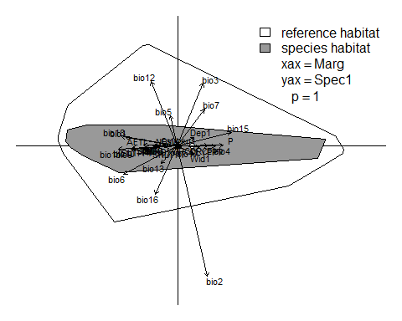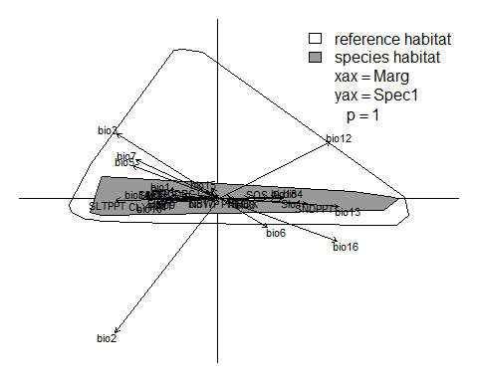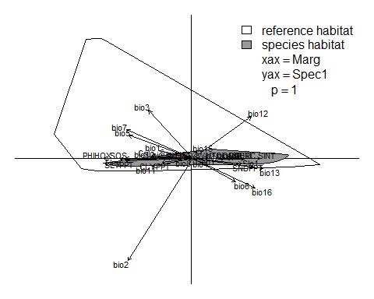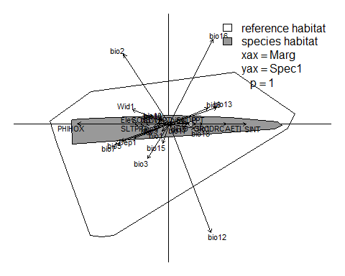

# Analyses factorielles

## AFC