Untitled

Aubin HAMADOU ABDOULAYE

21/04/2020

# Chapitre

## Section

### Sous-section

#### Sous-sous-section

1. This is an R Markdown document. Markdown is a simple formatting syntax for authoring HTML, PDF, and MS Word documents. For more details on using R Markdown see <http://rmarkdown.rstudio.com>.

When you click the **Knit** button a document will be generated that includes both content as well as the output of any embedded R code chunks within the document. You can embed an R code chunk like this:

summary(cars)

## speed dist   
## Min. : 4.0 Min. : 2.00   
## 1st Qu.:12.0 1st Qu.: 26.00   
## Median :15.0 Median : 36.00   
## Mean :15.4 Mean : 42.98   
## 3rd Qu.:19.0 3rd Qu.: 56.00   
## Max. :25.0 Max. :120.00

## Including Plots

You can also embed plots, for example:

### d’élection

1. Figure: Here is a really important caption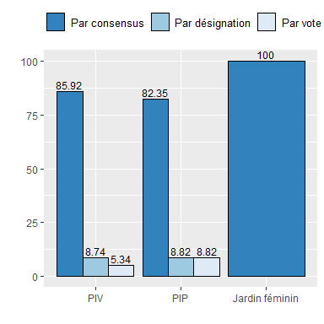



Note that the echo = FALSE parameter was added to the code chunk to prevent printing of the R code that generated the plot.

1. Durée du mandat selon le type d’amenagement

| **Var1** | **PIV** | **PIP** | **Jardin féminin** |
| --- | --- | --- | --- |
| Une campagne | 1.92 | 0.00 | 0 |
| 2 ans | 19.23 | 0.00 | 0 |
| 3 ans | 19.23 | 22.22 | 100 |
| 4 ans | 5.77 | 0.00 | 0 |
| 5 ans | 3.85 | 0.00 | 0 |
| Tant qu'il respecte ses engagements | 50.00 | 66.67 | 0 |
| A vie | 0.00 | 11.11 | 0 |
| Total | 100.00 | 100.00 | 100 |

Source Wagrinnova : Calcul des auteurs