Example Tree Structure

Here is an example of object tree in memory. UML rules were slightly bended so we can display not only objects (with their ids) but some of their values. Values of fields of primitive types - fields with references have their references shown as directional lines. Also, each "sub-box" of an object (class diagram boxes were used) is with stereotype explaining the "sub-box" content: properties (object fields), beans (in Spring's ApplicationContext), collection (elements of an collection), etc...

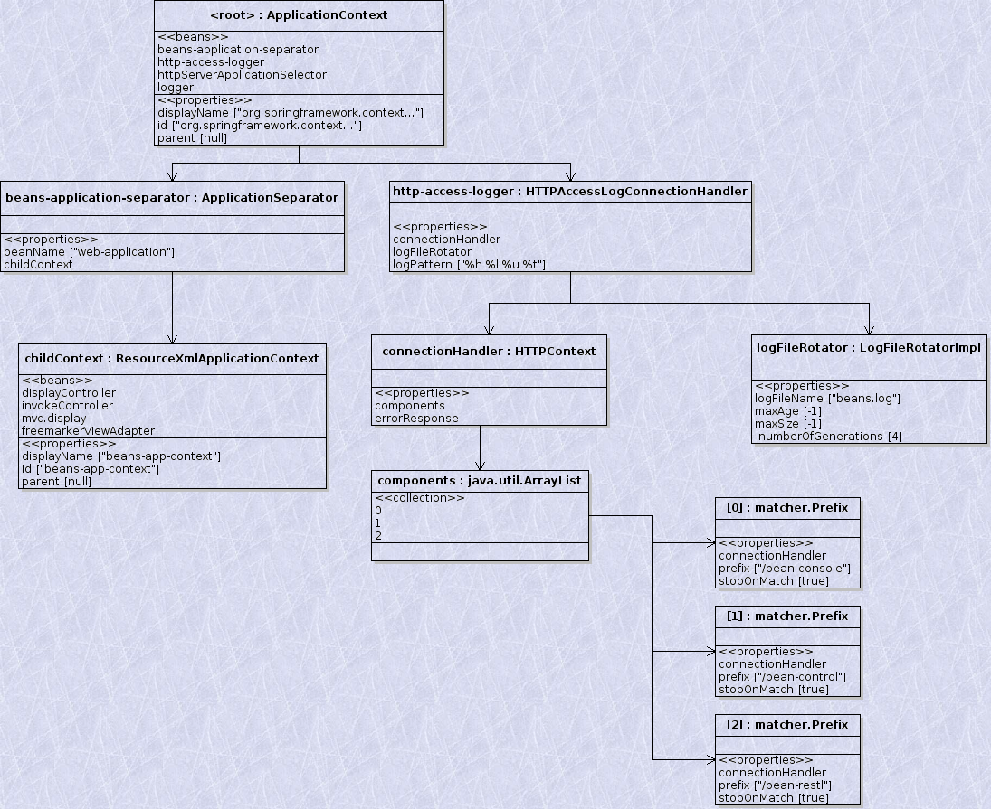

User Interface

UI looks something like this:

Tree | Current Bean:
 | Beans:
 | Collection:
 | Map:
 | Properties:
 | Methods:

Also, at the top of the page there are three buttons: Back, Top and Refresh.

First Step

When Application is started client will issue HTTP request to the server requesting root object: http://localhost:8080/bean-rest/.

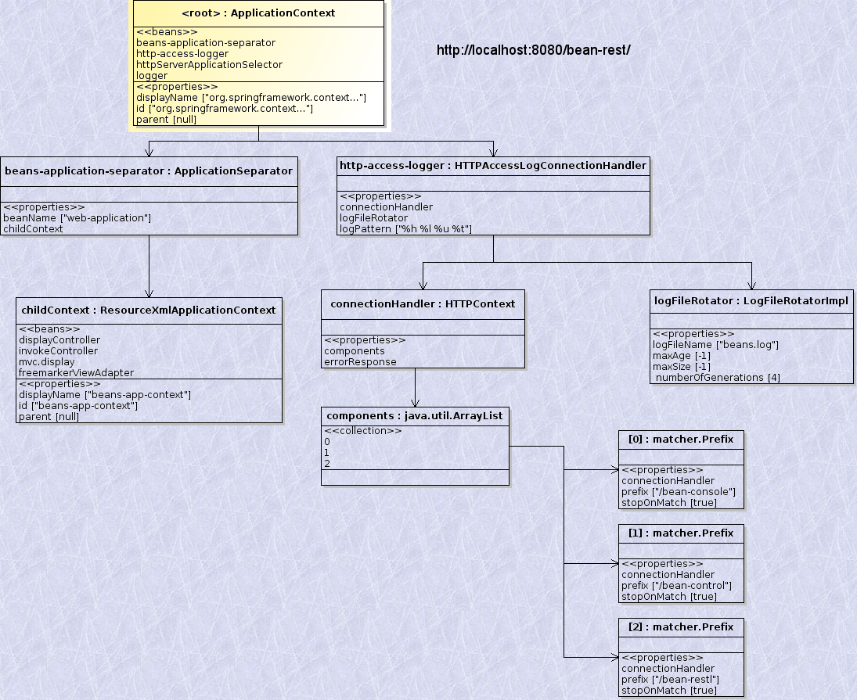
Representation of that object will be returned as following JSON structure:

{
"name" : "root",
"type" : " ApplicationContext",
"path" : "/"
"beans" :
{
{
"name" : "beans-application-separator", "type" : ApplicationSeparator,
"access" : "ro", "value" : ""
},
{
"name" : "http-access-logger", "type" : "HTTPAccessLogConnectionHandler"
"access" : "ro", "value" : ""
},
{
"name" : "httpServerApplicationSelector", "type" : "ApplicationSelector",
"access" : "ro", "value" : ""
},
{
"name" : "logger", "type" : "LogConnectionHandler"
"access" : "ro", "value" : ""
}
}
"properties" :
{
{
"name" : "displayName", "type" : "java.lang.String",
"access" : "rw" , "value" : "org.springframework.context..."
},
{
"name" : "id", "type" : "java.util.String",
"access" : "rw", "value" : "org.springframework.context..."
},
{
"name" : "parent", "type" : "ApplicationContext",
"access" : "ro", "value" : null
}
}

That response will render screen in the following way:

Tree | Current Bean:
<root>  (b) beans-application-separator  (b) http-access-logger  (b) httpServerApplicationSelector  (b) logger  (p) parent | Name: <root>  Type:ApplicationContext  Path: /
 | Beans:
 | beans-application-separator
 | http-access-logger
 | httpServerApplicationSelector
 | logger
 | Properties:
 | displayName | org.springframework.context...
 | id | org.springframework.context...
 | parent | null

Clicking on rows below 'Beans:' heading or 'Properties:' heading will invoke same process again. Less see what would happen if someone clicked on row with http-access-logger (below beans)

Step 2
Now clicking on the "http-access-logger" bean will create following URL: http://localhost:8080/bean-rest/b_http-access-logger. It will select following object in our tree:
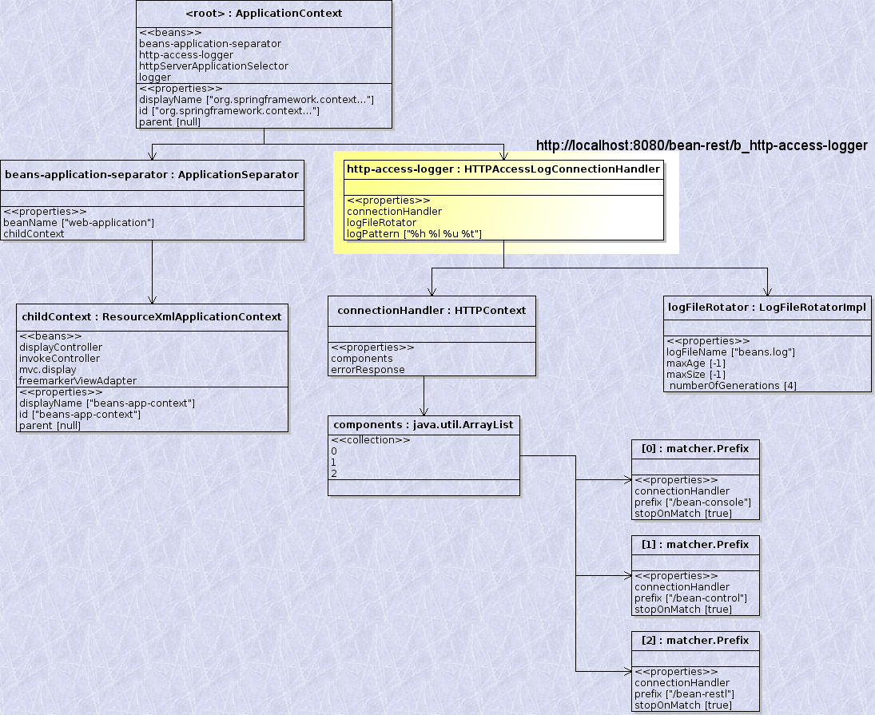
and that will produce following JSON content:
{
"name" : "http-access-logger",
"type" : "HttpLogAccessConnectionHandler",
"path" : "/b_http-access-logger"
"properties" :
{
{
"name" : "connectionHandler", "type" : "HttpContext",
"access" : "ro" , "value" : ""
},
{
"name" : "logFileRotator", "type" : "LogFileRotatorImpl",
"access" : "rw", "value" : ""
},
{
"name" : "logPattern", "type" : "java.lang.String",
"access" : "rw", "value" : "%h %l %u %t"
}
}
}

When that content is received by the client it will re-render screen to look like this:

Tree | Current Bean:
<root>  (b) beans-application-separator  (b) http-access-logger  (p) connectionHandler  (p) logFileRotator  (p) logPattern  (b) httpServerApplicationSelector  (b) logger  (p) parent | Name: http-access-logger  Type: HttpLogAccessConnectionHandler  Path: /b_http-access-logger
 | Properties:
 | connectionHandler
 | logFileRotator
 | logPattern | %h %l %u %t"

Now lets see what will happen if user clicks on a row "connectionHandler" in properties.

Step 3
Now following object will be selected on the server side (after sending request to URL: http://localhost:8080/bean-rest/b_http-access-logger/p_connectionHandler)
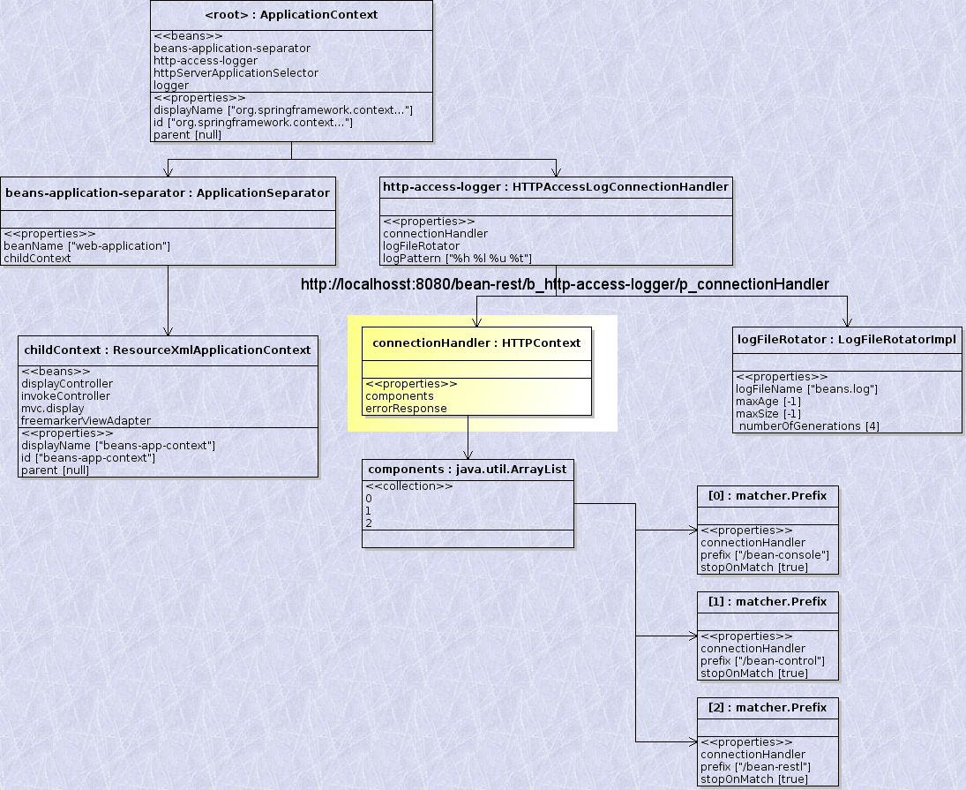
JSON structure returned back is:
{
"name" : "connectionHandler",
"type" : "HttpContext",
"path" : "/b_http-access-logger/p_connectionHandler"
"properties" :
{
{
"name" : "components", "type" : "java.util.ArrayList",
"access" : "rw" , "value" : ""
},
{
"name" : "errorResponse", "type" : "ErrorConnectionHandler",
"access" : "rw" , "value" : ""
}
}
}

That will render following result on screen.
Tree | Current Bean:
<root>  (b) beans-application-separator  (b) http-access-logger  (p) connectionHandler  (p) components  (p) errorHandler  (p) logFileRotator  (p) logPattern  (b) httpServerApplicationSelector  (b) logger  (p) parent | Name: connectionHandler  Type: HttpContext  Path: /b_http-access-logger/p_connectionHandler
 | Properties:
 | components
 | errorHandler

Step 4
If user clicks on "components" under properties then following URL needs to be called: http://localhost:8080/bean-rest/b_http-access-logger/p_connectionHandler/p_components. It will select following object:
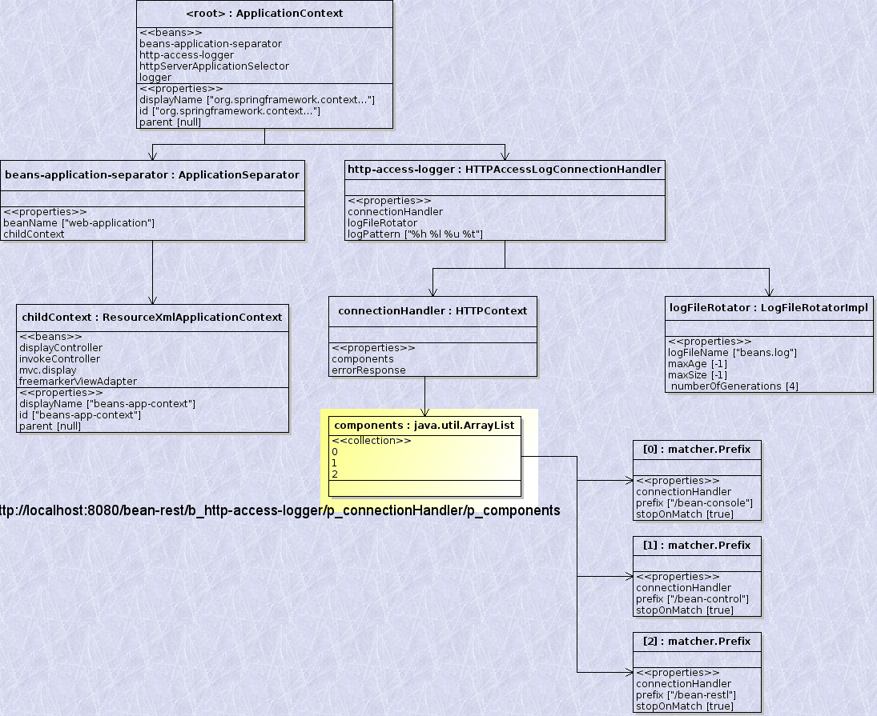
JSON object returned is:
{
"name" : "components",
"type" : "java.util.ArrayList",
"path" : "/b_http-access-logger/p_connectionHandler/p_components"
"collection" :
{
{
"type" : "matcher.Prefix",
"value" : ""
},
{
"type" : "matcher.Prefix",
"value" : ""
},
{
"type" : "matcher.Prefix",
"value" : ""
}
}
}

That will produce following outcome on the screen:

Tree | Current Bean:
<root>  (b) beans-application-separator  (b) http-access-logger  (p) connectionHandler  (p) components  (c) 0  (c) 1  (c) 2  (p) errorHandler  (p) logFileRotator  (p) logPattern  (b) httpServerApplicationSelector  (b) logger  (p) parent | Name: connectionHandler  Type: HttpContext  Path: /b_http-access-logger/p_connectionHandler
 | Collection:
 | 0
 | 1
 | 2

Last step
Now if user selects number 1 from the collection it will send a HTTP request to:
http://localhost:8080/bean-rest/b_http-access-logger/p_connectionHandler/p_components/c_1 and that will select following object:
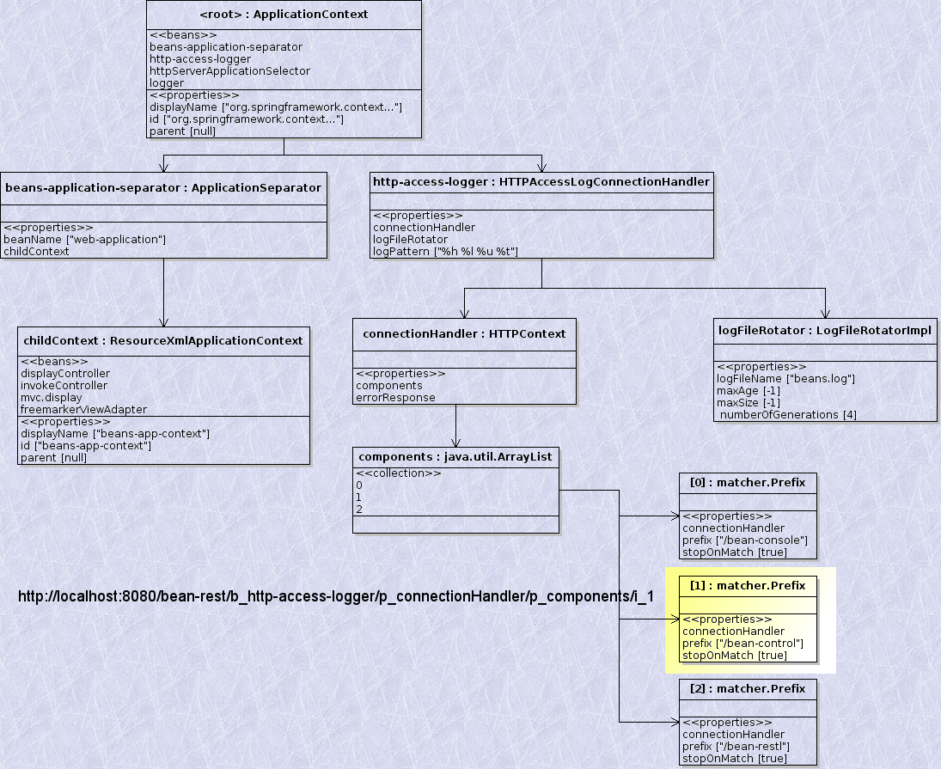
That will produce JSON response:
{
"name" : "1",
"type" : "matcher.Prefix",
"path" : "/b_http-access-logger/p_connectionHandler/p_components/c_1"
"properties" :
{
{
"name" : "connectionHandler", "type" : "SomethingConnectionHandler",
"access" : "ro" , "value" : ""
},
{
"name" : "prefix", "type" : "java.util.String",
"access" : "rw" , "value" : "/bean-control"
},
{
"name" : "stopOnMatch", "type" : "boolean",
"access" : "rw" , "value" : "true"
}
}
}

And that response will be rendered on screen like this:
That will render following result on screen.
Tree | Current Bean:
<root>  (b) beans-application-separator  (b) http-access-logger  (p) connectionHandler  (p) components  (c) 0  (c) 1  (p) connectionHandler  (c) 2  (p) errorHandler  (p) logFileRotator  (p) logPattern  (b) httpServerApplicationSelector  (b) logger  (p) parent | Name: connectionHandler  Type: HttpContext  Path: /b_http-access-logger/p_connectionHandler
 | Properties:
 | connectionHandler
 | prefix | /bean-control
 | stopOnMatch | TRUE

Beyond going forward
If user at this moment clicks on "(p) connectionHandler" in the tree step is going to repeat but result on screen will be slightly different - tree will have all the information from the last step:
Tree | Current Bean:
<root>  (b) beans-application-separator  (b) http-access-logger  (p) connectionHandler  (p) components  (c) 0  (c) 1  (p) connectionHandler  (c) 2  (p) errorHandler  (p) logFileRotator  (p) logPattern  (b) httpServerApplicationSelector  (b) logger  (p) parent | Name: connectionHandler  Type: HttpContext  Path: /b_http-access-logger/p_connectionHandler
 | Properties:
 | components
 | errorHandler
.
Similarly - if user presses "Top" button at any time - UI will look like the first step. Pressing "Back" button will display UI as it was in previous step and pressing on "Refresh" will just re-request current object form the server. "Top", "Back" and "Refresh" buttons will all send appropriate requests (composing right URLs) to the server and client will always display the received response.

