Appendix: Dashboard Figures and Visualizations
Project Title: Heart Disease Risk Prediction Using Machine Learning and Neural Networks
This appendix provides descriptions and interpretations of each visualization included in the Power BI dashboard. Each figure supports one or more of the research questions by illustrating patient characteristics, model performance, or neural network training results.

Figure 1. Heart Disease Distribution
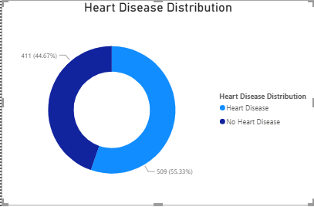
Description
This donut chart displays the overall distribution of patients with and without heart disease in the dataset. The visualization summarizes the proportion of positive and negative heart disease cases used throughout the analysis.
Significance
Understanding the class distribution is important because it provides context for interpreting the machine learning models and helps determine whether the dataset is reasonably balanced.
Key Insights
- The dataset contains both positive and negative heart disease cases.
- The distribution provides a foundation for evaluating model performance.
- The visualization offers a quick overview of the population included in the study.
Technical Notes
The visualization was created using the Heart Disease Status field from the exported dashboard dataset.

Figure 2. Heart Disease by Age Group
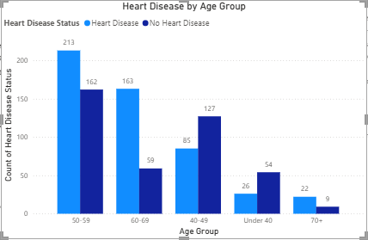
Description
This clustered column chart compares the number of patients with and without heart disease across different age groups.
Significance
Age is a well-known risk factor for cardiovascular disease. This visualization helps identify how heart disease prevalence changes among different age ranges.
Key Insights
- Certain age groups contain a higher number of heart disease cases.
- The chart highlights differences in disease prevalence across the population.
- The visualization supports the investigation of age as a predictive feature.
Technical Notes
Age values were grouped into categorical age ranges before visualization.

Figure 3. Heart Disease by Chest Pain Type
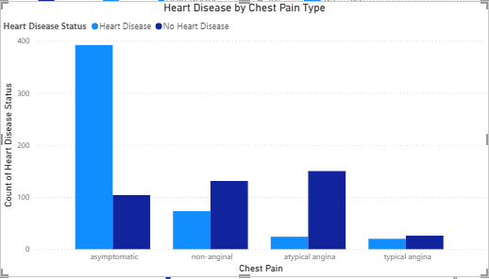
Description
This clustered column chart compares heart disease outcomes across different chest pain classifications.
Significance
Chest pain type is one of the strongest clinical indicators used to diagnose cardiovascular disease and serves as an important predictor within the machine learning models.
Key Insights
- Certain chest pain categories are associated with a higher proportion of heart disease.
- The visualization demonstrates the relationship between symptom type and diagnosis.
- Results support the predictive importance of chest pain.
Technical Notes
The chart uses the transformed chest pain categories from the processed dataset.

Figure 4. Top Predictors of Heart Disease
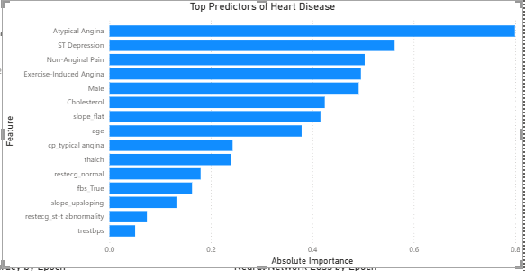
Description
This horizontal bar chart displays the most influential features identified by the Logistic Regression model based on the absolute value of each model coefficient.
Significance
The visualization directly answers the first research question by identifying which patient characteristics contribute most strongly to heart disease prediction.
Key Insights
- Multiple clinical variables contribute differently to prediction accuracy.
- Chest pain, ST depression, cholesterol, and other clinical measures demonstrate varying levels of predictive importance.
- The chart helps explain how the machine learning model makes predictions.
Technical Notes
Feature importance values were calculated from the Logistic Regression coefficients and ranked by absolute magnitude.

Figure 5. Model Accuracy Comparison
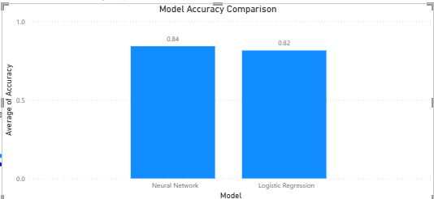
Description
This column chart compares the overall prediction accuracy of the Logistic Regression model and the Neural Network model.
Significance
The visualization directly addresses the second research question by identifying which machine learning model produced the highest predictive accuracy.
Key Insights
- Both models achieved strong predictive performance.
- The Neural Network produced slightly higher accuracy than Logistic Regression.
- The difference demonstrates the benefit of evaluating multiple algorithms.
Technical Notes
Accuracy values were exported from the completed model evaluation results.

Figure 6. Machine Learning Model Performance
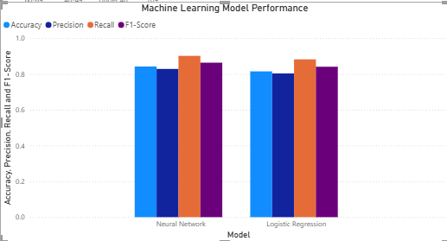
Description
This grouped column chart compares Accuracy, Precision, Recall, and F1-Score for both machine learning models.
Significance
Evaluating multiple performance metrics provides a more comprehensive assessment than accuracy alone.
Key Insights
- Both models performed consistently across multiple evaluation metrics.
- The Neural Network demonstrated slightly stronger overall performance.
- Similar metric values indicate stable model behavior.
Technical Notes
Performance metrics were generated after model evaluation and exported for dashboard visualization.

Figure 7. Neural Network Accuracy by Epoch
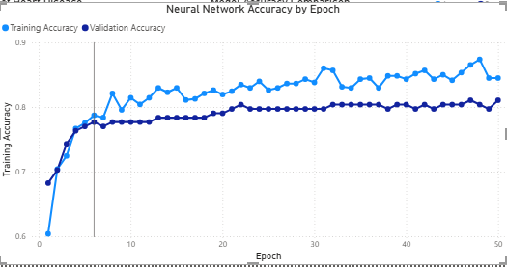
Description
This line chart illustrates the training and validation accuracy throughout the neural network training process.
Significance
The visualization demonstrates how the neural network improved during training and provides insight into the model's learning behavior.
Key Insights
- Training accuracy increased over successive epochs.
- Validation accuracy closely followed training accuracy.
- The model learned effectively without obvious signs of severe overfitting.
Technical Notes
Accuracy values were recorded during each training epoch using TensorFlow's training history.

Figure 8. Neural Network Loss by Epoch
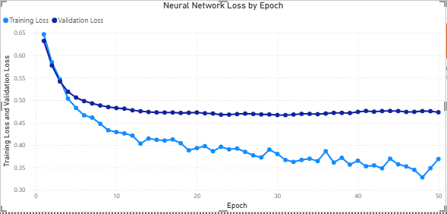
Description
This line chart displays training loss and validation loss during neural network training.
Significance
Loss curves provide additional evidence that the model successfully converged during training.
Key Insights
- Loss steadily decreased throughout training.
- Validation loss remained relatively stable.
- The curves indicate successful optimization of the neural network.
Technical Notes
Loss values were exported directly from the TensorFlow training history.

Figure 9. Interactive Scenario Analysis Dashboard
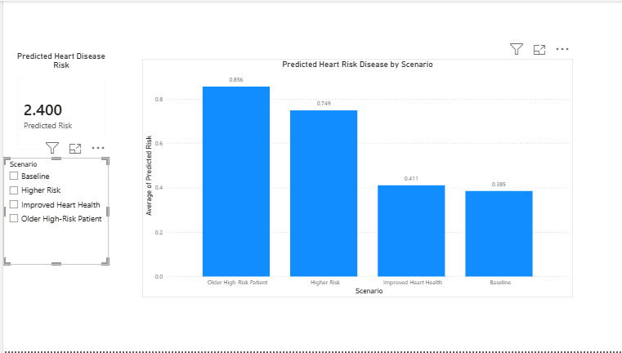
Description
Figure 9 presents the neural network’s predicted heart disease risk for four patient profiles: the baseline profile, Improved Heart Health, Higher Risk, and Older High-Risk Patient. The clustered column chart compares the predicted probability for each scenario, while the slicer allows users to select an individual scenario. The card then updates dynamically to display the predicted risk for the selected scenario.
Significance
This visualization demonstrates how the trained neural network responds when important cardiovascular features are changed. It extends the project beyond model evaluation by showing how the model may react to hypothetical real-world conditions. The interactive elements also allow users to explore the scenario results rather than viewing only a static comparison.
Key Insights
The baseline profile produced a predicted risk of approximately 0.385. The Improved Heart Health scenario produced a similar result of approximately 0.411, indicating that the selected improvements did not substantially reduce the model’s predicted risk when the remaining patient characteristics stayed unchanged. The Higher Risk scenario increased the prediction to approximately 0.749, while the Older High-Risk Patient scenario produced the highest predicted risk at approximately 0.856. Overall, the results show that the model responded most strongly when age and multiple cardiovascular risk factors were elevated together.
Technical Notes
The scenarios were created from a representative baseline profile based on the average feature values in the processed dataset. Selected variables, including age, resting blood pressure, cholesterol, maximum heart rate, ST depression, and exercise-induced angina, were modified to represent each hypothetical condition. The scenario records were standardized using the same StandardScaler applied during model training and then passed through the trained TensorFlow neural network. The resulting probabilities were exported to scenario_results.csv and imported into Power BI. The chart uses the average predicted risk for each scenario, and the slicer filters the card and chart dynamically.

Overall Dashboard Summary
The completed dashboard integrates exploratory data analysis, machine learning model evaluation, neural network training results, and interactive scenario analysis into a comprehensive decision-support tool. Together, the visualizations address the project's three research questions by identifying the strongest predictors of heart disease, comparing the performance of the Logistic Regression and Neural Network models, and demonstrating how changes in selected clinical features influence the neural network's predicted heart disease risk.
The addition of the interactive scenario analysis allows users to explore hypothetical patient profiles and observe how changes in cardiovascular risk factors affect the model's predictions. This enhances the dashboard by moving beyond descriptive analysis to demonstrate the practical application of predictive analytics in evaluating potential patient outcomes.

