|  |  |  |
| --- | --- | --- |
| **Assignment No. 4** | Game Design Document | 11-01-2024 |

|  |  |
| --- | --- |
| **Street Rivals: Showdown**  **Code X**    Abu Bakar Tahir – L1F21BSCS0503  Musa Khan – L1F21BSCS1264  Muhammad Hassan Javed – L1F21BSCS1057 | **Target Audience**: 7+  **Gamer Type**: Casual  **Target Platforms:** PC  **Genre:** Sports  **Number of Players:** 1 - 2 |

**Concept Image**

|  |
| --- |
|  |

**Elevator Pitch (High Concept Statement)**

In "Street Rivals," we target both casual and competitive gamers who crave the intensity of one-on-one basketball matchups. This game is designed for those who seek thrilling head-to-head competition and the sheer joy of showcasing their individual skills on the court. The soul of the game lies in its simplicity and emphasis on raw, unfiltered player-versus-player action, creating an authentic and immersive basketball experience.

Players take on the role of a street basketball Phenom, navigating an urban playground to challenge and outplay opponents in intense 1v1 showdowns. The core mechanics blend realistic ball-handling, precise shooting, and strategic defensive maneuvers, offering a mix of skill-based gameplay and tactical decision-making. The goal is simple yet exhilarating: outscore your opponent within the time limit, showcasing your prowess in a fast-paced, street-style basketball environment.

Set against the backdrop of vibrant urban landscapes, "Street Rivals" captures the essence of street basketball culture, featuring graffiti-adorned courts, dynamic weather conditions, and a pulsating hip-hop soundtrack. The constraints on the player's progress and flow are time-based, adding urgency to every possession and ensuring non-stop, adrenaline-pumping action. The game aims to evoke a sense of competitive excitement and achievement, tapping into the player's desire for individual glory in the street basketball scene.

Visually, "Street Rivals" adopts a stylized 3D graphical style, combining realistic player animations with a vibrant and expressive art direction. The game's unique selling point lies in its focus on head-to-head street basketball, offering an unparalleled experience that sets it apart from other sports games. "Street Rivals" is accessible on various gaming platforms, ensuring a broad reach for players to engage in thrilling 1v1 matchups. The game is developed on a proprietary engine, guaranteeing a seamless and visually striking experience for players across different platforms.

**Feature Set (Pillars of the Game)**

Street Rivals: Showdown Features:

* Authentic Street Basketball Action:

Immerse yourself in the gritty atmosphere of urban street basketball with realistic courts, vibrant environments, and dynamic weather conditions.

* Intense 1v1 Showdowns:

Experience the thrill of head-to-head matchups, showcasing your individual skills in fast-paced, adrenaline-fueled battles.

* Skill-Based Gameplay:

Master realistic ball-handling, precise shooting, and strategic defensive maneuvers to outplay your opponents.

* Dynamic Playground Locations:

Navigate a variety of uniquely designed street courts, each with its own challenges and opportunities for strategic play.

* Time-Based Matches:

Feel the pressure of timed matches, adding urgency to every possession and ensuring non-stop, action-packed gameplay.

* Hip-Hop Soundtrack:

Groove to an energetic and authentic hip-hop soundtrack that amplifies the street basketball vibe and keeps the momentum high.

* Stylized 3D Graphics:

Enjoy visually striking, stylized 3D graphics that blend realism with a vibrant art direction, bringing the street basketball culture to life.

* Individual Player Progression:

Customize and level up your player, unlocking new skills, outfits, and gear to showcase your unique style on the court.

* Global Leaderboards:

Compete against players worldwide and climb the global leaderboards, proving your skills and earning recognition as the ultimate street basketball Phenom.

* Raw, Unfiltered Street Basketball:

The game's primary focus on 1v1 street basketball differentiates it from other sports games, offering a unique and authentic experience that caters to both casual and competitive gamers.

**Design Influences**

The design of "Street Rivals: Showdown" draws inspiration from various sources to create a unique and compelling gaming experience:

1. NBA Street Series:

The NBA Street series serves as a key influence, particularly in capturing the street basketball culture and delivering an accessible yet skill-driven gameplay experience.

1. Urban Street Culture:

Real-life experiences and observations of urban street culture heavily influence the game's setting, aesthetics, and overall atmosphere. This includes graffiti-adorned courts, dynamic weather conditions, and the vibrant energy of street basketball.

1. Chiptune and Hip-Hop Music:

The energetic chiptune and hip-hop soundtrack take inspiration from the music culture associated with street basketball, enhancing the overall mood and providing a dynamic auditory experience.

**Similar games that target a comparable audience include:**

* NBA 2K Playground Series:

Like the NBA 2K Playground series, "Street Rivals" targets players who enjoy the combination of realistic basketball mechanics with an emphasis on street-style play.

* NBA Street Vol. 2:

"Street Rivals" shares similarities with the classic NBA Street Vol. 2 in terms of capturing the essence of street basketball. However, the focus on one-on-one matchups and the stylized 3D graphics set it apart.

**Differentiating factors for "Street Rivals" include:**

* Exclusive 1v1 Focus:

While other games may feature team-based street basketball, "Street Rivals" exclusively focuses on intense 1v1 matchups, providing a more intimate and strategic experience.

* Stylized 3D Graphics:

The combination of realistic yet stylized 3D graphics distinguishes "Street Rivals" from other sports games, creating a visually striking representation of street basketball culture.

* Time-Based Matches:

The incorporation of timed matches adds a unique urgency to gameplay, setting it apart from other street basketball games and contributing to the game's fast-paced and action-packed nature.

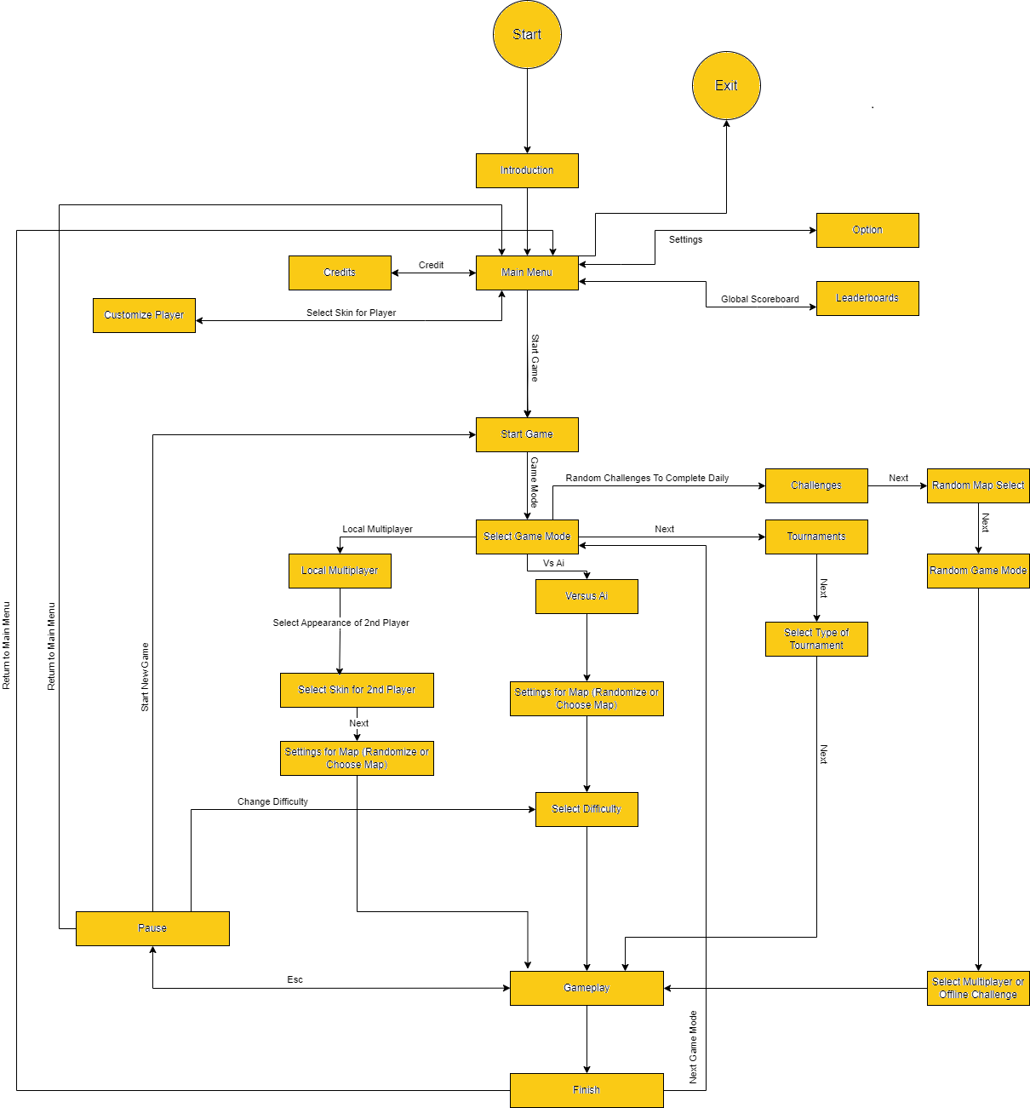

**Game Flow**

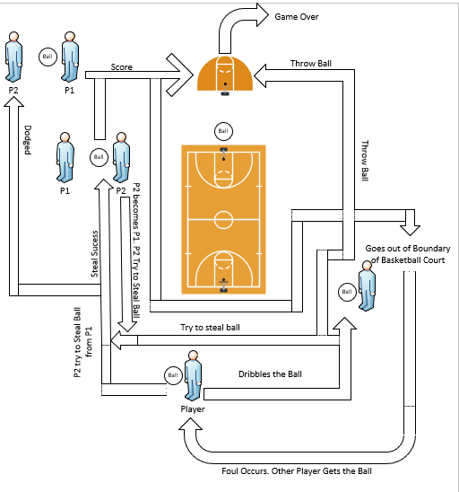

**Game Loop**

**Scope Management**

**Green Light (Must-Haves for MVP):**

* 1v1 Gameplay: Implement the core mechanics for intense 1v1 street basketball matchups.
* Basic Controls and Movement: Develop intuitive and responsive controls for player movement, ball-handling, shooting, and defensive actions.
* 2.5D Visuals: Create a visually appealing environment with stylized 3D graphics in a 2.5D visual, capturing the essence of urban street basketball.
* Timed Matches: Include the essential time-based game mechanic to add urgency and maintain a fast-paced gameplay experience.
* Dynamic Street Court Locations: Design multiple street courts with distinct characteristics, providing varied settings for gameplay.
* Chiptune/Hip-Hop Soundtrack: Integrate an energetic soundtrack that complements the urban street basketball theme.
* Local Multiplayer: Introduce local multiplayer functionality for players to compete against friends on the same device.

**Yellow Light (Stretch Features - Nice to Have, Depending on Resources):**

* Player Customization and Progression: Add a system for player customization, allowing players to personalize their avatars and progress through the game with unlockable items.
* Advanced Ball Physics: Enhance the realism of ball physics for a more immersive gaming experience.
* Additional Game Modes: Consider developing additional game modes beyond 1v1, such as tournaments or challenges, to diversify the gameplay experience.
* Enhanced Graphics and Animations: Invest in more detailed graphics and animations to further elevate the visual appeal.

**Red Light (Stretch Features - May Be Considered for Future Updates or Sequels):**

* Story Mode/Narrative: Develop a narrative-driven story mode for a deeper engagement with the street basketball world.
* Augmented Reality (AR) Integration: Explore the integration of AR features for an innovative and immersive gameplay experience.
* Online Tournaments and Events: Implement scheduled online tournaments and events to build a competitive community.
* Realistic Weather Effects: Introduce realistic weather effects, impacting gameplay dynamics and adding an extra layer of strategy.
* Expanded Social Features: Enhance social features, such as in-game chat, friend lists, and player profiles, to foster a stronger sense of community.
* Global Leaderboards: Implement a system to track and display player rankings globally, encouraging competition.
* Cross-Platform Play: Enable cross-platform play to broaden the player base and create a more vibrant community.
* Allow a switching to First-Person Mode from the 2.5D mode to 3D mode in Options to allow players to play in the way they like.

It's essential to prioritize features based on the MVP concept to ensure a solid foundation for the game's launch while allowing for potential future enhancements and expansions based on the game's reception and available resources.