**CG_Assignment_Report_3**

Name: Abu Taher

Student ID: 2410233

Date: 25 May 2025

**Task 1:**

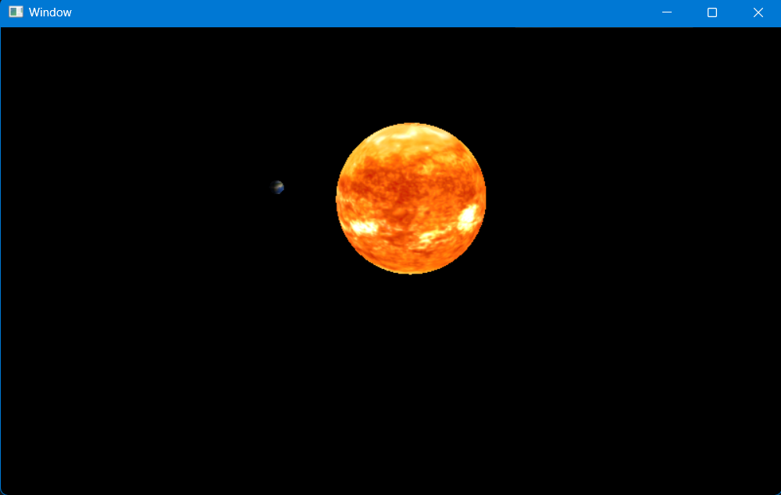

**Task 2:**

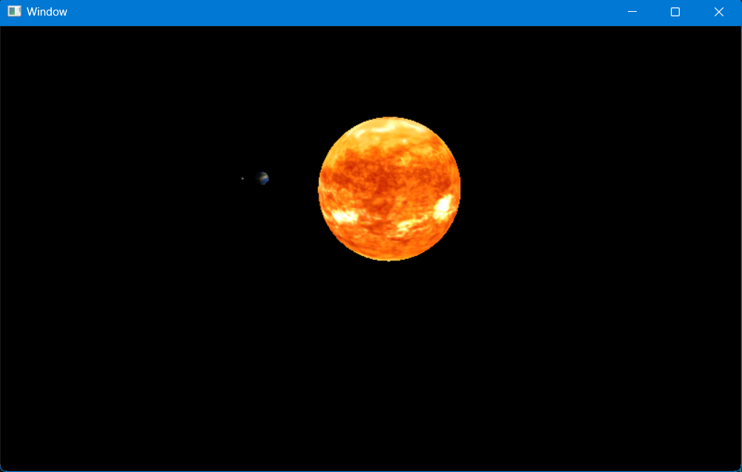

**Task 3:**



**Task 4:**

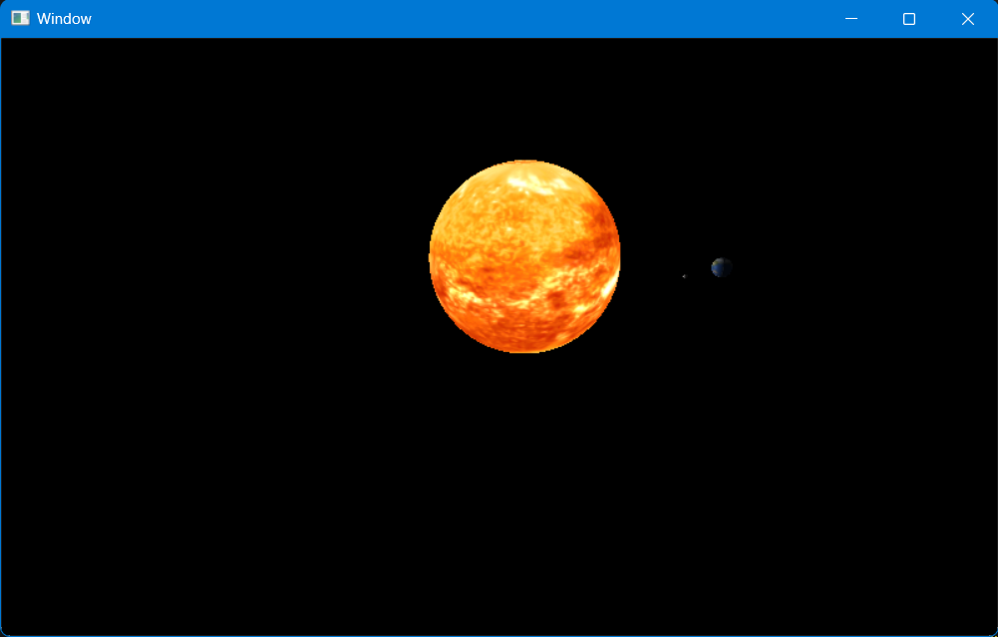

**Task 5:**

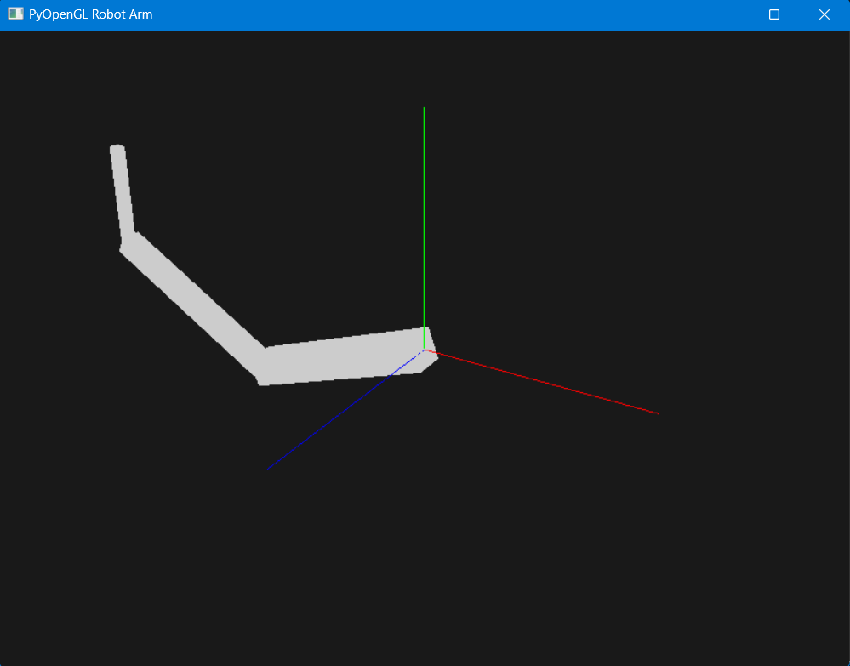

**Explanation:**

1. **Shoulder**

This is the root and base segment. I have implemented

Rotate: ‘shoulder_angle’ around z axis

Translate: Translated 1 unit along the z-axis

Scale: To make the upper arm

1. **Elbow**

This is the child of the shoulder.

Translate: 1 unit along the x axis

Rotate: rotate around z axis

Scale: To form the lower arm

1. **Wrist**

This is the grandchild of the elbow.

Translate: 1 unit along the x axis

Rotate: around z axis

Scale: to form the wrist segment.