SCORE90X
USER MANUAL
A Guide to Navigating the FIFA World Cup 2026 Dashboard
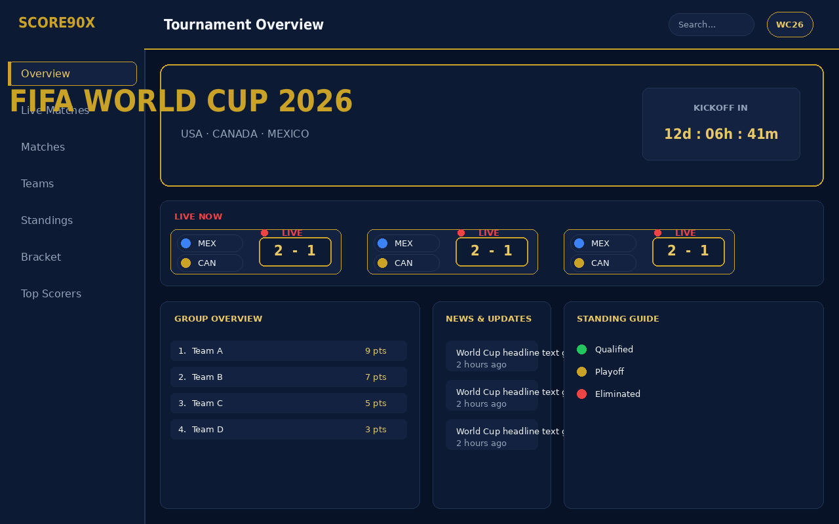
The Score90X Tournament Overview dashboard
Live URL: world-cup-score90-x.vercel.app
Author: Abu Thahir
Document Date: July 2026

1. Welcome to Score90X
Score90X is a live score and information dashboard for the FIFA World Cup 2026. It brings together live match scores, tournament standings, team and player profiles, a knockout-stage bracket, and a top-scorer leaderboard in one cinematic, dark-themed interface.
NOTE: This manual illustrates each screen using interface mockups built directly from the application's real design system (layout, colors, and typography) rather than live screen captures, so the visual language matches the deployed app.

1.1 Accessing Score90X
- Live site: world-cup-score90-x.vercel.app
- Works in any modern desktop or mobile browser — no account or sign-in is required.
- The interface automatically adapts to your screen size: a full sidebar on desktop, and a collapsible drawer menu on mobile.

1.2 How This Manual is Organized
Each section below covers one screen: what it shows, how to get there, and how to use it. Sections follow the order of the sidebar navigation: Overview, Live Matches, Matches, Teams, Standings, Bracket, Top Scorers, and Search.

2. Getting Around

2.1 Desktop Layout
On desktop and tablet screens, Score90X uses a fixed left sidebar plus a top navigation bar:
- Sidebar (left) — the SCORE90X logo and the main section links: Overview, Live Matches, Matches, Teams, Standings, Bracket, Top Scorers. The currently active section is highlighted with a gold accent bar.
- Top navbar — shows the current page title, a search field, and a World Cup 2026 badge.
- Main content area — scrolls independently of the sidebar, so navigation links stay visible at all times.

2.2 Mobile Layout
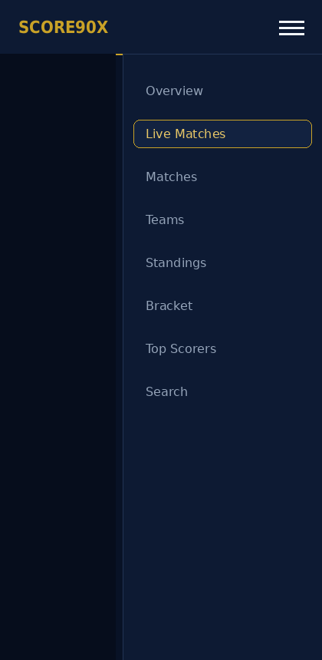
Mobile navigation drawer, opened via the hamburger icon
- Tap the hamburger icon (top-right) to open the navigation drawer.
- Tap any item in the drawer to jump to that section; the drawer closes automatically after selection.
- Tap outside the drawer, or the hamburger icon again, to close it without navigating.

3. Tournament Overview
The Overview page is the default landing screen — a snapshot of everything happening in the tournament right now.

Tournament Overview: hero banner, Live Now strip, group overview, news, and standing guide

3.1 What You'll See
- Hero banner — the tournament name, host countries, and a live countdown to kickoff.
- Live Now strip — horizontally scrollable cards for matches currently in progress, each showing both team names and the live score.
- Group Overview panel — a condensed points table for a featured group.
- News & Updates panel — short World Cup headlines with a relative timestamp.
- Standing Guide panel — a color-coded legend explaining what green/gold/red mean on standings tables (Qualified / Playoff / Eliminated).

3.2 How to Use It
1. Glance at the Live Now strip for anything happening right this moment.
2. Tap/click a live match card to jump straight to that match's full detail page.
3. Use the countdown banner to know how long remains before the tournament (or the next stage) begins.

4. Live Matches
The Live Matches page is a focused, filterable dashboard of match activity.
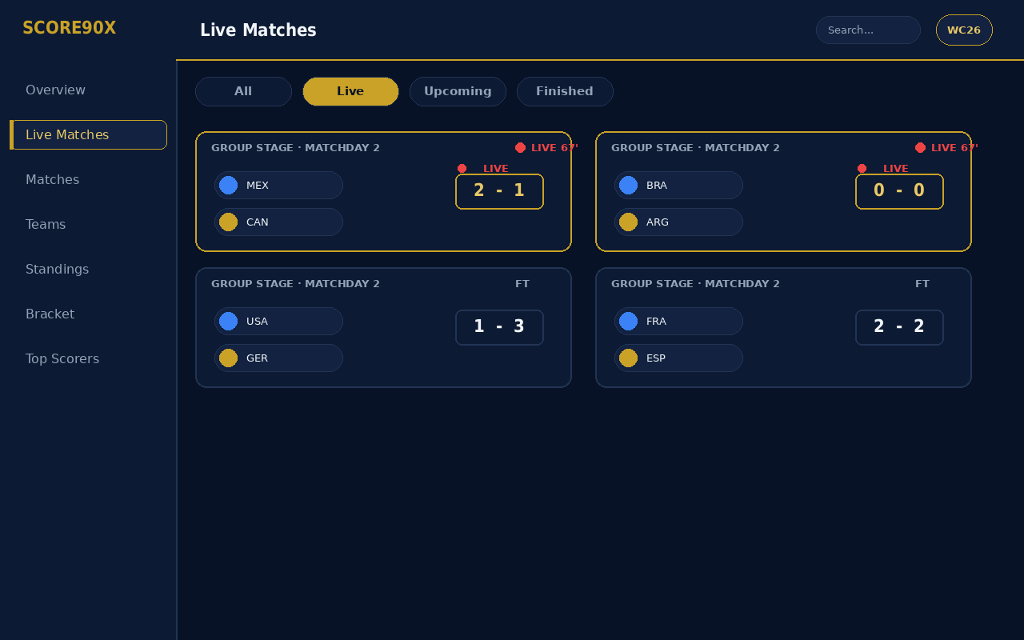
Live Matches dashboard with tab filters and live status indicators

4.1 Tabs
- All — every match in the competition.
- Live — only matches currently in progress, each marked with a pulsing red LIVE indicator and the current match minute.
- Upcoming — scheduled matches that haven't started.
- Finished — completed matches with their final score.

4.2 Reading a Match Card
- Top-left: competition stage and matchday (e.g. "Group Stage · Matchday 2").
- Top-right: status — LIVE with the current minute, or FT (Full Time) for completed matches.
- Center: both team names/crests and the current or final score.
- Tap/click anywhere on a card to open the full Match Details page for that fixture.

5. Match Details
Tapping any match card — from Overview, Live Matches, the Matches list, or the Bracket — opens its dedicated details page.
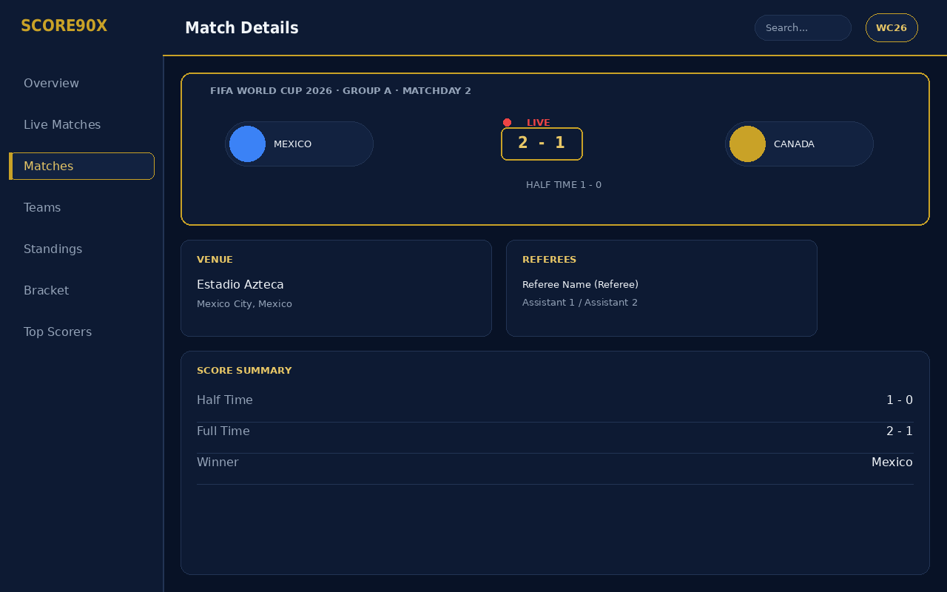
Match Details: live score banner, venue, referees, and score summary

5.1 Sections on This Page
- Live Score Banner — large team names and current/final score, with a half-time score line underneath when available.
- Venue card — stadium name and city.
- Referees card — the match officials and their roles.
- Score Summary — a breakdown of half-time score, full-time score, and the match winner.

5.2 Navigating Back
- Use the back button (top of the page) or your browser's back action to return to wherever you came from — the Live Matches list, Overview, or the Bracket.

6. Teams
The Teams page lists every nation competing in the tournament as a grid of team cards.
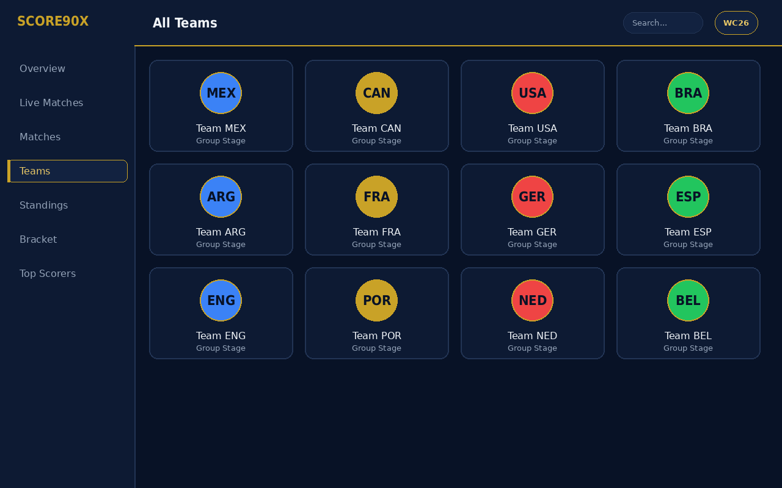
All Teams grid — one card per participating nation

6.1 Using the Teams Grid
- Each card shows the team crest, name, and current stage (e.g. Group Stage).
- Click/tap a card to open that team's full profile page.

6.2 Team Profile Page
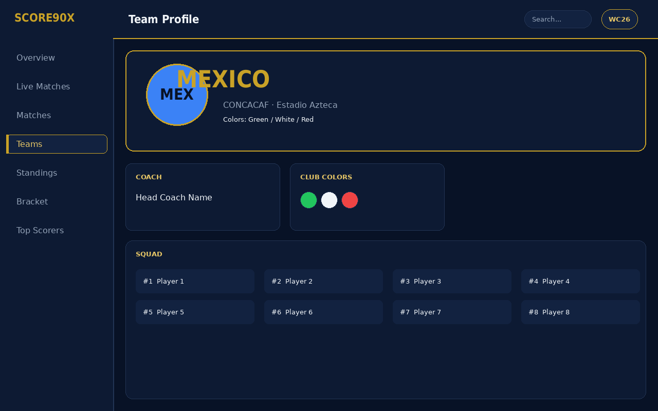
Team Profile: banner, coach, club colors, and squad list
- Profile banner — crest, full team name, confederation, and home venue.
- Coach card — the team's head coach.
- Club Colors card — the team's official kit colors as a swatch.
- Squad list — every registered player with shirt number; tap a player's name to open their individual profile.

7. Player Profiles
Selecting a player from a team's squad list (or from the Top Scorers leaderboard) opens their profile page.
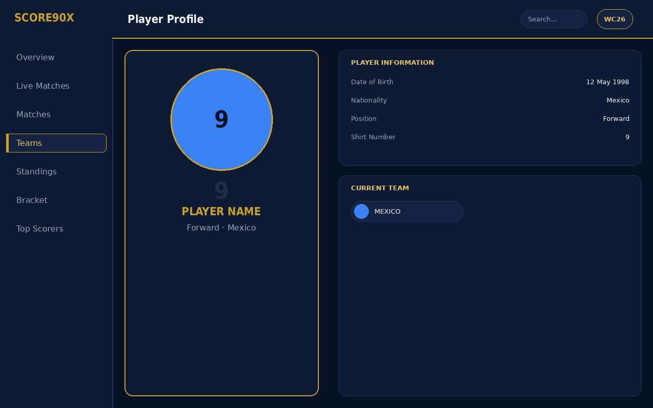
Player Profile: hero photo panel, player information, and current team

7.1 What's Shown
- Hero panel — the player's photo/silhouette with their shirt number watermarked in the background, name, and position.
- Player Information card — date of birth, nationality, position, and shirt number.
- Current Team card — the player's national team, linking back to that team's profile page.

8. Standings
The Standings pages present the tournament tables — both the overall Table Standings view and the Group Standings view.
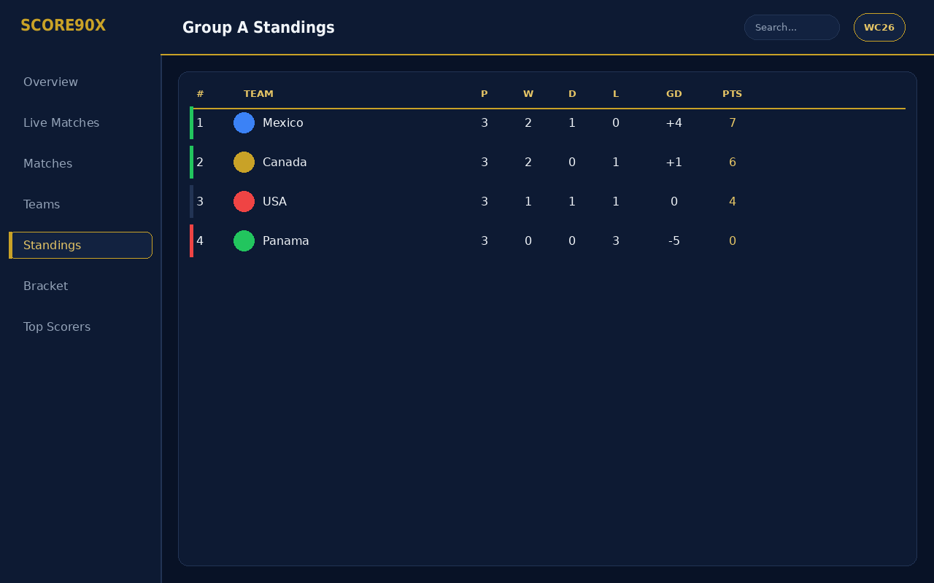
Group Standings table with the qualification-zone color guide applied

8.1 Reading the Table
- Columns: Position, Team, Played (P), Won (W), Drawn (D), Lost (L), Goal Difference (GD), Points (PTS).
- Tables are sorted by points, then goal difference, matching official tournament tie-break rules.
- The colored bar on the left edge of each row matches the Standing Guide legend from the Overview page — green for qualified, gold for playoff contention, red for eliminated.

8.2 Table vs. Group View
- Table Standings — a single combined view across the tournament.
- Group Standings — tables broken out by individual group (A, B, C, ...), matching the group-stage format.

9. Knockout Bracket
The Bracket page visualizes the knockout stage as a connected tree, from the Round of 16 through to the Final.
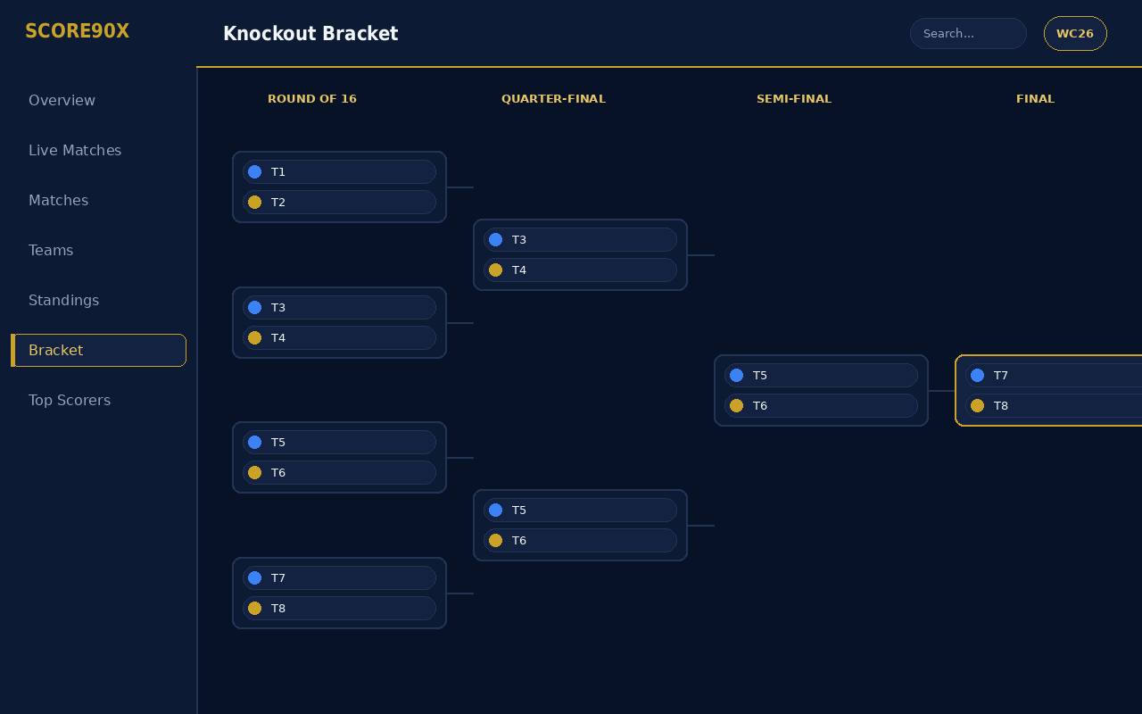
Knockout Bracket: Round of 16 through the Final, connected by round

9.1 Reading the Bracket
- Each column represents one knockout round; matches are connected by lines showing how winners advance.
- The Final is highlighted distinctly (gold border) as the culminating match of the tree.
- Each match box shows both competing teams; once a match is decided, the winner's slot carries forward into the next round.

9.2 Interacting with the Bracket
- Scroll horizontally to move between rounds if the bracket is wider than your screen.
- Click/tap any match box to open its full Match Details page.
- A skeleton loading state appears briefly while bracket data is being fetched.

10. Top Scorers
The Top Scorers page ranks players across the tournament by goals scored.
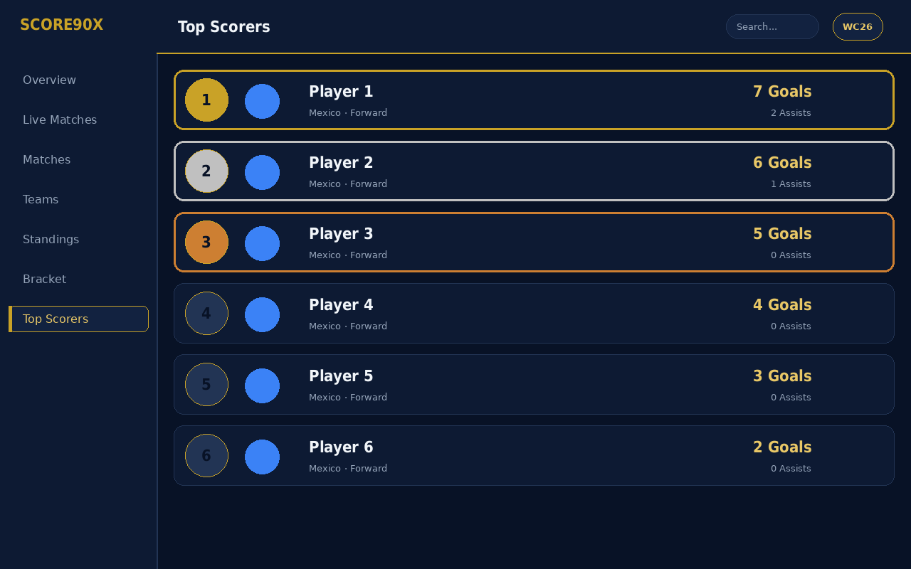
Top Scorers leaderboard with rank-based gold/silver/bronze styling

10.1 Reading the Leaderboard
- Rank badge — the top three ranks are styled in gold, silver, and bronze to stand out; other ranks use a neutral outline.
- Each row shows the player's name, nationality/position, goals, and assists.
- Tap/click a player's row to open their full Player Profile.

11. Search
The search field in the top navbar lets you jump directly to a team, player, or match without browsing through menus.

11.1 Using Search
1. Click the search field in the top navbar (desktop) or open it from the mobile drawer.
2. Type a team name, player name, or keyword.
3. Results appear on the Search Results page, grouped by type (Teams, Players, Matches).
4. Click any result to open its detail page.

12. Tips & Troubleshooting
Situation | What to know
Scores look slightly delayed | Live data is refreshed on a short delay (a few minutes) rather than instantly, to keep the app fast and reliable.
A page shows a skeleton/loading state | This is normal while data loads — it should resolve within a few seconds on a normal connection.
A page shows an error message | This usually means the underlying data source is temporarily unavailable; try refreshing the page after a minute.
The sidebar is missing on my screen | On narrower screens (tablet/mobile), the sidebar is replaced by the drawer menu — use the hamburger icon.
I want to go back to where I was | Use the in-app back button where available, or your browser/device back gesture.

