

**The Problem Statement**

A registry block implements a finite state machine (FSM) model for

managing parameter loading and manipulation based on input data. The inputs to this block include a clock signal, a global reset, a data input (data_in) and a parameter load signal (prmtr_ld). The outputs from the block are a masked parameter (mask_param), coded parameter (code_param) and a synchronisation jump width (sjw). A finite state machine is used to implement this logic. The task is to take the 8-bit data input (data_in) and convert it into 11-bit encoded outputs for mask_param and code_param.

**Block Diagram**

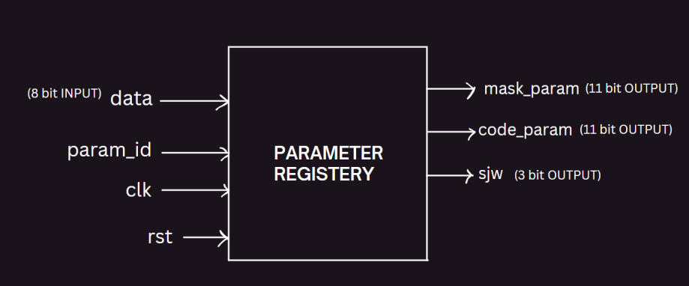

**State Diagram**

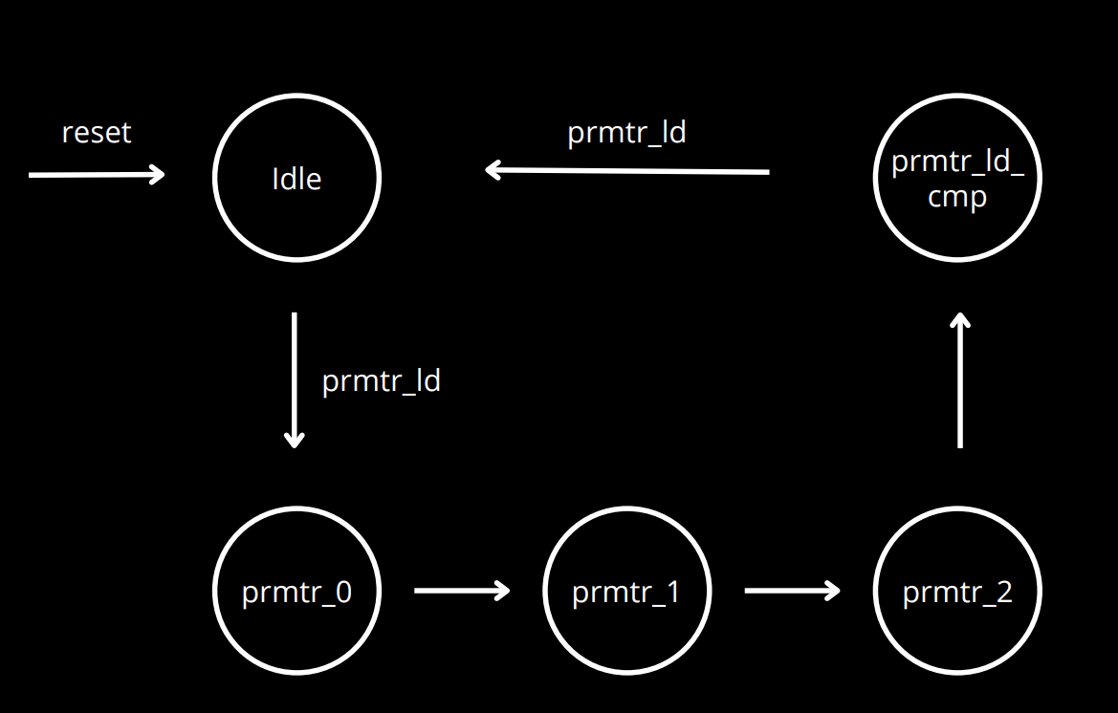

**Design Code**

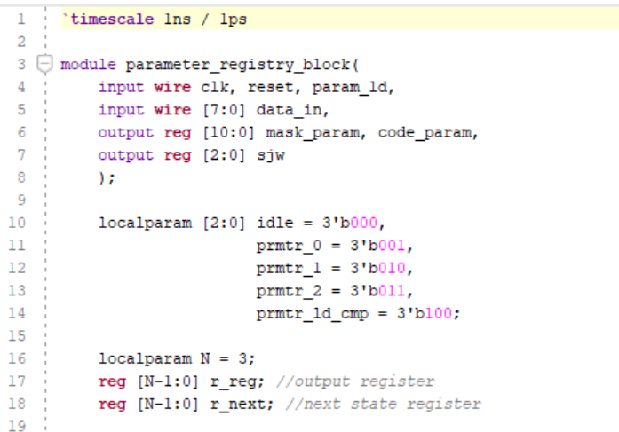

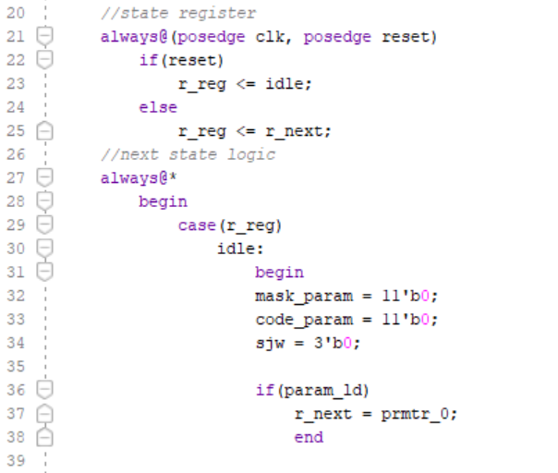

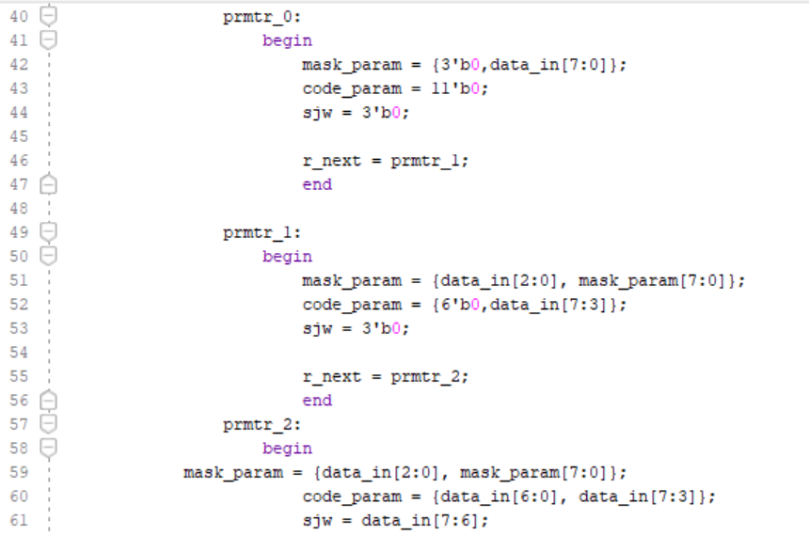

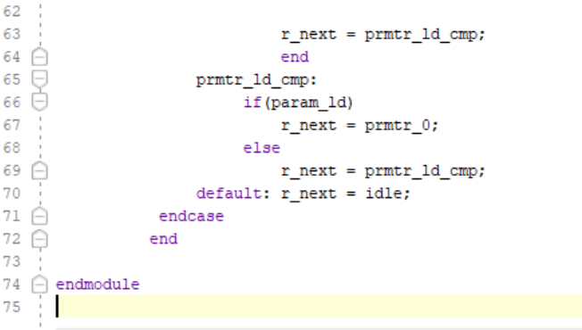

**Testbench Code**

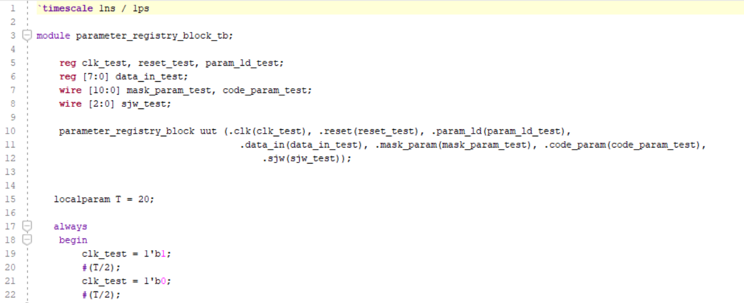

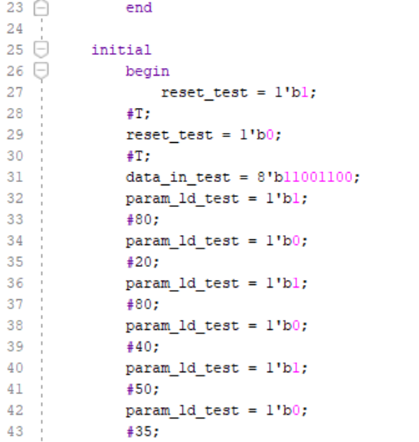

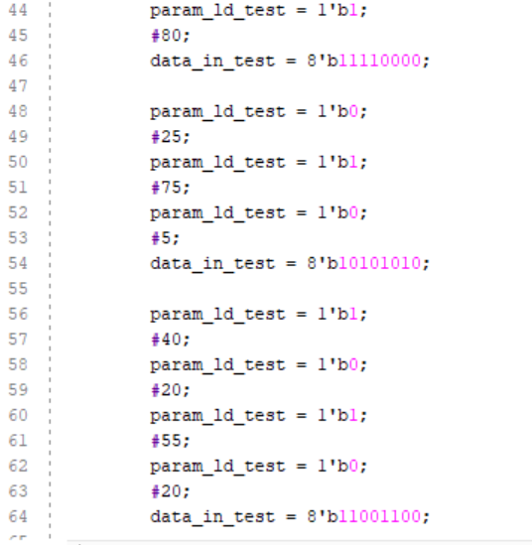

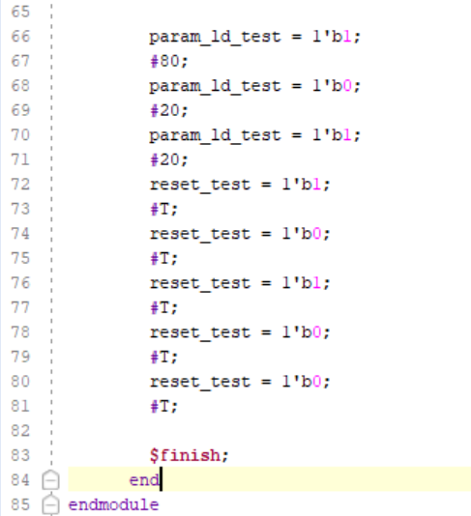

**Code Coverage**

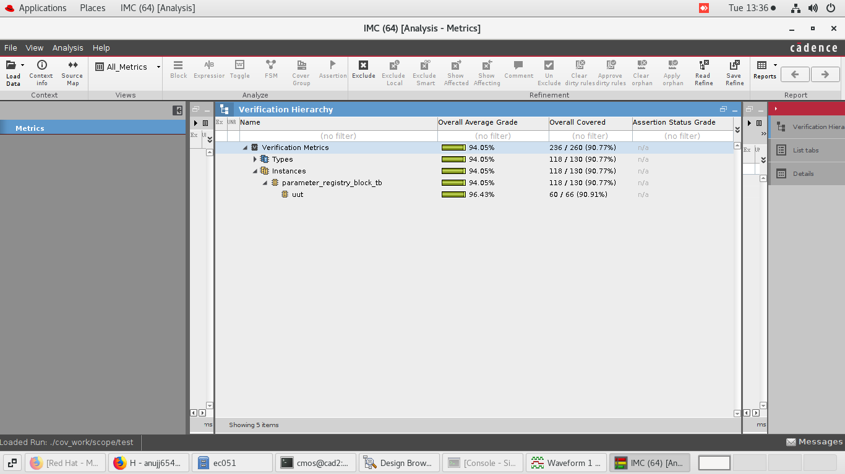

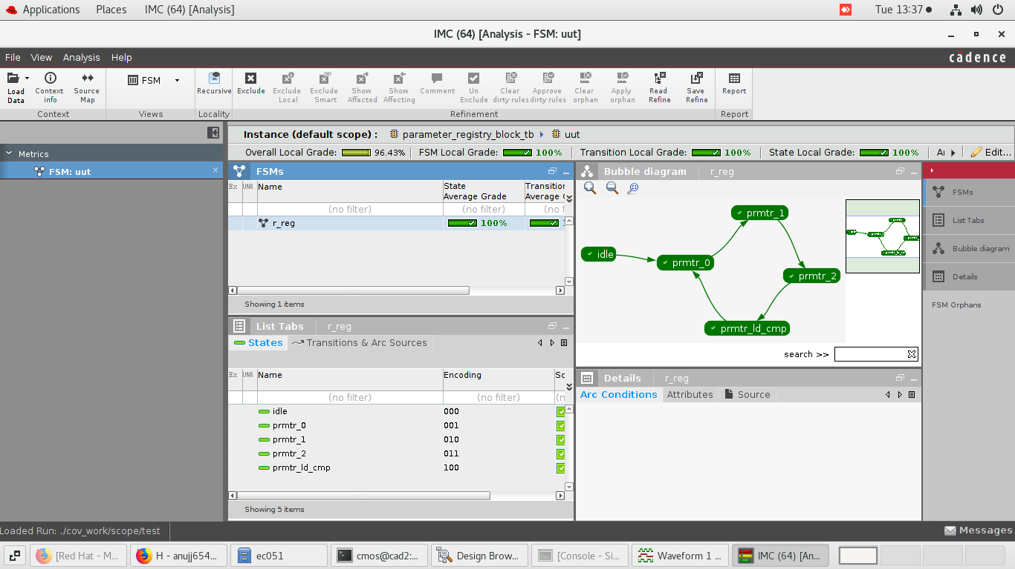

**Simulation Results**

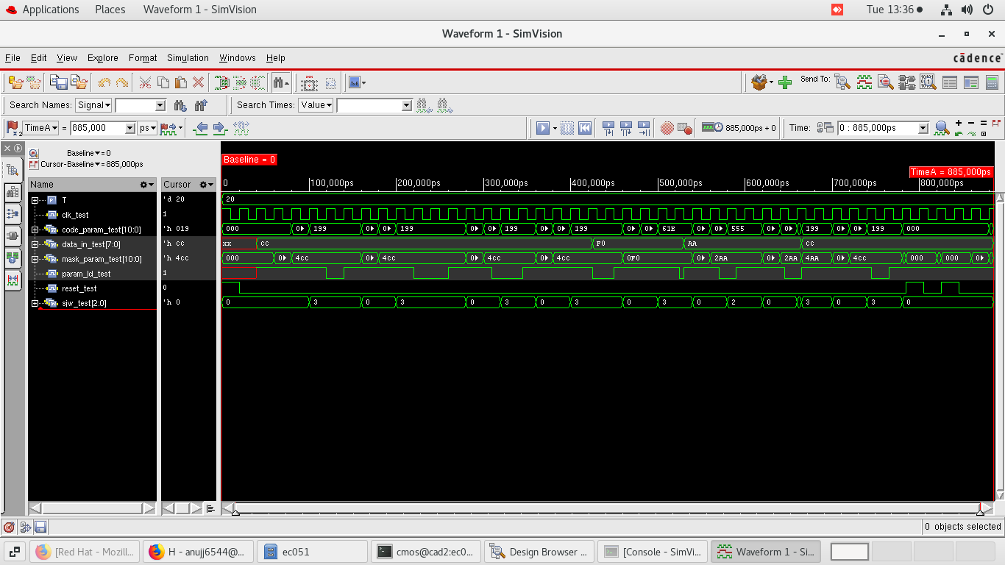

**Synthesis Schematic**

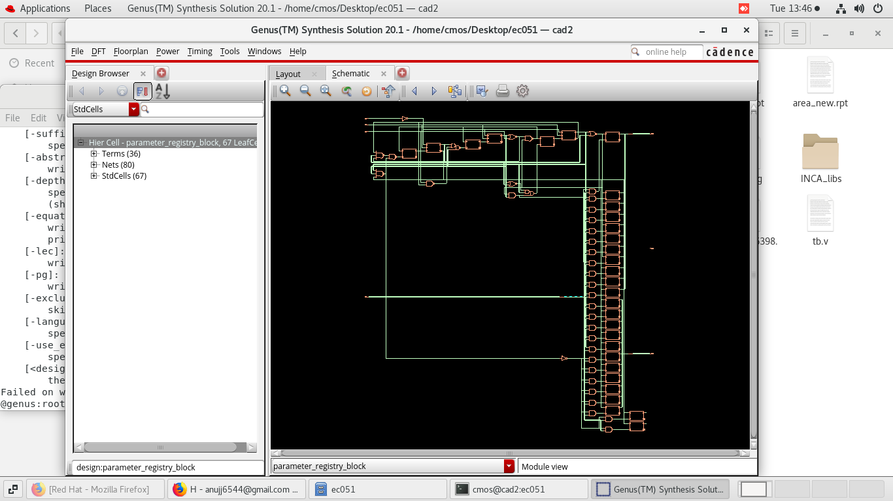

**Power Report**

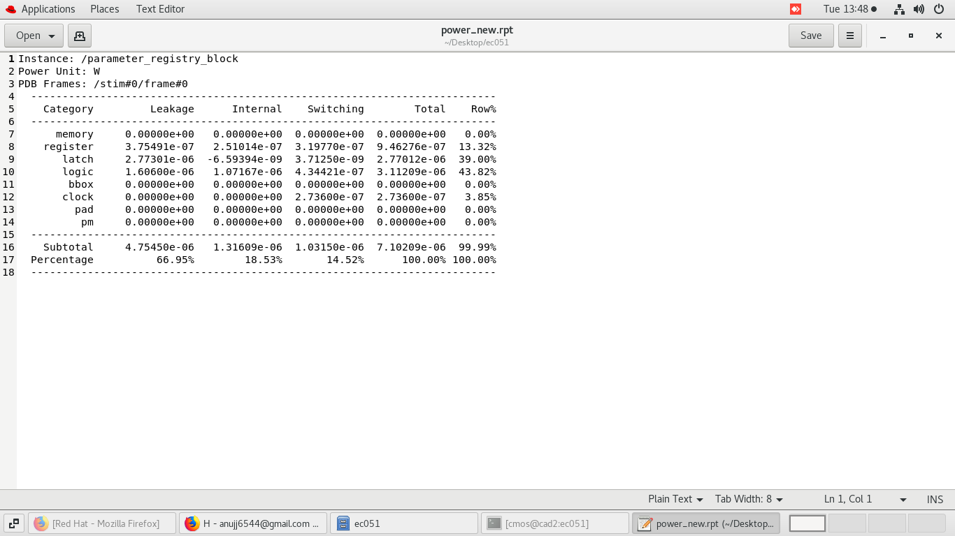

**Area Report**

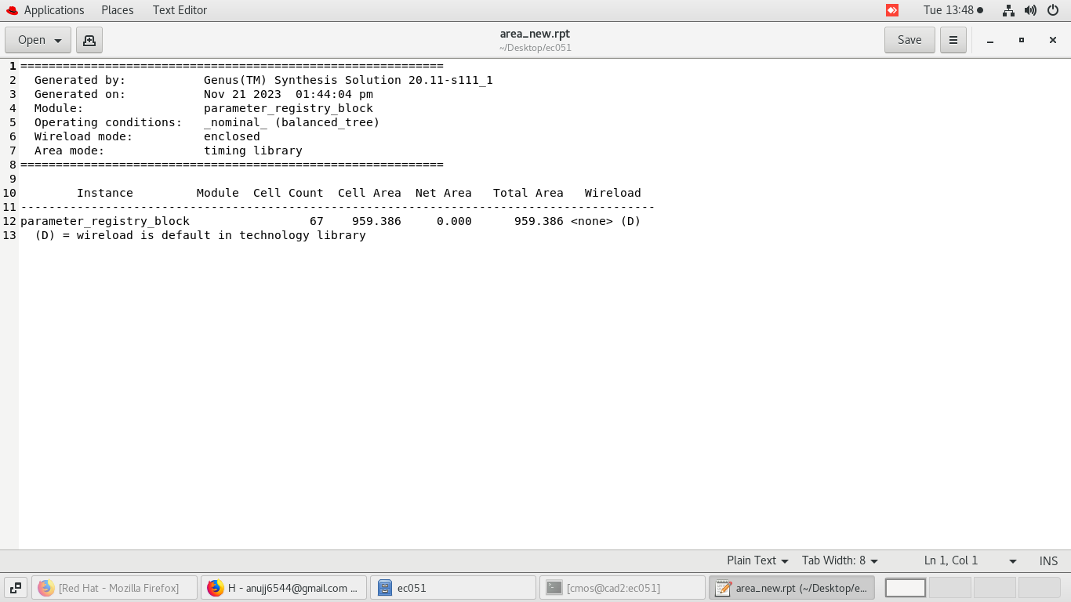

**Timing Report**

