ASSIGNMENT - 1

**50 Start-up’s data analysis**

**Problem Statement**: This particular dataset holds data from 50-startups in New York, California, and Florida. The features in this dataset are R&D spending, Administration Spending, Marketing Spending, and location features, while the target variable is: Profit.

Explored and visualized the 50-startups dataset

**1. Profit by state and R&D spends:**

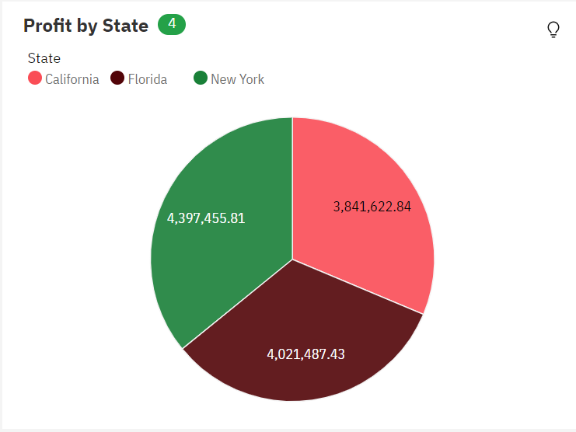

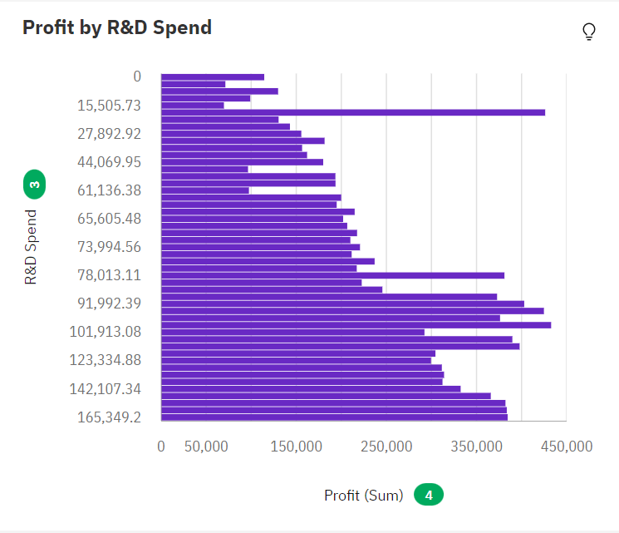

**2. Marketing Spend and Profit by Marketing Spend:**

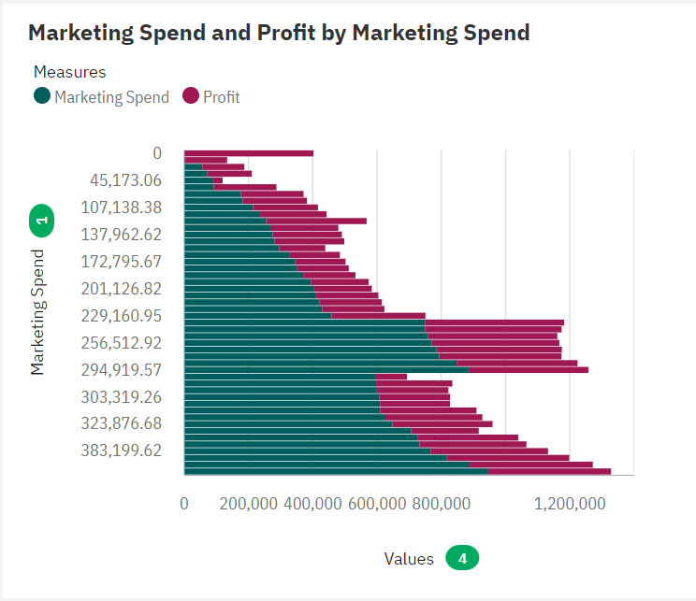

**3. Administration by Administration:**

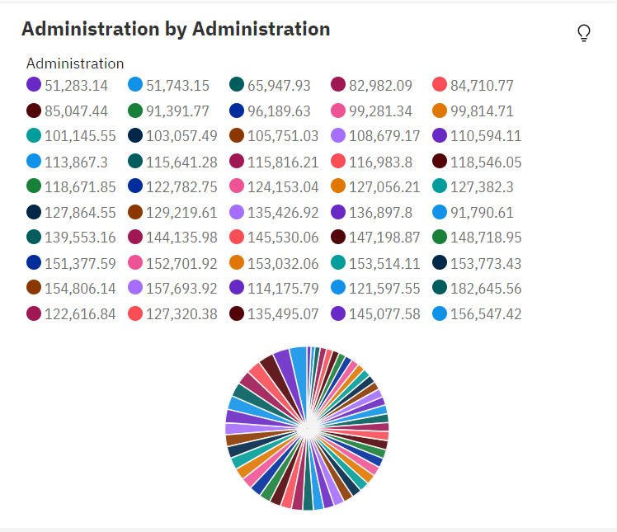

**4.Profit by State:**

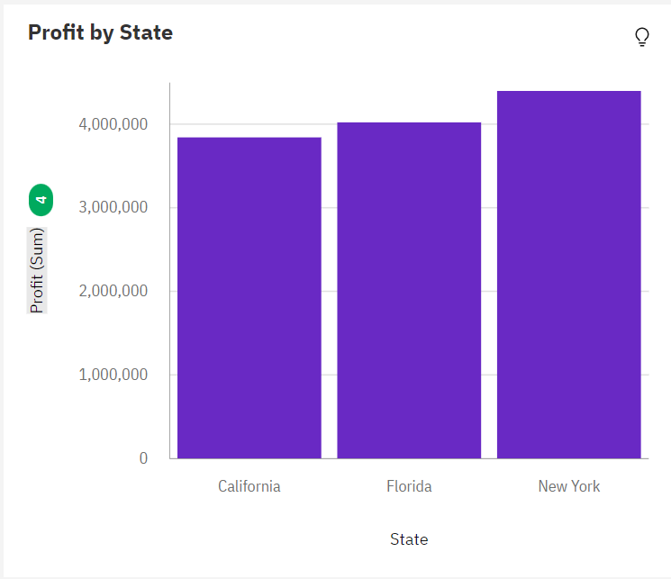

**5.Profit and Profit by Administration:**

5.