**Session 1: How to Solve Big Data**

Assignment 1

Student Name: Abarajithan SA

Course: Big Data Hadoop & Spark Training

Start Date:  2017-09-09

End Date:  2017-11-26

**Assignment 1** –Import Acadgild VM into Oracle virtual box by following the document shared in the dashboard.

1. The ACADGILD_32_Bit.ova has been downloaded and imported to the Oracle VM.

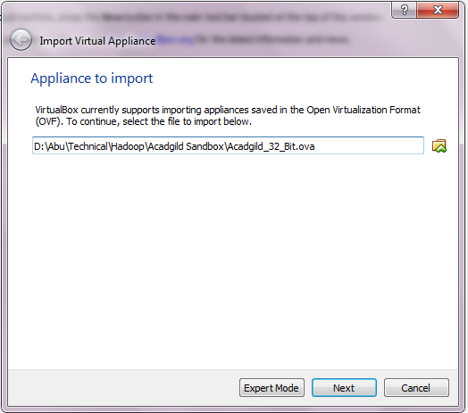

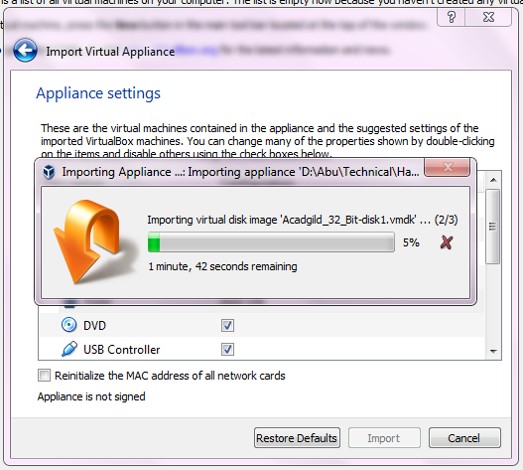

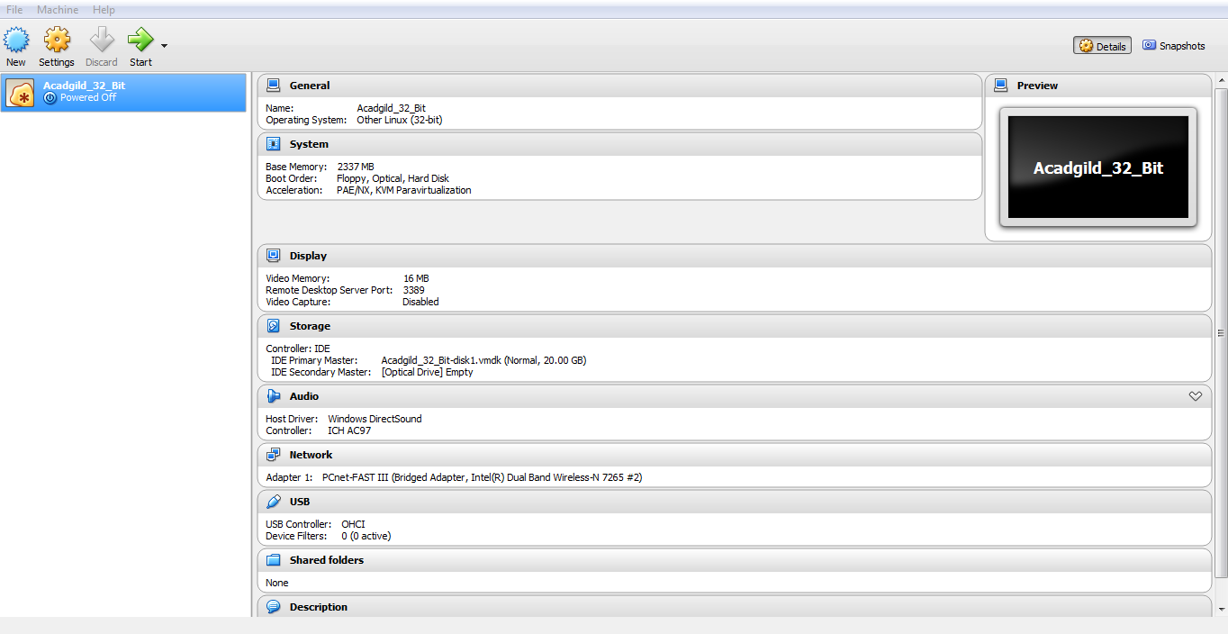

Logged in as user ACADGILD,

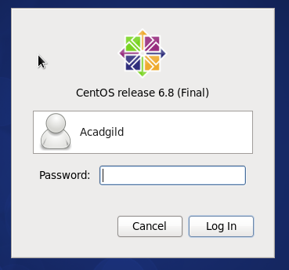

Expected Output:

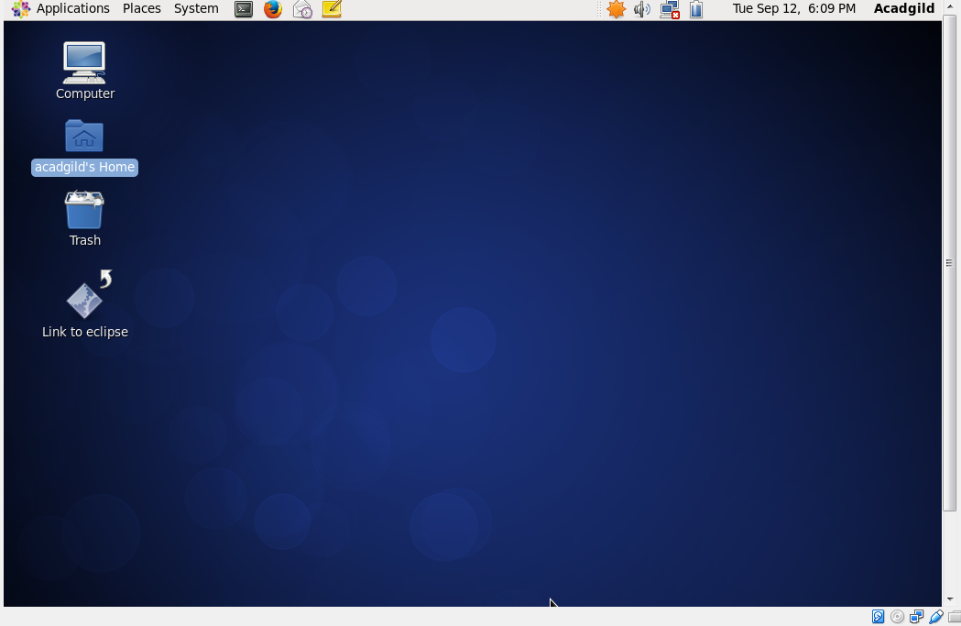

**Problem Statement**

Import Acadgild VM into Oracle virtual box by following the document given in the dashboard.

**Status: Completed.**