**Session 2: SOLVING BIG DATA PROBLEM & HADOOP FRAMEWORK**

Assignment 1.2

Student Name: Abarajithan SA

Course: Big Data Hadoop & Spark Training

Start Date:  2017-09-09

End Date:  2017-11-26

Table of Contents

1. **Assignment 1.22**
2. **Linux Commands Outputs3**
3. **Assignment 1.2** –Explain the below linux commands with an example. Share the screenshot of each command with the output:
4. pwd
5. vi
6. touch
7. mkdir
8. rm
9. ls
10. echo
11. cat
12. who
13. cd
14. date
15. cal
16. mv
17. cp
18. which
19. **Linux Commands Outputs:**
20. **pwd**

‘pwd‘ stands for ‘**Print Working Directory**‘. As the name states, command ‘pwd‘ prints the current working directory or simply the directory user is, at present. It prints the current directory name with the complete path starting from root (/).

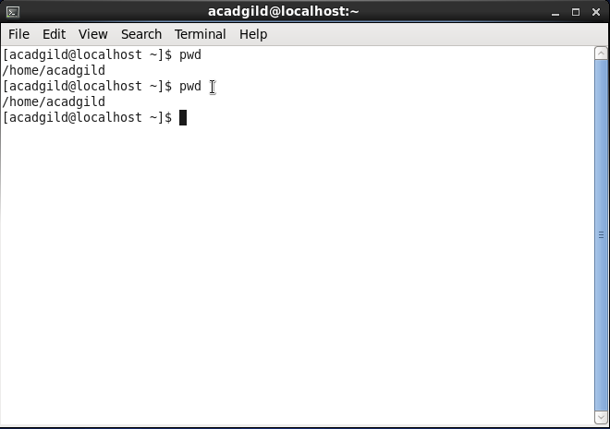

1. **vi**

vi is an interactive text editor which is display-oriented: the screen of your terminal acts as a window into the file you are editing. Changes you make to the file are reflected in what you see.

Using vi you can insert text anywhere in the file very easily. Most of the vi commands move the cursor around in the file. You can move the cursor forward and backward in units of characters, words, sentences, and paragraphs. Some of the operators, liked for delete and c for change, can be combined with the motion commands to make them operate on entire words, paragraphs, etc., in a natural way.

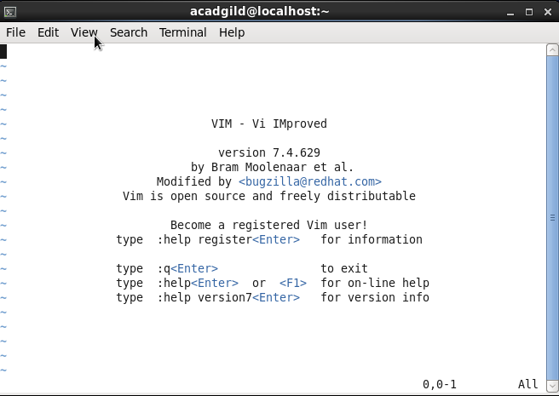

1. **touch**

The touch command is the easiest way to create new, empty files. It is also used to change the timestamps (i.e., dates and times of the most recent access and modification) on existing files and directories.

touch's syntax is

touch [option] file_name(s)

Ex: touch acadgild’s home

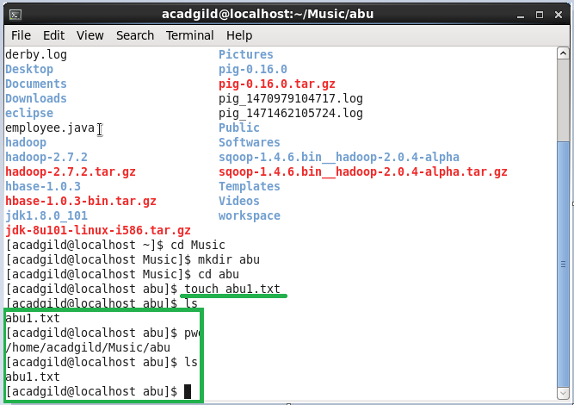

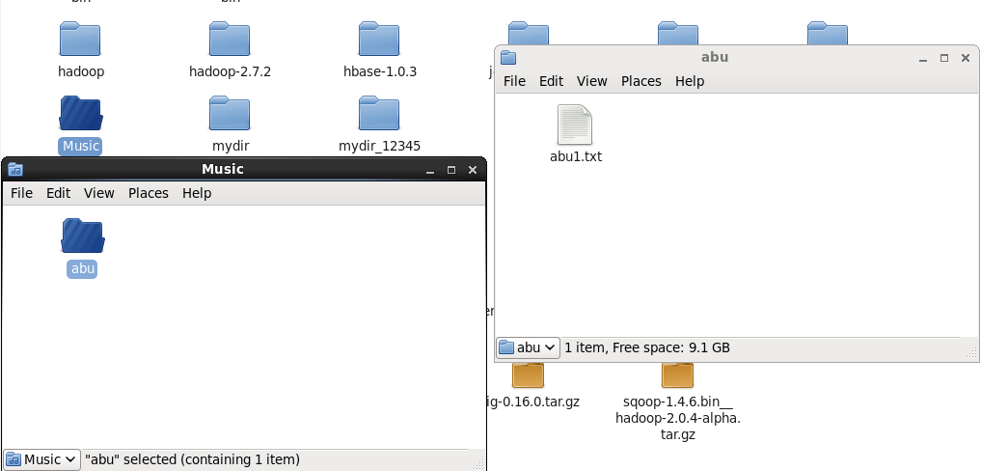

1. **mkdir**

If the specified DIRECTORY does not already exist, mkdir creates it.

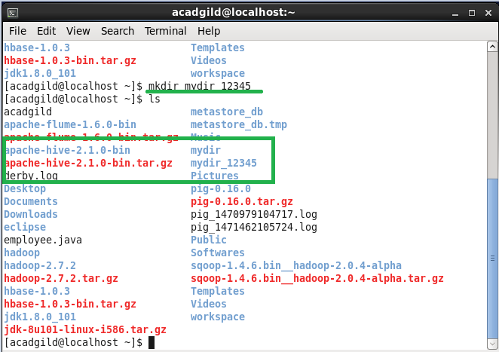



1. **rm**

The **rm** command removes (deletes) files or directories. **rm** removes each specified FILE. By default, it does not remove directories; see Removing Directories below for details.

The removal process unlinks a file name in a filesystem from data on the storage device, and marks that space as usable by future writes. In other words, removing files increases the amount of available space on your disk.

The data itself is not destroyed, but after being unlinked, it becomes inaccessible. Remove your files wisely! The effects of an **rm** operation cannot be undone.

EX: a ‘**newfolder’** and ‘**newfolder.txt’** has been created under the directory ‘**abu’**, the text files and the directory is going to be removed using **rm** command

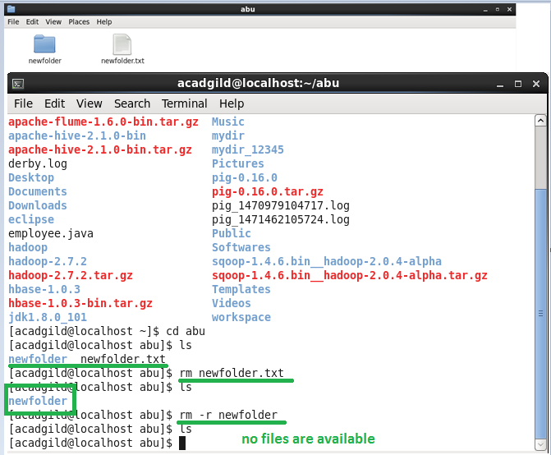

1. **ls**

**ls** is a command to list files,

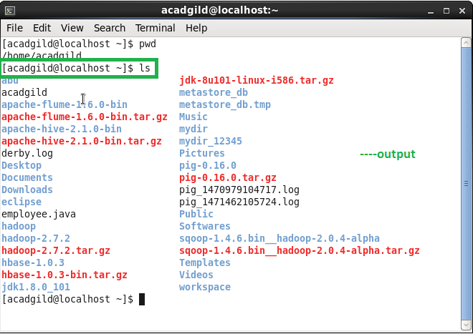

We have 15 other Basic ‘ls’ Command Examples in Linux, i.e. ls –I, ls –a, ls –lh, ls –F, ls –r, ls –R, ls –ltr, ls –IS, ls –i, ls - -version, ls - -help, ls -1 /tmp, ls –n.

1. **echo**

The echo Command. **echo** is a built-in command in the bash and C shells that writes its arguments to standard output. A shell is a program that provides the command line (i.e., the all-text display user interface) on Linux and other Unix-like operating systems

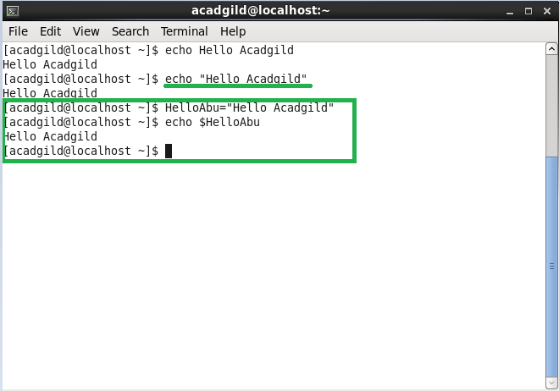

1. **cat**

The cat (short for “**concatenate**“) command is one of the most frequently used command in Linux/Unix like operating systems. **cat** command allows us to create single or multiple files, view contain of file, concatenate files and redirect output in terminal or files.

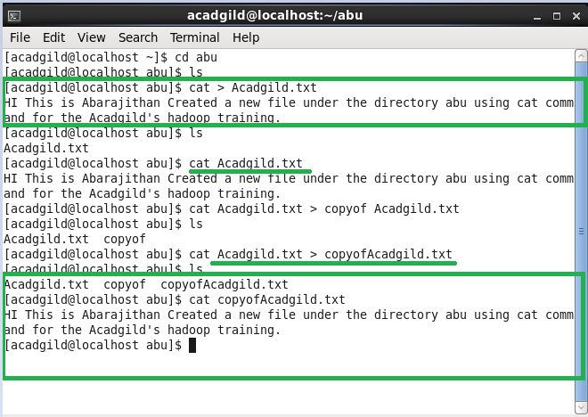

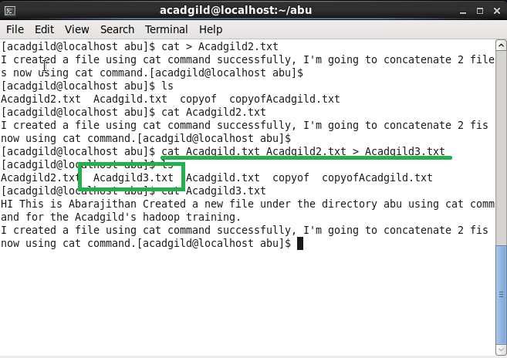

1. **who**

As a Linux user, sometimes it is required to know some basic information like:

* Time of last system boot
* List of users logged-in
* Current run level etc

Though this type of information can be obtained from various files in the Linux system but there is a command line utility 'who' that does exactly the same for you.

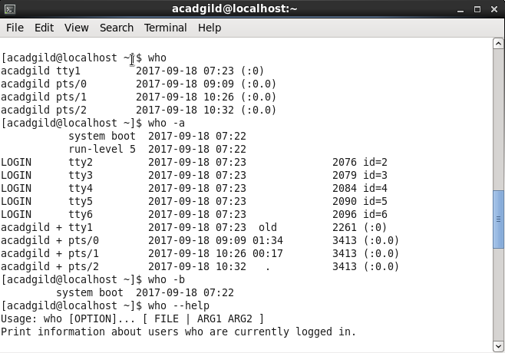

1. **Cd**

The **cd** command is used to change the current directory (i.e., the directory in which the user is currently working) in Linux and other Unix-like operating systems

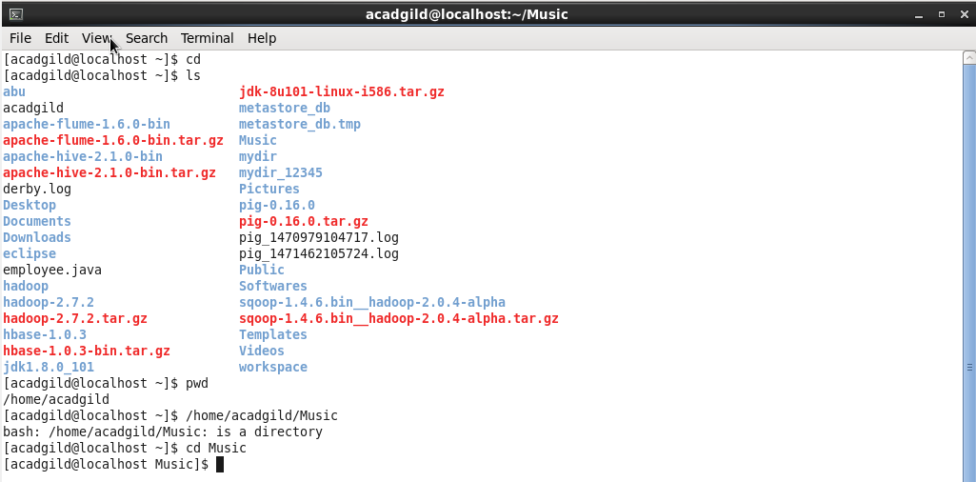

1. **Date**

The **date** command is used to print out, or change the value of, the system's time and date information.

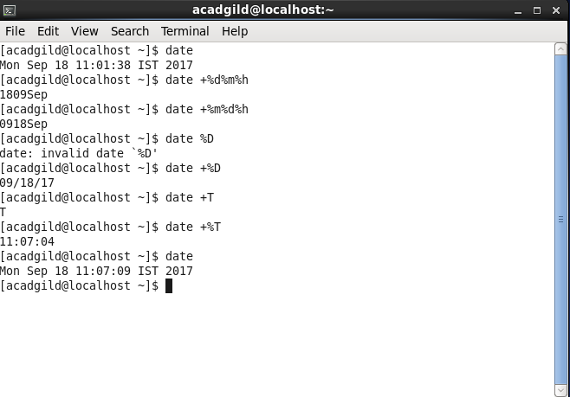

1. **Cal**

Display a conveniently-formatted calendar from the command line.

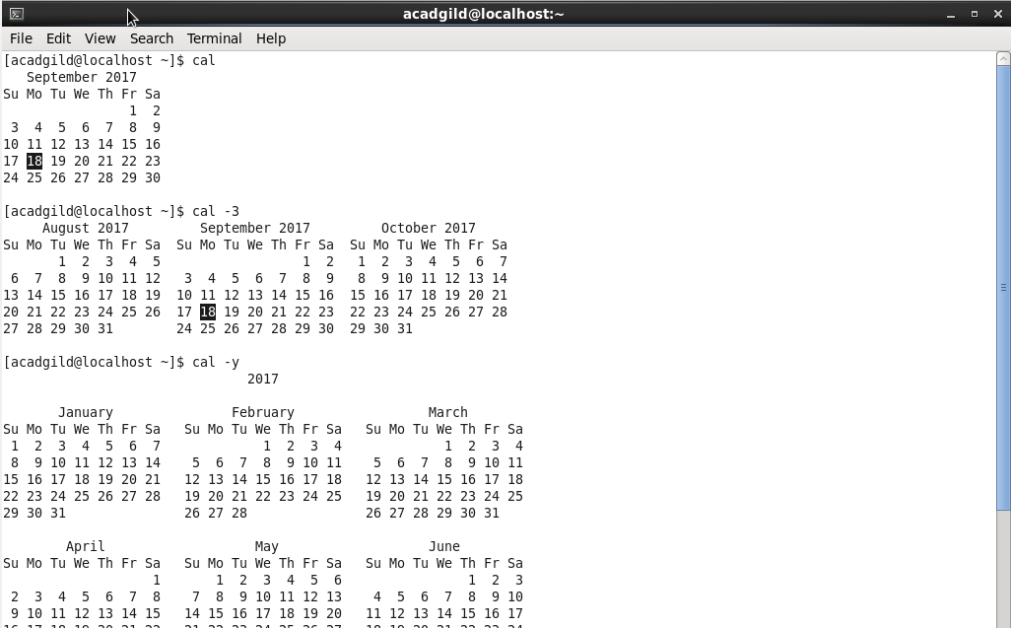

1. **Mv**

Linux mv command. **mv** command is used to move files and directories.

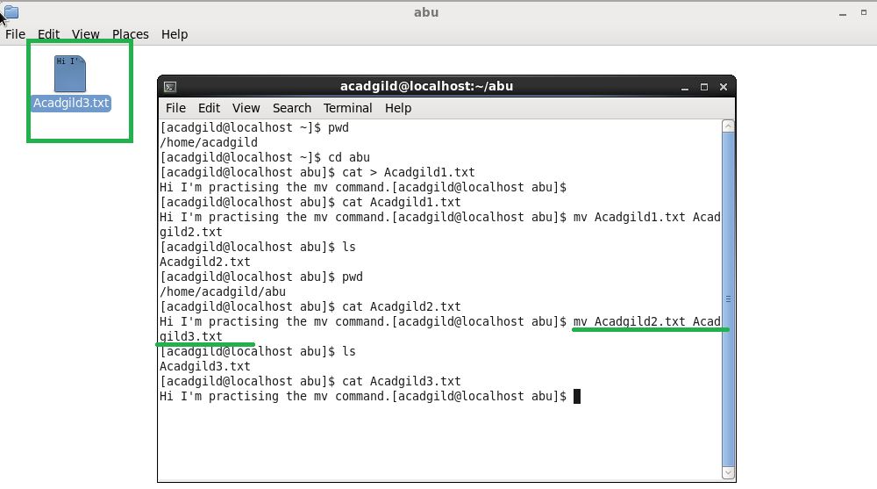

1. **Cp**

cp is a Linux shell command to copy files and directories.

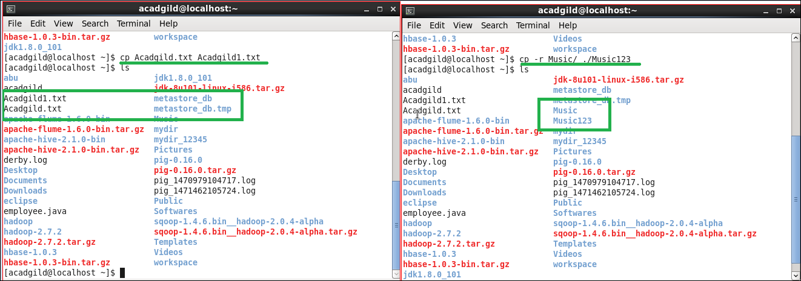

1. **Which**

Which command is very small and simple command to locate executables in the system. It allows user to pass several command names as arguments to get their paths in the system. “**which**” commands searches the path of executable in system paths set in $PATH environment variable.

