**Session 12: Introduction to Scala**

Assignment 12.1

Student Name: Abarajithan SA

Course: Big Data Hadoop & Spark Training

Start Date:  2017-09-09

End Date:  2017-11-26

**Assignment 12.1** –Importing acadgild_spark vm using Oracle vmThe ACADGILD_32_Bit.

Contents

Introduction 2

Step1 2

Step2 3

Step3 5

Step4 7

Step5 7

# Introduction

In this assignment, we are going to import acadgild_spark vm.

Download the acadgild vm using the below link and save it into your system.

<https://drive.google.com/open?id=0ByJLBTmJojjzY0pvVW9YUlFwLUk>

# Step1

Import the Acadgild VM,

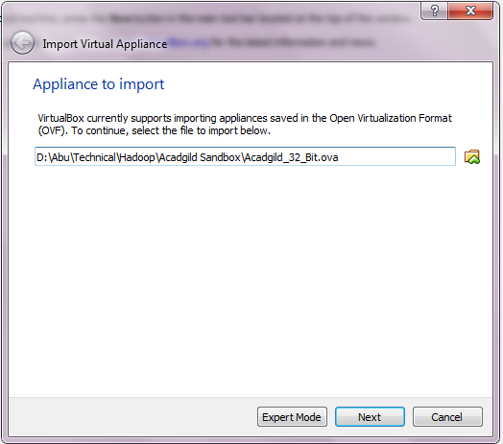

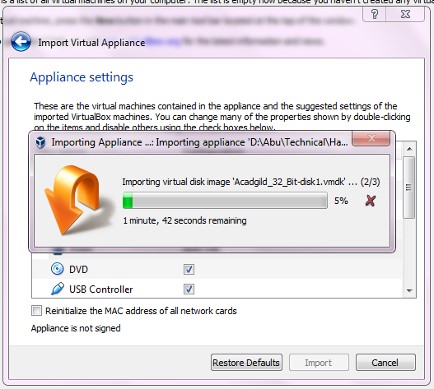

# Step2

Implement the appliance settings,

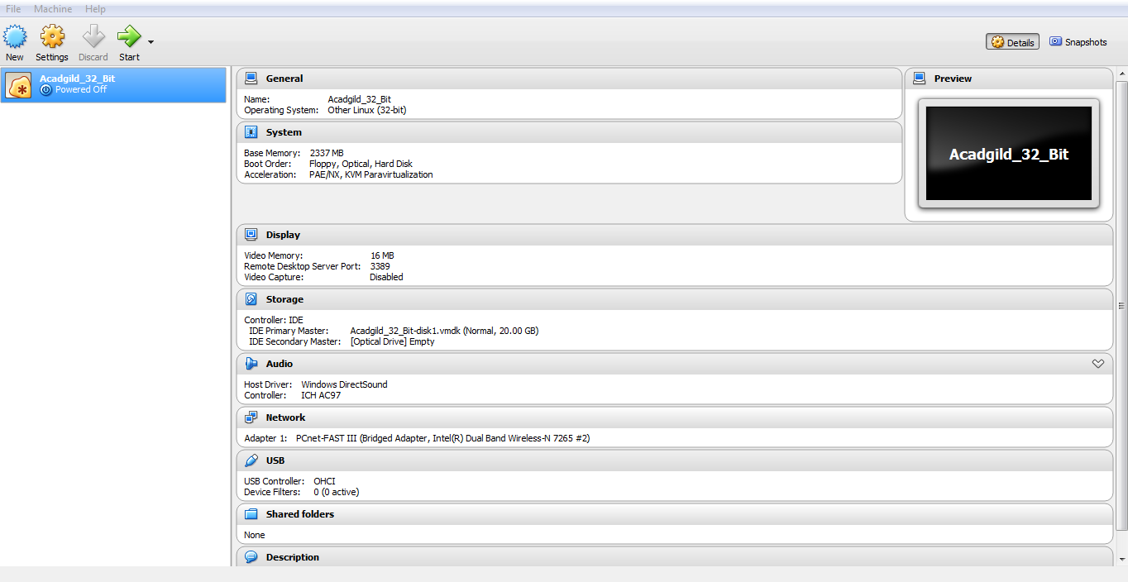

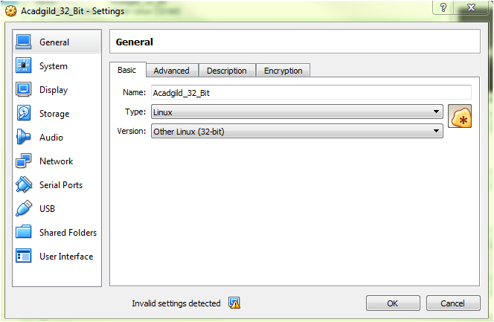

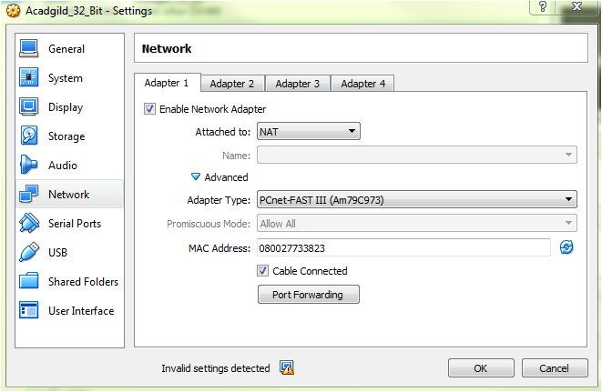

# Step3

Logged in as user ACADGILD,

We need to give the password as acadgild.

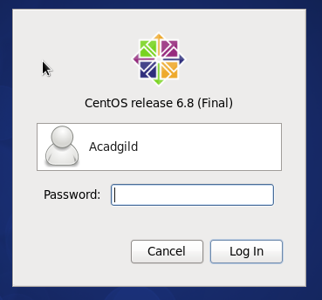

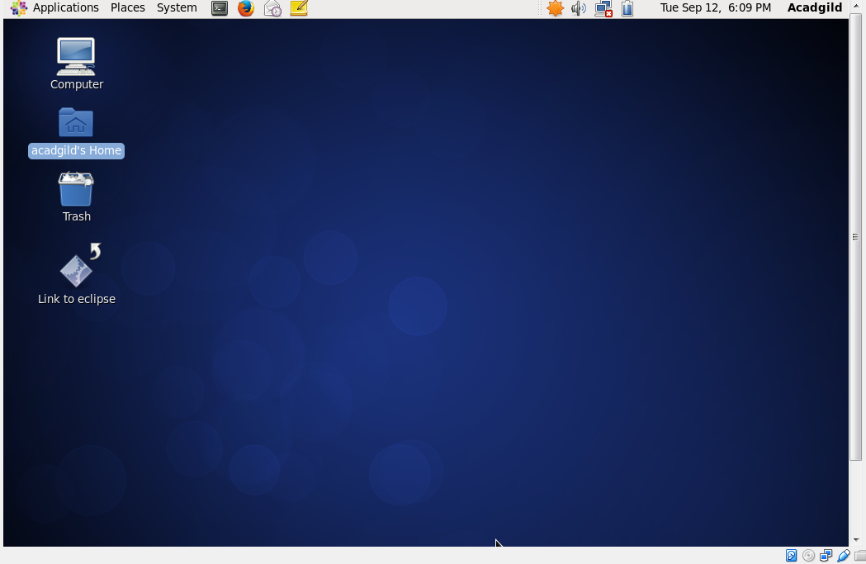

s

# Step4

Use the MobaXterm to type the commands in the linux shell, Open the terminal and type the command **jps** to check the list of daemons, we need to start all the daemons for the first time.



Starting Hadoop Daemons,

***Start-all.sh***

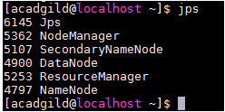

# Step5

Starting spark daemons Master, Workers.

Move into the sbin folder of spark installed directory (Here spark is installed in /home/acadgild/spark-2.2.0-bin-hadoop2.7/sbin.)

Starting Master:

Command: **./start-master.sh**

Starting Slaves:

Command: **./start-slaves.sh**

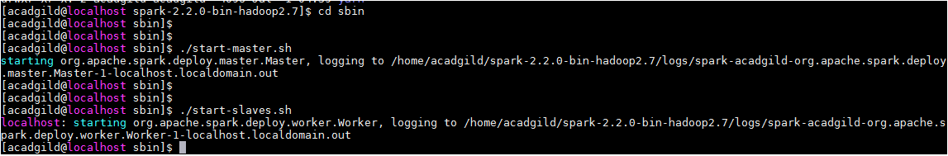

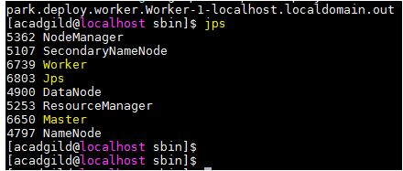

Now, the VM is ready for working in the Scala/spark shell.

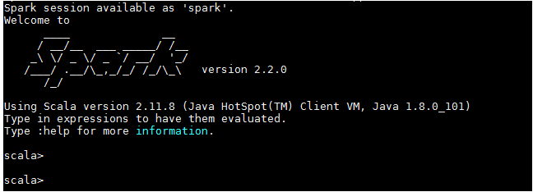

*************************End of Document*************************