**Session 15: SCALA - SESSION IV**

Assignment 15.1

Student Name: Abarajithan SA

Course: Big Data Hadoop & Spark Training

Start Date:  2017-09-09

End Date:  2017-11-26

**Assignment 15.1**–

Write a simple program in Scala to show Simple Inheritance and Multiple Inheritance.

Contents

Introduction 1

Problem Statement 1

Task 1 – Write a simple program to show inheritance in scala. 2

Output 2

Task 2 – Write a simple program to show multiple inheritance in scala. 3

Output 3

# Introduction

In this assignment, we are going to write a simple SCALA code to show Single Inheritance and Multiple inheritance in Scala.

# Problem Statement

1. Write a simple program to show inheritance in scala.
2. Write a simple program to show multiple inheritance in scala.

# Task 1 – Write a simple program to show inheritance in scala.

Inheritance is an object oriented concept which is used to reusability of code. You can achieve inheritance by using **extends** keyword. To achieve inheritance a class must extend to other class. A class which is extended called **super** or **parent** class. A class which extends class is called **derived** or **base** class.

Scala Code

**package** Assignment15_1  
  
**class** Superclass *// Super or parent class, going to be extended by base class*{  
 **val** *value1*:String = **"Assignment 15.1 example code"**}  
**class** baseclass **extends** Superclass{ *// base or derived class extends parent class* **val** *value2*:String = **"Scala Single Inheritance"** *println*(**"value1="**+ *value1*)  
 *println*(**"value2="**+ *value2*)  
}  
**object** Main{  
 **def** main(args: Array[String]): Unit={  
 **new** baseclass()  
 }  
}

## Output

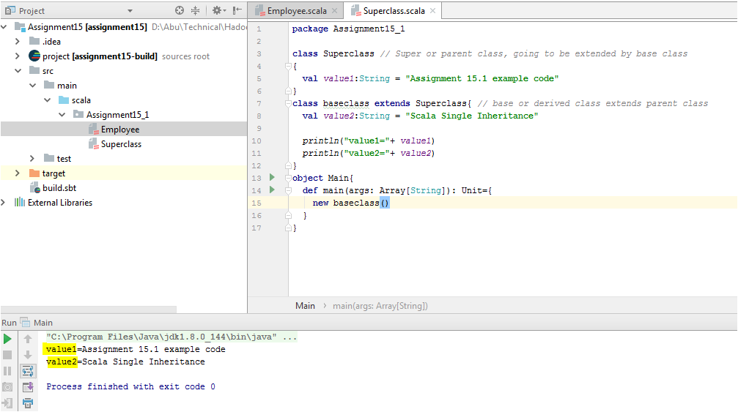

# Task 2 – Write a simple program to show multiple inheritance in scala.

Scala supports various types of inheritance including single, multilevel, **multiple**, and hybrid. You can use single, multilevel and hierarchal in your class. **Multiple** and **hybrid** can only be achieved by using **traits**.

Traits in Scala are best described as “**interfaces that can provide concrete members**.”

**package** Assignment15_1  
  
**trait** Base1 {  
 **def** print(){*println*(**"Multiple Inheritance in Scala is completed"**)}  
}  
**trait** A **extends** Base1{  
 **override def** print(){*println*(**"For Scala Inheritance"**);**super**.print()}  
}  
**trait** B **extends** Base1{  
 **override def** print(){*println*(**"Writing simple Scala programs"**);**super**.print()}  
}  
**class** Base2{  
 **def** print(){*println*(**"This line will not be printed"**)}  
}  
**class** C **extends** Base2 **with** A **with** B{  
 **override def** print(){*println*(**"This is Assignment 15.2"**);**super**.print()}  
}  
**object** MainObj **extends** App{  
 (**new** C).print()  
}

## Output

