**Session 16: INTRODUCTION TO APACHE SPARK**

Assignment 16.1

Student Name: Abarajithan SA

Course: Big Data Hadoop & Spark Training

Start Date:  2017-09-09

End Date:  2017-11-26

**Assignment 16.1**– Perform Apache Spark operations.

Contents

Introduction 1

Problem Statement 1

Task1 - Find the sum of all numbers 2

Task2 - find the total elements in the list 2

Task3 - calculate the average of the numbers in the list 2

Task4 - find the sum of all the even numbers in the list 2

Task5 - find the total number of elements in the list divisible by both 5 and 3. 2

# Introduction

In this assignment, we are going to perform some Spark RDD operation with the given problem statement.

# Problem Statement

1. Given a list of numbers - List[Int] (1, 2, 3, 4, 5, 6, 7, 8, 9, 10)

- find the sum of all numbers

- find the total elements in the list

- calculate the average of the numbers in the list

- find the sum of all the even numbers in the list

- find the total number of elements in the list divisible by both 5 and 3.

# Task1 - Find the sum of all numbers

RDD,

***val nums = sc.parallelize(List(1, 2, 3, 4, 5, 6, 7, 8, 9, 10))***

***val sum=nums.sum()***



# Task2 - find the total elements in the list

***val count = nums.count()***



# Task3 - calculate the average of the numbers in the list

***val average=nums.mean()***



# Task4 - find the sum of all the even numbers in the list

***val even=nums.filter(i=>(i%2==0))***



***val sum_even=even.sum()***



# Task5 - find the total number of elements in the list divisible by both 5 and 3.

***val divisible = nums.filter(i=>(i%3==0) || (i%5==0))***

***divisible.count()***

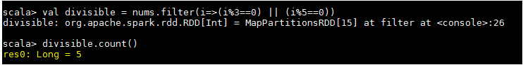

***divisible.collect()***



***divisible.foreach(println)***

