**Session 2: HDFS**

Assignment 2.1

Student Name: Abarajithan SA

Course: Big Data Hadoop & Spark Training

Start Date:  2017-09-09

End Date:  2017-11-26

**Assignment 2.1** –This assignment will help you to consolidate the concepts learnt in the session 2.

**Problem Statement:**

Task 1:

Check whether **/user/acadgild** directory exists or not in the HDFS.

If it doesn't exist, then create this.

Create a directory **/user/acadgild/hadoop.**

Task 2:

Create a file in HDFS under directory **/user/acadgild/hadoop**, with name **word-count.txt**.

Whatever we type on screen should get appended to the file.

Try to type (on screen) few lines from any online article or textbook.

Outputs:

Task 1:

Check whether **/user/acadgild** directory exists or not in the HDFS.

If it doesn't exist, then create this.

Create a directory **/user/acadgild/hadoop.**

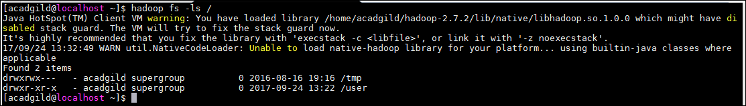

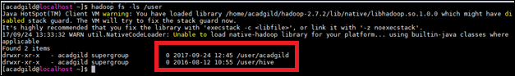

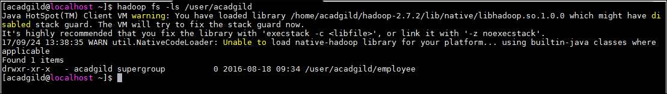

Creating a directory **hadoop** under /user/acadgild in the HDFS.

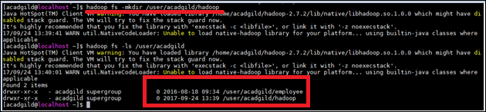

**Task 1 completed.**

Task 2:

Create a file in HDFS under directory **/user/acadgild/hadoop**, with name **word-count.txt**.

Whatever we type on screen should get appended to the file.

Try to type (on screen) few lines from any online article or textbook.

1. Command used to append in the text file **word-count.txt.**
2. **hadoop fs –appendToFile – hadoop/wordcount.txt**

Text appended to the file,

*“This is hadoop session, Pig introduction is going on.*

*Hadoop is an open source, Java-based programming framework that supports the processing and storage of extremely large data sets in a distributed computing environment. It is part of the Apache project sponsored by the Apache Software Foundation.* “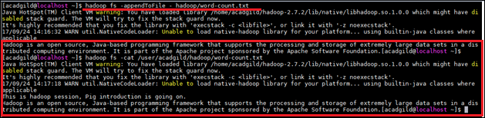

1. to read the appended text from the file,
2. **hadoop fs -cat /user/acadgild/hadoop/word-count.txt**

**Task 2 completed.**