**Session 1: HDFS**

Assignment 2.2

Student Name: Abarajithan SA

Course: Big Data Hadoop & Spark Training

Start Date:  2017-09-09

End Date:  2017-11-26

**Assignment 2.2** –This assignment will help you to consolidate the concepts learnt in the session 2.

**Problem Statement:**

Task: 3

Create a file max-temp.txt in local FS.

Put some 10-15 records of date and temperature example:

dd-mm-yyyy,temperature

Example:

10-01-1990,10

10-02-1991,20

Move this file to HDFS at /user/acadgild/hadoop.

Tasks: 4

Change the permission of the file /user/acadgild/hadoop/max-temp.txt, such that

Only the owner and the group members have full control over the file.

Others do not have any control over it.

Outputs:  
Task: 3

Create a file **max-temp.txt** in local FS.

Put some 10-15 records of date and temperature example:

dd-mm-yyyy,temperature

Example:

10-01-1990,10

10-02-1991,20

Move this file to HDFS at **/user/acadgild/hadoop.**

1. Creating a file **max-temp.txt** in local FS and the “dd-mm-yyyy,temperature” data has been put.

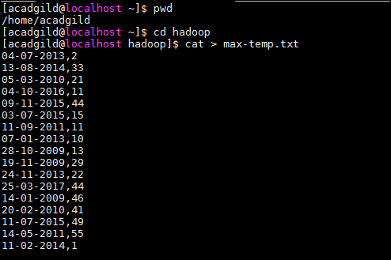

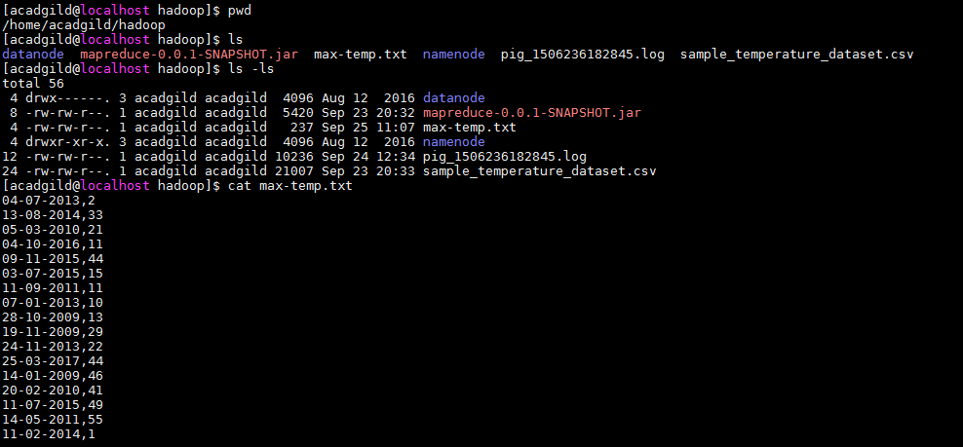

1. Moving this file to HDFS **/user/acadgild/hadoop.**

**Cmd: hadoop fs -put max-temp.txt /user/acadgild/hadoop**

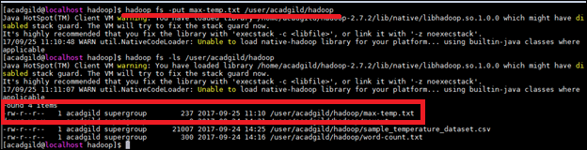

**Task 3 is completed**

Tasks: 4

Change the permission of the file **/user/acadgild/hadoop/max-temp.txt**, such that

Only the owner and the group members have full control over the file.

Others do not have any control over it.

[acadgild@localhost hadoop]$ **hadoop fs -ls /user/acadgild/hadoop**

Found 4 items

-rw-r--r-- 1 acadgild supergroup 237 2017-09-25 11:10 /user/acadgild/hadoop/max-temp.txt

User – acadgild

Group - supergroup

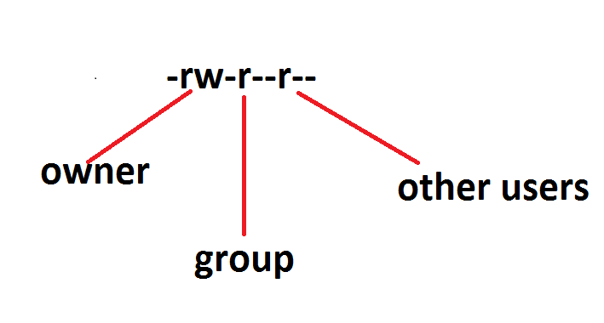

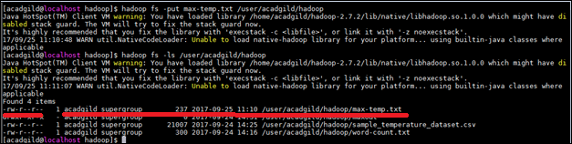

Providingonly the owner and the group members have full control over the file,

**Cmd: hadoop fs -chmod o+rx /user/acadgild/hadoop/max-temp.txt**

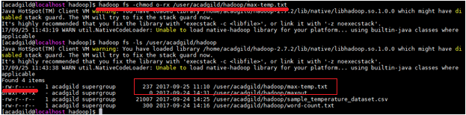

**Task 4 is completed**