**Session 4: SCHEDULERS IN YARN & INTRODUCTION TO PIG**

Assignment 4.3

Student Name: Abarajithan SA

Course: Big Data Hadoop & Spark Training

Start Date:  2017-09-09

End Date:  2017-11-26

**Assignment 4.3** – Write a program to implement wordcount using Pig.

Share the screenshots of the commands used with its associated output.

Contents

Problem Statement 2

Introduction 2

Input Texts 2

PIG Commands – Word Count Example 2

1. Load the data from HDFS 2

2. Convert the Sentence into words and Convert Column into Rows 2

3. Apply GROUP BY 3

4. Generate Word Count 4

Expected Output 5

Complete PIG Code 5

# Problem Statement

Write a program to implement word count using Pig. Share the screenshots of the commands used with its associated output.

# Introduction

In this assignment we are going to write **word count** program using Pig Latin.

# Input Texts

We have the below words in the text file wordcountpig.txt which is placed at /home/acadgild/hadoop.

***“Write a program to implement wordcount using Pig. Share the screenshots of the commands used with its associated output.***

***Here we will write a simple pig script for the word count program.”***

# PIG Commands – Word Count Example

## Load the data from HDFS

**“Word_Count = LOAD '/home/acadgild/hadoop/wordcountpig.txt' USING PigStorage(',') AS (line:chararray);”**



## Convert the Sentence into words and Convert Column into Rows

**“Convert_Words = FOREACH Word_Count GENERATE FLATTEN(TOKENIZE(line,' ')) AS word;”**



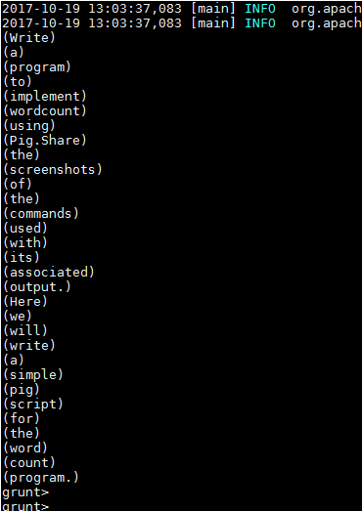

## Apply GROUP BY

**“Grouped = GROUP Convert_Words BY word;”**



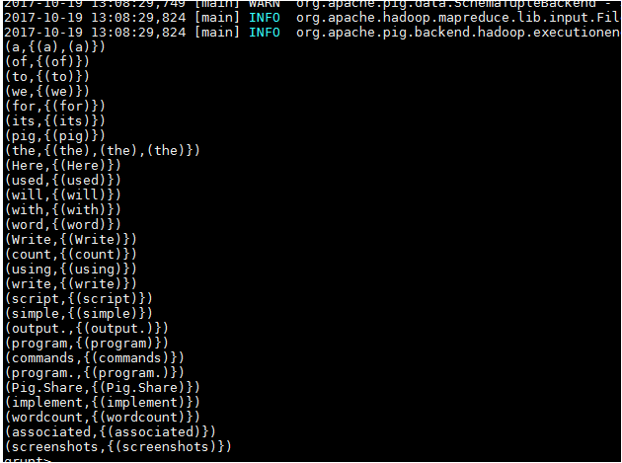

## Generate Word Count

**“wordcountpig = FOREACH Grouped GENERATE group, COUNT(Convert_Words);**

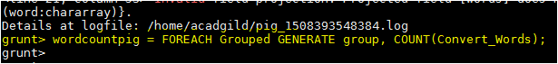

## Expected Output

**DUMP wordcountpig;**

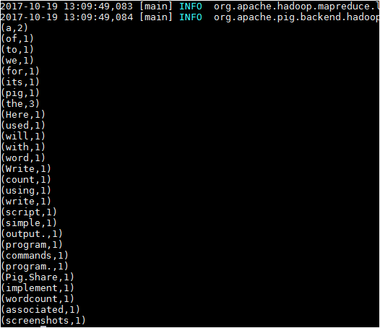

### Complete PIG Code

**Word_Count = LOAD '/home/acadgild/hadoop/wordcountpig.txt' USING PigStorage(',') AS (line:chararray);**

**Convert_Words = FOREACH Word_Count GENERATE FLATTEN(TOKENIZE(line,' ')) AS word;**

**Grouped = GROUP Convert_Words BY word;**

**wordcountpig = FOREACH Grouped GENERATE group, COUNT(Convert_Words);**

**DUMP wordcountpig;**

**xxxxxx--------------------COMPLETED------------------xxxxxx**