**Session 6: HIVE Introduction**

Assignment 6.2

Student Name: Abarajithan SA

Course: Big Data Hadoop & Spark Training

Start Date:  2017-09-09

End Date:  2017-11-26

**Assignment 6.1**– Write HIVE commands to achieve the tasks provided in the problem statement.

Contents

Introduction 2

Input Data set 2

Problem Statement 2

Prerequisite 2

Task1 4

HIVE Commands 4

Output 4

Task2 4

HIVE Commands 4

Output 4

TASK 3 5

HIVE Commands 5

Output 5

TASK 4 5

HIVE Commands 5

Output 5

TASK 5 6

HIVE Commands 6

Output 6

# Introduction

In this assignment we are going to perform the below tasks using HIVE commands.

# Input Data set

<https://drive.google.com/file/d/0Bxr27gVaXO5sa0JBamZXdkpYUFk/view?usp=sharing>

# Problem Statement

1. Fetch date and temperature from temperature_data where zip HIVE Commands is greater than 300000 and less than 399999.
2. Calculate maximum temperature corresponding to every year from temperature_data table.
3. Calculate maximum temperature from temperature_data table corresponding to those years which have at least 2 entries in the table.
4. Create a view on the top of last query, name it temperature_data_vw.
5. Export contents from temperature_data_vw to a file in local file system, such that each file is '|' delimited.

# Prerequisite

1. Create a DATABASE **“custom”** and create a TABLE “**temperature_data”** inside **custom** having below fields:

**date (mm-dd-yyyy) format**

**zip code**

**temperature**

As part of the Assignment 6.1 we had created the Database as per the above,

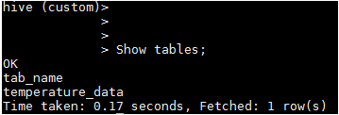

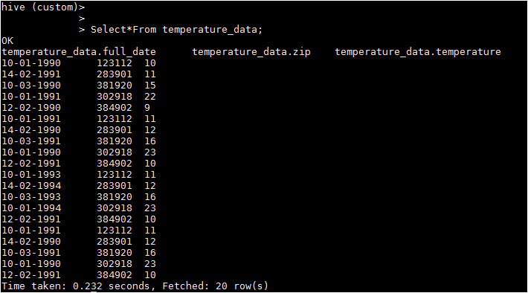

Hence we are going to perform the task provided for this assignment.

# Task1

Fetch date and temperature from **temperature_data** where **zip** is greater than 300000 and less than 399999.

### HIVE Commands

***hive (custom) >Select * From temperature_data where zip BETWEEN 300000 AND 399999;***

### Output

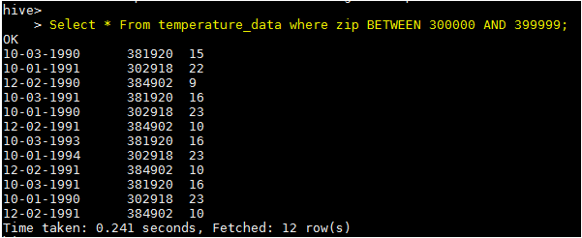

# Task2

Calculate maximum temperature corresponding to every year from **temperature_data** table.

### HIVE Commands

***hive (custom) > SELECT SUBSTRING(full_date,7,4), MAX(temperature) FROM custom.temperature_data GROUP BY SUBSTRING(full_date,7,4);***



### Output

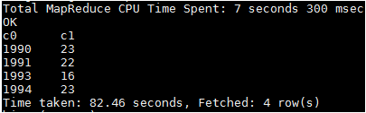

# TASK 3

Calculate maximum temperature from **temperature_data** table corresponding to those years which have at least **2** entries in the table.

### HIVE Commands

***hive(custom)>SELECT full_date, MAX(t1.temperature) as temperature FROM (SELECT SUBSTRING(full_date,7,4) full_date, temperature FROM temperature_data)t1 GROUP BY full_date HAVING count(t1.full_date)>=2;***



### Output

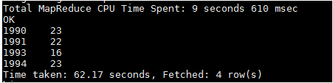

# TASK 4

Create a view on the top of last query, name it **temperature_data_vw.**

### HIVE Commands

***CREATE VIEW temperature_data_vw AS SELECT full_date, MAX(t1.temperature) as temperature FROM (SELECT SUBSTRING(full_date,7,4) full_date, temperature FROM temperature_data)t1 GROUP BY full_date HAVING count(t1.full_date)>=2;***





### Output

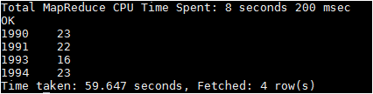

# TASK 5

Export contents from **temperature_data_vw** to a file in local file system, such that each file is '|' delimited.

### HIVE Commands

***INSERT OVERWRITE LOCAL DIRECTORY '/home/acadgild/hadoop/temperature_data_vw.txt' ROW FORMAT DELIMITED FIELDS TERMINATED BY '|' SELECT * FROM temperature_data_vw;***



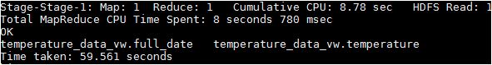

### Output

***cat /home/acadgild/hadoop/temperature_data_vw.txt/\****

