**Session 6: HIVE Operations**

Assignment 7.1

Student Name: Abarajithan SA

Course: Big Data Hadoop & Spark Training

Start Date:  2017-09-09

End Date:  2017-11-26

**Assignment 7.1**– Calculate the number of employees corresponding to each skill from the table 'employee' which is loaded in the Demo.

Contents

Introduction 2

Associated Data files 2

Problem Statement 2

HIVE Queries 2

Task 4

HIVE Query 4

Expected Output 4

# Introduction

In this assignment, I’m going to create a table called **‘emp_details’** with a table name called **‘employee’** which contains the columns name, technology, nos and the location. The given dataset file will be loaded in to the database ‘**emp_details’** into the table employee.

The given dataset file is placed at **home/acadgild/hadoop.**

# Associated Data files

<https://drive.google.com/file/d/0Bxr27gVaXO5sQWV4UUpOXzNuZDA/view?usp=sharing>

# Problem Statement

Calculate the number of employees corresponding to each skill from the table 'employee' which is loaded in the Demo.

# HIVE Queries

1. ***CREATE DATABASE emp_details;***
2. ***USE emp_details;***
3. ***CREATE TABLE employee***

***(name STRING,***

***technology STRING,***

***nos INT,***

***location STRING)***

***ROW FORMAT DELIMITED***

***FIELDS TERMINATED BY ',';***

***LOAD DATA LOCAL INPATH '/home/acadgild/hadoop/emp_details.txt'***

***INTO TABLE emp_details.employee;***

1. Creating a Database named **emp_details**

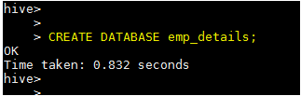

1. Create a Table **employee** with the columns **name**, **technology** and **location** as STRING type and **nos** as integer type. We are taking the input data from the location '/home/acadgild/hadoop/emp_details.txt'

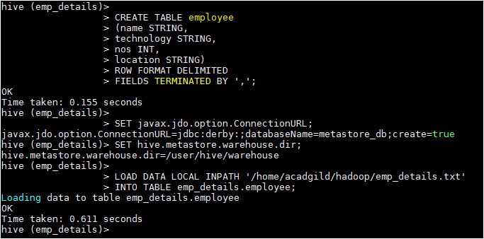

1. Data in the table **employee**

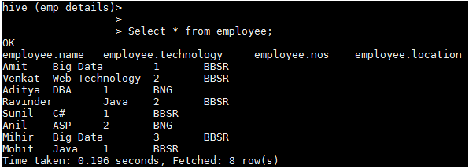

# Task

Now, calculate the number of employees corresponding to each skill from the table **'employee'**

## HIVE Query

***Select technology, SUM(t1.nos) as No_Of_Employee FROM(Select technology, nos FROM employee) t1 GROUP BY technology;***



# Expected Output

