Lahore Garrison University
DHA Phase 6 Lahore



Student Name | Abu Bakar
Student Roll No | Fa23/BSCS/272
Section | G
Subject | Web Technologies
Instructor Name | Mr. M Yousaf

1. Demonstrating an XSS Payload on an Insecure Page

1.1 Vulnerable HTML Page:
<!DOCTYPE html>

<html>

<head>

<title>XSS Demo - Insecure</title>

</head>

<body>

<h2>Insecure Comment Box</h2>

<form id="commentForm">

<input type="text" id="commentInput" placeholder="Type something..." />

<button type="submit">Post</button>

</form>

<div id="comments"></div>

<script>

document.getElementById('commentForm').addEventListener('submit', function(e) {

e.preventDefault();

const input = document.getElementById('commentInput').value;

document.getElementById('comments').innerHTML += "<p>" + input + "</p>";

});

</script>

</body>

</html>

Output:
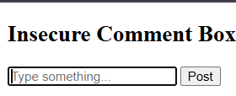
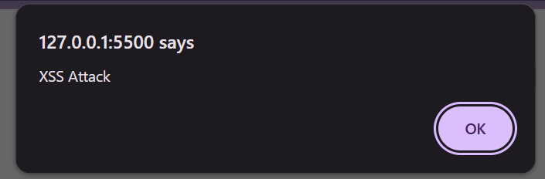

- Implementing Input Sanitization With DOMPurify:
<!DOCTYPE html>
<html>
<head>
<title>XSS Prevention - Secure</title>
<!-- Include DOMPurify CDN -->
<script src="https://cdn.jsdelivr.net/npm/dompurify@3.0.0/dist/purify.min.js"></script>
</head>
<body>
<h2>Secure Comment Box</h2>
<form id="commentForm">
<input type="text" id="commentInput" placeholder="Type something..." />
<button type="submit">Post</button>
</form>
<div id="comments"></div>
<script>
document.getElementById('commentForm').addEventListener('submit', function(e) {
e.preventDefault();
const input = document.getElementById('commentInput').value;
const clean = DOMPurify.sanitize(input);
const p = document.createElement('p');
p.textContent = clean;
document.getElementById('comments').appendChild(p);
});
</script>
</body>
</html>

Output:
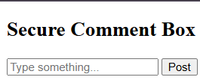

3. CSRF Protection — Explanation & Token Mockup
3.1 What is CSRF?
Cross-Site Request Forgery (CSRF) forces a user to take unwanted actions on a site where they are authenticated (e.g., changing password, posting something).
Attackers exploit:
Browser auto-sending cookies (session cookies)
Malicious hidden forms or requests
3.2 CSRF Token Concept:
A CSRF token is a secret, random value generated by the server and included in forms.
The server verifies the token on form submission.
3.3 Frontend Example Including Token:
<!DOCTYPE html>
<html lang="en">
<head>
<meta charset="UTF-8">
<meta name="viewport" content="width=device-width, initial-scale=1.0">
<title>Document</title>
</head>
<body>
<form id="secureForm">
<input type="hidden" id="csrfToken" value="mock-random-token-12345">
<input type="text" id="comment" />
<button>Post</button>
</form>
<script>
document.getElementById("secureForm").addEventListener("submit", e => {
e.preventDefault();
const token = document.getElementById("csrfToken").value;
console.log("Sending with CSRF token:", token);
// Example simulated server check
if (token !== "mock-random-token-12345") {
alert("CSRF token invalid!");
} else {
alert("Form submitted securely!");
}
});
</script>
</body>
</html>
Output:
