Complete Milestones Report

Project Information
Project Title: Smart Daily Activity Tracker (Namaz, Study & Skills)
Course: Database Systems Lab
Instructor: Ali Hassan
Team Member: Abu Bakar Sadiq And Muhammad Ilyas
Technology Stack: PHP, MySQL, HTML, CSS, JavaScript

Milestone 1

1. Introduction
The Smart Daily Activity Tracker is a web-based system designed to help students track their daily prayers, study activities, and skill development progress. Its an Digital Register that keeps student Nimaz ,Study and Skill Record.

2. Entity Relationship Diagram (ERD)

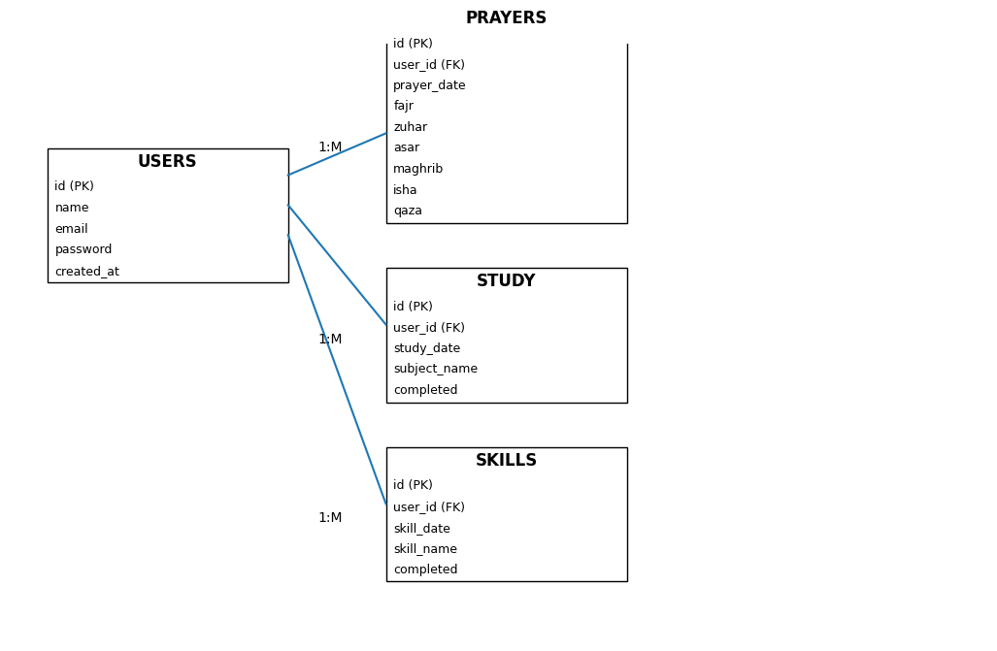

3. Relational Database Schema

USERS Table
Attribute | Data Type | Constraint
id | INT | Primary Key
name | VARCHAR(100) | NOT NULL
email | VARCHAR(150) | UNIQUE
password | VARCHAR(255) | NOT NULL
created_at | TIMESTAMP | DEFAULT CURRENT_TIMESTAMP

PRAYERS Table
Attribute | Data Type | Constraint
id | INT | Primary Key
user_id | INT | Foreign Key
prayer_date | DATE | NOT NULL
fajr | TINYINT(1) | DEFAULT 0
zuhar | TINYINT(1) | DEFAULT 0
asar | TINYINT(1) | DEFAULT 0
maghrib | TINYINT(1) | DEFAULT 0
isha | TINYINT(1) | DEFAULT 0
qaza | TINYINT(1) | DEFAULT 0

STUDY Table
Attribute | Data Type | Constraint
id | INT | Primary Key
user_id | INT | Foreign Key
study_date | DATE | NOT NULL
subject_name | VARCHAR(255) | NOT NULL
completed | TINYINT(1) | DEFAULT 0

SKILLS Table
Attribute | Data Type | Constraint
id | INT | Primary Key
user_id | INT | Foreign Key
skill_date | DATE | NOT NULL
skill_name | VARCHAR(255) | NOT NULL
completed | TINYINT(1) | DEFAULT 0

4. Relationships
A one-to-many relationship exists between the USERS table and the PRAYERS, STUDY, and SKILLS tables. Each user can have multiple records in these tables.

Milestone 2 — ERD Design & Normalization

Normalization

1NF (First Normal Form):
Justification: The initial schema was designed with 1NF in mind. Every attribute holds atomic, single values. We avoided using multi-valued columns or comma-separated lists. For example, instead of storing multiple skills in a single skills column under the Users table, we created a dedicated Skills table where each skill gets its own distinct row. Similarly, daily prayers are separated into individual boolean columns (fajr, zuhar, etc.) rather than an array. No changes were needed to achieve 1NF.

2NF
Justification: For a table to violate 2NF, it must have a composite primary key and partial dependencies. In our schema, all tables (Users, Prayers, Study, Skills) utilize a single-column, auto-incrementing id as their primary key. Because there are no composite keys, every non-key attribute is fully dependent on the entire primary key by default. Therefore, the schema naturally satisfies 2NF without requiring structural changes.

3NF
Justification: We evaluated all non-key attributes across the schema to ensure they depend only on the primary key and not on any other non-key attributes (transitive dependency). For instance, in the Study table, subject_name and completed status depend solely on the specific study session's id, not on the user_id or study_date. Because all attributes relate directly to the primary key of their respective tables, no transitive dependencies exist. No changes were necessary.
Remove Duplicates
We reviewed all tables for redundant columns and repeated data. The schema correctly uses user_id as a foreign key across the Prayers, Study, and Skills tables to prevent duplicating user information (like name and email) in every daily log. No overlapping attributes were found.

Milestone 3 — Dataset Preprocessing
Prepare Your Dataset
Because this project tracks personal daily habits, we used synthetic data to populate the database.
Dataflow
The Smart Daily Activity Tracker system manages user productivity data through a structured dataflow process involving input, processing, storage, and output stages.
Data Input : Data enters the system through interactive frontend forms developed using HTML, CSS, and JavaScript. Registered users provide input by:
• Marking completed daily prayers
• Logging completed study subjects
• Tracking skill development progress
• Creating accounts and logging into the system

Processing:
The backend is developed using PHP. When users submit forms, PHP scripts validate the input data, manage user sessions, and execute SQL queries. The system uses INSERT, UPDATE, and SELECT operations to interact with the MySQL database securely using prepared statements.
Processed data is stored in relational database tables including:
• users
• prayers
• study
• skills
Relationships between tables are maintained using primary keys and foreign keys. Each activity record is associated with a specific user through.

Milestone 4 — Database Setup (DDL)
CREATE DATABASE activity_tracker_db;
USE activity_tracker_db;
-- USERS TABLE
CREATE TABLE users (
id INT AUTO_INCREMENT PRIMARY KEY,
name VARCHAR(100) NOT NULL,
email VARCHAR(150) NOT NULL UNIQUE,
password VARCHAR(255) NOT NULL,
created_at TIMESTAMP DEFAULT CURRENT_TIMESTAMP
);
-- PRAYERS TABLE
CREATE TABLE prayers (
id INT AUTO_INCREMENT PRIMARY KEY,
user_id INT NOT NULL,
prayer_date DATE NOT NULL,
fajr TINYINT(1) DEFAULT 0 CHECK (fajr IN (0,1)),
zuhar TINYINT(1) DEFAULT 0 CHECK (zuhar IN (0,1)),
asar TINYINT(1) DEFAULT 0 CHECK (asar IN (0,1)),
maghrib TINYINT(1) DEFAULT 0 CHECK (maghrib IN (0,1)),
isha TINYINT(1) DEFAULT 0 CHECK (isha IN (0,1)),
qaza TINYINT(1) DEFAULT 0 CHECK (qaza IN (0,1)),
created_at TIMESTAMP DEFAULT CURRENT_TIMESTAMP,
CONSTRAINT fk_prayers_user
FOREIGN KEY (user_id)
REFERENCES users(id)
ON DELETE CASCADE
);
-- STUDY TABLE
CREATE TABLE study (
id INT AUTO_INCREMENT PRIMARY KEY,
user_id INT NOT NULL,
study_date DATE NOT NULL,
subject_name VARCHAR(255) NOT NULL,
completed TINYINT(1) DEFAULT 0 CHECK (completed IN (0,1)),
created_at TIMESTAMP DEFAULT CURRENT_TIMESTAMP,
CONSTRAINT fk_study_user
FOREIGN KEY (user_id)
REFERENCES users(id)
ON DELETE CASCADE
)
- SKILLS TABLE
CREATE TABLE skills (
id INT AUTO_INCREMENT PRIMARY KEY,
user_id INT NOT NULL,
skill_date DATE NOT NULL,
skill_name VARCHAR(255) NOT NULL,
completed TINYINT(1) DEFAULT 0 CHECK (completed IN (0,1)),
created_at TIMESTAMP DEFAULT CURRENT_TIMESTAMP,
CONSTRAINT fk_skills_user
FOREIGN KEY (user_id)
REFERENCES users(id)
ON DELETE CASCADE
);
-- INDEXES
CREATE INDEX idx_prayers_user_id
ON prayers(user_id);
CREATE INDEX idx_study_user_id
ON study(user_id);
CREATE INDEX idx_skills_user_id
ON skills(user_id);
CREATE INDEX idx_prayer_date
ON prayers(prayer_date);
CREATE INDEX idx_study_date
ON study(study_date);
CREATE INDEX idx_skill_date
ON skills(skill_date);
Milestone 5 — Data Population (DML)
This milestone focuses on populating the Smart Daily Activity Tracker database using DML operations including INSERT, UPDATE, DELETE, and validation queries.
1. INSERT Queries
USE activity_tracker_db;
INSERT INTO users (name, email, password)
VALUES
('Ali', 'ali@gmail.com', 'hashed_password_1'),
('Ahmad', 'ahmad@gmail.com', 'hashed_password_2'),
('Usman', 'usman@gmail.com', 'hashed_password_3');
INSERT INTO prayers
(user_id, prayer_date, fajr, zuhar, asar, maghrib, isha, qaza)
VALUES
(1, '2026-04-01', 1,1,1,1,1,0),
(1, '2026-04-02', 1,1,0,1,1,0),
(2, '2026-04-01', 1,0,1,1,1,0);
INSERT INTO study
(user_id, study_date, subject_name, completed)
VALUES
(1, '2026-04-01', 'Database Systems', 1),
(1, '2026-04-01', 'Artificial Intelligence', 1),
(2, '2026-04-01', 'Software Engineering', 0);
INSERT INTO skills
(user_id, skill_date, skill_name, completed)
VALUES
(1, '2026-04-01', 'Python', 1),
(1, '2026-04-02', 'SQL', 1),
(2, '2026-04-01', 'Machine Learning', 0);
2. UPDATE Query
UPDATE study
SET completed = 1
WHERE id = 3;
3. DELETE Query
DELETE FROM skills
WHERE id = 3;
4. Validation Queries
SELECT COUNT(*) AS total_users FROM users;
SELECT COUNT(*) AS total_prayers FROM prayers;
SELECT COUNT(*) AS total_study FROM study;
SELECT COUNT(*) AS total_skills FROM skills;
SELECT *
FROM users
WHERE email IS NULL;
SELECT *
FROM prayers
WHERE prayer_date IS NULL;
SELECT
users.name,
prayers.prayer_date,
prayers.fajr,
prayers.isha
FROM users
JOIN prayers
ON users.id = prayers.user_id;
5. Explanation
The INSERT queries populate the database with synthetic records. The UPDATE query modifies an existing study record, while the DELETE query removes a skill record. Validation queries are used to verify row counts, NULL constraints, and foreign key relationships.

