Data-Driven Smart Traffic Management System Overview and Analysis

Student Name: Abu Bakar Amjad
Student ID: CC3672431

A dissertation submitted in partial fulfilment of the requirements of Leeds Beckett University for the degree of BA (Hons) / MA / MSc XXXXXX

Collaborating Establishment (if any)

Month and Year of Submission
May 2026

Abstract
This project presents the design, implementation and evaluation of a data-driven smart traffic management system using publicly available traffic data. The main aim of the project is to determine whether a rule-based signal control system based on real-world data could be effective in improving the management of traffic flow compared to a traditional fixed-timing system. The system was developed using Python, with the Pandas library used to manage, clean and analyse data, while Power BI was included to create a visual interactive dashboard to display patterns and outcomes of the various systems. A rule-based algorithm was implemented to dynamically set signal timings based on key variables, including traffic volume, time of day, and directional flow. Three systems were developed: a fixed-time system acting as a baseline, a basic smart traffic system and an enhanced smart traffic system incorporating additional features. The performances of these systems were evaluated using a delay metric. These systems were then compared between each other to compare the practicality of each system. These results showed that the advanced smart system and the basic smart system were substantially more practical at managing traffic compared to the basic fixed-time system. These findings highlight the effectiveness of data-driven traffic management in improving efficiency without the need for expensive and complex hardware or advanced machine learning techniques. Overall, the project demonstrates a significant improvement in urban traffic control, providing a strong foundation for future research and real world implementation.

Student’s Declaration
Students must declare that the dissertation is their own work.

Signature Abu Bakar
Student’s Full Name ABU BAKAR AMJAD
Acknowledgements
Firstly, I would like to thank ALLAH for giving me health and allowing me to complete this project to its fullest, while guiding me and blessing me through every hardship along the way. I believe that God made this possible and allowed me to see the day I finish my studies and move onto a next chapter in my life.
Secondly, I would like to thank my supervisor, Ms. Mohid Maktuba, for her patience and perseverance in pushing me to achieve the best in this project and guiding me through every step, while ensuring I managed my time appropriately and put the work in.
I would also like to thank my family and friends for supporting me through what I believe is the biggest assignment of my life, whether they did It unknowingly or knowingly, they were always there for me when I needed someone to talk to, or whenever I needed any advice on what to do and how to get it done and allowed me to get to this point with their unwavering help and support.

Table of Contents
List of Figures i
Chapter One: Introduction 1
1.1 Background 1
1.1.1 Traditional traffic management systems 1
1.1.2 The solution 1
1.2 Rationale 1
1.3 Research aim and objectives 2
1.4 Structure of the Report 2
Chapter Two: Literature Review 3
2.1 Introduction 3
2.2 Traditional and Smart Traffic Management Systems 3
2.3 Data-Driven Traffic Management 3
2.4 Smart Cities and IoT-Based Traffic systems 4
2.5 Alternative Approaches to Traffic Management 4
2.6 Summary 5
Chapter Three: Review of Technologies 6
3.1 Introduction 6
3.2 Python for Data Analysis and Implementation 6
3.3 Data Processing Using Pandas 7
3.4 Data Visualisation Using Power BI 7
3.5 Publicly Available Traffic Data 8
3.6 Simulation Software (Not Used) 8
3.7 Hardware-Based Traffic System (Not Used) 8
3.9 Summary and Key findings 9
Chapter Four: Methodology 9
4.1 Introduction 9
4.2 Development Methodology 9
4.2.1 Key stages of Development 10
4.3 Why Agile Methodology was selected 11
4.4 Alternative Methodology: The Waterfall Method (Not used) 11
4.5 Alternative Methodology: The Spiral Model (Not Used) 12
4.6 Design of the Rule-Based System 12
4.7 Design Techniques Used 13
4.8 Alternative Design Approach (Not Used) 13
4.9 Product requirements 14
4.10 Summary 14
Chapter Four: Results and Discussion 14
4.1 Introduction 14
4.2 System implementation stages 14
4.2.1 Data gathering and preprocessing 15
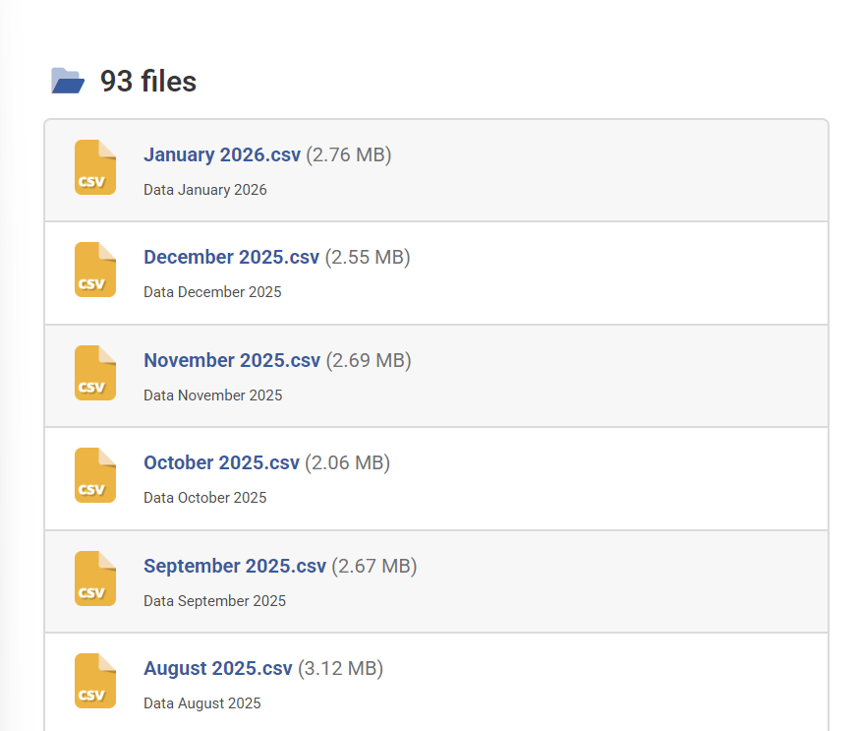 15
4.2.2 Fixed-timing system implementation 18
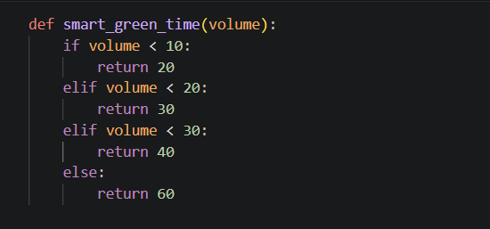 19
4.2.3 Enhanced Smart System Implementation 20
4.2.4 Delay Scores 22
4.2.5 Visualisation Dashboard 24
4.3 Testing methodology 24
4.4 Discussion of Implementation 25
4.5 Summary 25
Chapter Five: Product Evaluation 25
5.1 Introduction 25
5.2 Evaluation Against the Project Aim 25
5.3 Evaluation Against Objectives 26
5.4 Analysis of Results 26
5.5 Limitations of the System 27
7.1 Evaluation of Project Management Approach 27
7.2 Challenges Encountered 27
7.3 Successes of the Project 28
7.4 Areas for Improvement 28
Chapter Seven: Conclusion 29
References 30
Appendix I GAI statement 31
Appendix II Ethics application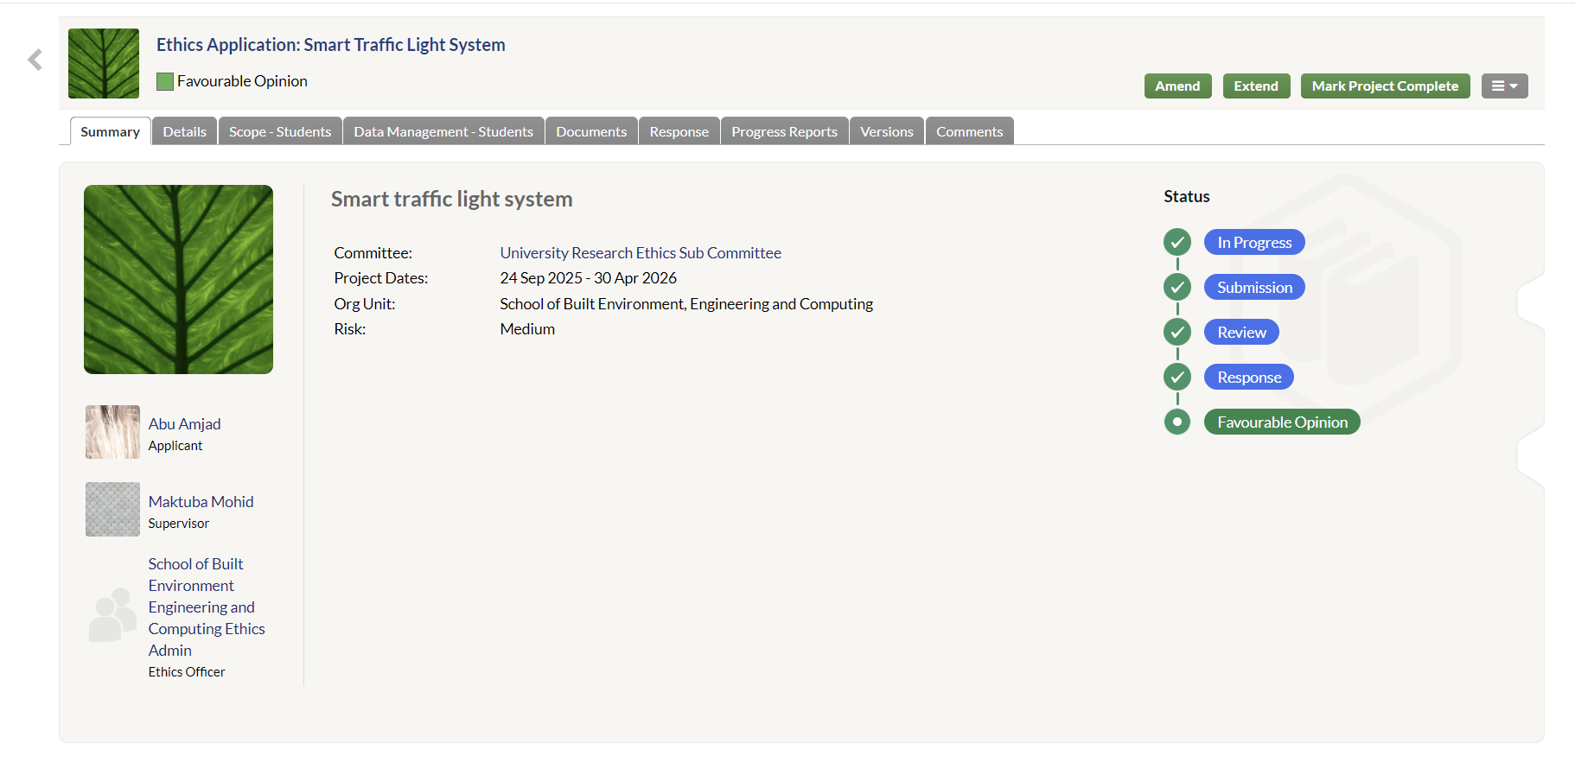 32

List of Figures
Figure 2.1 Title of figure 2

Chapter One: Introduction

Background
Traffic congestion is a persistent issue in modern society, affecting developing cities all around the world. The increase of population, urbanisation and vehicular ownership have resulted in heavy traffic flow and therefore increased congestion. Consequently, road networks often experience traffic jams, especially during peak hours, for example during school opening times, leading to increased travel times, fuel consumption and environmental pollution. These effects not only impact commuters but also have a big number of economic and environmental implications.

1.1.1 Traditional traffic management systems
Traditional traffic management systems usually rely on fixed signal timings, where traffic lights operate for a certain amount of time that has been predetermined disregarding real-time traffic conditions changing. While these systems are easy to implement and maintain they lack flexibility and will often result in inefficient traffic flow. For example, a fixed traffic system may assign equal green light durations even when one direction is experiencing higher volumes of traffic leading to unnecessary delays and congestions, especially during peak periods where there is an elevated number of vehicles on the roads.

1.1.2 The solution
In response to the above limitations presented by fixed systems, smart traffic management systems have appeared as a promising solution. These systems aim to dynamically adjust signal duration times based on real-time data-driven conditions, allowing for more efficient traffic control. Advanced data analysis and computing technologies have made it possible for publicly available traffic data to be used to develop, simulate and evaluate such intelligent traffic management methods.

1.2 Rationale
The reason for the development of this project is based on the increasing need for cost-effective and flexible solutions to traffic congestions. While many existing smart traffic systems rely on hardware components such as sensors and cameras, these variants can be expensive to develop, implement and maintain. However, a data-driven approach allows for intelligent traffic management systems to be developed using existing reliable datasets, rendering it more accessible and practical.

This project explores the potential of using public traffic data to develop a simulation of a smart traffic control system. By making note of patterns such as traffic volume, time of day and direction of travel, it is possible to make guided decisions about the timings of traffic signals. This approach follows the wider trend of data-driven decision making in modern computing, where breakthroughs are developed from data. Furthermore, this project also gives an opportunity to highlight the importance of using technology to improve efficiency and sustainability in urban settings, while also presenting an opportunity to apply computing skills like data analysis and programming to address an existing problem in today’s society.

1.3 Research aim and objectives
The aim of this project is to create and analyse a data-driven smart traffic management system developed using publicly available traffic data.
To achieve this aim, various objectives have been set and ensured to have been met:
- To collect and analyse an accurate real-world traffic dataset to identify traffic patterns and trends like peak hours and distribution.
- To develop and implement a fixed-time traffic management system to act as a starting baseline for comparison.
- To design and implement a smart traffic management system adjusting green light timings based on traffic conditions.
- To further develop an enhanced version of the system incorporating additional factors such as time of day and direction of the flow of traffic.
- To compare performances of the smart system against the initial fixed-time system using a delay metric.
- To evaluate the effectiveness of the smart system to improve traffic flow and lower environmental harm.
- Finally, present the results using graphs and a Power BI dashboard to visualise the changes.

1.4 Structure of the Report
This report is structured into various chapters, each addressing the different phases of development and key aspects of the project. The first chapter is an introduction to the overall project including the aims and objectives and reasoning for the project. Chapter Two presents a literature review of research carried out relating to smart traffic management systems and approaches that are data driven. Chapter Three reviews the several technologies and tools used for this project and evaluates the use of alternatives if there are any. Chapter Four discusses the methodology and the chosen approach to designing and developing the project. Chapter Five will describe the implementation of the system and its tests to ensure it is in fully working order, while also providing evidence of the findings alongside results of the evaluation of the systems. Finally, Chapter Six concludes the report by summarising the findings and identifying potential areas of improvement for any future research.

Chapter Two: Literature Review

2.1 Introduction
Traffic congestion is a critical issue in modern society, causing increased travel times, contributing to increased fuel consumption and environmental pollution. As cities advance in aspects of technology and vehicle usage becomes increasingly common, traditional traffic management systems are becoming obsolete to higher traffic demands. Because of this, significant research has been conducted into the possible development of intelligent traffic management options. This chapter reviews the research and usage of existing literature on fixed-timing and smart traffic systems, data driven approaches and alternative techniques to manage traffic, to then evaluate the findings and establish a relevance to the system developed in this project.

2.2 Traditional and Smart Traffic Management Systems
Traditional traffic management systems usually set a fixed timing, where green traffic lights operate based on predetermined schedules. While being simple to implement, these systems are static and lack flexibility to adapt to changing traffic conditions. Studies have shown that these fixed-time systems can lead to inefficient traffic control, especially during peak hours where traffic demand keeps changing (Markos Papageorgiou, 2004). This limitation creates increased traffic congestion and delays, as green light timings do not react and reflect real-time changes in traffic volume.

To address these limitations, adaptive traffic systems have been developed. These systems use real-time data collected through the use of sensors and cameras to efficiently and dynamically adjust signal timings, therefore allowing traffic lights to remain green for a longer period when necessary. Systems such as SCOOT have shown improvements in traffic flow by optimising signal timings in response to traffic changes using vehicle detectors (Hunt P B, 1981). Furthermore, self-organising traffic lights are also used to operate autonomously based on local traffic conditions, to reduce the need for centralised control (Gershenson, 2004).

Despite their effectiveness and various advantages, these systems usually require a serious investment into their development and infrastructure. This is because the use of sensors, cameras and communication networks increase both implementation and maintenance costs. This is a big challenge for widespread implementation, particularly in resource-lacking environments. In contrast, the approach developed in this project uses already existing traffic data from trustworthy sources to simulate adaptive behaviour, offering a more cost-effective substitute.

2.3 Data-Driven Traffic Management
Recent advancements in data analytics have brought the emergence of data-driven traffic analysis and management systems. These systems rely on analysing traffic patterns and optimise traffic flow by using previous real-time data. These approaches have been shown to improve traffic efficiency by identifying patterns such as peak hours, busier days, and directional flow through deep learning techniques (Zhang J, 2012).

The use of big data and machine learning has further enhanced the competence of traffic management systems. For example, deep learning techniques have been implemented to predict the flow of traffic with increased accuracy (Yisheng Lv, 2015). Likewise, reinforcement learning has been used to develop adaptive systems that learn and improve their strategies over time (Richard Sutton, 2014). These approaches allow for continued improvement and adaptation to changing factors, making them extremely useful and effective in complex traffic environments.

However, while machine learning does offer many significant advantages, they also present some disadvantages. These systems require large amounts of data, computer resources and a complex training process which consequently increases costs and makes this approach very time consuming (Li Li, 2016). Additionally, the lack of transparency in decision-making can make these systems harder to be evaluated, which is why simpler rule-based approach would be more practical for projects of a smaller scale.

This is why; the system developed in this project uses a simple data-driven rule-based approach. Rather than relying on complex machine learning techniques, it uses predefined rules to adjust green light timings based on various traffic factors such as volume. This approach is easier to implement, doesn’t require extensive training and has lower costs, while still displaying the benefits and uses of a smart traffic control system, making it more suitable overall.

2.4 Smart Cities and IoT-Based Traffic systems
The idea of smart cities has been a very important driving factor in the implementation and development of smart traffic management systems. Smart cities make use of huge amounts of data and new technologies to improve urban infrastructure and services (M. Batty, 2012). Within these circumstances, traffic management plays a crucial role in enhancing urban traffic flow and sustainability for future developing cities.

IoT-based traffic managing systems have been thoroughly studied as part of smart city movements. This is because, these systems make use of sensors and cameras to collect real-time traffic data to then process it to reach the end goal of making traffic signal timings more effective in improving traffic flow and reducing environmental harm and frustration for the residents of the cities in question when traffic increases travel times (Luigi Atzori, 2010).

While these systems can be very effective and advanced, issues such as data privacy, reliability, maintenance costs, and scalability need to be taken under consideration when implementing IoT-based solutions. These obstacles demand alternative approaches to be taken into consideration to achieve similar benefits, as they can be very expensive and time consuming making the development process a lot more complicated. Making use of publicly available data, as demonstrated in this project, gives a practical solution to the above complications.

2.5 Alternative Approaches to Traffic Management
Various alternative approaches to managing traffic flow have been explored and researched as part of the literature review. Simulation-based models are often used to analyse traffic systems and test different control strategies. These models allow researchers to study traffic patterns and behaviours in controlled environments. However, they can sometimes be inaccurate in representing real-world conditions (Barcelo, 2010).

Government guidelines and traffic engineering principles also play a huge part in managing traffic appropriately. An example is the Traffic Signal Timing Manual which provides standardised methods and regulations to design and optimise traffic signals (Koonce, 2008). These guidelines can be useful; however, they are often based on fixed or semi-adaptive traffic systems and may not fully relate to real-world traffic scenarios.

Artificial intelligence-based approaches can also be taken into consideration to manage traffic, for example predictive models that forecast traffic conditions (Eleni I Vlahogianni, 2014) and systems that make use of historical data to optimise the flow of traffic (Zuduo Zheng, 2011). While these approaches have very advanced capabilities, they can be complicated to implement, require a lot of resources and may not always be entirely accurate.

Compared to these approaches the rule-based system implemented in this project provides a more simple and effective method to accurately manage changing traffic conditions. It doesn’t require complex computational infrastructures and models while also achieving improvements in traffic flow.

2.6 Summary
This chapter has reviewed key developments in traffic management systems, including fixed-time systems, adaptive smart systems, data-driven approaches and the use of artificial intelligence. While IoT and machine learning have a lot of potential, they often require advanced resources and infrastructures. In contrast, data-driven approaches provide a more cost-effective alternative that is able to achieve significant improvements in the way traffic flow is managed. The literature studied in this review supports the approach used in this project, which uses a rule-based system to simulate smart traffic behaviour making use of publicly available data from the Leeds city council. By combining data analysis and a simple control strategy, the project demonstrates how intelligent traffic management can be achieved without the need of costly and complex infrastructure.

Chapter Three: Review of Technologies

3.1 Introduction
This chapter reviews the various technologies, tools, and platforms used in the development of the smart traffic management system. The selection of appropriate technologies is of extreme importance to the project, as it has a direct impact on effectiveness, scalability, and practicality of the final solution. This section evaluates the chosen technologies, such as: Python for data processing, Power BI to create a visual dashboard for the data, and publicly available datasets. Alternative technologies are also considered and compared to justify the final decisions made during development.

3.2 Python for Data Analysis and Implementation
Python was used as the primary programming language for this project due to its extensive capabilities and support for data analysis, simplicity, flexibility and previous knowledge in the programming language. Python is used in data science and has a large variety of libraries that can be used to make data analysis, processing and the development of an algorithm much simpler, making it very suitable for this type of project.

One of the advantages of Python is its readability and ease of use, which allows for easier and faster development of the product. In this project, Python was used to process the traffic data obtained from the Leeds City Council website, analyse its traffic patterns, implement and display the smart traffic management system produced. The rule-based algorithm developed in this project makes use of Python functionalities and libraries to adjust green light signal timings based on the traffic patterns, like volume, identified beforehand.

Python also allows efficient handling of large datasets. Libraries such as Pandas give powerful tools for the manipulation of data, allowing data to be cleaned and analysed efficiently. This was very useful in this project as the dataset obtained from the council’s website was very vast and required preprocessing to ensure accuracy and usability, which also influenced the decision to choose Pandas for the handling of data.

Despite the various advantages, Python does have various limitations compared to other languages. Python may not be as efficient for larger applications as C++ or other languages may be, and it is also slower than others like Java and C++. However, for the purpose of this project, where the focus is on a fast-paced development of a simulation and data analysis, Python presents itself as a more than adequate choice under the circumstances and because of previous knowledge and experience with the programming language in past appliances.

For the development of this project Python was used to load and process the dataset, analyse various traffic patterns, implement the rule-based smart traffic management system, and calculate delay scores for different systems to test their effectiveness. The use of Python for this project, allowed rapid development and made it easier to apply modifications to the system in each stage of development and allowed for quick testing and refinement of the rule-based algorithm.

3.3 Data Processing Using Pandas
The Pandas library was used for data processing and analysis. Pandas is a powerful data analysis tool which is built on top of the Python programming language. The Pandas library provides data structures and various functions for handling structured datasets. It allows for efficient and fast manipulation of large datasets, making it ideal for the analysis of the traffic data used in this project.
Pandas was used in this project to read the dataset, clean the data and extract any relevant information and features that could be used for the development of this project, like volume and time of day. It also allowed the calculation of additional variables such as hourly traffic, which was essential for the identification of peak traffic periods.

Pandas can also perform operations like filtering, grouping and aggregation which made it a very valuable choice for this project. For example, grouping traffic data by hour allowed for the identification of peak traffic hours, which was a valuable information required for this project to implement the smart management system.

An alternative to Pandas could have been Microsoft Excel, which is commonly used to data analysis. While Excel is known for its intuitive, easy to use GUI and its effectiveness for smaller datasets, it was not chosen for this project. This is because, the traffic dataset was quite large making Pandas more suitable because of its ability to handle larger datasets, implement algorithms and its excellence in cleaning and transforming complex datasets.

Another alternative to Pandas, was SQL databases, which are effective for handling large datasets with ease and storing them. However, for this project, Pandas was chosen because of its flexibility and ability to manipulate data which was a necessary requirement for the identification of key patterns and their application to the development of the smart management system, which influenced the final decision to use Pandas as a tool to manage, clean and process data, which allowed the plotting of graphs to show the data with ease.

3.4 Data Visualisation Using Power BI
Power BI was selected as the primary tool for the visualisation and display of the data in this project. This is because of its ability to create interactive and professional dashboards. Visualisation is a main aspect of this project as it plays a crucial role in understanding traffic patterns and the outcomes of the smart traffic management system. In this project Power BI was used to visualise traffic volume across different times (hours), compare the traffic flow in different directions and display performance differences between different traffic systems implemented as part of the project, to analyse their performances.

Power BI was also chosen because it allows users to create dashboards without extensive programming knowledge making it accessible and faster to implement. It also allows users to explore the data dynamically because of its interactive features, making the datasets displayed on the graphs, clearer and easier to understand for even those who do not have much computing knowledge, or haven’t previously seen the dataset.

Alternative visualisation tools include Tableau and Matplotlib. Tableau provides similar functionalities to Power BI; however, it often requires a paid license, making it unsuitable for this project because, being a university project, it required making minimal expenses towards the development of the smart traffic system. Matplotlib, being a Python-based library, offers greater control over visualisation of data but requires extensive coding and does not display interactive dashboards, making Power BI more ideal because of its ease of use compared to other options.

Taking the various advantages and disadvantages into consideration and after exploring various different tools, Power BI was chosen as it meets the requirements for this project and allows the visualisation of interactive graphs on a dashboard to compare the different systems and the effectiveness of the implemented smart traffic management system.

3.5 Publicly Available Traffic Data
The dataset is also a very important aspect of this project and it was obtained from the Leeds City Council website. This means the data is public and the use of publicly available data allows for the development or realistic and practical systems without the need for an expensive data collection process. Advantages of collecting and using publicly available data are many, and they include: accessibility, cost-effectiveness and real-world relevance as they have been obtained by a trustworthy source, which in this case is the council.

There may be, however, some quality issues, missing or inconsistent values or the requirement for processing. However, despite these limitations the dataset was adequate for this project as it provided enough information to analyse and determine traffic patterns to develop the smart traffic system.

An alternative method would have been to collect data in real-time using sensors and cameras. While this would increase accuracy and tailor the data to the exact needs of this project, it would require a significant increase in spending, time and complexity. This is why for the need of this project public data was selected, and this influenced the decision to develop a system that would not require any hardware.

3.6 Simulation Software (Not Used)
Simulation of a traffic management system was considered as another way to develop a smart traffic management system. Tools such as SUMO (Simulation of Urban Mobility) can simulate complex traffic scenarios and provide accurate results, however this was not implemented because of its high complexity, time constraints and a need for significant expertise and a detailed configuration, which influenced the use of a simpler data-driven model instead of a full simulation.

3.7 Hardware-Based Traffic System (Not Used)
Initially, the aim of this project was to implement a real-word traffic system making use of sensors, cameras, lights and a raspberry-pi. These would have been used to collect real-time data and process it to carry out various functions to create a highly responsive traffic control. However, these were not used because of high implementation costs, need for physical installation and maintenance and time constraints. These were also hard to obtain, because of shortages in availability and higher costs if bought out of pocket.

Hardware systems are very effective and accurate but they can be very costly and complex. This reinforced the decision to implement a more cost-effective system using existing data to develop and display a similar traffic control system.

3.9 Summary and Key findings
This chapter has reviewed the various technologies used to develop the smart traffic management system, while also identifying and evaluating alternative technologies that could have been chosen. Python and Pandas were selected for data processing and implementation due to their flexibility and efficiency, while Power BI was chosen for visualisation due to its ease of use and its ability to create interactive dashboards.

Alternative technologies, including simulation tools and hardware-based approaches were also reviewed but not selected due to their complexity, higher costs and their need of expertise and resources.

Simpler, data-driven technologies were finally used to provide a practical and effective solution to manage traffic without the need of complex infrastructures. This directly influenced the development of a rule-based smart traffic management system that is cost-effective, scalable and easy to implement.

Chapter Four: Methodology

4.1 Introduction
This chapter presents the methodology and design approach used for the development of the data-driven smart traffic management system. An appropriate selection of methodologies is essential, as it gives a well-structured framework for the development process and it ensures that the project’s objectives are achieved throughout and the project meets the criteria set at the beginning. This chapter evaluates the different development methodologies, justifies the selected approach, and outlines the various stages followed during the project. In addition, the system design is described in detail, including the techniques used to facilitate the development of the smart traffic management system.

4.2 Development Methodology
The development of this project followed an Agile methodology, which is an iterative and flexible approach to software development. Agile focuses on continuous improvements over time, regular feedback from stakeholders, and a step-by-step development of the required product, as can be seen in figure 1 below, making it very suitable for projects where requirements are not clear or they may change over time.

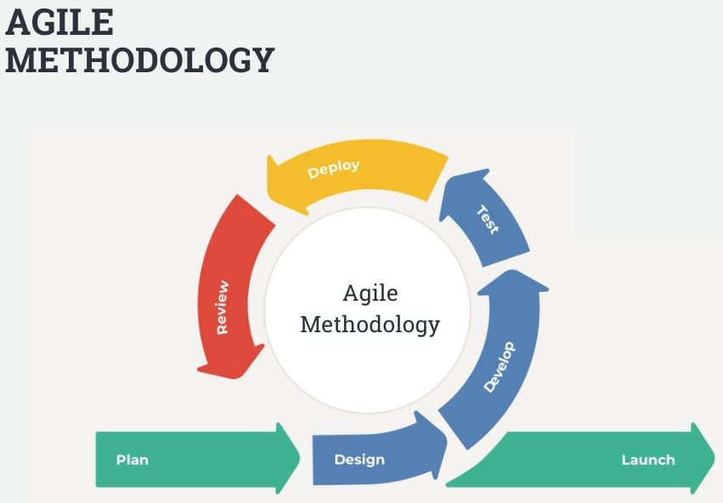
Figure 1 (Interquality, 2017)

The Agile approach was particularly suited for this project due to its data-driven nature. As the traffic dataset was explored, new variables were identified that influenced the design of the system. This required flexibility in development, which Agile provides. The system was developed in multiple stages or sprints, which consisted of: data analysis, implementation of a basic model, and the later development of a more advanced system. Another reason why the Agile methodology was well suited for this project was the presence of a secondary opinion, being the supervisor, allowing the use of feedback received to then apply further changes to the system, making Agile the best option.

4.2.1 Key stages of Development
This project followed various stages of development:

- Data collection and Preprocessing
The traffic dataset was collected from the Leeds City Council’s website and then cleaned to ensure accuracy and suitability to the project, ensuring that it was reliable and accurate. This included handling missing values and organising the data into a suitable form for the project.
- Data Analysis
The traffic dataset was analysed to identify patterns leading to trends such as peak hours and the heavier flow of traffic in specific directions. This stage provided important insights that influenced the design of the system.
- Initial development of the system
A fixed-time traffic system was implemented as a starting model. This allowed for later comparison with more advanced systems.
- Smart System Implementation
A basic rule-based system was developed to adjust signal timings based on the volume of traffic. This was the first feature identified for the project, which demonstrates the first implementation following the Agile methodology.
- Enhanced System Development
After successfully implementing the first feature of the project, an improved system was developed, incorporating factors such as time of day and direction of traffic.
- Testing and Evaluation
The performance of each system was evaluated using delay metrics and compared against each other to see the effect of a smart system to the flow of traffic. Finally it was visualised using an interactive dashboard containing graphs.

These stages demonstrate the iterative nature of the Agile methodology, where the workload is split into small stages, and each stage builds further on the previous one.

4.3 Why Agile Methodology was selected
Agile was selected over alternative methodologies due to its flexibility and iterative development capabilities. One key advantage of Agile is its ability to allow changes to be made during development, making it easier to manage and allowing the division of the total workload into smaller, easier to handle steps. As new features were identified from the dataset, the system could be modified accordingly with ease.

Additionally, Agile supports continuous testing and evaluation of each stage of development, which was essential for this project. Each stage and version of the system was tested and improved based on the results obtained, ensuring that the final product was effective and met the requirements of the expected final product.

4.4 Alternative Methodology: The Waterfall Method (Not used)
Another methodology opposed to Agile is the Waterfall methodology. This follows a linear and sequential approach to development, where each stage needs to be completed before moving onto the next, making it less flexible. These phases include requirements gathering, design, implementation, testing and maintenance as can be seen in figure 2 below. The Waterfall methodology demands a well thought out and accurate documentation of the requirements and what the end-user needs from the project before the design and implementation phases. This reduces flexibility as both parties need to align on the requirements of the project before anything is developed. This may take a long time, making the waterfall methodology unsuitable for this project as the requirements were implemented and improved as the project progressed, making the Agile methodology the suitable choice.

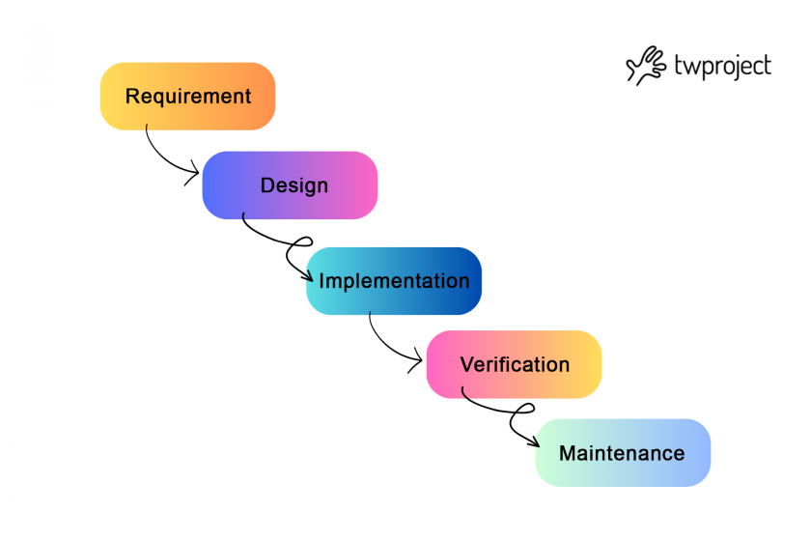
Figure 2 (twproject, 2025)

One key advantage of the Waterfall methodology is its clear structure and documentation. Each stage is well defined and thought out at the start, which can make the project easier to manage giving a clearer sense of direction. However, this can become a significant limitation if requirements were to change, as once a phase has been completed it is very difficult to backtrack and return to it without affecting the whole project’s timings, therefore affecting deadlines.

Agile on the other hand, offers greater flexibility by dividing the workload into sprints and allowing any changes to be made before another sprint begins ensuring that everything is developed effectively. This was very important for this project, as the system design and outcome were influenced by the insights gained from the dataset and the feedback of the end-user (the supervisor), therefore, they needed constant adjustments. Agile allowed for the iterative refinements and the development of multiple versions of the traffic system including a basic and advanced model.

Another difference between the two methodologies is their approach to testing. In the Waterfall method, testing is conducted after the implementation phase is complete. This can result in issues being found late in the development process, making them more difficult and costly to amend. On the other side, Agile incorporates testing in each sprint, allowing for the detection and correction of any issues early-on in the development cycle. This continuous testing approach improves the overall quality of the final product.

4.5 Alternative Methodology: The Spiral Model (Not Used)
The Spiral model is also an iterative project management approach; however, they differ significantly in structure and application. Agile is a flexible methodology that focuses on continuous development, end-user feedback and frequent improvements. The Spiral model, in contrast, combines iterative development with a stronger focus on risk assessment and management. Each cycle of the Spiral consists of four key phases: planning, risk analysis, development and evaluation, as can be seen in figure 3 below. This approach ensures that potential risks are identified and addressed early in the development phase. As a result, the Spiral model is often used in large-scale or high-risk projects, where careful planning and evaluation are essential.
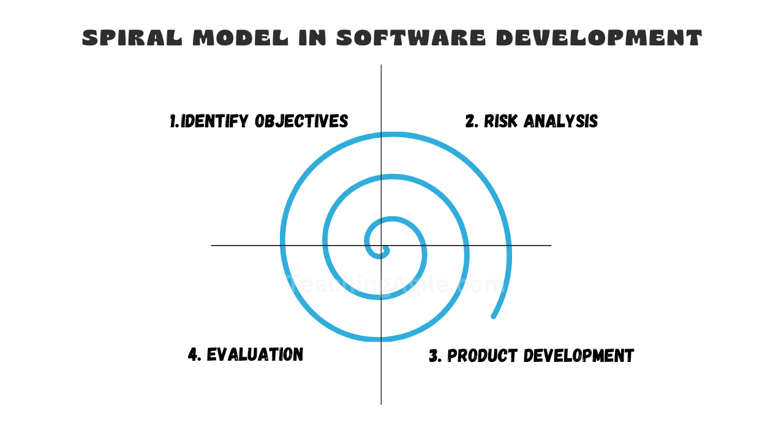
Figure 3 (Talreja, 2023)

Due to the use of data analysis for this project, the use of the Spiral model was not required because of the size and low risk approach of the smart traffic management system. This is why the Spiral model was not used to manage this project, presenting the Agile method as a more fitted approach, prioritising simplicity and speed over detailed risk management.

4.6 Design of the Rule-Based System
The main aspect of the system is a rule-based algorithm that adjusts traffic signal timings based on traffic volume and other features. The system uses predefined rules to determine the duration of green lights taking into consideration the following aspects.
Firstly, traffic volume is used to determine the base green light duration. Higher traffic volumes will result in longer green light timings, while lower volumes will lead to shorter green light durations. This ensures that busier roads are given priority, reducing congestion and improving the flow of traffic.

In addition to traffic volume, the system also takes into consideration the time of day. After analysing the data obtained from the Leeds city council, it has been determined that peak hours of traffic often occur during morning and evening periods. The system increases the duration of the green light during these peak hours and reduces them during off-peak periods, allowing for more efficient management.

Another feature of the smart traffic management system is the consideration of traffic direction. Different directions may experience higher levels of congestion. The system, therefore, allocates longer green light periods based on directional traffic flow, ensuring that heavily congested directions are prioritised.

The system is then designed to include a comparison framework, where three different traffic control strategies are implemented: a fixed-timing system(baseline), a basic smart system and an advanced smart system. This allows the evaluation of their performance, providing a clear visualisation of their effectiveness.

Finally, the system calculates a delay score, which provides a quantitative measure of system performance and is used to evaluate the efficiency of each traffic control strategy.

4.7 Design Techniques Used
Several design techniques were used during the development of this project:

A modular design was used where the system was divided into smaller components, making it more manageable and clearer. These include: data processing, algorithm implementation and finally the evaluation. This made the system easier to develop and test.

The system was develop using an Iterative design, which meant that it was divided in multiple stages, with each version improving on the previous one, therefore aligning with the Agile project management methodology.

Finally, this project used a Data-driven design, where decisions were based on the analysis of real-world data which was available publicly on the Leeds City Council’s website, ensuring that the system reflects actual traffic conditions obtained from a trustworthy source.

4.8 Alternative Design Approach (Not Used)
An alternative design approach was the use of hardware components like sensors and cameras to create a traffic dataset to then be used for the prediction of traffic patterns. While this approach offers higher accuracy, it requires a large set of expertise, requires higher funding for a larger amount of hardware and it is also more time-consuming. This influenced the decision to implement a rule-based system, which simply required a reliable dataset and Python oriented programming skills.

4.9 Product requirements
The system developed in this project was designed to meet a set of requirements, which are as follow:
- Ability to effectively process traffic data.
- Ability to find and analyse traffic patterns such as peak hours, volume and directional flow of traffic.
- Ability to adjust green traffic signal timings dynamically to meet different needs.
- Ability to analyse and compare different implemented traffic systems.
- Ability to visualise and display results using graphs and an interactive dashboard.

These requirements were used to guide the design and implementation of the system and its features.

4.10 Summary
This chapter presented the methodology and design approaches used in the development of the smart traffic management system. The Agile methodology was selected due to its flexible nature and suitability to changing requirements and iterative development, while alternative methodologies such as Waterfall and the Spiral method were rejected due to their limitations.

The system design is based on a data-driven, rule-based approach, which provides a simple yet effective solution for managing traffic efficiently. Design techniques were also explored, providing reasoning for the selection of design techniques such as modular and iterative approaches as opposed to alternative approaches, which were rejected due to their complexity and resource requirement.

Overall, the chosen methodology and design approach ensured that the system was practical, scalable and that it aligned with the project requirements.

Chapter Four: Results and Discussion

4.1 Introduction
This chapter presents the implementation and testing of the data-driven smart traffic management system. The system was developed using Python and is based on a rule-based approach to dynamically adjust green traffic light timings using real-word traffic data.
This chapter explains how the system was constructed, providing detailed steps, including data preprocessing, algorithm development, and system comparison. Additionally, the testing approach is also discussed to demonstrate the correctness, reliability and effectiveness of the system.

4.2 System implementation stages
The system was implemented in stages, starting from the gathering of data, leading to the implementation and the testing of the product.

4.2.1 Data gathering and preprocessing
The first stage of the implementation involved finding a reliable dataset, which did not have any copyright or any ethical complications to ensure that the project was ethically appropriate. This influenced the decision to use a publicly available dataset, which ensure the ethical compliance of the data being used in this study. A fairly recent dataset was then found and selected on the Leeds City Council website. In figure 4.1 below we can see the dropdown list of various reliable datasets, where the “December 2025” data was selected to be used in the development of this project.

Figure 4.1 - Dataset options found from Leeds Council
After gathering the required dataset, it was then downloaded to a personal machine and added to the project directory. This allowed the data to be used and linked to the project using Visual Studio Code. This was done using the Pandas library in Python.

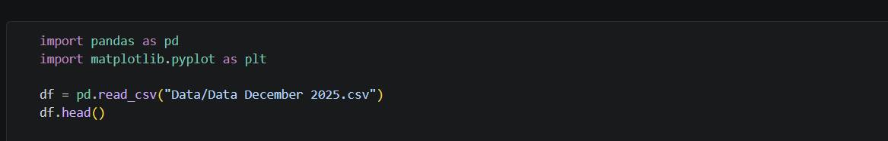
Figure 4.2 – loading the dataset and ensuring it is read correctly.
The code shown in figure 4.2 loads the dataset into a DataFrame and displays the first few rows to ensure that the data is imported correctly. This step is necessary, as it makes sure that the dataset is structured properly before further processing. This was done effectively as can be seen from the output in figure 4.3 below.

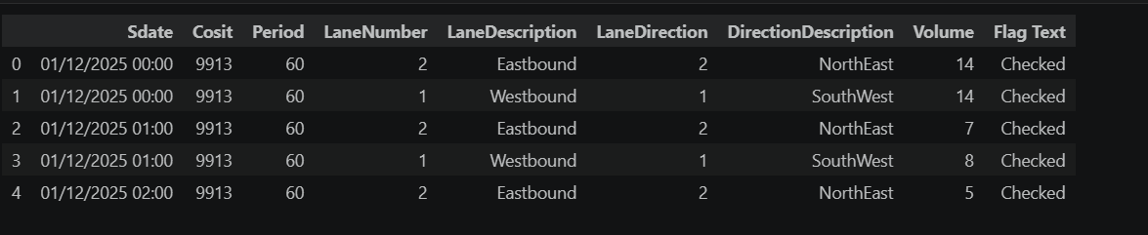
Figure 4.3 – successfully loaded dataset.
After loading the dataset correctly, data preprocessing was carried out to ensure accuracy and usability. This can be seen in figures 4.4 – 4.6 below.

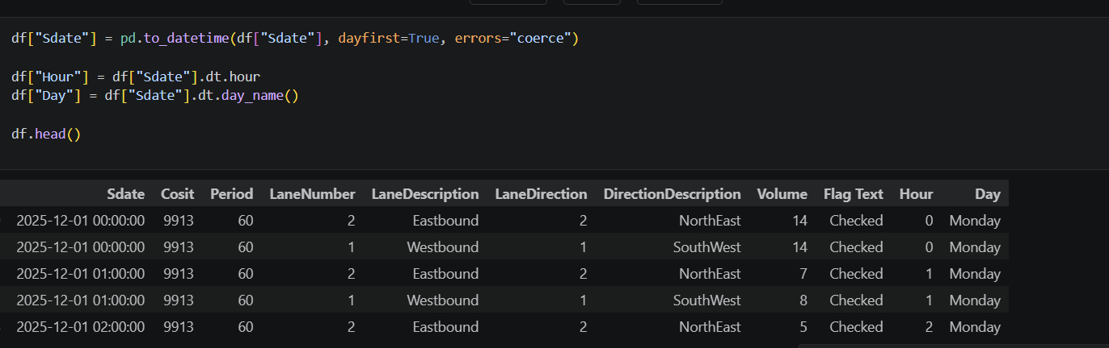
Figure 4.4 – data preprocessing stage
The code above clearly displays the preprocessing stage. Here, the “Sdate” column is converted into an appropriate format containing the exact date and time of each dataset value by creating new columns named “Hour” and “Day”. It then displays the data, to ensure everything works correctly and the first 4 rows are then displayed. This made the dataset more usable towards the requirements of the final product, which ensured the efficiency of the project.

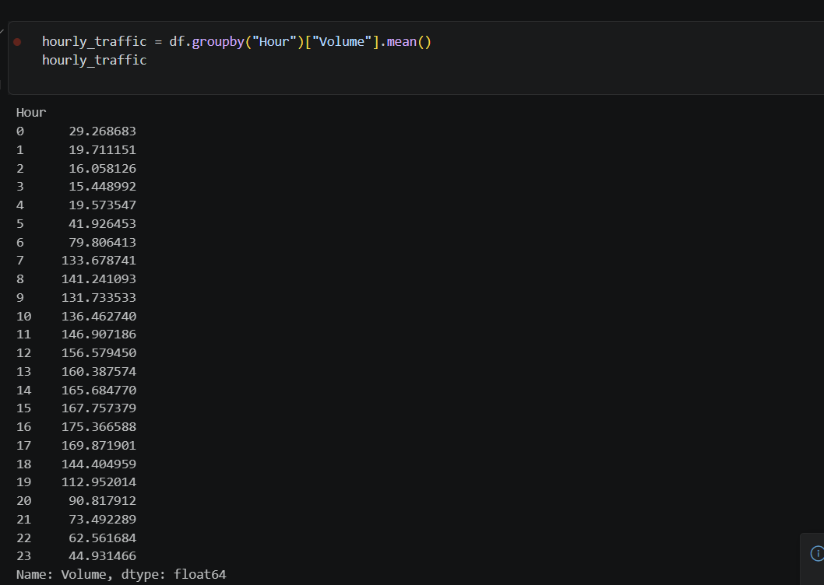
Figure 4.5 – grouping volume for each hour.
Next, to make the data clearer, the code in figure 4.5 displays the grouping of the traffic volume into an hourly average. This allows a clearer visualisation of the data and allows the identification of peak traffic hours, which were later used to improve the system.

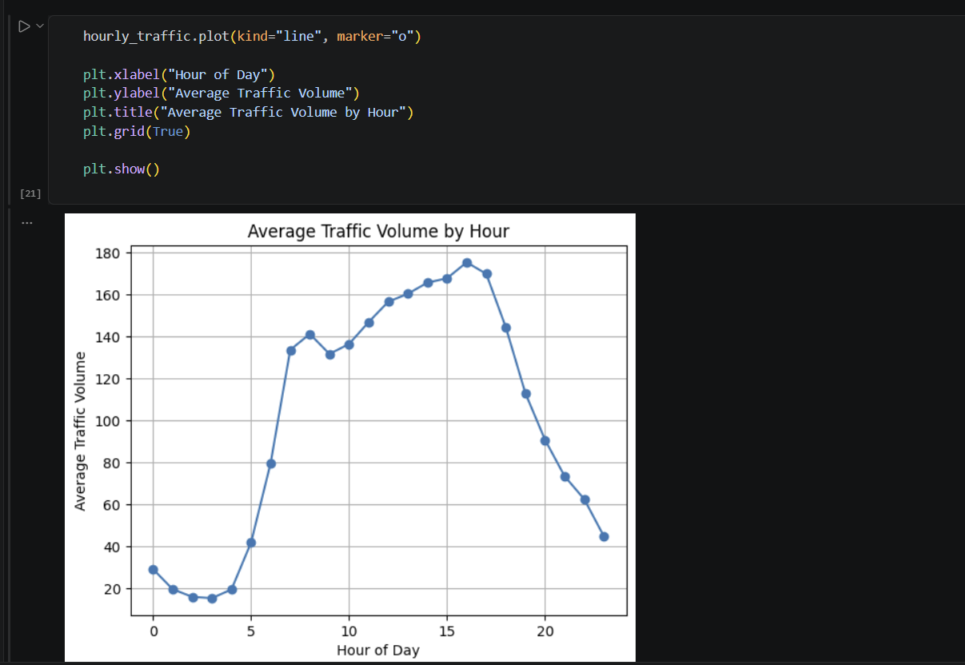
Figure 4.6 – visualise the average hourly traffic volume.
The data was then plotted on a graph seen in figure 4.6. This made it easier to identify the changes in traffic volume during various hours of the day.

4.2.2 Fixed-timing system implementation
A fixed-time traffic management system was implemented as a baseline model. This system assigns a constant green traffic signal duration, which does not change based on traffic changes.

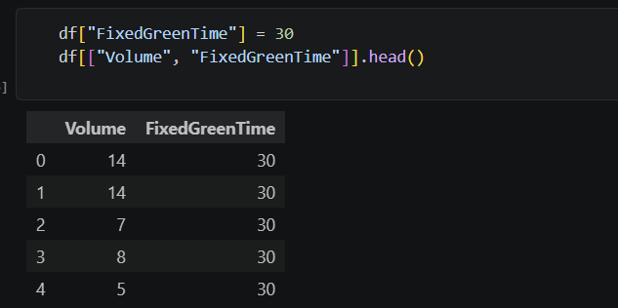
Figure 4.7 – implementing fixed-time system
This can be seen in figure 4.7 above. This implementation represents a traditional traffic control system, where all directions receive equal green time. While simple to implement, this approach does not adapt to the changing conditions in traffic, which can be seen in the graph displayed in figure 4.6, making it inefficient during peak hours. The fixed system was included to provide a point of comparison to evaluate how effective the smart system is.

Next, the first was implementation of the smart system was defined. This is a rule-based smart system where the green light timings change following the density of traffic volume.

Figure 4.8 – defining initial smart system.
The code shown in figure 4.8 displays the function. This function defines a smart green time, by taking traffic volume as input and returning green timings accordingly. For example, if volume of traffic is less than 10 the green light will stay green for 20 seconds and if volume is less than 30 the green light will stay for 40 seconds and if the volume is anything higher, the system will keep the light green for 60 seconds, meaning that lower traffic volumes result in shorter green light times, whereas higher volumes of traffic will result in the green traffic light to stay on for longer. These values were then applied to the traffic data being used to ensure the correct implementation and the first 10 rows were then displayed, while comparing them to the fixed system, as can be seen in figure 4.9.

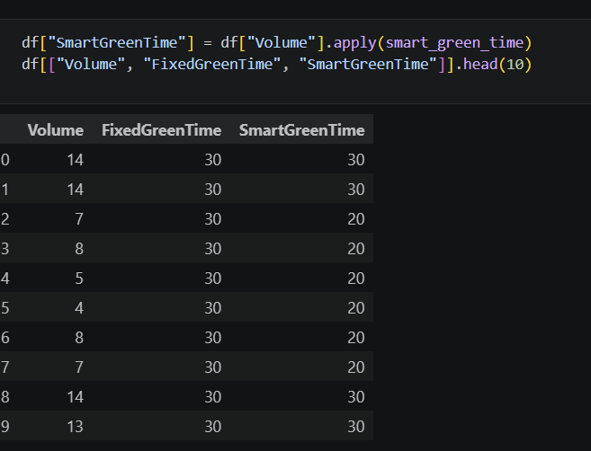
Figure 4.9 – application of smart timings.

4.2.3 Enhanced Smart System Implementation
An enhanced version of the smart system was then developed to implement additional features taken into consideration, such as the time of day.
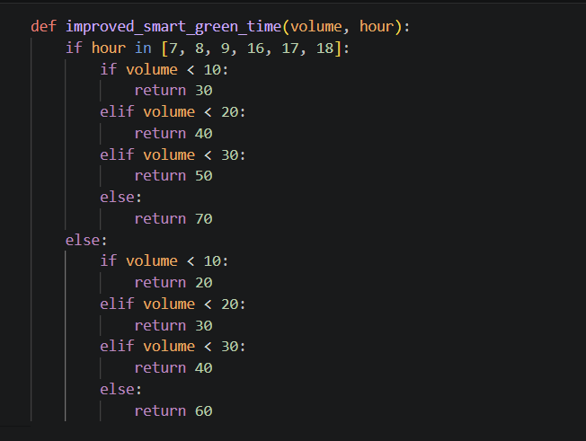
Figure 5 – Adding peak hours.
The code in figure 5 displays the adjustment based on both traffic volume and time of day. During peak hours, which are 7am to 9am and 4pm to 6pm, the system increases the green light duration to accommodate higher traffic demand. This enhancement improves the system’s ability to handle real-world traffic patterns.

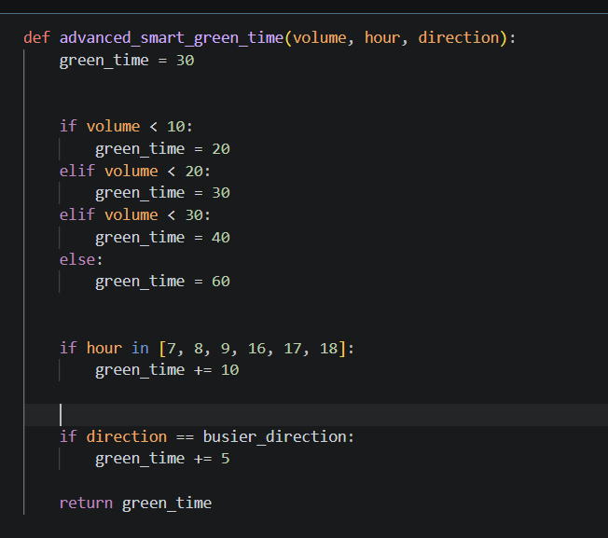
Figure 5.1 – Further improvements on smart system.
The system was then improved further, as seen in figure 5.1. The code shows the implementation of busier directions on top of the volume and peak hour traffic. This means that, if the traffic is flowing in the direction with the highest average traffic volume, it will add another 5 seconds to the timing of the green light, making it last even longer for the busier direction, which was determined to be traffic heading west.

4.2.4 Delay Scores
To evaluate the system performance, a delay metric was included.
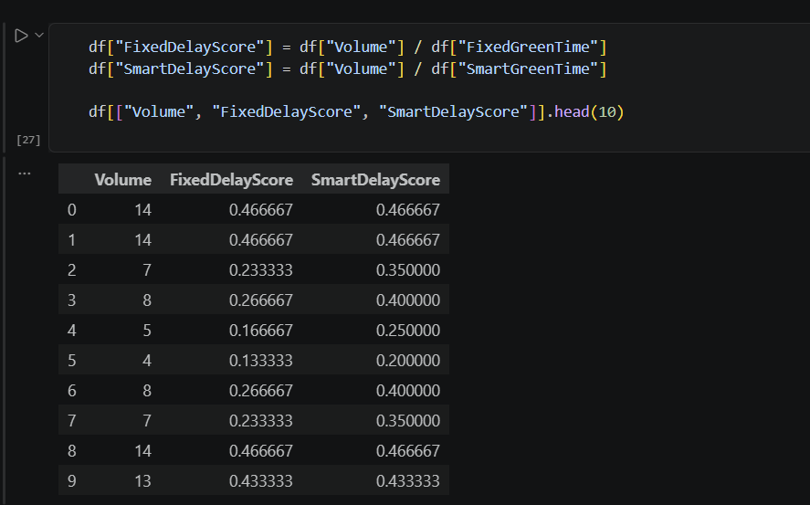
Figure 6 - Delay metric implemented
Figure 6 shows exactly this. The delay metric is calculated by dividing the volume by the green time duration. This calculation measures the efficiency of the system. A lower delay score suggests that traffic is flowing more efficiently and it shows better performance. The delay metric provides a simple and effective way to compare the different traffic control strategies.

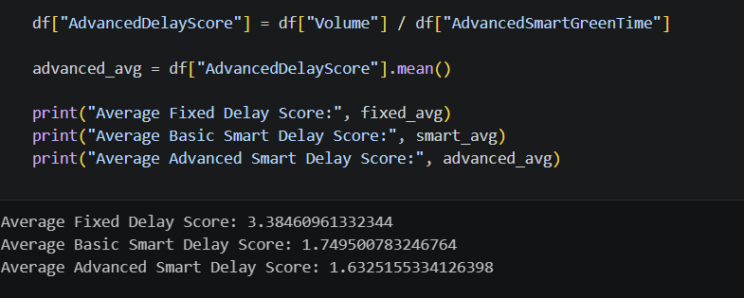
Figure 6.1 – Average delay score of all systems.
The delay metric was further used to compare the three traffic control systems’ performances. The code in figure 6.1 shows the display of each system’s average delay score, where the advanced smart system, has the lowest average out of the three. As it was determined before, the lower delay score means that the system is the most efficient. This proves that the advanced smart traffic system handles fluctuating traffic demand a lot better than the fixed traffic management system.

4.2.5 Visualisation Dashboard
After the final product was developed, the outcomes of the project were displayed on an interactive dashboard. This was created using Power BI, to ensure that the findings of the project were shown clearly and made interactive so that the end-user can hover over each graph and see the exact values at each point displayed. This can be seen in figure 6.2 below.
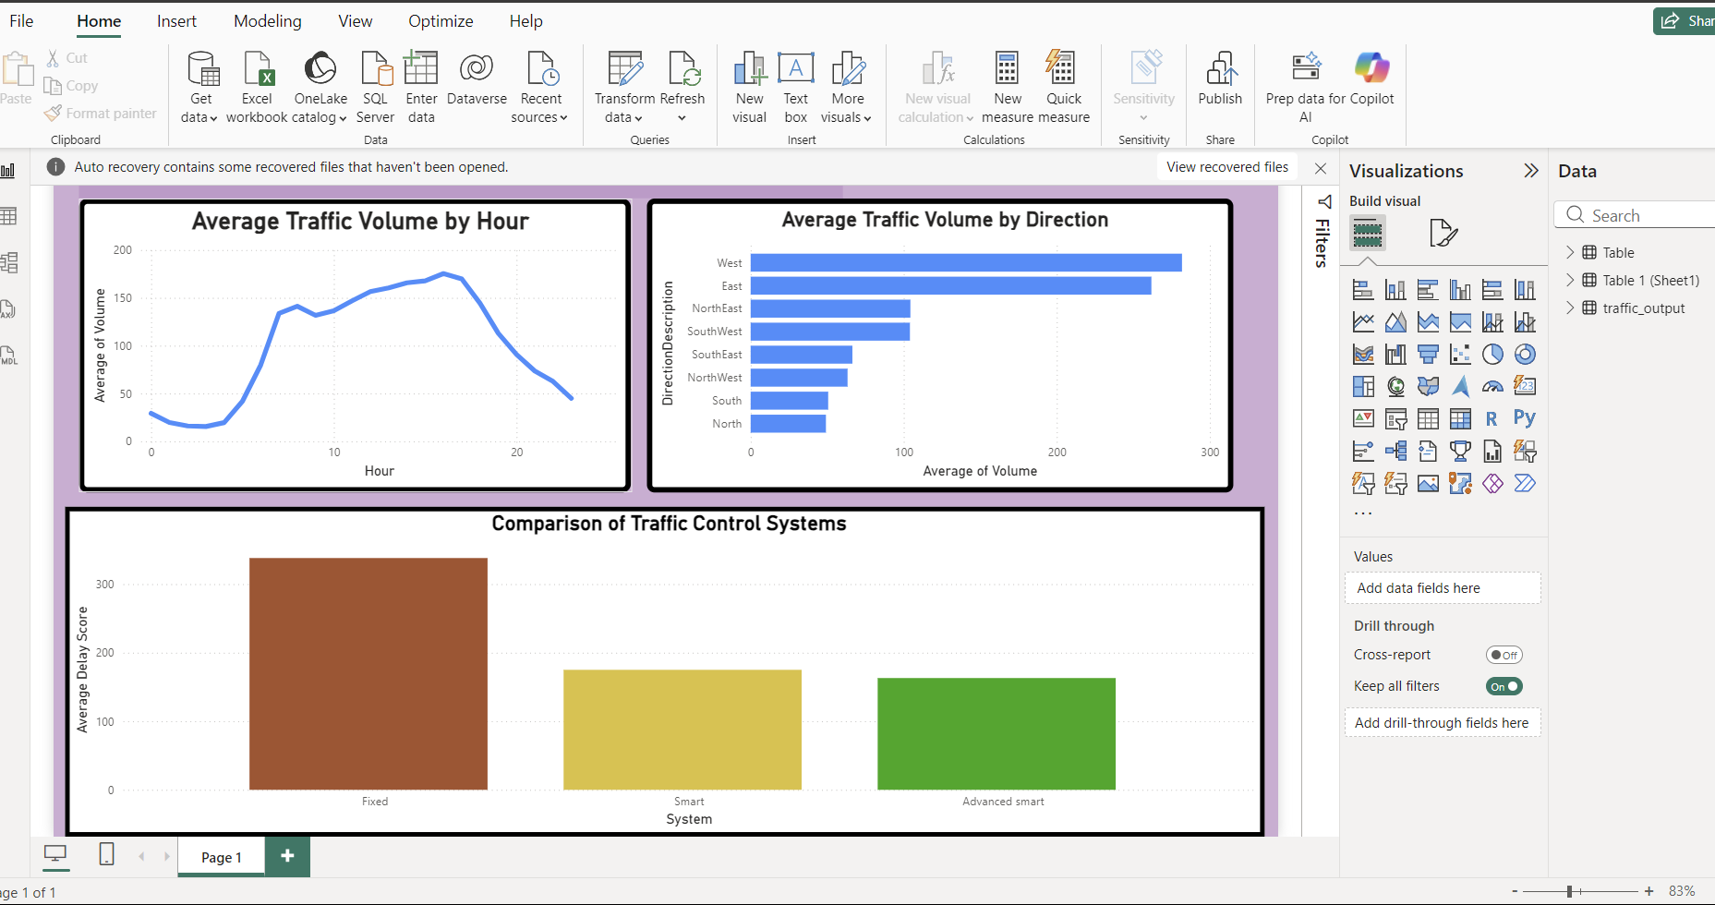
Figure 6.2 – interactive dashboard.

4.3 Testing methodology
Testing of the project was carried out throughout the development, as reinforced by the Agile management methodology, to ensure that the system was functioning correctly and producing reliable results. Testing was implemented in various ways.

Firstly, Functional Testing was used to verify that each component of the system produced the correct and expected output. For example, when testing the green light timings for the first version of the smart system, the “smart_green_time” function was tested with different inputs to ensure that the correct green times were returned, while also ensuring no errors were found. This confirmed that the system logic was working as intended.

Secondly, Data testing was also implemented to ensure that the system handled the dataset correctly by verifying that: the dataset was loaded correctly, preprocessing steps were applied successfully and calculations were accurate. This was done by printing out the first 10 rows of the dataset after applying each change to ensure that the dataset was behaving as expected. This was essential to ensure that the system produced valid results when applied to the dataset.

Another important testing method, was Comparative Testing. This was used to evaluate the performance of each system opposed to one another. It also checked that the same dataset was being applied to each system and after implementing a delay score, the results were then compared showing that the fixed system produced the highest delay, whereas the smart and advanced traffic control systems produced a significantly reduced delay. This proved that the changes applied to the smart systems made them a lot more efficient and demonstrated the positive improvements to the management of changing traffic demand.

4.4 Discussion of Implementation
The implementation of the system demonstrates that data-driven approaches can improve the management of traffic. The use of a rule-based system allowed for a simple yet effective solution that also adapts to changing traffic conditions. One key advantage of this approach is its simplicity and its low-costs, which make this approach very practical and efficient. However, the system does have some limitations. For example, because of the use of fixed thresholds, the system may not capture and apply all the variations in traffic behaviour and it also does not take into consideration external factors such as accidents and weather conditions.

4.5 Summary
This chapter has described the main stages of implementation and testing of the smart traffic management system developed for this project. The system was developed using Visual Studio Code and Python and includes multiple traffic control methods, allowing for the comparison and visualisation of their performances. Testing methods were also used to ensure that everything worked correctly and behaved as expected, and these methods demonstrate that the smart system massively improves traffic flow compared to a fixed-time traffic system.

Chapter Five: Product Evaluation

5.1 Introduction
This chapter evaluates the effectiveness of the data-driven smart traffic management system developed in this project. The evaluation is based on a comparison between the final product and the initial project aims and objectives. It is also evaluated using quantitative results, such as the delay scores, and qualitative analysis of its strengths and limitations. This ensures that the evaluation is balanced and fairly shows how well the system meets its intended purpose.

5.2 Evaluation Against the Project Aim
The main aim of this project was to develop a data-driven traffic management system using publicly available traffic data and to evaluate its effectiveness compared to a traditional fixed-timing traffic system. This aim has been successfully achieved. The system was developed using a reliable real-world traffic dataset, and it incorporates features such as traffic volume, time of day and directional flow. The system has been developed to successfully adjust traffic signal timings based on these various factors, demonstrating the properties of a smart traffic system.

Furthermore, the system was evaluated using a delay score, allowing for the direct comparison with a traditional traffic management system. The results clearly showed that the smart system was highly effective and significantly improved traffic flow, while taking into consideration various factors that may affect it, indicating that the project aim has been met.

5.3 Evaluation Against Objectives
The project was also evaluated against the set objectives:

Objective 1: Data collection and preprocessing.
- This first objective was successfully met. The traffic dataset was obtained from a reliable public source and processed correctly using the Pandas library. Data cleaning and transformation was then carried out, which ensured that the dataset was accurate and suitable for the project.

Objective 2: Data analysis to identify patterns to be used in the development
- This objective was also achieved. Data analysis was carried out and identified patterns such as peak hours, traffic volume and direction. These findings informed the design of the smart traffic system, ensuring that it was advanced and efficient.

Objective 3: Implementation of a fixed-timing system
- A fixed-time system was implemented successfully and it acted as a baseline for the comparison of the performance of the systems, proving the benefits of a smart traffic management system.

Objective 4: Development of an advanced smart traffic management system
- This objective was achieved successfully, as a smart traffic system was implemented taking into consideration various factors affecting traffic such as time of day, volume and direction, which improved efficiency in handling the changing traffic demand.

Objective 5: Evaluation of the finished product and visualisation
- This was yet another successful objective, as the systems were evaluated using a delay score and displayed on an interactive dashboard developed using Power BI to compare and interpret the results.

Overall, all the objectives were successfully met, which demonstrates the effectiveness of the system developed and the overall project.

5.4 Analysis of Results
The performance of the system was evaluated using delay scores. The following results were seen:

- Fixed system = 3.38
- Smart system = 1.75
- Advanced smart system = 1.63

These results show an immense improvement in the flow of traffic when using the smart traffic management system. This reduces delays by almost 50% compared to a basic fixed-timing traffic control system. This demonstrates that adjusting durations of green light timings based on real-world traffic data can significantly improve the flow of traffic, reducing delays and congestion.

5.5 Limitations of the System
Despite the various strengths of the system, there are some limitations. One limitation of the system is the simple model, which takes into consideration only part of the factors that may affect traffic in a real-world scenario, for example accidents and weather conditions.
Another limitation to this project is the static rules. This is because, the rule-based approach uses set thresholds, which may not apply to all kinds of situations. Finally, the system also relies heavily on data, which means that, if compromised, it may heavily affect the whole product.

Compared to a real-world system, the system developed in this project is a lot simpler and limited. In the real world, systems often use sensors, cameras and machine learning techniques to optimise traffic flow in real time. While this is more efficient, the system developed demonstrates that, even through the use of data analysis, significant improvements can be achieved, while highlighting the potential of cost-effective solutions.

5.6 Overall Evaluation

Overall, the system is considered successful. It meets the project aim and all the objectives set, demonstrates measurable improvements in traffic flow, and provides a cost-effective yet practical solution for traffic management. This system demonstrates simplicity and effectiveness, making it suitable for smaller-scale applications. Even though there are limitations, the system is valid and can be used for further development.

Chapter Six: Product Evaluation

7.1 Evaluation of Project Management Approach
This project followed an Agile Methodology, which proved to be very effective in managing the development of the smart traffic management system. Agile allowed the iterative development of the project, meaning that the system could be continuously improved based on findings and new ideas or objectives during the development phase. It also allowed the workload to be split into smaller more manageable sprints, which made the implementation of all the features easier and manageable against the time constraints.

Although the project was developed individually and not in a team, Agile principles were still applied effectively. Tasks were completed in stages and progress was regularly reviewed. This made the project more organised and aligned with objectives and the overall aim.

7.2 Challenges Encountered
During the development of this project, several challenges were encountered. One major challenge was finding a reliable and public dataset, that would also be adequate for the needs of this project. This added time to the research phase before the actual implementation began.

Another challenge encountered was working with and handling real-world data. This was because the dataset contained inconsistencies and thousands of variables. To overcome this, the Pandas library was used to effectively preprocess and clean the data to make it accurate and more manageable towards the requirements of the project.
Another challenge was the display of graphs and visualisation of data on Power BI. This was because of the limited knowledge on the use of the platform. This was overcome through the use of a YouTube demonstration video explaining the various functions of the application and how to become familiar with it.

7.3 Successes of the Project
Despite some challenges, the project achieved many key successes. The system was able to successfully demonstrate that a data-driven approach can improve traffic management significantly by simple setting some rules. The results showed a clear reduction in delays when using the smart system compared to the fixed system.

Another success was the efficient use of public data. This showed the development of a practical solution without spending thousands on the collection of data, while also implementing reliable and accurate data into the development of the project.

The system was also able to implement various important features, which heavily contributed towards the success of the final product. This ensured that the project did not simply take volume into consideration, but also implemented the use of peak hours and direction of travel, which are important considerations to be made when managing a busy city and its traffic.

7.4 Areas for Improvement
While the project was successful overall, there are some areas for improvement that would make the project more efficient. One of which is the need for more aspects of real-world traffic to be implemented into the logic of the smart traffic management system. This would improve its effectiveness by taking into consideration factors such as road collisions, weather conditions and special events like football matches, which are all factors that would affect traffic delays.

Another area of improvement is the inclusion of more advanced data. This would be data obtained from hardware components such as sensors, cameras or the implementation of machine learning to make a more advanced version of the smart system to manage traffic even more effectively.

Finally, the last improvement that could be made to make this project industry ready, would be to implement a small simulation to display exactly how the smart traffic system handles junctions and other traffic scenarios to give a clear idea to investors on how it acts and how effective it is.

Chapter Seven: Conclusion
This project developed a data-driven smart traffic management system using publicly available traffic data and to evaluate its effectiveness against a more traditional fixed-timing traffic management system. Through the implementation of data analysis techniques and rule-based system design, the project was able to successfully demonstrate that a change in traffic signals can improve traffic flow and reduce congestions, which makes this project more efficient and beneficial towards real-world issues such as pollution and the rise of fuel prices. This is because the decrease of congestion would also reduce fuel consumption and the release of harmful gases into the atmosphere. Despite some limitations and areas of improvement, the project has achieved its aim and the objectives that were set. Based on the quantitative analysis of the outcomes of the project, and the review of them using a delay metric, it can be concluded that a data-driven rule-based approach can prove successful in the management of traffic and provide many benefits to the society and the environment compared to a traditional traffic control system.

References
Barceló, J. (2010) Fundamentals of Traffic Simulation. New York: Springer.

Eleni I. Vlahogianni, Karlaftis, M.G. and Golias, J.C. (2014) ‘Short-term traffic forecasting: Where we are and where we’re going’, Transportation Research Part C: Emerging Technologies, pp. 3–19.

Gershenson, C. (2004) ‘Self-organizing traffic lights’, Complex Systems.

Hunt, P.B., Robertson, D.I., Bretherton, R.D. and Winton, R.I. (1981) ‘SCOOT – A traffic responsive method of coordinating signals’, Transport and Road Research Laboratory Report.

Interquality (2017) What is Agile. Available at: https://interquality.com (Accessed: [add date]).

Koonce, P. and Rodegerdts, L. (2008) Traffic Signal Timing Manual. Washington, DC: Federal Highway Administration.

Li, L., Lv, Y. and Wang, F.-Y. (2016) ‘Traffic signal timing via deep reinforcement learning’, IEEE/CAA Journal of Automatica Sinica, 3(3), pp. 247–254.

Lv, Y., Duan, Y., Kang, W., Li, Z. and Wang, F.-Y. (2015) ‘Traffic flow prediction with big data’, IEEE Transactions on Intelligent Transportation Systems.

Atzori, L., Iera, A. and Morabito, G. (2010) ‘The Internet of Things: A survey’, Computer Networks.

Batty, M., Axhausen, K.W., Giannotti, F., Pozdnoukhov, A., Bazzani, A., Wachowicz, M., Ouzounis, G. and Portugali, Y. (2012) ‘Smart cities of the future’, European Physical Journal.

Papageorgiou, M., Diakaki, C., Dinopoulou, V., Kotsialos, A. and Wang, Y. (2004) ‘Review of road traffic control strategies’, Proceedings of the IEEE.

Sutton, R.S. and Barto, A.G. (2014) Reinforcement Learning: An Introduction. Cambridge: MIT Press.

Talreja, A. (2023) Spiral Model: Definition, Phases, Advantages & Disadvantages. Available at: https://teachingagile.com (Accessed: [add date]).

TWproject (2025) Waterfall methodology: what it is and what it is for. Available at: https://twproject.com (Accessed: 2026)

Lv, Y., Duan, Y., Kang, W., Li, Z. and Wang, F. (2015) ‘Traffic flow prediction with big data: A deep learning approach’, IEEE Transactions on Intelligent Transportation Systems.

Zhang, J., Zheng, Y. and Qi, D. (2012) ‘Deep spatio-temporal residual networks for citywide crowd flows prediction’, Proceedings of the AAAI Conference on Artificial Intelligence.

Zheng, Z., Ahn, S. and Chen, D. (2011) ‘Freeway traffic oscillations: Microscopic analysis of formations and propagations using wavelet transform’, Transportation Research Part B: Methodological.

Leeds City Council (2025) Leeds annual traffic growth. Available at: https://datamillnorth.org/dataset/leeds-annual-traffic-growth-e6q0n (Accessed: 2026).

Appendix I GAI statement
I understand that to use the work and ideas of others, including generative AI output, without full acknowledgement, is academic unfair practice.
I confirm that this coursework submission is all my own, original work and that all sources, summaries, paraphrases and quotes are fully referenced as required by the LBU Academic Regulations.
DECLARATION OF GENERATIVE AI USE: (delete one of the below as appropriate)
I DID use Generative AI technology in the development, writing, or editing of this assignment. I have included a copy of the reference used, and the output generated in the Appendix section. If you have any concerns about whether you have used generative AI tools (in)correctly, please seek advice before submitting your assignment from academic staff responsible for the assessment that this submission relates to. The shaded boxes are examples to help you with completing this section.

Appendix | Generative AI Tool (e.g. ChatGPT) | How generative AI Tool was used | Reference
A | ChatGPT 5.3 | Asked to explain concepts relating to smart traffic systems | OpenAI (2026) ChatGPT (GPT-5.3)  https://chatgpt.com/
B | ChatGPT 5.3 | Used to generate project ideas and possible features | OpenAI (2026) ChatGPT (GPT-5.3)  https://chatgpt.com/
C | ChatGPT 5.3 | Used to create a plan of action to follow to manage time | OpenAI (2026) ChatGPT (GPT-5.3)  https://chatgpt.com/
D | ChatGPT 5.3 | Used to suggest testing strategies | OpenAI (2026) ChatGPT (GPT-5.3)  https://chatgpt.com/
E | ChatGPT 5.3 | Used to understand software tools like Power BI | OpenAI (2026) ChatGPT (GPT-5.3)  https://chatgpt.com/
F | ChatGPT 5.3 | Asked to explain error messages for debugging | OpenAI (2026) ChatGPT (GPT-5.3)  https://chatgpt.com/

Appendix II Ethics application

