LAB 11 & 12

Name = Abubaker Attique

Section = 3-A

Roll No = P20-0560

Introduction :

We were introduced to the Coal physical lab where we were guided by the sir about the hardware implementation of the program and how to burn that program in the hardware.

Code:

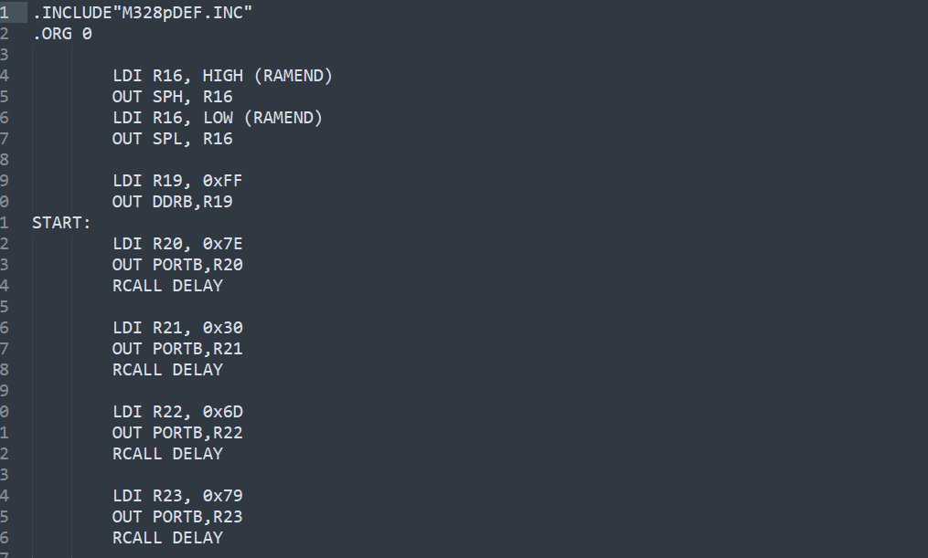

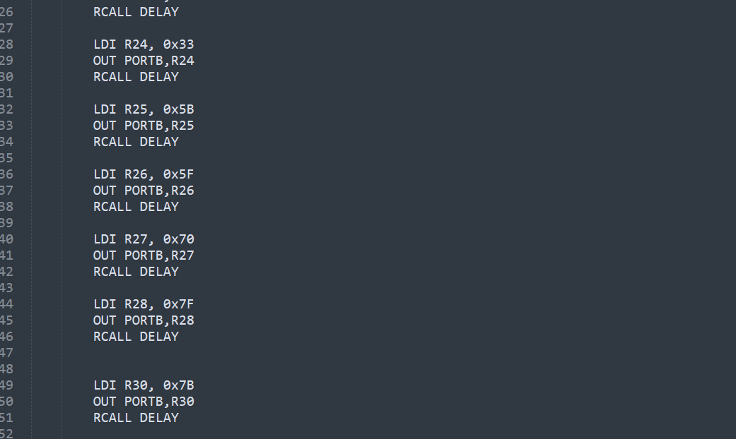

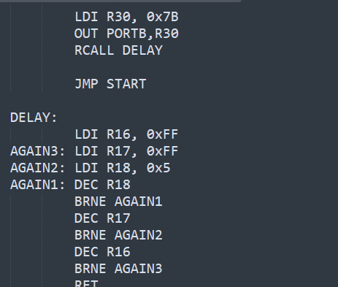

This code is about the segment display where we run this on the computer at the lab and we also give the break about 2 sec

This all was perform in the form of group where we all participated.

