Coal Lab 1

Name = M.Shehzad

Class = 3A

Roll No = P20-0171

**Introduction:**

In the first Lab we were all introduced to teacher and our teacher gave us a brief introduction.

After that we were guided to the lab environment. Sir also gave a brief intro about what COAL is.

**Installation Process:**

In the installation process sir gave the editor’s detail and the link from where it will can be downloaded.

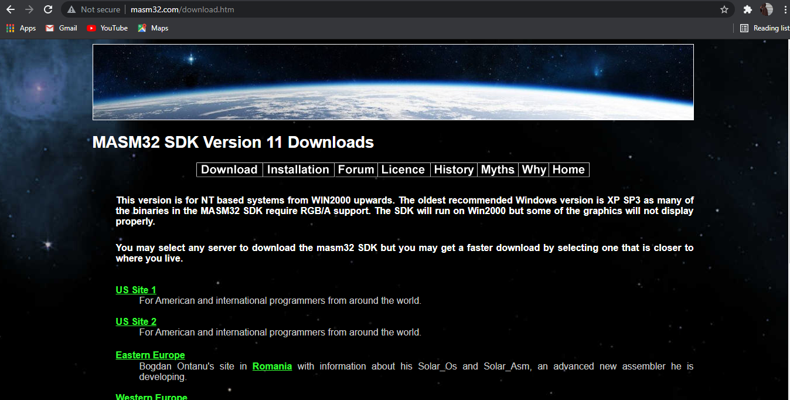

**Installation start**

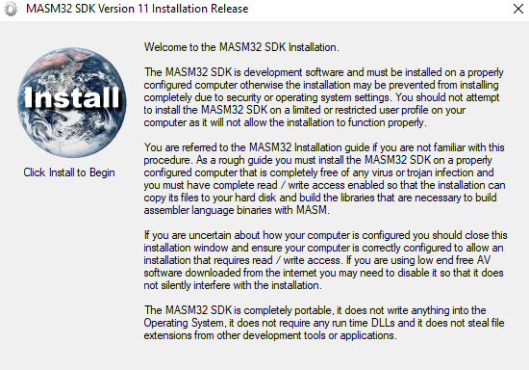

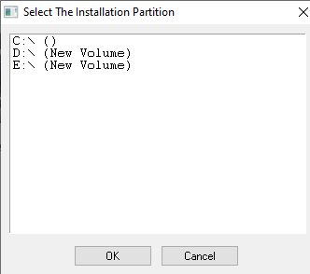

**Extraction**

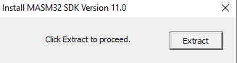

**Final installation.**

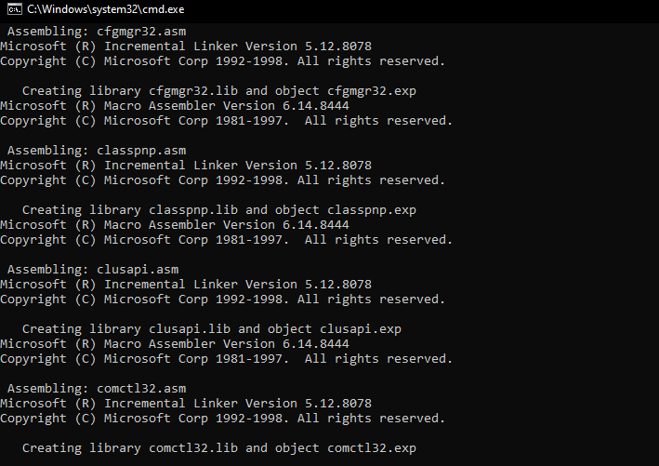

**Run it:**

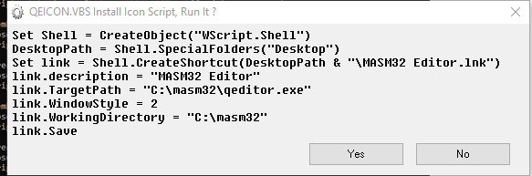

**assembler instructions:**

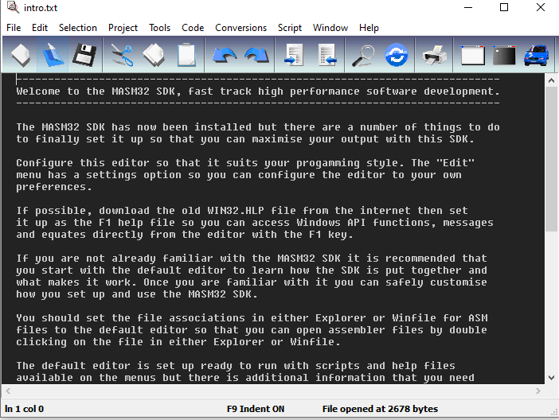



**Program (HELLO WORLD)**

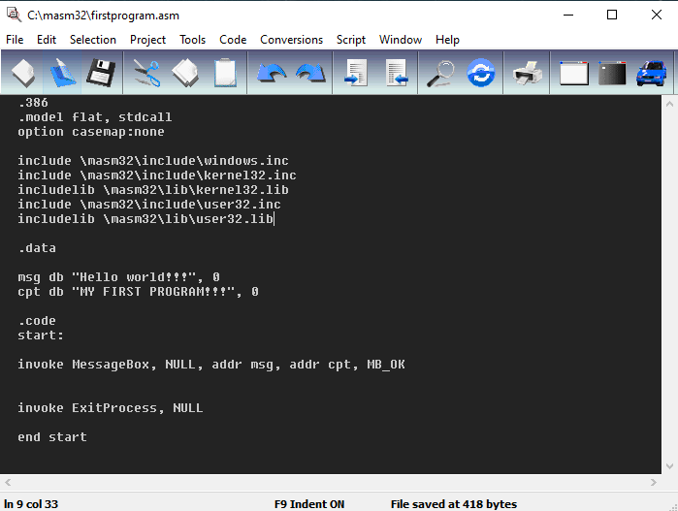

Result:

R