Coal Lab 2

Name = Abubaker Attique

Class = 3A

Roll No= P20-0560

In our second lab we know the difference between MASM vs Nasm.

Then we install the Nasm and DoxBox for the assembly programming.

DoxBox is the assembler debugger where our programming is executed in the memory.

INSTALLATION PROCESS:

We install the DoxBox from the usb provided by the sir.

Installing DOXBOX:

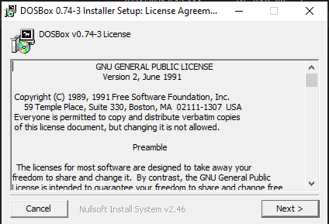

INSTALLATION COMPLETE:

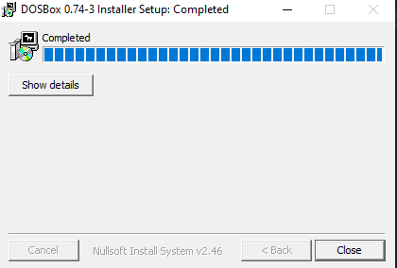

Dox window:

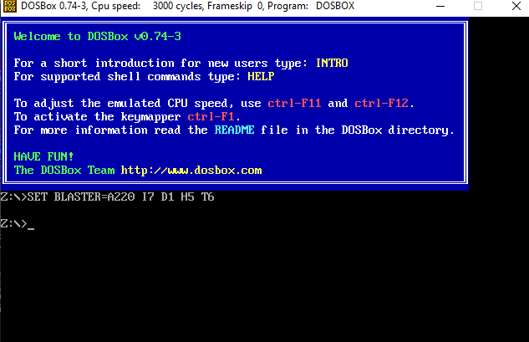

Mount :

* We need to mount the path where our folder is save.

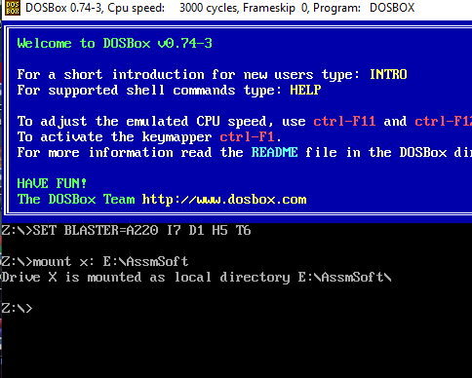

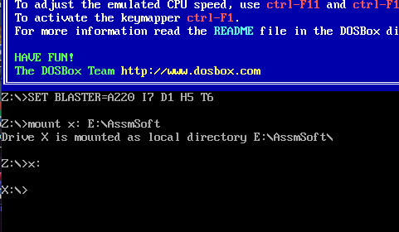

* By typing the AFD the debugger will be opened.

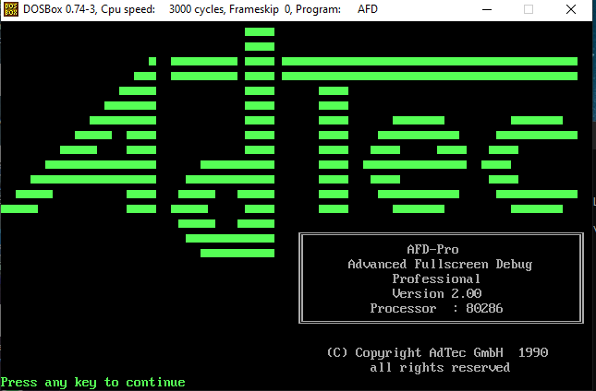

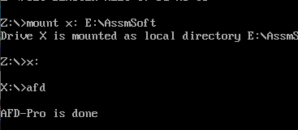

* Debugger will log like this.

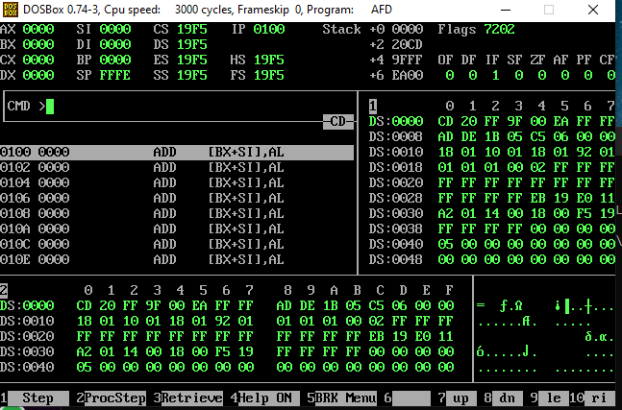

Now we will write the first code in the notebook and save this save as first.asm and save this file in the AssmSoft folder so that doxbox can easily debug this program file.

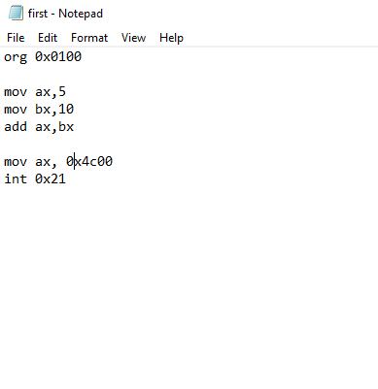

Now we need to convert the .asm file into .com

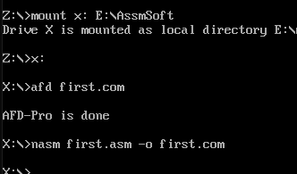

After this type afd first.com

The debugger will be open and start debugging the program.aa

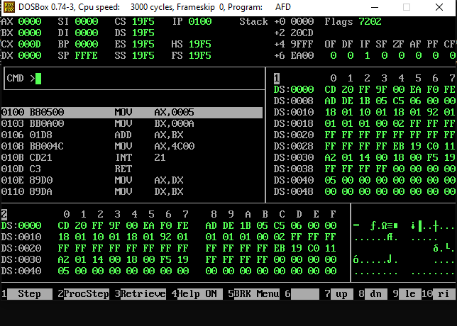

As we have assing the value to the ax which is 5.

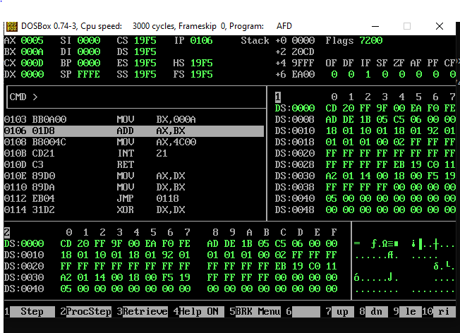

Now by looking the second line line of the program we have giving the bx = 10.

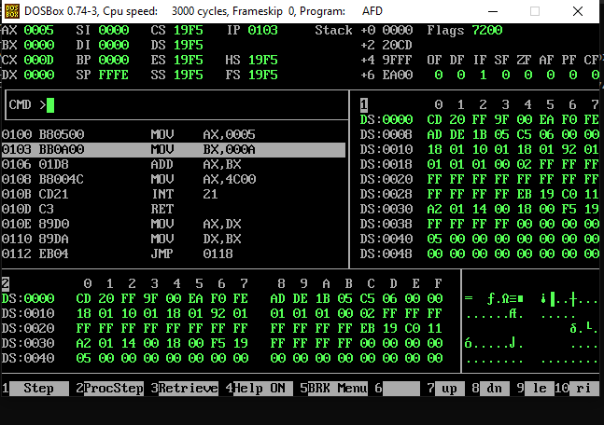

In 3 line of the program ax and bx both will be added.

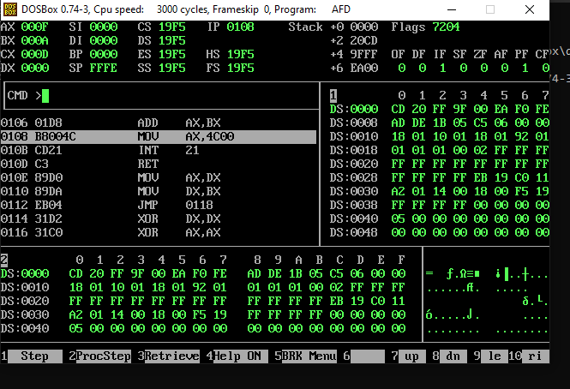

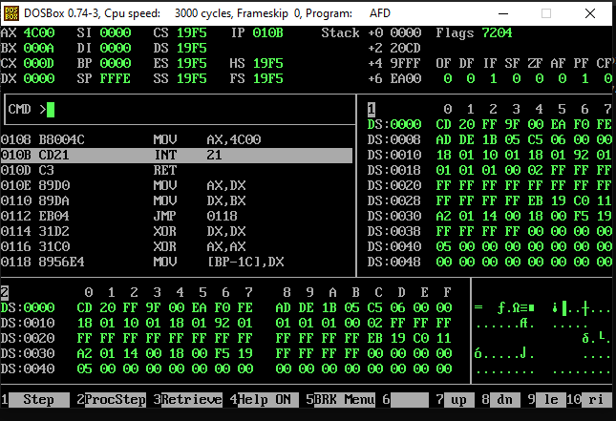

Now the program is finished.

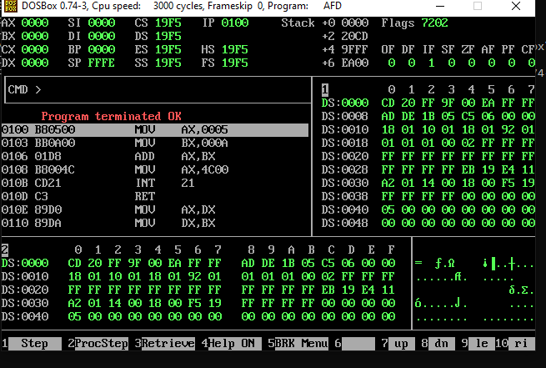

By writing the quit the debugger will be closed.

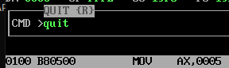

We will return to this again.

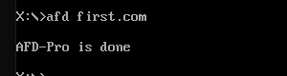

Thx