**LAB REPORT : 5**

**Name = Abubaker Attique**

**Roll num= P20-0560**

**-----------------------------------**

**TASK 2 :**

**Flags**

**CODE:**

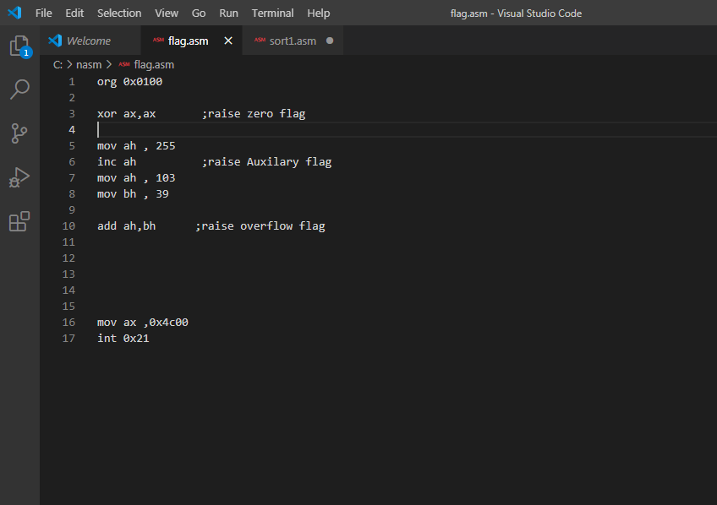

**Explanation With output :**

* The zero flag will be set because our previous instruction

( XOR AX,AX ) results lead to zero.

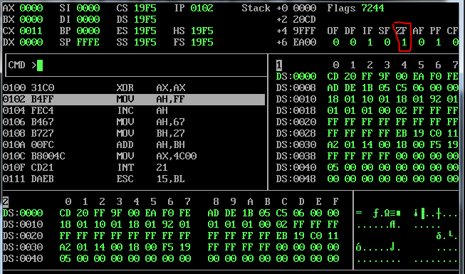

* The Auxiliary Flag will be set because first we store 255 in AH(Maximum Number) and after that we increment it and it will overflow.

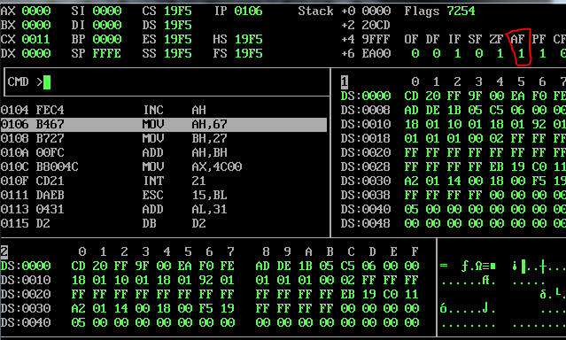

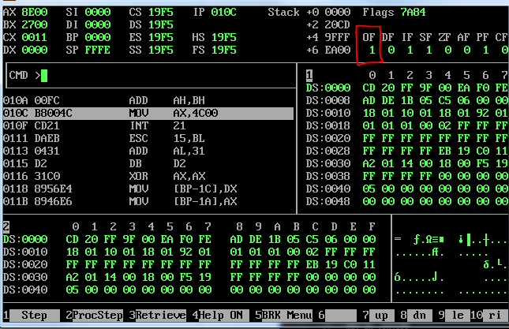

**TASK 2 :**

**Sorting**

**Example1 :-**

**CODE:**

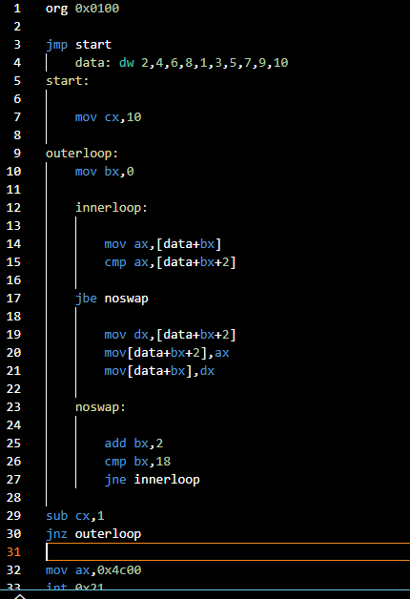

**OUTPUT:**

The Data is sorted in DS as shown below.

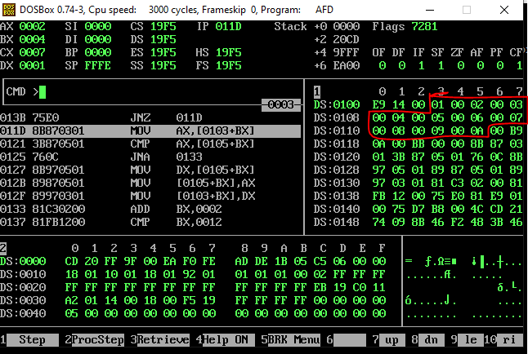

**Example2 :-**

**CODE:**

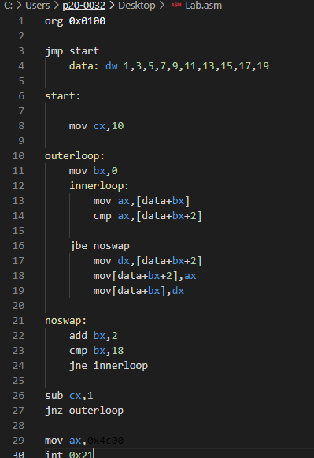

**OUTPUT:**

The Data is sorted in DS as shown below

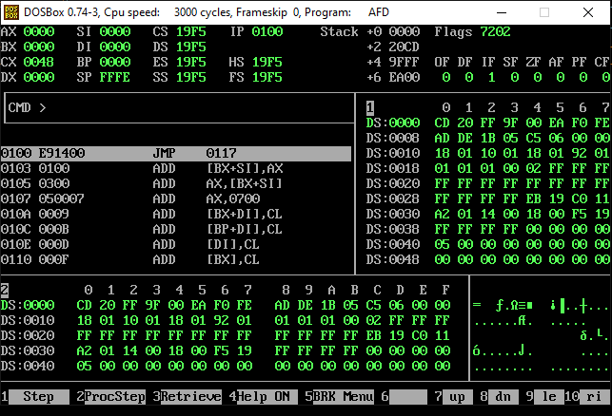

**Example3 :-**

**CODE:**

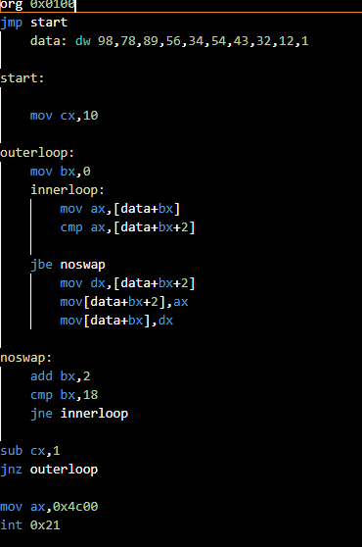

**OUTPUT:**

The Data is sorted in DS as shown below

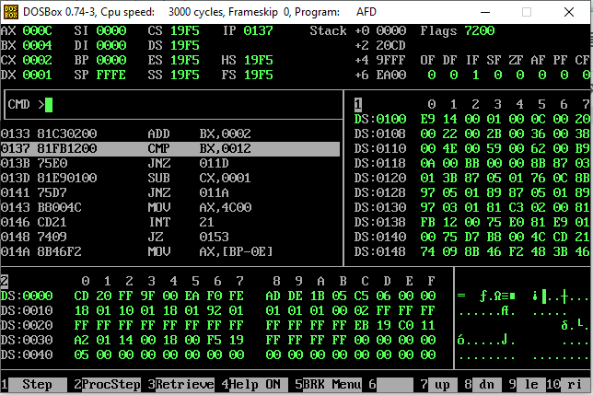

**THANKS**