Name = Abubaker Attique

Roll no = P20-0560

Lab report 7

-----------------------------------------------------------------------------------------------------------------------------

EXTENDED REGISTERS

**Addition, result would be 32bit number**

[org 0x0100]

jmp start

num1: dw 0x40FF ; 4400, 40FF

dest: dw 0x40FF

src: dw 0x1001

start:

; shift

shl byte [num1], 1

rcl byte [num1 + 1], 1

; addition

xor ax, ax ; clear

mov al, byte[src]

add byte[dest], al

mov al, [src + 1]

adc byte[dest + 1], al

mov ax, 0x4c00

int 0x21

**Multiplication, result would be 32bit number**

[org 0x0100]

jmp start

multiplicand: dw 0xC8 ; 200 = 0b 11001000

multiplier: db 0x32 ; 50 = 0b 00110010

result: dw 0 ; should be 10,000 = 0x2710

start:

mov cl, 8

mov dl, [multiplier]

checkbit:

shr dl, 1

jnc skip

mov al, [multiplicand] ; extended addition

add byte [result], al

mov al, [multiplicand + 1]

adc byte [result + 1], al

skip:

shl byte [multiplicand], 1 ; extended shift

rcl byte [multiplicand + 1], 1

dec cl

jnz checkbit

; exit syscall

mov ax, 0x4c00

int 0x21

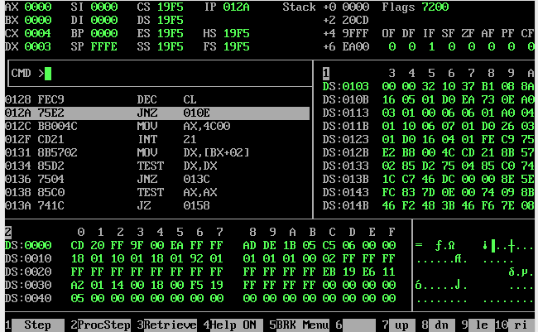

**Bitwise Operations**

1. And
2. Or
3. Xor
4. Not

**What is masking ?**

A mask is a value used to force certain bits to zero or one within some other value. A mask typically affects certain bits in an operand (forcing them to zero or one) and leaves other bits unaffected. The appropriate use of masks allows you to extract bits from a value, insert bits into a value, and pack or unpacked a packed data type.

**Why making is useful in assembly language ?**

It provides the ability for selectively disabling the interrupts. An interrupt pin which is already masked cannot interrupt, even though the interrupt pin is still in active state and the interrupts which are generally enabled using the EI set of instructions.

**Bit Masking**

Bit masks are used to access specific bits in a byte of data. This is often useful as a method of iteration, for example when sending a byte of data serially out a single pin. In this example the pin needs to change it's state from high to low for each bit in the byte to be transmitted. This is accomplished using what are known as bitwise operations and a bit mask.