NAME = Abubaker Attique
Roll no = P20-0560
Section = 3A
-----------------------------------------------------------------------------------
PRINTING

.MODEL SMALL
.STACK 100H
.DATA
DIGIT1 DB 0AH, 0DH, "ENTER FIRST DIGIT: $"
DIGIT2 DB 0AH, 0DH, "ENTER SECOND DIGIT: $"
RESULT DB 0AH, 0DH, "RESULT IS $"
.CODE
MAIN:
MOV AX, @DATA
MOV DS, AX

LEA DX, DIGIT1
MOV AH, 09H
INT 21H

MOV AH, 01H
INT 21H

MOV BL, AL

LEA DX, DIGIT2
MOV AH, 09H
INT 21H

MOV AH, 01H
INT 21H

MOV BH, AL
ADD BH, BL

MOV AL, BH
MOV AH, 00H
AAA

MOV BL, AL
MOV BH, AH

LEA DX, RESULT
MOV AH, 09H
INT 21H

MOV DL, BH
ADD DL, 30H
MOV AH, 02H
INT 21H

MOV DL, BL
ADD DL, 30H
MOV AH, 02H
INT 21H

MOV AH, 4CH
INT 21H
END MAIN

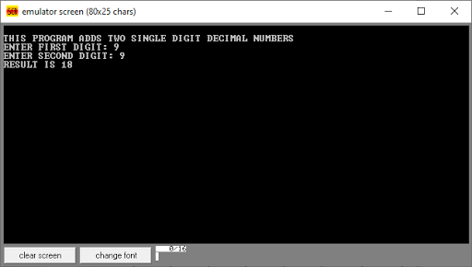

---------------------------------------------------------------------------------------------------

.MODEL SMALL
.STACK 100H
.DATA

MSG DB 0AH, 0DH, "ENTER YOUR NAME: $"
NUMBER DB 0AH, 0DH, "ENTER A DIGITI: $"
INNAME DB 20 DUP("?")
.CODE

START:
MOV AX, @DATA
MOV DS, AX

;;------------------------------------------------------------

LEA SI, INNAME

LEA DX, MSG
MOV AH, 09H
INT 21H
;;------------------------------------------------------------
MOV DX, SI
MOV AH, 0AH
INT 21H
;;------------------------------------------------------------
LEA DX, NUMBER
MOV AH, 09H
INT 21H

MOV AH, 01H
INT 21H
;;------------------------------------------------------------
SUB AL, 30H
MOV BL, AL

MOV SI, 02H
;;------------------------------------------------------------
AGAIN:

MOV DL, 0AH
MOV AH, 02H
INT 21H

MOV DL, 0DH
MOV AH, 02H
INT 21H

XOR BH, BH
PUSH BX
;;------------------------------------------------------------
DAGAIN:

MOV DL, INNAME+SI
MOV AH, 02H
INT 21H
DEC BL
CMP BL, 00H

JNZ DAGAIN
;;------------------------------------------------------------
POP BX
INC SI
CMP INNAME+SI, 0DH
JNZ AGAIN
;;------------------------------------------------------------

MOV AH, 04CH
INT 21H

END START





