NAME = Abubaker Attique
Roll no = P20-0560
Section = 3A
---------------------------------------------------------------------------------------------------------------------------
SUBROUTINES

Code 01
------------------

[org 0x100]

jmp start

data: dw 5, 6, 7, 8
swapflag: db 0

swap:
mov ax, [bx + si] ; this changes ax
xchg ax, [bx + si + 2]
mov [bx + si], ax

ret

bubblesort:
dec cx
shl cx, 1 ; This changes cx

mainloop:
mov si, 0 ; This changes si
mov byte[swapflag], 0

innerloop:
mov ax, [bx + si] ; This changes ax
cmp ax, [bx + si + 2]
jbe noswap

call swap ; another call here
mov byte[swapflag], 1

noswap:
add si, 2
cmp si, cx
jne innerloop

cmp byte[swap], 1
je mainloop

ret ; notice this!!

start:
mov bx, data
mov cx, 4

; make a function call
call bubblesort

; data is now sorted!

mov ax, 0x4c00
int 0x21

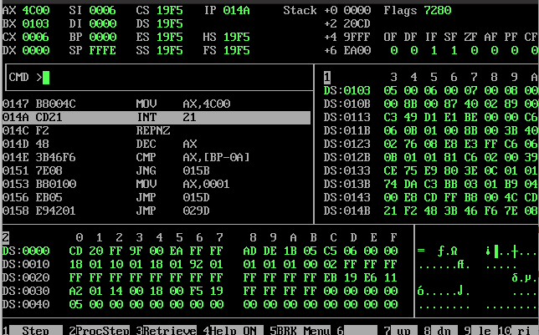

Code 02
------------------

[org 0x0100]

jmp start
array: dw 10,1,5,2,6,3,2,11
start:
mov si , 0
mov bp,0
L1:
mov di , 0
mov bx , si
mov di , si
L2:
mov ax , [array+di]
cmp [array+bx] , ax
jbe nochange
mov bx , di
nochange:
add di , 2
cmp di , 16
jne L2

mov ax , [array+bx]
mov dx , [array+si]
mov [array+bx] , dx
mov [array+si] , ax

add si , 2
cmp si , 16
jne L1

mov ax , 0x4c00
int 0x21

