NAME = Abubaker Attique
Roll no = P20-0560
Section = 3A
--------------------------------------------------------------------------------

PARAMETRIZED SUBROUTINES

Code 1:
----------------
[org 0x100]

jmp start

data: dw 60, 55
swapflag: db 0

swap:
push ax ; -----------------------;
;
mov ax, [bx + si] ;
xchg ax, [bx + si + 2] ;
mov [bx + si], ax ;
;
pop ax ; -----------------------;

ret

bubblesort:
; handle stack issue for parameters -------------
push bp
mov bp, sp

push ax
push bx
push cx
push si

mov bx, [bp + 6] ; address of data to sort
mov cx, [bp + 4] ; number of elements to sort

; same old code from here -----------------------
dec cx
shl cx, 1

mainloop:
mov si, 0 ; use as array index
mov byte[swapflag], 0 ; reset swap flag for this iteration

innerloop:
mov ax, [bx + si]
cmp ax, [bx + si + 2]
jbe noswap

call swap ; another call here
mov byte[swapflag], 1

noswap:
add si, 2
cmp si, cx
jne innerloop

cmp byte[swap], 1
je mainloop

; handle parameter stack issue at end again -------------------
pop si
pop cx
pop bx ; check removal
; pop ax
pop bp ; bp was the first thing pushed, so last popped!
; stack cleared? ----------------------------------------------

ret 4 ; what is this guy?

start:
mov bx, data
mov cx, 2

push bx
push cx
; make a function call
call bubblesort

; data is now sorted!

mov ax, 0x4c00
int 0x21

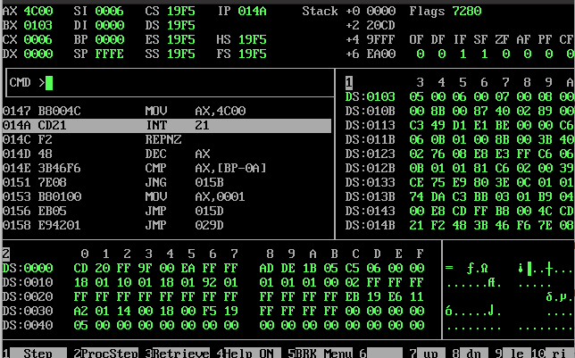

Code 2:
====================
[org 0x100]

jmp start

data: dw 60, 55
; swapflag: db 0 ; Globals are bad! Let's make this local.

swap:
push ax ; -----------------------;
;
mov ax, [bx + si] ;
xchg ax, [bx + si + 2] ;
mov [bx + si], ax ;
;
pop ax ; -----------------------;

ret

bubblesort:
; handle stack issue for parameters -------------
push bp
mov bp, sp

sub sp, 2 ; make space on the stack, just below BP
; only if you want to do local variables

push ax
push bx
push cx
push si

mov bx, [bp + 6] ; address of data to sort
mov cx, [bp + 4] ; number of elements to sort

; same old code from here -----------------------
dec cx
shl cx, 1

mainloop:
mov si, 0 ; use as array index
; mov byte[swapflag], 0 ; reset swap flag for this iteration
mov word [bp - 2], 0 ; has to be a word

innerloop:
mov ax, [bx + si]
cmp ax, [bx + si + 2]
jbe noswap

call swap ; another call here
; mov byte[swapflag], 1
mov word [bp - 2], 1

noswap:
add si, 2
cmp si, cx
jne innerloop

cmp word [bp - 2], 1
je mainloop

; handle parameter stack issue at end again -------------------
pop si
pop cx
pop bx
pop ax

mov sp, bp ; sp should be restored

pop bp ; bp was the first thing pushed, so last popped!
; stack cleared? ----------------------------------------------

ret 4

start:
mov bx, data
mov cx, 2

push bx
push cx
; make a function call
call bubblesort

; data is now sorted!

mov ax, 0x4c00
int 0x21

