

**Marketing Finance Instructions SOP3/4**

# SUMMARY OF REQUIREMENTS

**SOP 3**

* Pricing update for CY (Cigs, OTP, THP Consumables) highlighting any changes versus SOP2 submission
* Shared Cost allocation update based on any changes from SOP2 submission.
* Competition Reporting (separate guidance to be issued)

**SOP 4**

* Detailed Pricing update for CY and CY+1 (Cigs, OTP, THP Consumables) with Pricing initiatives and excise assumptions
* Marketing Investment update for CY and CY + 1 to be in line with Channel Reporting guidelines and following the new WBS structure for New Categories
* New Categories Channel Reporting for CY and CY+1 (this is mandatory for markets with > £1m of the Total NTO in Channels other than Traditional Retail)
* Shared Cost allocation between Combustibles and New Categories for CY and CY+1 based on Global Allocation rules given below

**More details on each of the above are provided in the document below.**

# PRICING UPDATE

# Reporting Requirements for upcoming cycles

The pricing tracker submission is required for CY as per the standard monthly practice. For SOP4, CY+1 and detailed pricing submissions including pricing initiatives and excise assumptions will be required.

For SOP3, Pricing update is required for CY highlighting any changes versus SOP2 submission

Further details on the automated pricing tracker are included below.

# Focus areas for SOP3/4 Reporting

1. **Automated Pricing Tracker**

• The pricing tracker is available in BPC under: Company folder -> profit and loss -> 123 - Pricing Tracker

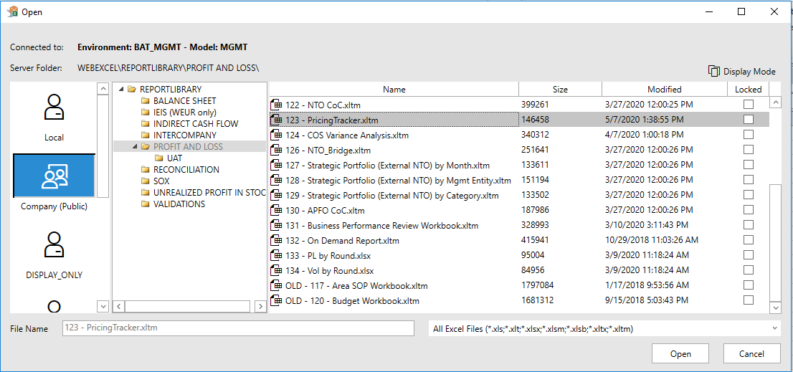

• Report can be utilised by markets if it meets the required expectations.

• Offline submission will be collected as per the current process for both CY (including YTD) and CY+1 (SOP4)

# MARKETING INVESTMENT

For the SOP4 exercise, it is important the correct level of granularity for CY and CY+1 is reported for the following:

* Product Category (e.g. Combustibles, THP, Modern Oral, Vapour)
* Half year phasing
* Channels (For NC only)
* Cost Element Group

# SHARED COST ALLOCATION (Not applicable to US)

The purpose of this section is to summarise the Group’s approach to accounting for shared and dedicated costs for Marketing in terms of allocation to respective Material Groups (Combustibles, New Categories etc). The guidance applies to both 2021 and 2022.

As an example, dedicated costs would include employee expenses for Trade Representatives covering New Categories only. Shared costs would include a Head of Marketing Finance who would split their time between Traditional and New Categories. Allocation rules are required to split Shared Costs between different categories.

**Approach to be followed**

|  |  |  |
| --- | --- | --- |
| **P&L Line** | **Direct Cost Allocation** | **Shared Cost Allocation** |
| Above NTO lines | Automatically allocated at SKU level |  |
| MI in GTO | Automatically allocated based on WBS |  |
| Cost of Sales | Automatically allocated at SKU level and Cost Centres | Shared Cost to be allocated based on NTO proportion ONLY if the TOTAL New Categories NTO is more than 10% of Market NTO.  In the case where a market has more than one New Category products (THP, Vapour, Modern Oral), cost should be allocated if the total NTO of combined New Categories exceed 10% of Market NTO.  e.g. If a market has 3% THP NTO, 5% Vapour NTO and 4% Modern Oral NTO, it needs to allocate shared costs to New Categories as combined NTO is more than 10%. Shared Costs should be proportioned between different Products based on their NTO. So, 3% of Shared Costs should go to THP, 5% to Vapour and 4% of Modern Oral. |
| Brand Expenditure | Automatically allocated based on WBS |  |
| NBE: RTM Overheads | To be allocated if 100% dedicated to New Categories | Shared Cost to be allocated based on NTO proportion ONLY if the TOTAL New Categories NTO is more than 10% of Market NTO.  In the case where a market has more than one New Category products (THP, Vapour, Modern Oral), cost should be allocated if the total NTO of combined New Categories exceed 10% of Market NTO.  e.g. If a market has 3% THP NTO, 5% Vapour NTO and 4% Modern Oral NTO, it needs to allocate shared costs to New Categories as combined NTO is more than 10%. Shared Costs should be proportioned between different Products based on their NTO. So, 3% of Shared Costs should go to THP, 5% to Vapour and 4% of Modern Oral. |
| NBE: Marketing Overheads |
| R&D Costs |
| *Admin Overheads | Shared Costs allocation not required. |
| *OIE |

*These lines are not required for Category Contribution but are used for assessing LRD profitability, hence the requirement.

**Markets will need to create dedicated New Categories cost centres (if not already set up) to enable the correct reporting. Material Group related to New Categories’ product must be assigned to each New Categories’ cost centre.**

# NEW CATEGORIES INSTRUCTIONS FOR SOP4

Unless specified otherwise, the below reporting requirements for New Categories apply to 2021 and 2022:

**Net Turnover**

• Review the NTO/unit for each Brand Range to ensure the reporting is accurately reflected.

**Brand Range Reporting**

• Reporting for all markets (including Non-TaO) should be focused on specific Brand Ranges only, e.g. epen3. Action for Markets/Regions: Attached is a list of the Brand Ranges which markets should focus on – please ensure that the reporting of NTO and CoS (absolute and per unit) is addressed, particularly for these ranges only.

* Though there are currently no THP consumable Brand Ranges, it must be ensured that the financials are allocated correctly to either the King Size Demi-Slim (KDS) or King Size Super-Slim (KSSS) formats



**Channel and Cost of Fulfilment Reporting**

• Brand Expenditure should be reported in accordance with the Pink Book and Orange Book guidelines. Brand Expenditure should be allocated accordingly to the relevant Cost Element Group (CEG), whilst the CEG ‘Other Consumer/Customer Focused’ should not exceed 5% of the Total Brand Expenditure in each market.

* Markets with New Categories are required to report MI by Channel for 2021 and 2022 according to the Orange Book
* For all markets who sale through channels other than Traditional retail, the following Cost Centres need to be correctly reported to be used in New Categories cost of fulfilment reporting
* NBE - Marketing Overheads - Consumer Retail Outlets
* NBE - Marketing Overheads - Consumer Digital Activation: Ecommerce (ISSC)

**Channel Reporting**

There is an increasing Group focus on the channels through which New Categories are sold. Because of this, Channel Reporting in BPC will be required for **CY and CY+1 Forecast Volumes and Financials** in markets that have > £1m of the Total NTO in Channels other than Traditional Retail. The requirement for Channel Reporting covers TaO and Non-TaO markets.

**Markets that cannot perform Channel Reporting due to RTM Model or any system limitations should inform the Central New Categories Finance team in advance.**

A full channel breakdown is required for P&L all lines from Sales Volume to External Net Turnover. Channel splits for COS are not currently required.

The key channels which need to be reported are:

-Traditional retail

-NGP shops owned by BAT

-NGP shops owned by 3rd parties

-Online BAT owned

-Online owned by 3rd parties

In order to report Channel Volumes and Financials, markets are required to use the Analysis Dimension in BPC. No further granularity past the above Channels is required. However, it must be ensured that, the split of the Channels is correct and there are no volumes or revenue financials remaining under the “No Analysis” category.

In order to report volumes and revenue by Channel, a one-time set up must be completed in ECC. Each existing customer in SAP will be mapped to the relevant customer group in its Masterdata. Once this has been done, Actual sales will flow to the correct Channel without any other intervention. Also, going forward any new customers must have the customer group entry data field completed when raising a new Masterdata request.

Markets must then use drivers-based forecast. This means End Markets must maintain drivers for each Channel in BPC. This can be done by copying the drivers from ECC to BPC. SPI will then have to report volumes by Channel. The drivers will then ensure Financials are populated by Channel.

**MI in GTO Allocation**

Markets are to ensure that BE: Customer Investment is reported accordingly for all Product Categories / Brands to generate an accurate MI in GTO reflected in NTO. As guiding principles:

* If a contract clearly states the investment breakdown by Product Category and/or Brand, then the MI must be reported accordingly, using the relevant WBS.
* In cases whereby a single contract covers multiple Product Categories / Brands, markets are advised to reflect the MI between different Product Categories / Brands based on:
  + Share of space used (e.g. Assortment and Listing Fees) or;
  + Duration of the promotion or;
  + Any other criteria that generates an appropriate reflection of spend

For consistency, defined WBSs and SKUs should be assigned and the use of dummy SKU/WBS should be kept to an absolute minimum.

Allocation from below to above NTO should be based on GTO of each SKU within the Brand specified in the WBS. This is required for both Actuals and Forecast reporting going forward. **Markets and GBS teams are required to ensure that no other allocation method is used**. Below is an example of this:

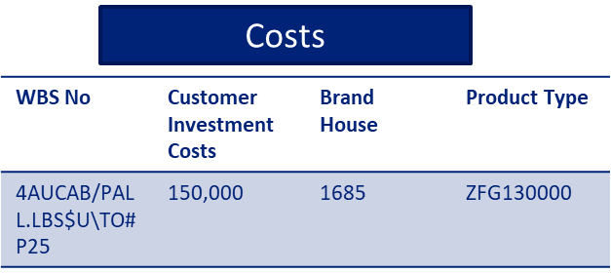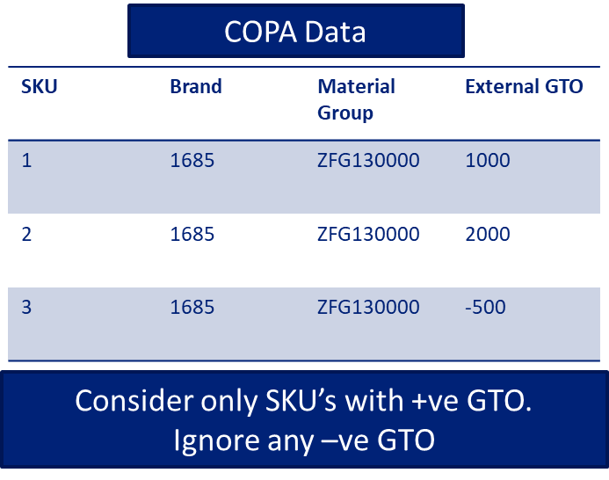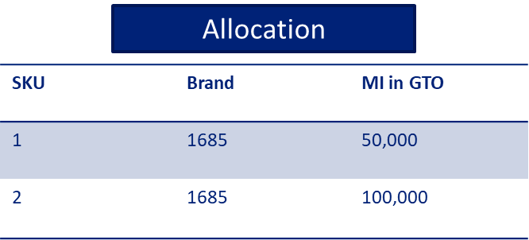 Step 1: Cost posted against WBS Step 2: Assessment of GTO of each SKU Step 3: Posting above NTO based on GTO

GBS will perform the above allocation during month-end reporting (utilizing Alteryx / VBA), and will liaise with End Markets to deliver an accurate allocation.

The allocation will be made for **all SKUs** and therefore cover **all Product Categories.**

Below are examples of unique cases whereby GBS will liaise with End Markets to ensure the allocation is applied correctly:

1. **Different Material Group in Product settings (SKU) versus WBS settings.**

E*xample: The Material Group for a WBS EPOK was settled as FG Oral Nicotine Pou (ZFG13500****3****) and the sales were posted under SKUs with material group FG Oral Tob Pouch (ZFG13500****4****).*

Solution: End Markets must reclassify the amount to another WBS, taking into consideration the Sales registered in the current month

1. **Customer Investments costs booked without sales** (Pre-sales marketing expenses, automated SAP settings for WBS amounts distributed as percentages per different brands, etc.)

*Example:  Epok WBS expenses registered in April, without any sale booked during the month*

Solution: To reallocate the amount on dummy SKUs with EM approval

1. **Customer Investments costs booked with negative sales (GTO) only**

              Solution: To reallocate the amount on dummy SKUs with EM approval

MI in GTO spend for New Categories will be automatically allocated in General Stores – GS (Traditional Retail Channel) for both actual and forecast, the only exceptions being the entities which are currently using the Customer/Territory breakdown: Australia, SAA DF, Indo China DF, Japan DF, GTR, HK China DF, Channel Islands