FUNCTIONAL REQUIREMENTS

Product Name: SWAGLABS

Prepared by: Md. Abu Hanif Siam

Date: May 04, 2025

## **Overview**

SWAGLAB is free open source e-commerce platform for online merchants. SWAGLAB provides a professional and reliable foundation from which to build a successful online store. This foundation appeals to a wide variety of users; ranging from seasoned web developers looking for a user-friendly interface to use, to shop owners just launching their business online for the first time. SWAGLAB has an extensive amount of features that gives you a strong hold over the customization of your store. With SWAGLAB's tools, you can help your online shop live up to its fullest potential.

## **Requirements**

SWAGLAB requires certain technical requirements to be met for the store to operate properly. First, a web server must be created to make the SWAGLAB store publicly available on the web. Domain names and hosting services can easily be purchased for an affordable price.

When selecting a hosting service, you should check to see that these server requirements are provided and installed on their web servers:

These extensions must be enabled for SWAGLAB to install properly on the web

server.

* PHP 5.4
* jQuery 2.1.1
* JavaScript
* Database (MySQL suggested)
* Web Server (Apache suggested)

## **SWAGLAB Frontend**

This Document is intended to be used as an introduction to the SWAGLAB default store front. The store front reveals how the customer views and interacts with the store.The products seen above are included as sample data with the SWAGLAB installation. These products can easily be removed and replaced with the shop's products later.

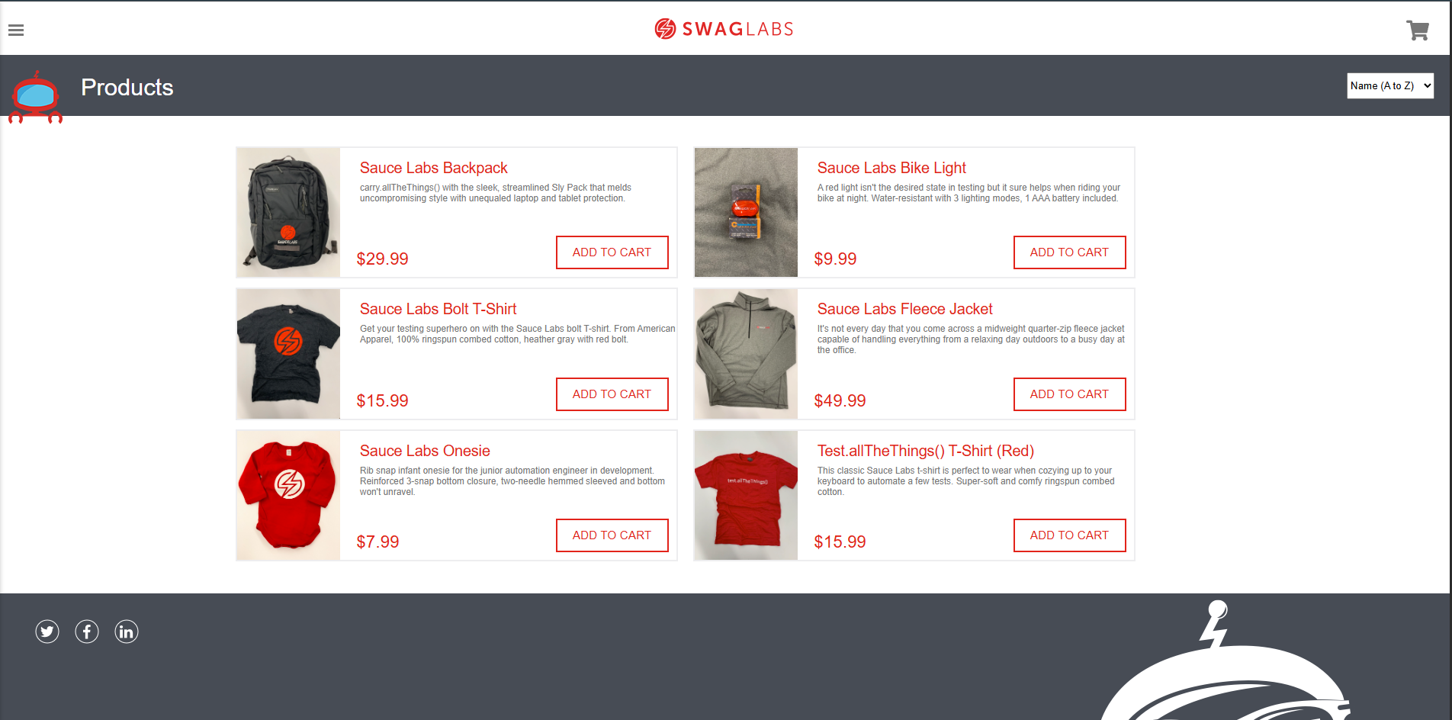

# **Navigating the shop**

The SWAGLAB default theme makes navigating a shop's products easily accessible to its customers.

## **Home page**

The home page is arguably the most important page in the shop, in terms of presentation. In most cases, this will be the first page that a customer interacts with (especially if they are directed to the store site from a search engine). The shop's homepage needs to be user-friendly, while at the same time highlighting the shop's products. The first step in becoming familiar with the store front is understanding the anatomy of the SWAGLAB default homepage.

### **The Header**

The header will be displayed at the top of the page, on every page of the store; not just the home page.



The header has the following navigation options:

* Store logo: The store logo is not responsive. It is only given for the design purpose.
* Shopping Cart: Displays the number of items purchased, and the total price of the order. Clicking on the button will contain all of the products added to the cart and an option to "View Cart" or "Checkout".
* Filter out box: The customers can sort the products compared to the name in ascending or descending order or price from low to high or high to low.

### **Featured Products**

SWAGLAB gives you the option of featuring specific products of their choosing on the home page.

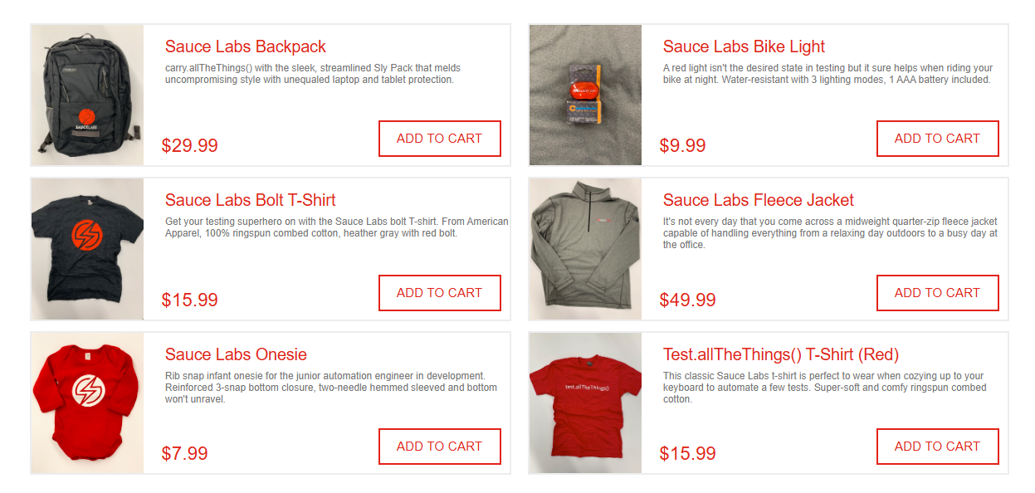

The Featured section includes the product image, name, price and an option to add the product directly to the Shopping Cart.The carousel is only located on the Home Page in the default.

## **Product Pages**

The SWAGLAB default product page will follow the structural format seen below.

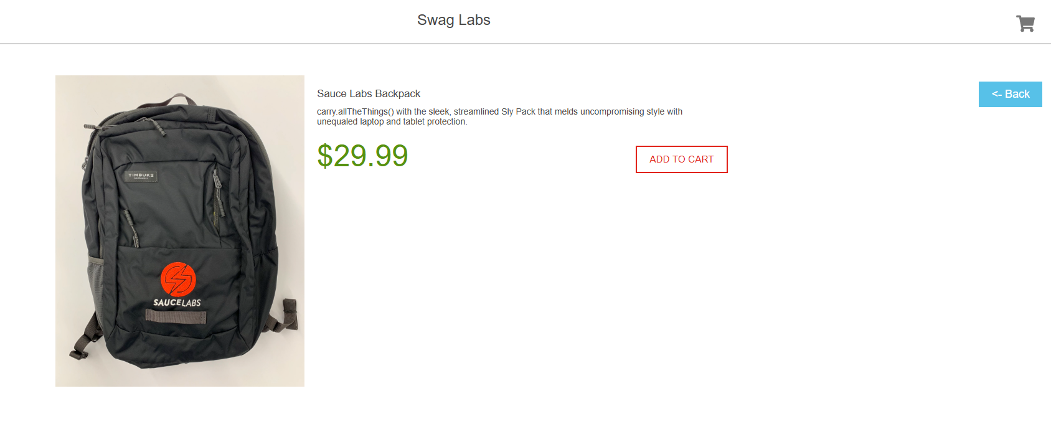

The product page can be divided into the following sections:

* Product image: The product image can be displayed on the left of the product details and price.
* Product details: The description of product materials given there.
* Add to Cart: The customer adds the product to the cart. And then if the customer wants to remove the product. They can remove it by clicking the remove button.
* Back Button: To get back to the home page, clicking on this button will take to the home page
* Shopping Cart: To checkout, click on the shopping cart and it will take to the checkout page.

## 

## 

## 

## **Shopping Cart Page**

Once a customer adds a product to the cart, they can access the shopping cart in the header under "Shopping Cart".

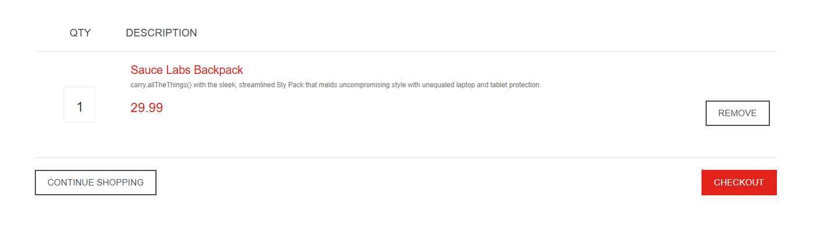

The shopping cart gives an overview of the product selected by including the categories "Product Name","Quantity", "Unit Price", and "Total". The customer has an option to “Remove” the product. The "Continue Shopping" button links back to the homepage.

## **Checkout**

Once a product has been added to the cart, the customer can continue to the checkout to make their product purchase. The Checkout page can be accessed in the header section of “Your Cart ”page Customer checkout using SWAGLAB is a simple process that can be completed in 6 steps.

Step 1: Checkout options

The customer can log into account

Step 2: Billing details

Personal details including "First Name", "Last Name" and "Zip/Postal Code"are filled into a form.

Step 3: Delivery details

In Billing Details, the user can check a box to indicate that the delivery details and billing details are the same. This will cause it to skip over this step to Delivery Method. If the delivery details are different from the billing details the customer can enter this information in a form in this section.

Step 4: Payment method

The website automatically adjust the payment

Step 6: Finish the order

In this last step, the customer will see an overview of their purchase; including the product description, quantity, and price (with tax & shipping).

