# Virtual IBAN Engine — Requirements, Design & API Specification

## 1. Goal

## 2. Actors

## 3. High-level Functional Requirements

### 3.1 Pool Account per Merchant

### 3.2 Virtual IBANs

### 3.3 Balances & Transactions

Engine maintains ledger for:

Transactions can be:

### 3.4 T24 Integration

### 3.5 Merchant APIs

### 3.6 Accounting Principles

### 3.7 Operational

## 4. Non-functional Requirements

## 5. Important Business & Technical Assumptions

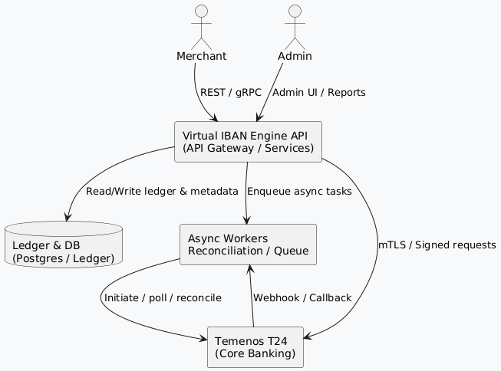

**Diagram 1: System Architecture**

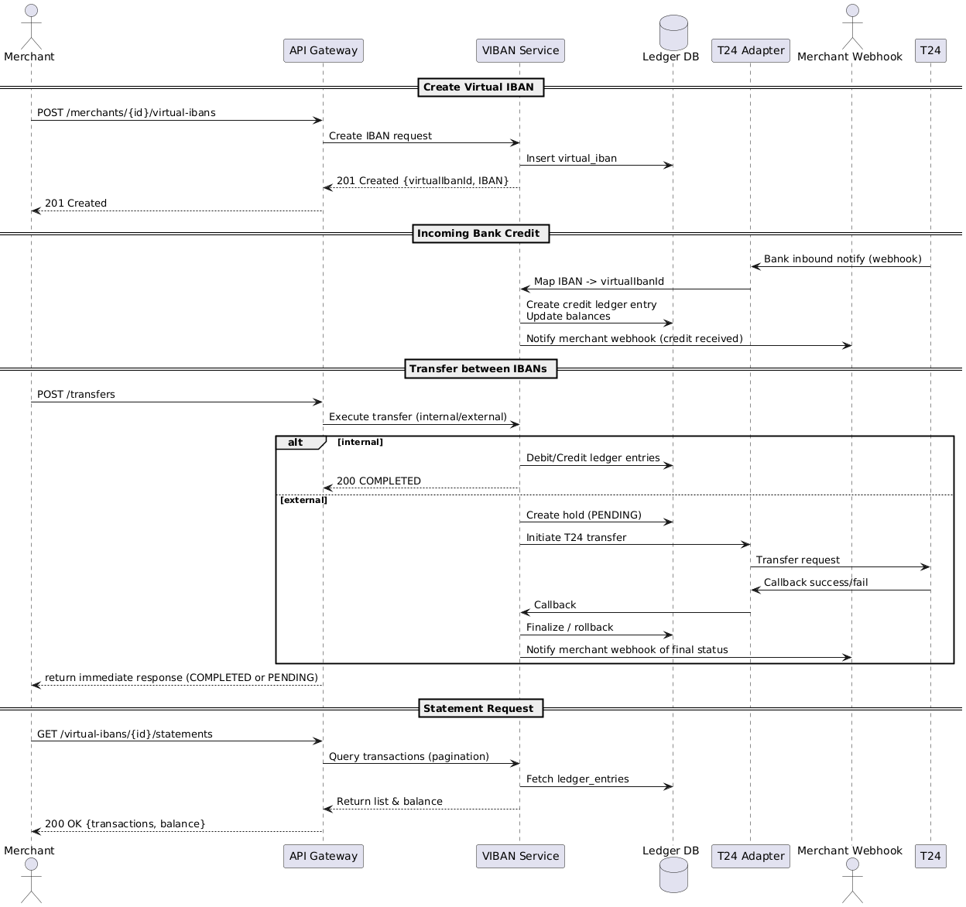

**Diagram 6: Merchant API Interaction Flow**

## 8. Data Model (Tables)

### merchants

### pool_accounts

### virtual_ibans

### ledger_entries

### transactions (logical)

### t24_events (store callbacks)

### audit_log

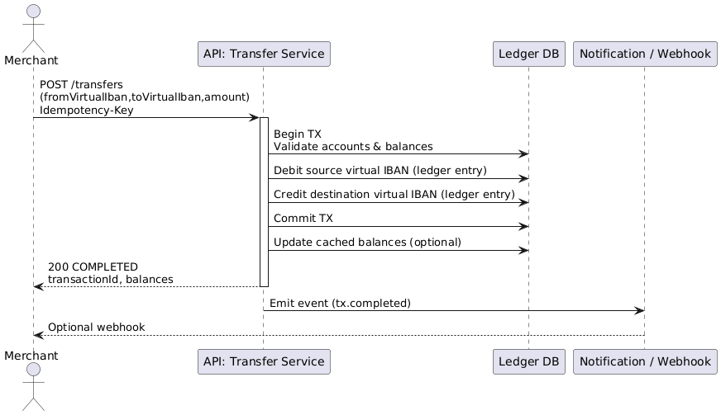

**Diagram 2: Internal Transfer Sequence (Same Pool)**

## 10. Error Handling & Statuses

## 11. Idempotency & Duplicate Prevention

## 12. Security & Compliance

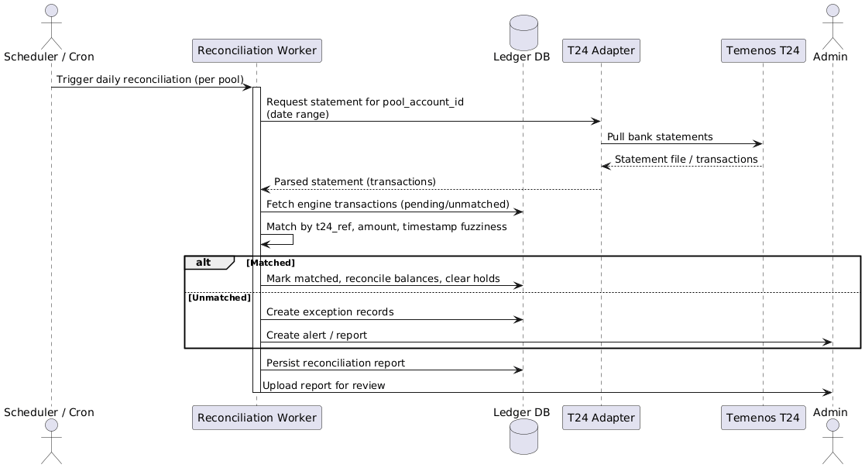

**Diagram 5: Reconciliation Flow (T24 ↔ Engine)**

## 14. Monitoring & Observability

## 15. Testing & QA Checklist

## 16. Operational & Deployment Notes

## 17. Example SQL Snippets (Postgres)

## 18. Edge Cases, Checks & Recommendations (Must-have)

## 19. Diagram Reference

All diagrams are now integrated into their relevant sections throughout this document:

**PlantUML Source Files:**All diagram sources are available in the diagrams/directory for rendering.

**How to Render:**Visit , paste the content from any .pumlfile, and export as PNG or SVG.

## 20. Roadmap & Optional Features

## 21. Deliverables & Next Steps (Recommended)

## 22. Summary Validation Checklist