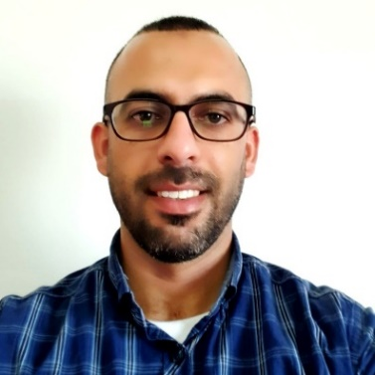Sanad Ahmad Mobile: 0594 55 80 90

Email: sanad.ahmed2000@gmail.com

Address: Jaba' – Jenin – Palestine

Jobs: IT Project Manager | AI Trainer

______________________________________________________________________________________

** Academic Qualifications

|  |  |  |  |  |
| --- | --- | --- | --- | --- |
| Degree | Track | Institution | Year | GPA |
| Tawjihi | Scientific | Secondary School | 2007 | 3.7 |
| Bachelor | IT: Computer Science | Arab American University | 2011 | 3.76 |
| Master | Computer Science: Machine Learning | Arab American University | 2021 | 4.00 |
| Ph.D. Candidate | Artificial Intelligence:  Natural Language Processing - NLP | Birzeit University | 2024 | 3.7 |

** Publications

1. [NLU-STR at SemEval-2024 Task 1: Generative-based Augmentation and Encoder-based Scoring for Semantic Textual Relatedness](https://scholar.google.com/citations?view_op=view_citation&hl=en&user=e1jnMCoAAAAJ&sortby=pubdate&citation_for_view=e1jnMCoAAAAJ:2osOgNQ5qMEC)
2. [Context-Gloss Augmentation for Improving Arabic Target Sense Verification](https://scholar.google.com/citations?view_op=view_citation&hl=en&user=e1jnMCoAAAAJ&citation_for_view=e1jnMCoAAAAJ:u-x6o8ySG0sC)
3. [Salma: Arabic sense-annotated corpus and wsd benchmarks](https://scholar.google.com/citations?view_op=view_citation&hl=en&user=e1jnMCoAAAAJ&citation_for_view=e1jnMCoAAAAJ:9yKSN-GCB0IC)
4. [Classification and Prediction of Low-Density Lipoprotein Cholesterol LDL-C …](https://scholar.google.com/citations?view_op=view_citation&hl=en&user=e1jnMCoAAAAJ&citation_for_view=e1jnMCoAAAAJ:u5HHmVD_uO8C)
5. [Detecting Network Traffic-based Attacks Using ANNs](https://scholar.google.com/citations?view_op=view_citation&hl=en&user=e1jnMCoAAAAJ&citation_for_view=e1jnMCoAAAAJ:d1gkVwhDpl0C)

** Work Experience

1. Dimensions InfoTech – Palestine (<http://dimensions-infotech.com>)
   1. Eclaims and Integration Specialist Jan 2018 – Now
2. Dimensions Healthcare – Dubai (<http://www.dimensions-healthcare.com/>)
   1. Software Development (4 years) & Team Lead (2 years): Jan 2012 - Jan 2018
3. Arab American University – Palestine (https://www.aaup.edu/)
   1. Teaching Assistant: Jan 2011 - Jan 2012
4. Robotics & AI – Palestine
   1. Trainer (Workshops & Training Programs): Jan 2021 - Now

** Key Experiences

|  |  |
| --- | --- |
| Business | Technical |
| Markets: Palestine, Dubai, and Saudi Arabia | Technology: ASP.Net (Forms), WCF, EF6 |
| IT Project Management & Team Lead | Robotics, AI, & NLP: Python + Models |
| System Analysis | Web App\Service Development |
| Technical Consultation | Code Management: GitLab, VSTS, SVN |
| Clients Relationships | Help Desk & Support |
| Business Development | Research & Teaching Assistance |

** Languages Mother tongue Arabic, & Very Good English