

American International University-Bangladesh (AIUB)  
Department of Computer Science  
Faculty of Science &Technology (FST)  
Spring 21 22

Section: B  
Software Quality Assurance and Testing

Recycle Trash

A Report submitted By

|  |  |  |
| --- | --- | --- |
| SN | Student Name | Student ID |
| 1 | MD Abu Torab Ibnul Baki | 18-38814-3 |
| 2 | Abu Hasnat Jelani Chahad | 19-39734-1 |
| 3 | Hordoya Banik | 18-37995-2 |
| 4 | MD. Hasibul Hasan | 19-39610-1 |

Under the supervision of

Abhijit Bhowmik

Associate Professor

Department of Computer Science

Faculty of Science & Technology

American International University-Bangladesh

Software Test Plan

for

Recycle Trash

Version 1.0 approved

Prepared by

MD Abu Torab Ibnul Baki

Abu Hasnat Jelani Chahad

Hordoya Banik

MD. Hasibul Hasan

American International University-Bangladesh

20 April, 2022

Table of Contents

Revision History 3

1. TEST PLAN IDENTIFIER:RS-MTP01.3 4

2. REFERENCES 4

3. INTRODUCTION 4

3.1 Background to the Problem 4

3.2 Solution to the Problem 4

4. REQUEIREMNT SPECIFICATION 4

4.1 System Features 4

4.2 System Quality Attributes 6

4.3 System Interface 7

4.4 Project Requirements 10

5. FEATURES NOT TO BE TESTED 11

6. TESTING APPROACH 12

6.1 Testing Levels 12

6.2 Test Tools 13

6.3 Meetings 17

7. TEST CASES 18

8. ITEM PASS/FAIL CRITERIA 28

9. TEST DELIVERABLES 28

10. STAFFING AND TRAINING NEEDS 28

11. RESPONSIBILITIES 29

12. TESTING SCHEDULE 30

13. PLANNING RISKS AND CONTINGENCIES 31

14. APROVALS 31

# Revision History

|  |  |  |  |
| --- | --- | --- | --- |
| Revision | Date | Updated by | Update Comments |
| 0.1 | 2022.04.10 | MD Abu Torab Ibnul Baki | First Draft |
| 0.2 | 2022.04.11 | Abu Hasnat Jelani Chahad | Second Draft |
| 0.3 | 2022.04.12 | Hordoya Banik | Third Draft |
| 0.4 | 2022.04.13 | MD Abu Torab Ibnul Baki | Forth Draft |
| 0.5 | 2022.04.14 | MD Abu Torab Ibnul Baki | Fifth Draft |
| 0.6 | 2022.04.16 | MD. Hasibul Hasan | Sixth Draft |
| 0.7 | 2022.04.17 | Hordoya Banik | Seventh Draft |
| 0.8 | 2022.04.18 | MD Abu Torab Ibnul Baki | Eighth Draft |
| 0.9 | 2022.04.20 | Abu Hasnat Jelani Chahad | Ninth Draft |

# TEST PLAN IDENTIFIER:RS-MTP01.3

# REFERENCES

* Software Quality And Testing Course PowerPoint Slides
* [What is Postman Automation? - GeeksforGeeks](https://www.geeksforgeeks.org/what-is-postman-automation/#:~:text=Postman%20is%20a%20cutting-edge%20Automation%20tool%2C%20which%20can,Postman%20Runner%20functionality%20this%20feature%20can%20be%20used.?msclkid=d6e6137bc00311ecbd51cacea19a9553)

# INTRODUCTION

## 3.1 Background to the Problem

We often throw out our unused stuff. Unused stuff could be our unusable clothes, paper, different kitchen utensils like pot and pans, broken mobile phone and laptop that mix various elements of the environment such as soil, water cause of environmental balance. Again, these unused stuffs accumulate in our home and cause our home burdens. These unusable stuffs are no longer used for any of our purpose and occupy the place of residence.

## 3.2 Solution to the Problem

So our purpose is to recycle this unusable stuff. So we want to develop a platform where people can sell their unusable stuff. These unusable stuff will be collected on behalf of our platform and recycle them. Collecting unusable stuff and turning them into usable things can no longer upset the balance of the environment. Moreover people will be able to earn some money by selling these unusable stuff to us without leaving them at home.Through this system, it will be possible to collect unusable stuff without any physical labor. Those unusable stuff can be recycled and sold in the outside market.

# REQUEIREMNT SPECIFICATION

## System Features

**1.Employee/buyer Feature**

1.1 Register to the website to make their own account

1.2 Login to the website

1.3 Logout from the system

1.4 Can change the password

1.5 Can see all product(unusable stuff)

1.6 Can delete any product using the unique product id

1.7 Can see all seller

1.8 Can delete any seller using seller unique id

1.9 Can contact seller

1.10 Can contact system admin

1.11 Can add or remove vouchers

Priority Level: High

Precondition: admin must have valid user name and password

**2.Admin Feature**

2.1 Register to the website to make their own account

2.2 Login to the website

2.3 Logout from the system

2.4 Can change the password

2.5 Can see all product(unusable stuff) and delete any product

2.6 can delete any employee

2.7 can view all employee

2.8 Can see all seller

2.9 Can delete any seller using seller unique id

Priority Level: High

Precondition: employee must have valid user name and password

**3.Seller Feature**

3.1 Register to the website to make their own account

3.2 Login to the website

3.3 Logout from the system

3.4 Can change the password

3.5 can add product to the website

3.6 can delete own product

3.7 Can contact system admin

3.8 Can add own location information

Priority Level: High

Precondition: seller must have valid user name and password

## System Quality Attributes

1. **Usability:** This can be measured in terms of ease of use. The application should be user-friendly. A regular user of ours should be able to post about his/her products on an average of 3 minutes and a maximum of 5 minutes. Our system features are easy to learn as navigation is very simple. It’s also Easy for a new or infrequent users to learn to use the system.
2. **RELIABILITY AND CORRECTNESS:** No software is free from bug. Our software gives the exact output what user wants, It’s correctness has been ensured. Our software does not crash randomly as It has been tested and no false output is generated so It’s more reliable to use for our users.
3. **Modularity**: Every system we have to develop module wise. In our system there are also many modules and it has been integrated to make it a whole system. So we can easily detect bugs in any module and then we just have to solve that particular module we don’t have to think about other modules so it makes the work easy for our tester. In addition of that we can also add new features in our system as it has been developed module wise.
4. **Maintainability:** It means how easily the maintenance team can perform their task. The main task of our maintenance team is to solve the bugs, adding something new or changing some features. Our one maintenance programmer shall be able to modify any features with 25 labor hours or less of development effort.
5. **Efficiency:** Major system quality attribute. Measured in terms of time required to complete any task given to the system. The application will have large scale in efficiency.
6. **TESTABILITY:** It means how easily the testing team can perform their task. Testability is very much depended on modularity and as our system is developed module wise so tester will have a easy going, they don’t have to check every module to fix bugs.
7. **FLEXIBILITY:** The effort required to modify an operational program. A maintenance programmer who has at least eight months of experience supporting this product shall be able to make a new copy output available to the product, including code modifications and testing, with no more than 2 hour of labor*.*

## System Interface

**1. Login interface :**

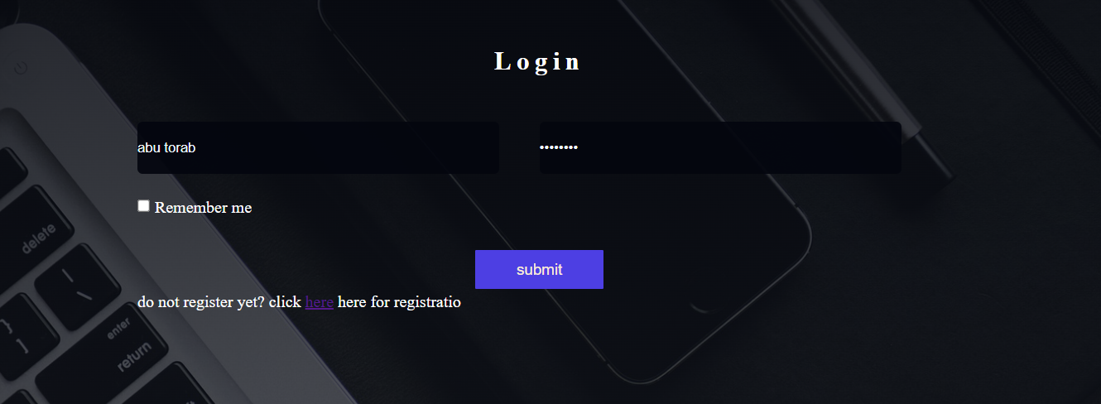

**2. Registration interface:**

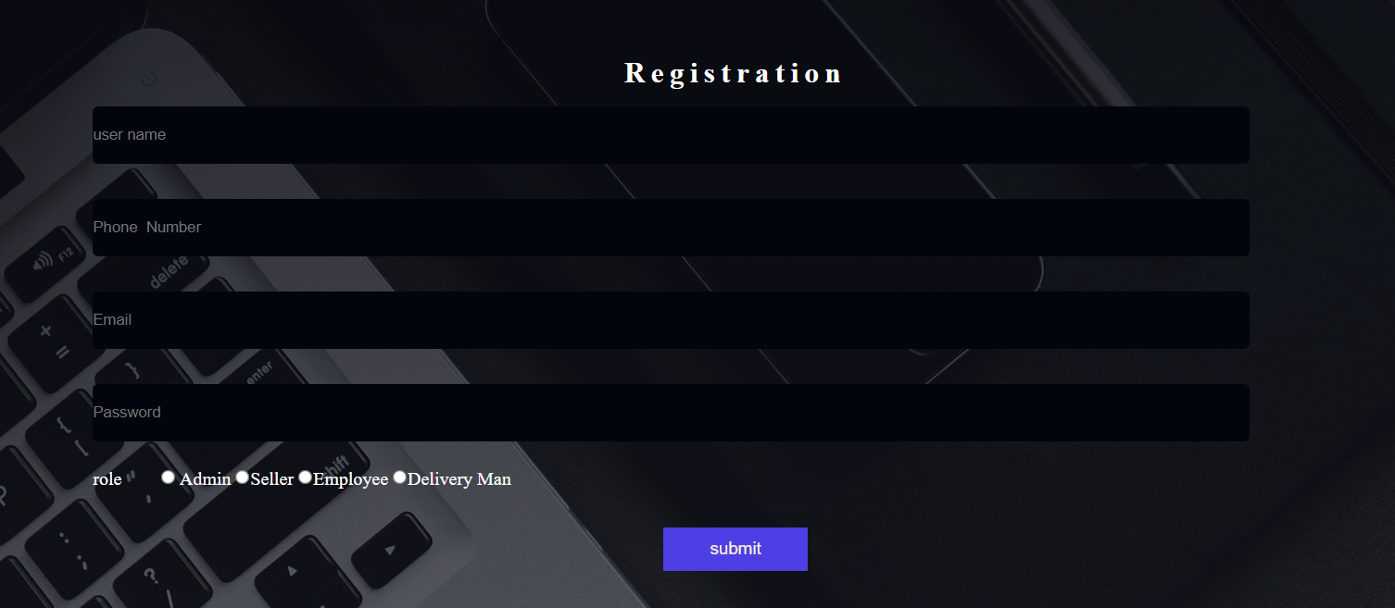

**3. Password Change Interface:**

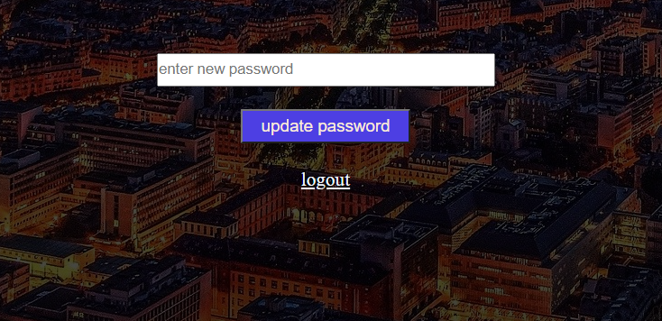

**4. View Seller interface:**



**5.Delete Seller interface :**



**6. View Product interface :**

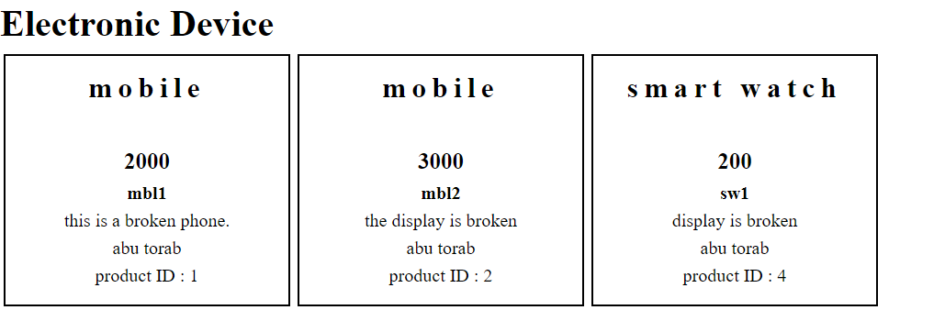

**7. Delete product interface:**

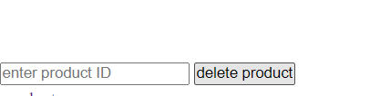

## Project Requirements

Effort Estimation:

Our project is to develop an application named “Recycle Trash”.

Development Time = 2 Months

Required number of peoples = 4

Budget Estimation:

Duration in weeks = 2*4 = 8 weeks

Office days = 5 days

Working hours = 8 Hours

So Per week working hours is = (5*8) hours

= 40 hours

So Total Working hours is = (40*8) hours

= 320 hours.

Developer salary is = 1000 Taka

Total developers Salary = (1000*320) Taka

= 320000 Taka

|  |  |  |
| --- | --- | --- |
| Expanse | Amount | Total Amount |
| Salary for 4 developer |  | 320000 Taka |
| 3 months office rent | 3*10000 | 30000 Taka |
| Electricity and other costs |  | 20000 Taka |
| 1 months Maintenance  cost | 4*10*1200 | 48000 Taka |
| Travel Cost | 1*5000 | 5000 Taka |
| Total Cost |  | 423000Taka |
| 15% of total cost(profit) |  | 63450 Taka |
| Now total budget is |  | 486450 Taka |

# FEATURES NOT TO BE TESTED

The following is a list of the areas that will not be specifically addressed. All testing in these areas will be indirect as a result of other testing efforts. For example:

**Buyers can contact system admin**: In our web application there is a feature where a buyer can contact system admin. This feature is not to be tested in this release of the software.

**Buyers can contact seller**: A buyer can contact seller feature was not tested because of low risk, has been tested before and was considered stable.

**Buyers can add or remove vouchers:** Buyer can add a voucher or remove a voucher in our application. It will be released but not tested as a functional part of the release of this version of the software.

**Seller Can contact system admin**: This feature was also not been tested because of the same reason of buyer can contact seller feature, due to low risk.

**Seller Can add own location information:** We have a feature in our system where a seller can add own location but it is not mandatory at the first place and due to a tight schedule to follow so we opt out this feature to be tested of this version of the software.

# TESTING APPROACH

* **Unit Testing:** First we will do the Unit Testing. **In this testing we will tests individual software units or components. For instance, each class or method. The goal is to ensure that each unit of software code works as intended. This testing is carried out by developers throughout the development (coding) phase of an application.** In this step, we will implement “White Box Testing” technique.
* **Integration Testing:** After that in the second part we will do the Integration. **In this testing we will make sure that** all the software modules are integrated logically and tested as a group. Our project is made up of several software modules written by Four programmers. The goal of this level of testing is to find flaws in the way various software modules interact when they're integrated. In this step, we will follow the “Bottom-up Integration” technique.
* **System Testing:** Then we will do the system testing. Through the system testing we will test of full-featured, fully integrated system. Then we will verify if it meets all the requirement . Black-box testing falls under this condition. So ,At this level, we will follow “Black Box Testing” technique.
* **Acceptance Testing:** The last phase of our testing is Acceptance Testing. We will do this Testing for checking the acceptability of our product. This test will be done to check whether any defect missed during the functional testing phase. At this level, we will follow the “Black Box Testing” technique. After that, we may run unit tests again.

## Testing Levels

* SYSTEM/INTEGRATION Testing will be performed by the test manager and development team leader with assistance from the individual developers as required. No specific test tools are available for this project. Programs will enter into System/Integration test after all critical defects have been corrected. A program may have up to two Major defects as long as they do not impede testing of the program (I.E. there is a work around for the error).
* UNIT TESTING will be done by the developer, and the results will be authorized by the team lead. Before unit testing may be accepted and passed on to the test person, the programmer must submit proof of unit testing (test case list, sample output, data printouts, defect information). The test person will receive all unit test information as well.
* The customer will do ACCEPTANCE testing with the help of the test manager and development team leader. After the System/Integration test is completed, the acceptance test will run in parallel with the existing manual ZIP/FAX process for one month.

## Test Tools

1. Post Man

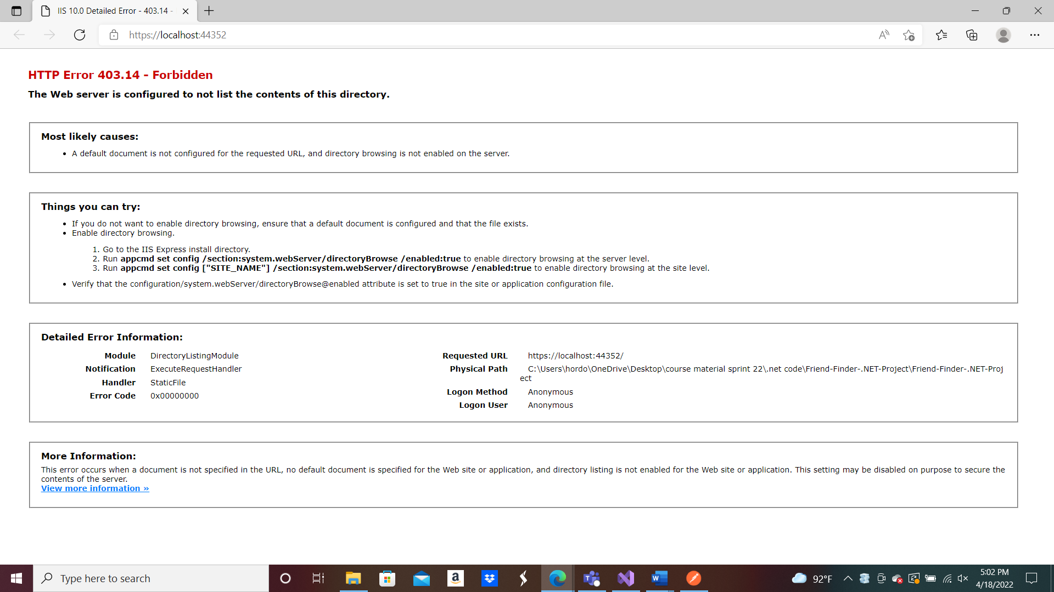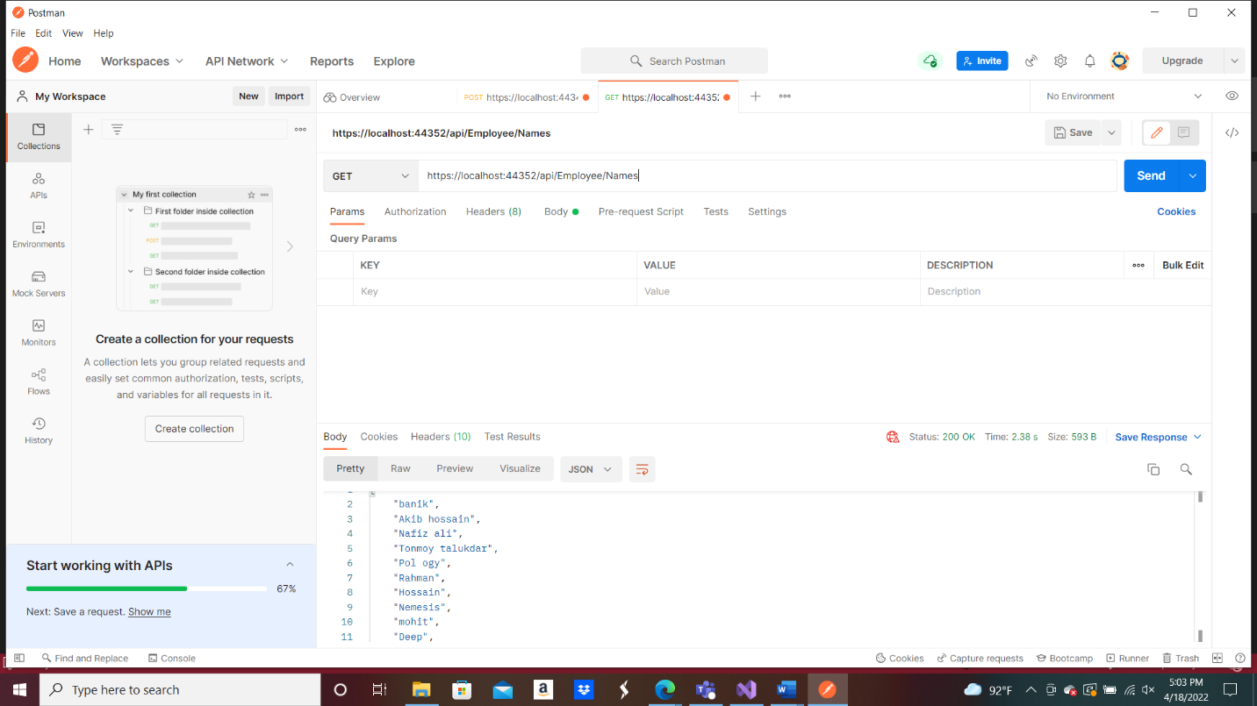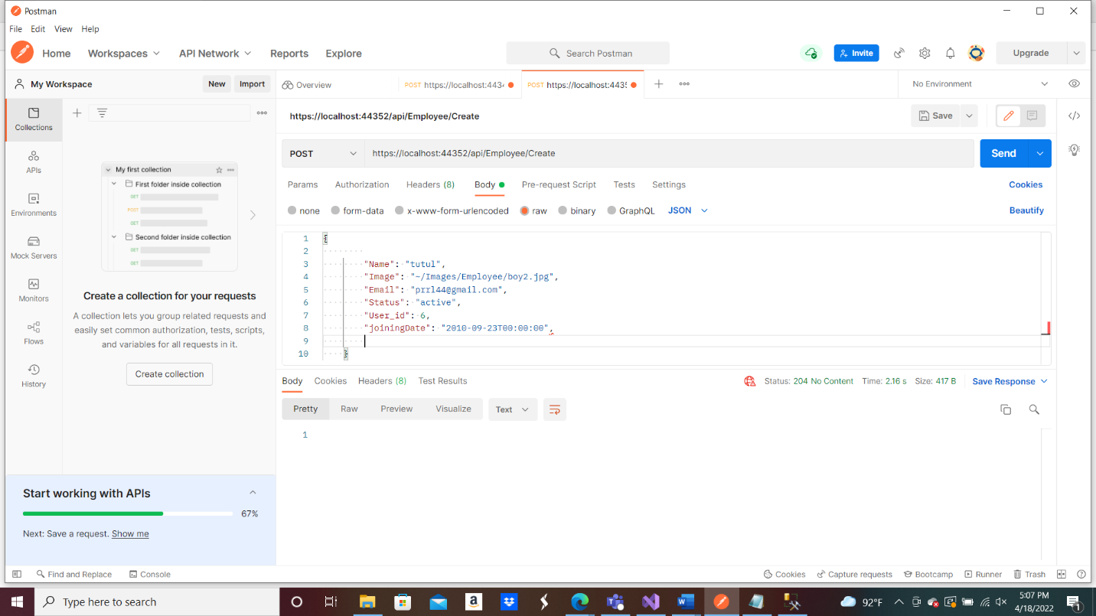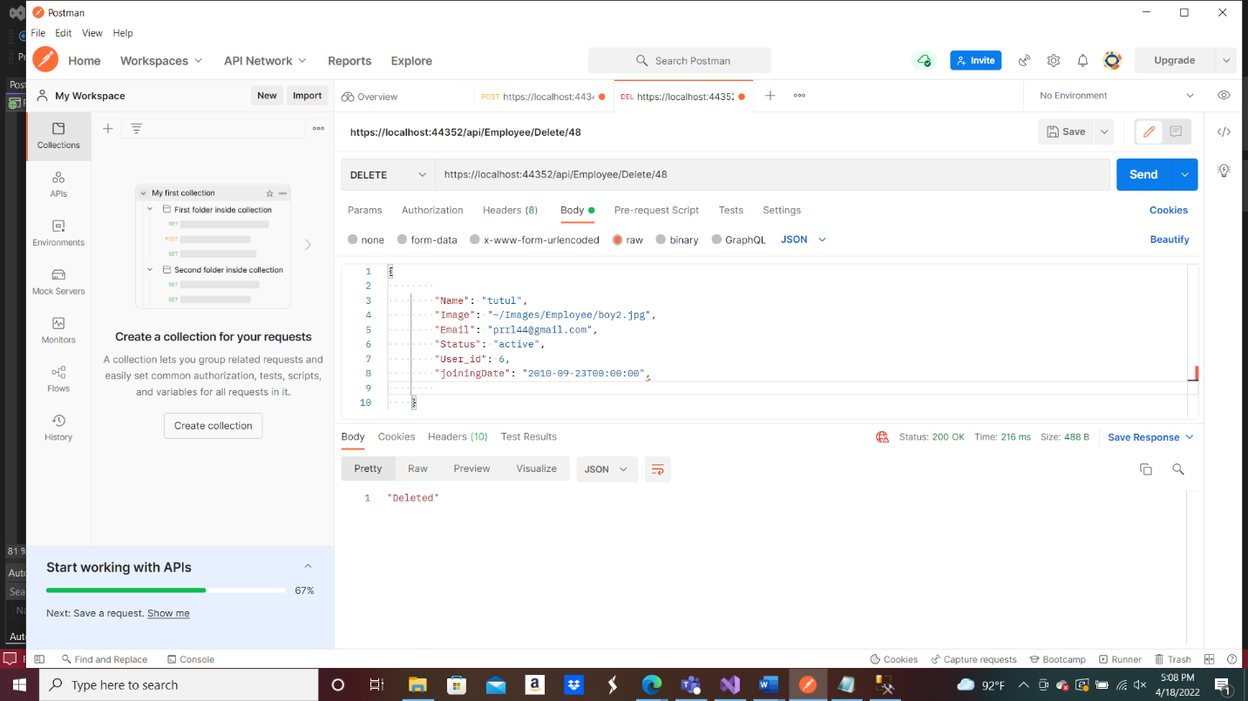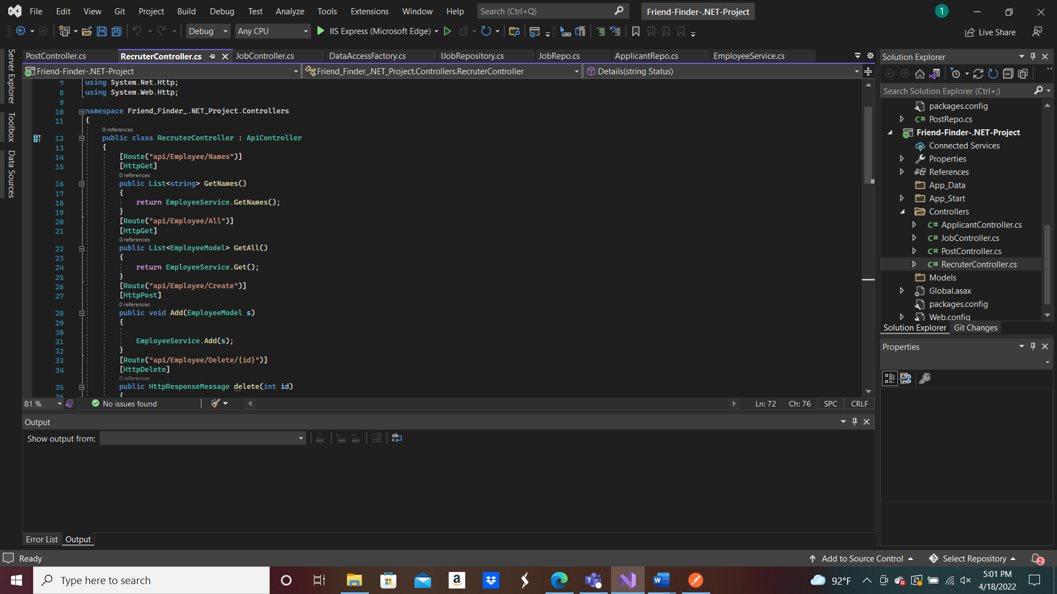

.

## Meetings

One of the main factor to be a successful testing team is to distribute the right work to the right person. So in order to be a successful team doing regular team meeting is very important. So, the test team will meet once in every week to evaluate the progress of each member whether they have done their assigned work or not. And check whether they are facing any problem if they face any problem regarding testing then other team will help him and try to solve it as early as possible. The team lead of testing team will meet development and project manager once in every two weeks. Extra meeting will be arranged if there is any emergency situation.

# TEST CASES

## Log in

This Test case will Test the website login page by verifying valid username and password

|  |  |  |  |  |  |
| --- | --- | --- | --- | --- | --- |
| **Project Name:** Recycle Trash | | | **Test Designed by:** Md. Abu Torab Ibnul Baki | | |
| **Test Case ID:**  Login_01 | | | **Test Designed date:** 13-04-2022 | | |
| **Test Priority (Low, Medium, High):** High | | | **Test Executed by**: Md. Abu Torab Ibnul Baki | | |
| **Module Name:** Login | | | **Test Execution date:** 15-04-2022 | | |
| **Test Title:** Verifying login with valid username, password | | |  | | |
| **Description:** Test the website login page | | |  | | |
| **Precondition (If any):** Users must type valid username & password | | | | | |
| **Test Steps** | **Test Data** | **Expected Results** | | **Actual Results** | **Status (Pass/Fail)** |
| 1. Go to the website.  2. Click the “Login” button.  3. Enter username or gmail id or yahoo id  4. Enter password.  5. Click “Submit” button | Username: Hasubul1234  Password: HK12#” | Users should  Login to the  website | | As expected, | Pass |

Figure : 1.1

* 1. **Registration**

**This Test case will check the registration with valid username,email,password and date of birth**

|  |  |  |  |  |  |
| --- | --- | --- | --- | --- | --- |
| **Project Name:** Recycle Trash | | | **Test Designed by:** Md. Abu Torab Ibnul Baki | | |
| **Test Case ID:**  Registration_02 | | | **Test Designed date:** 13-04-2022 | | |
| **Test Priority (Low, Medium, High):** High | | | **Test Executed by**: Md. Abu Torab Ibnul Baki | | |
| **Module Name:** Registration | | | **Test Execution date:** 15-04-2022 | | |
| **Test Title:**  Registration  with valid username, email and password, dateof birth. | | |  | | |
| **Description:** Test the website registration. | | |  | | |
| **Precondition (If any):** User must  fill up all the input field. | | | | | |
| **Test Steps** | **Test Data** | **Expected Results** | | **Actual Results** | **Status (Pass/Fail)** |
| 1. Go to the website.  2. Click the “registration” button  3.Enter all valid information.  4. Click “Submit” button | Username: Hasubul1234  Gmail: [Hasan@gmail.com](mailto:Hasan@gmail.com)  Dateof birth:  16/02/1999  Gender: male  Password: HK12# | Users should  registration to the  website | | As expected, | Pass |
| **Post Condition:** User is validated with database and successfully register an account. The account details are stored in the database | | | | | |

* 1. **Log out**

This Test case will Test that the login option is working properly or not

|  |  |  |  |  |  |
| --- | --- | --- | --- | --- | --- |
| **Project Name:** Recycle Trash | | | **Test Designed by:** Md. Abu Torab Ibnul Baki | | |
| **Test Case ID:**  Logout_03 | | | **Test Designed date:** 13-04-2022 | | |
| **Test Priority (Low, Medium, High):** High | | | **Test Executed by**: Md. Abu Torab Ibnul Baki | | |
| **Module Name:** logout | | | **Test Execution date:** 15-04-2022 | | |
| **Test Title:**  Verifying logout option | | |  | | |
| **Description:** Test the website logout option | | |  | | |
| **Precondition (If any):** 1. Need account on this website  2. Need to be logged in | | | | | |
| **Test Steps** | **Test Data** | **Expected Results** | | **Actual Results** | **Status (Pass/Fail)** |
| 1. go to the site  2. log in to the site  3. Click the “Logout” button |  | Successful logout | | As expected, | Pass |
| **Post Condition:** User goes back to the home page | | | | | |

* 1. **Change Password**

**This Test case will check the change password feature is working accurately or not**

|  |  |  |  |  |  |
| --- | --- | --- | --- | --- | --- |
| **Project Name:** Recycle Trash | | | **Test Designed by:** Md. Abu Torab Ibnul Baki | | |
| **Test Case ID:**  changePassword_04 | | | **Test Designed date:** 13-04-2022 | | |
| **Test Priority (Low, Medium, High):** High | | | **Test Executed by**: Md. Abu Torab Ibnul Baki | | |
| **Module Name:** Update Password | | | **Test Execution date:** 15-04-2022 | | |
| **Test Title:**  Can change password from the profile. | | |  | | |
| **Description:** Test password is update or not. | | |  | | |
| **Precondition (If any):** User Must have to login into profile. | | | | | |
| **Test Steps** | **Test Data** | **Expected Results** | | **Actual Results** | **Status (Pass/Fail)** |
| 1. go to the site  2. log in to the site  3. write new password to the input field  4. click change password button | New Password=1#4$dy$ | Successful update password | | As expected, | Pass |
| **Post Condition:** The updated password is stored in the database | | | | | |

* 1. **show product**

**This Test case will check that the feature is showing all the product with their corresponding details or not**

|  |  |  |  |  |  |
| --- | --- | --- | --- | --- | --- |
| **Project Name:** Recycle Trash | | | **Test Designed by:** Md. Abu Torab Ibnul Baki | | |
| **Test Case ID:**  showProduct_05 | | | **Test Designed date:** 13-04-2022 | | |
| **Test Priority (Low, Medium, High):** High | | | **Test Executed by**: Md. Abu Torab Ibnul Baki | | |
| **Module Name:** show Product | | | **Test Execution date:** 15-04-2022 | | |
| **Test Title:**  show all the product with their corresponding details | | |  | | |
| **Description:** Test all the products are visible or not | | |  | | |
| **Precondition (If any** User Must have to login and go to product page | | | | | |
| **Test Steps** | **Test Data** | **Expected Results** | | **Actual Results** | **Status (Pass/Fail)** |
| 1. go to the site  2. log in to the site  3. go to the product page |  | Can see all the product with details | | As expected, | Pass |
| **Post Condition:** | | | | | |

* 1. **delete product**

**This Test case will check the test delete product option**

|  |  |  |  |  |  |
| --- | --- | --- | --- | --- | --- |
| **Project Name:** Recycle Trash | | | **Test Designed by:** Md. Abu Torab Ibnul Baki | | |
| **Test Case ID:**  deleteProduct_06 | | | **Test Designed date:** 13-04-2022 | | |
| **Test Priority (Low, Medium, High):** High | | | **Test Executed by**: Md. Abu Torab Ibnul Baki | | |
| **Module Name:** Delete Product | | | **Test Execution date:** 15-04-2022 | | |
| **Test Title:** delete product with their unique id | | |  | | |
| **Description:** test the delete product option | | |  | | |
| **Precondition (If any):** 1.User Must have to login and go to product page.  2. User must type the product id in the input field. | | | | | |
| **Test Steps** | **Test Data** | **Expected Results** | | **Actual Results** | **Status (Pass/Fail)** |
| 1. go to the site  2. log in to the site  3. go to the product page  4. type the product id in the input field  5. click the delete option | Product id =”p1” | Remove the product from the product page | | As expected, | Pass |
| **Post Condition:** the information that is stored in the database for the product will be removed. | | | | | |

* 1. **view seller**

**This Test case will test that view seller option is showing all the seller with their corresponding details or not**

|  |  |  |  |  |  |
| --- | --- | --- | --- | --- | --- |
| **Project Name:** Recycle Trash | | | **Test Designed by:** Md. Abu Torab Ibnul Baki | | |
| **Test Case ID:**  viewSeller_07 | | | **Test Designed date:** 13-04-2022 | | |
| **Test Priority (Low, Medium, High):** High | | | **Test Executed by**: Md. Abu Torab Ibnul Baki | | |
| **Module Name:** View seller | | | **Test Execution date:** 15-04-2022 | | |
| **Test Title:** show all the seller with their corresponding details | | |  | | |
| **Description:**Test all the seller are visible or not | | |  | | |
| **Precondition (If any):** 1.User Must have to login and go to seller page. | | | | | |
| **Test Steps** | **Test Data** | **Expected Results** | | **Actual Results** | **Status (Pass/Fail)** |
| 1. go to the site  2. log in to the site  3. go to the seller page |  | Can see all the seler with details | | As expected, | Pass |
| **Post Condition:** | | | | | |

* 1. **delete seller**

**This Test case test that the Delete Seller option is deleting seller option with their unique ID or not**

|  |  |  |  |  |  |
| --- | --- | --- | --- | --- | --- |
| **Project Name:** Recycle Trash | | | **Test Designed by:** Md. Abu Torab Ibnul Baki | | |
| **Test Case ID:**  deleteSeller_08 | | | **Test Designed date:** 13-04-2022 | | |
| **Test Priority (Low, Medium, High):** High | | | **Test Executed by**: Md. Abu Torab Ibnul Baki | | |
| **Module Name:** Delete seller | | | **Test Execution date:** 15-04-2022 | | |
| **Test Title:** delete seller with their unique id | | |  | | |
| **Description:** test the delete seller option | | |  | | |
| **Precondition (If any):** 1.User Must have to login and go to seller page.  2. User must type the seller id in the input field. | | | | | |
| **Test Steps** | **Test Data** | **Expected Results** | | **Actual Results** | **Status (Pass/Fail)** |
| 1. go to the site  2. log in to the site  3. go to the seller page  4. type the seller id in the input field  5. click the delete option | Seller id =”s1” | Remove the seller from the seller page | | As expected, | Pass |
| **Post Condition:** the information that is stored in the database for the seller will be removed. | | | | | |

* 1. **view employee**

**This Test case will test that view employee option is showing all the employee with their corresponding details or not**

|  |  |  |  |  |  |
| --- | --- | --- | --- | --- | --- |
| **Project Name:** Recycle Trash | | | **Test Designed by:** Md. Abu Torab Ibnul Baki | | |
| **Test Case ID:**  viewEmployee_09 | | | **Test Designed date:** 13-04-2022 | | |
| **Test Priority (Low, Medium, High):** High | | | **Test Executed by**: Md. Abu Torab Ibnul Baki | | |
| **Module Name:** View employee | | | **Test Execution date:** 15-04-2022 | | |
| **Test Title:** show all the employee with their corresponding details | | |  | | |
| **Description:**Test all the employee are visible or not | | |  | | |
| **Precondition (If any):** 1.User Must have to login and go to employee page. | | | | | |
| **Test Steps** | **Test Data** | **Expected Results** | | **Actual Results** | **Status (Pass/Fail)** |
| 1. go to the site  2. log in to the site  3. go to the employee page |  | Can see all the employee with details | | As expected, | Pass |
| **Post Condition:** | | | | | |

* 1. **delete employee**

**This Test case test that the Delete employee option is deleting employee option with their unique ID or not**

|  |  |  |  |  |  |
| --- | --- | --- | --- | --- | --- |
| **Project Name:** Recycle Trash | | | **Test Designed by:** Md. Abu Torab Ibnul Baki | | |
| **Test Case ID:**  deleteEmployee_10 | | | **Test Designed date:** 13-04-2022 | | |
| **Test Priority (Low, Medium, High):** High | | | **Test Executed by**: Md. Abu Torab Ibnul Baki | | |
| **Module Name:** Delete Employee | | | **Test Execution date:** 15-04-2022 | | |
| **Test Title:** delete employee with their unique id | | |  | | |
| **Description:** test the delete employee option | | |  | | |
| **Precondition (If any):** 1.User Must have to login and go to employee page.  2. User must type the employee id in the input field. | | | | | |
| **Test Steps** | **Test Data** | **Expected Results** | | **Actual Results** | **Status (Pass/Fail)** |
| 1. go to the site  2. log in to the site  3. go to the employee page  4. type the employee id in the input field  5. click the delete option | employee id =”e1” | Remove the employee from the employee page | | As expected, | Pass |
| **Post Condition:** the information that is stored in the database for the employee will be removed. | | | | | |

# ITEM PASS/FAIL CRITERIA

Here we have implemented a total of 10 test cases. At first, when applied the test case to system 70% of the test cases were passed successfully and 30% were fail. The test cases were failing due to some query related issues on the database. When the test case was applied after solving query related problem, all the test cases are successfully passed.

# TEST DELIVERABLES

* Test plan
* Test results documents
* Test summary
* Errors
* Bug report

# STAFFING AND TRAINING NEEDS

This section shows how to staff the test jobs and prepare them for the work. Staffing is set for the duration of the project. It's realistic to assume that the vast majority of the staff will agree to do some testing. The following occupations are recognized:

Project Manager: Responsible for maturing the complete execution of the Web website. This includes creating requirements, managing the seller relationship, and overseeing the testing cycle.

Test Manager: Responsible for fostering the expert test strategy, examining the test deliverable, dealing with test cycles, collecting measurements and reporting progress to the Project Manager, and recommending when testing should be completed.

Test Engineer: Planning tests, creating test methods, creating test information, running tests, preparing occurrence reports, examining episodes, writing mechanized test strategies, and detailing measurements to the test administrator are all responsibilities of this position.

The test manager and test specialists should be familiar with the website development life cycle. Because this project is being developed in a traditional manner, this is a nonexclusive depiction of Staffing and Training requirements. As a result, the names of conscious people for each project aren't given.

# RESPONSIBILITIES

|  |  |  |
| --- | --- | --- |
| Name | Role | Responsibilities |
| MD. HASIBUL HASAN | Project Manager | 1. Completion of the Project.  2. Execute all the test cases and report defects.  3. Control whole project. |
| ABU HASNAT JELANI CHAHAD | Quality Analyst | 1. Creation of test plans, test forms, test cases and test information.  2. Carry out testing as per the characterized methods. 3.Prepare all reports related to program testing carried out. |
| Hordoya Banik | Programmer | 1. Researching, designing, implementing, and managing software programs.  2. Writing and implementing efficient code.  3. Deploying software tools, processes, and metrics. |
| MD. ABU TORAB IBNUL BAKI | Test  Engineer | 1. Characterizing the testing activities All obligations of test planning  2. To check in the event that the group has all the fundamental assets to execute the testing exercises.  3. Prepare the report of testing activities.  4. Overhauling extend directors frequently around the advance of testing exercises.  5. Develop test cases and prioritize testing activities.  6. Execute all the test cases and report defects.   7. make documentation |

# TESTING SCHEDULE

|  |  |  |
| --- | --- | --- |
| **Task Name** | **Duration** | **Responsible** |
| Design | 3 days | Project Manager |
| Writing code | 15 days | programmer |
| Test plan | 3 days | Quality Analyst & Test  Engineer |
| Test case | 5 days | Quality Analyst |
| Unit testing | 2 days | Project Manager & Test  Engineer |
| Test case report | 7 days | Test  Engineer |
| Documentation | 7 days | Test  Engineer |

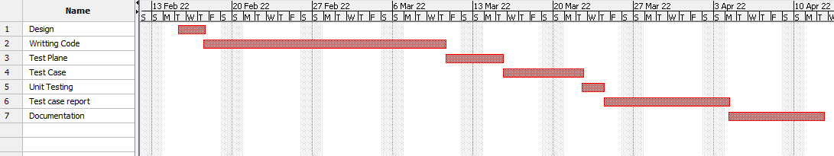

# PLANNING RISKS AND CONTINGENCIES

|  |  |  |  |
| --- | --- | --- | --- |
| Risk | Probability | Impact | Mitigation |
| Error in function | Medium | Medium | Test the web app frequently and maintain daily backup. |
| Give invalid input | High | high | Tell user to use right data type in each input field |
| Loss of encrypted data(password) | Medium | high | Maintain security check and backup |

# APROVALS

|  |  |
| --- | --- |
| Project Sponsor | MD Abu Torab Ibnul Baki |
| Development Management | Abu Hasnat Jelani Chahad |
| EDI Project Manager | Hordoya Banik |
| RS Test Manager | MD. Hasibul Hasan |
| RS Development Team Manager | MD Abu Torab Ibnul Baki |
| Reassigned Sales | Abu Hasnat Jelani chahad |
| Order Entry EDI Team Manager | Hordoya Banik |

# REFERENCES

* Software Quality And Testing Course PowerPoint Slides
* [What is Postman Automation? - GeeksforGeeks](https://www.geeksforgeeks.org/what-is-postman-automation/#:~:text=Postman%20is%20a%20cutting-edge%20Automation%20tool%2C%20which%20can,Postman%20Runner%20functionality%20this%20feature%20can%20be%20used.?msclkid=d6e6137bc00311ecbd51cacea19a9553)
* <https://sourceforge.net/projects/projectlibre/>
* <https://www.postman.com/automated-testing/>
* <http://www.onestoptesting.com/test-plan/features-not-to-be-tested.asp>
* SQAT - CH.02 - Quality Attributes [4.2: System quality Attributes]
* <https://www.softwaretestinghelp.com/>
* <https://www.softwaretestinghelp.com/how-to-write-effective-test-cases-test-cases-procedures-and-definitions/>
* <https://www.w3schools.com>/