**Alexa Has Only 2 Tasks to perform:**

**1. Listen**

Alexa will pay attention to your order, as: "Hello Alexa, play music," "Hello Alexa, what's the time?"

Alexa will pay attention to your order, get it, and afterward do some activity as indicated by your order.

**2. Speaking**

At the point when Alexa will comprehend your order after paying attention to it, it will play out some activity on it.

**Now let’s Implement Those Two Features:**

To implement these two features, we will require two Python modules:

1. SpeechRecognition
2. Python Text-To-Speech (pyttsx3)

**1. SpeechRecognition**

This Python module performs speech recognition. It helps Alexa to listen what we are saying, catch that, and act accordingly.

Use the command below to install SpeechRecognition module, from your terminal:

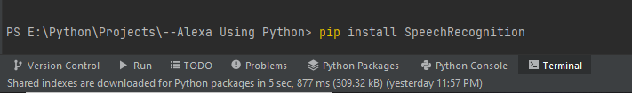

Once installed and imported, we can use it in our task.

**2. Python Text-To-Speech (pyttsx3)**

[Text-to-Speech](https://pypi.org/project/pyttsx3/) (TTS) module for Python works without internet or any delay.

First you’ll have to install it:

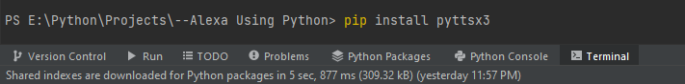

Our Alexa can finally speak with the help of this module.

**Starting the Fun Part**

We’ll create three different functions and each will be responsible for a single task.

**Step #1. Importing modules**

Let’s first import the modules:



**Step #2. Initializing of modules**

To use them lets initialize them and make their objects:

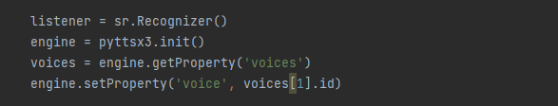

**Step #3. Create a method to convert text to speech - talk() method.**

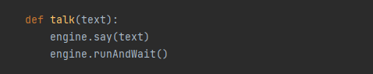

**Step #4. Create a method for Speech Recognition**

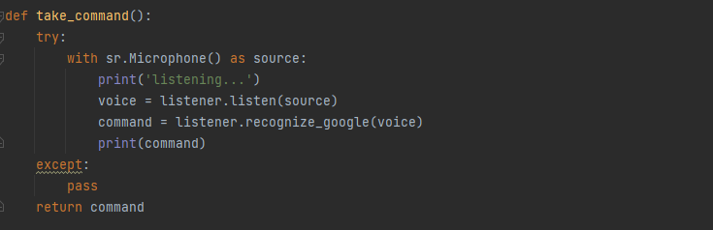

**Step #5. Creating a method for response**

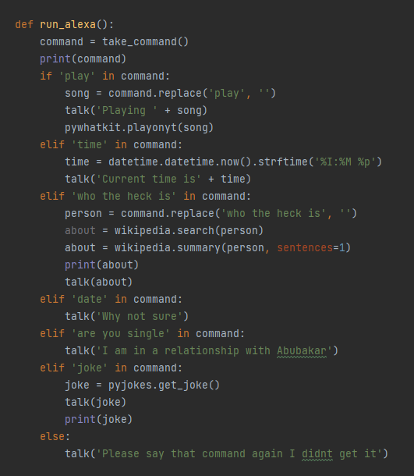

Here, we need to understand a few things:

**i. Fetching required part:** Suppose you want to hear a specific song or music. You’ll speak to Alexa this way: Play music_name. Using this command, we will just remove the word ‘*play*’ and get only the ‘*music_name*’ part:



And, then we will store that music name (without ‘Play’) in variable song.

**ii) pywhatkit.playonyt():** To use this module we have to install this module first and then import it. [PyWhatKit](https://pypi.org/project/pywhatkit/)  has features to help us in automation. This module has a *playonyt()* method which we will use to play the required songs directly on YouTube.

First we’ll have to install it:

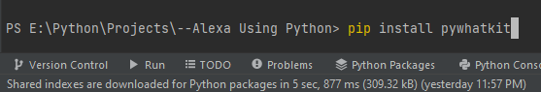

And then import it.

**iii. datetime.datetime.now():**To use datetime Module first we have to install it and then import it. This module helps us to manipulate dates and times. The method *now()* returns the current time, datetime module is built-in Python module.

Import it this way:



**iv. wikipedia.summary():** First we will need to install and import the Wikipedia module. This Python library makes it easy to access data from Wikipedia. The *summary()* method gets the data from the summary section of the Wikipedia.

As we know it’s a third party module, then, we’ll have to install it first:

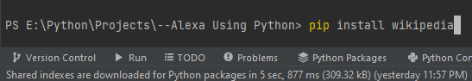

And then import it in our code.

**v. pyjokes.get_joke():** First of all we have to install and import pyjokes module in order to use it in our program. This module will generate some funny jokes randomly which our Alexa will crack.

This is also a third-party module so first, we will have to install pyjokes.

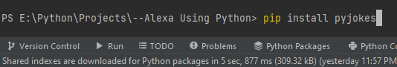

And then import it.

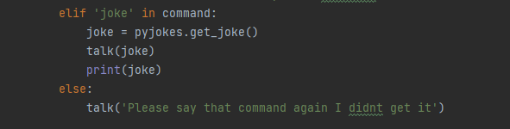

**Step #6. Let’s run our Alexa**

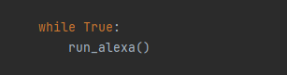

Finally, we make the call to the *run_alexa()* method.

Now we have created our own Alexa. Yay!

Using some Python skills and with the help of some other modules you can add more features to Alexa.

**The Whole Code**

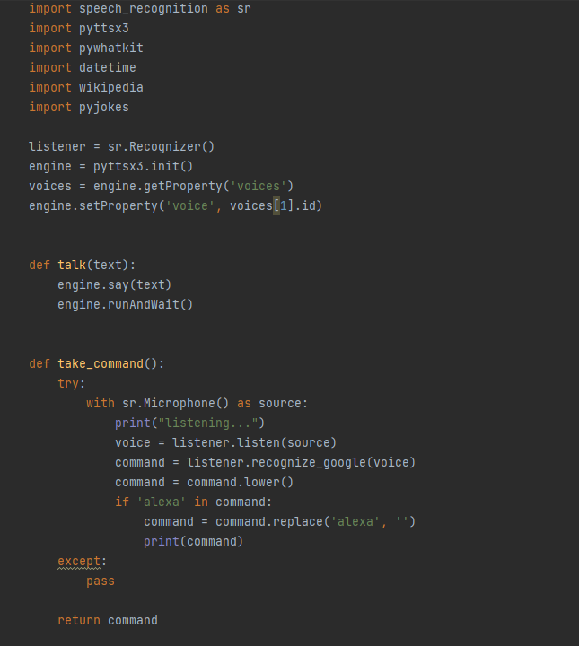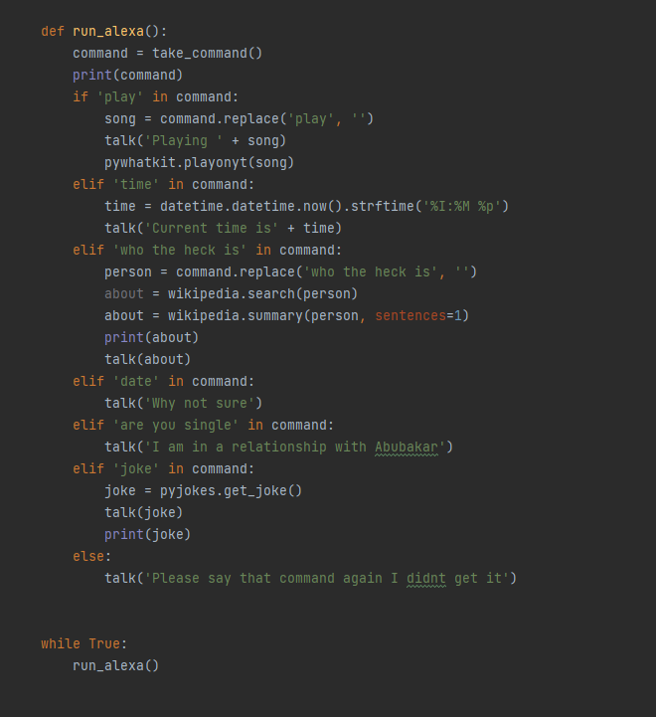

Now you can Enjoy your Alexa.