**National Textile University, Faisalabad**

**(School of Engineering & Technology)**

|  |  |
| --- | --- |
| **Group Members:** | 1. **Abu Bakar (21-NTU-CS-1291)** 2. **Kainat Murtaza (21-NTU-CS-1323)** 3. **Mahnoor Ijaz (21-NTU-CS-1329)** |
| **Class:** | **BSSE-A** |
| **Project:** | **Axis Studio** |
| **Semester:** | **5th** |
| **Course Name:** | **Web Engineering** |
| **Submitted To:** | **Dr. Abdul Qayyum** |
| **Submission Date:** | **23/01/2024** |

**UML Diagrams for Axis Studio**

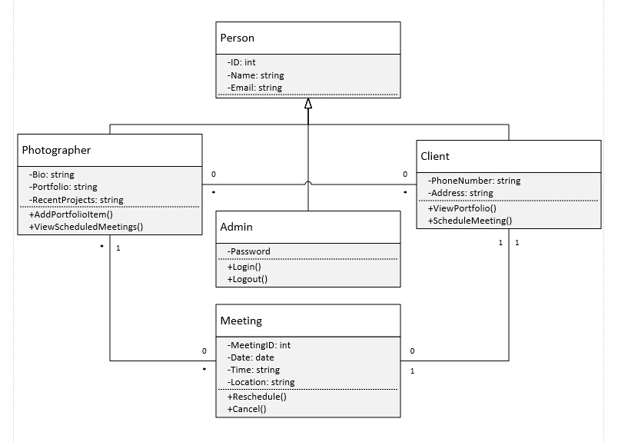**Class Diagram**

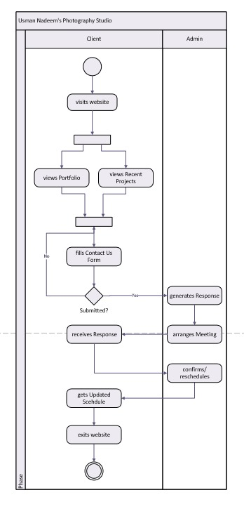**Activity Diagram**

**Use-Case**

**Entity Relationship Diagram (ERD)**

