Calculus for Data Science
How rates of change, slopes, and curvature let a machine learn from data
A set of study notes built around one running example: predicting a student's exam score.
Covers limits, derivatives, partial derivatives, the chain rule, integrals, gradients, gradient descent, Jacobians, Hessians, and Taylor series, with the machine learning use of each idea explained along the way.

Contents
0. The dataset we will use throughout
1. Limits and continuity
2. Derivatives
3. Partial derivatives
4. The chain rule
5. Integrals
6. The gradient
7. Gradient descent
8. Jacobians
9. Hessians
10. Taylor series
11. A complete pipeline, start to finish
12. Summary table

0. The dataset we will use throughout
Every idea in these notes is tied to the same small dataset, so that calculus stops feeling like a pile of separate tricks and starts feeling like one connected set of tools. The dataset is synthetic, meaning it was generated with a formula rather than collected from real students, which gives us the useful property of knowing exactly what relationship we are trying to uncover.
Picture a class of 150 students. For each one we record seven things about how they prepared for a final exam, and then their actual score on that exam.
- Hours_Studied, the number of hours spent studying
- Attendance, the percentage of classes attended
- Practice_Problems, how many practice problems they worked through
- Sleep_Hours, average hours of sleep per night during exam preparation
- Previous_Score, their score on an earlier test
- Study_Consistency, a rating of how evenly spread out their studying was, rather than cramming
- Motivation_Level, a self reported rating of how motivated they felt
The target we want to predict is Final_Exam_Score. It was generated from this rule:
$Score = 20 + 4·Hours + 0.8·Attendance + 2·Practice + 3·Sleep + 5 sin(Hours/3) − 0.7{(Hours − 8)}^{2} + noise$
the rule used to generate Final_Exam_Score for every student in the dataset
Look closely at the pieces of that rule, because each one earns its place. The terms with Attendance, Practice_Problems and Sleep_Hours are plain straight line relationships: more of each simply adds more to the score. The term with Hours_Studied is different in two ways. There is a wave shaped sine piece, and there is a squared piece centered on 8. That squared piece is what will let us talk about peaks and valleys later, because it punishes hours far away from 8 more and more the further they get. A small random noise term is added at the end so the data looks the way real measurements do, a little messy rather than perfectly clean.
This single formula is doing a lot of work for us. It contains something that behaves like a straight line, something that curves, something that has a clear high point, and something with several variables mixed together. That is exactly the mix of behavior calculus was built to describe, so we will return to this same formula again and again, looking at it through a different lens in every section.

What the numbers look like
Across the 150 students, Hours_Studied ranges from 0 to about 16, with most students clustered between 5 and 10 hours. Attendance sits mostly between 70 and 95 percent. The resulting Final_Exam_Score ranges from about 103 to 247. That range looks unlike a typical 0 to 100 test because the formula above was chosen to create interesting curves rather than to mimic a real grading scale, so treat the score as a useful stand in for any outcome you are trying to predict, rather than a literal exam mark.
Two objects will come up constantly from here on. The table of raw values is usually called df, short for data frame. Once we separate the seven input columns from the target column we call them X and y. And because some of the numbers, like Attendance and Hours_Studied, live on very different scales, we will often work with a standardized version, X_std, where every column has been rescaled to have a mean of 0 and a spread of 1. Standardizing does not change the relationships in the data, it only makes the numbers easier to compare and, as we will see in the gradient descent section, easier to optimize over.
With the dataset in place, we can start asking calculus questions about it. The first and most basic one is deceptively simple: what happens as we get closer and closer to a particular point, without necessarily landing on it. That question is a limit, and it is where we begin.

1. Limits and continuity
Before we can talk about rates of change, we need a way to talk about what a function is doing near a point, even when we never quite land on that point. That idea is called a limit, and despite the intimidating name it matches something you already do naturally. If you keep studying more and more hours, getting closer and closer to, say, 8 hours, you have a good sense of what score to expect at 8 hours even before you get there. That expected value, the one the function settles toward as the input gets closer and closer to a target, is the limit.
A limit does not care what happens exactly at the point, only what happens as you approach it. Sometimes those two things agree and sometimes they do not. Limits can also be one sided, meaning we only look at values coming from the left or only from the right, and in some cases a function can grow without bound as it nears a point, which we call an infinite limit.
$\lim_{x→a}{f(x) = L}$
as x gets closer to a, f(x) gets closer to the number L

Continuity
A function is continuous at a point when three things line up: the function has a value there, the limit exists there, and the limit actually equals that value. Informally, continuity means you could trace the curve with a pen without lifting it off the page. A removable discontinuity is a single missing or misplaced point, like a tiny pinhole in an otherwise smooth curve. A jump discontinuity is more dramatic, the curve genuinely leaps from one level to another, the way a grading system might jump from a B to an A at exactly 90 percent with nothing in between.
Our score formula, built from ordinary sums, a sine wave, and a squared term, is continuous everywhere. As Hours_Studied moves from 7.9 to 8.0 to 8.1, the predicted score moves smoothly along with it, never jumping or tearing. This is worth pausing on, because it is not a given. If our data generating process had a rule like give a bonus of 10 points if attendance is at least 90 percent and nothing otherwise, the score function would jump abruptly at exactly 90, and that single missing rung on the ladder would cause real problems for the tools we build in later sections.

Why this matters for machine learning
Nearly every optimization method used to train a machine learning model leans on the assumption that small changes to a parameter produce small, predictable changes to the output. That assumption is really a statement about continuity. It is also why some popular building blocks are chosen carefully. The ReLU activation function used in neural networks is continuous everywhere, even though it has a sharp corner at zero, but a small number of exotic functions used in older or more specialized models can have genuine jumps, and training tends to behave badly around those jumps because the usual slope based reasoning breaks down there.
Try it yourself
1. Give an everyday example, outside of school, where a small change in an input causes a sudden jump rather than a smooth change in the output.
2. If the score function had a rule that added a fixed bonus only when Attendance was 90 percent or higher, at what point would it become discontinuous, and would it be a jump or a removable gap.
3. Why might a machine learning model trained with gradient based methods struggle to fit data that comes from a process with a jump discontinuity in it.
With continuity in hand, we are ready to ask a sharper question. Instead of just what value a function approaches, we can ask how fast it is changing as it gets there. That question is the derivative, and it is the real engine behind almost everything in the rest of these notes.

2. Derivatives
The derivative answers a very practical question. If a student studies a little more, how much does their expected score change. Not the total change over a big jump, but the change at this exact instant, for this exact number of hours. That instantaneous rate of change is the derivative, and it is the single most useful idea in this entire subject.
There is an important difference between the average rate of change and the instantaneous rate of change. If a student goes from 3 hours to 11 hours of studying, we can compute the average rate of change by taking the score difference and dividing by the hours difference. Graphically, this average rate of change is the slope of the secant line, a straight line drawn through the two points on the curve. The instantaneous rate of change, by contrast, is the slope of the tangent line, the line that just grazes the curve at a single point without crossing through it. As the two points used for the secant line are dragged closer and closer together, the secant line rotates until, in the limit, it becomes the tangent line. This is exactly why we needed limits first.
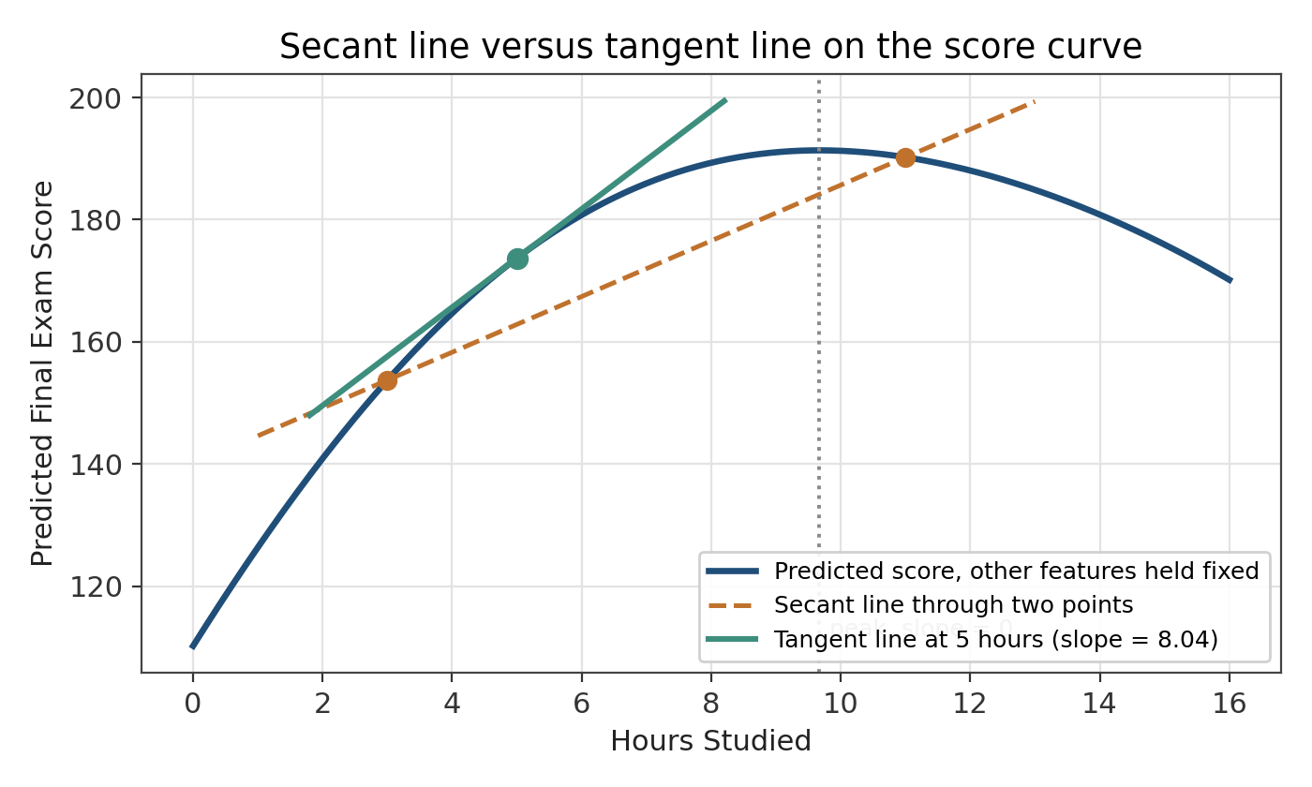
the dashed orange line is a secant line through two points, the solid teal line is a tangent line at a single point, and its slope is the derivative there
Formally, the derivative of f at a point x is defined as the limit of the average rate of change as the gap h shrinks to zero.
$f'(x) = \lim_{h→0}{\frac{f(x+h) − f(x)}{h}}$
the derivative: how fast f is changing right at x
You do not need to run this limit by hand every time. A handful of rules let you find derivatives quickly for the kinds of functions that show up constantly in practice.
- Constant rule. The derivative of a constant is 0. A flat line has zero slope everywhere.
- Power rule. The derivative of x raised to the power n is n times x raised to the power n minus 1. This is the workhorse rule behind the squared term in our score formula.
- Sum and difference rule. The derivative of a sum is the sum of the derivatives, and the same goes for a difference. You can differentiate a complicated formula piece by piece and add the results back together.
- Product rule. For two functions multiplied together, the derivative is the first times the derivative of the second, plus the second times the derivative of the first.
- Quotient rule. For one function divided by another, there is a similar but slightly longer pattern involving both derivatives and the square of the bottom function.
- Chain rule, in brief. When one function sits inside another, you differentiate the outer function and multiply by the derivative of the inner one. This rule is so important for machine learning that it gets its own full section next.
Applying the sum rule and the power rule to the part of our score formula that depends only on Hours_Studied gives us a clean derivative we can actually use.
$f'(Hours) = 4 + \frac{5}{3} cos(Hours/3) − 1.4(Hours − 8)$
the slope of the score curve at any number of hours studied, holding the other features fixed

Reading the sign of the derivative
The sign of the derivative tells a simple story. Where it is positive, the function is climbing, so one more hour of studying raises the expected score. Where it is negative, the function is falling, so an extra hour actually predicts a slightly lower score. Where it is exactly zero, the curve is momentarily flat, and we call that a critical point. Working through the formula above and solving for where it equals zero shows that this happens at about 9.67 hours of studying. Just before that point the slope is positive, and just after it the slope turns negative, which is the signature of a local maximum, a peak. If a critical point instead had negative slope before it and positive slope after, it would be a local minimum, a valley. A point where the curve changes from curving one way to curving the other way, without necessarily having a zero slope, is called an inflection point.
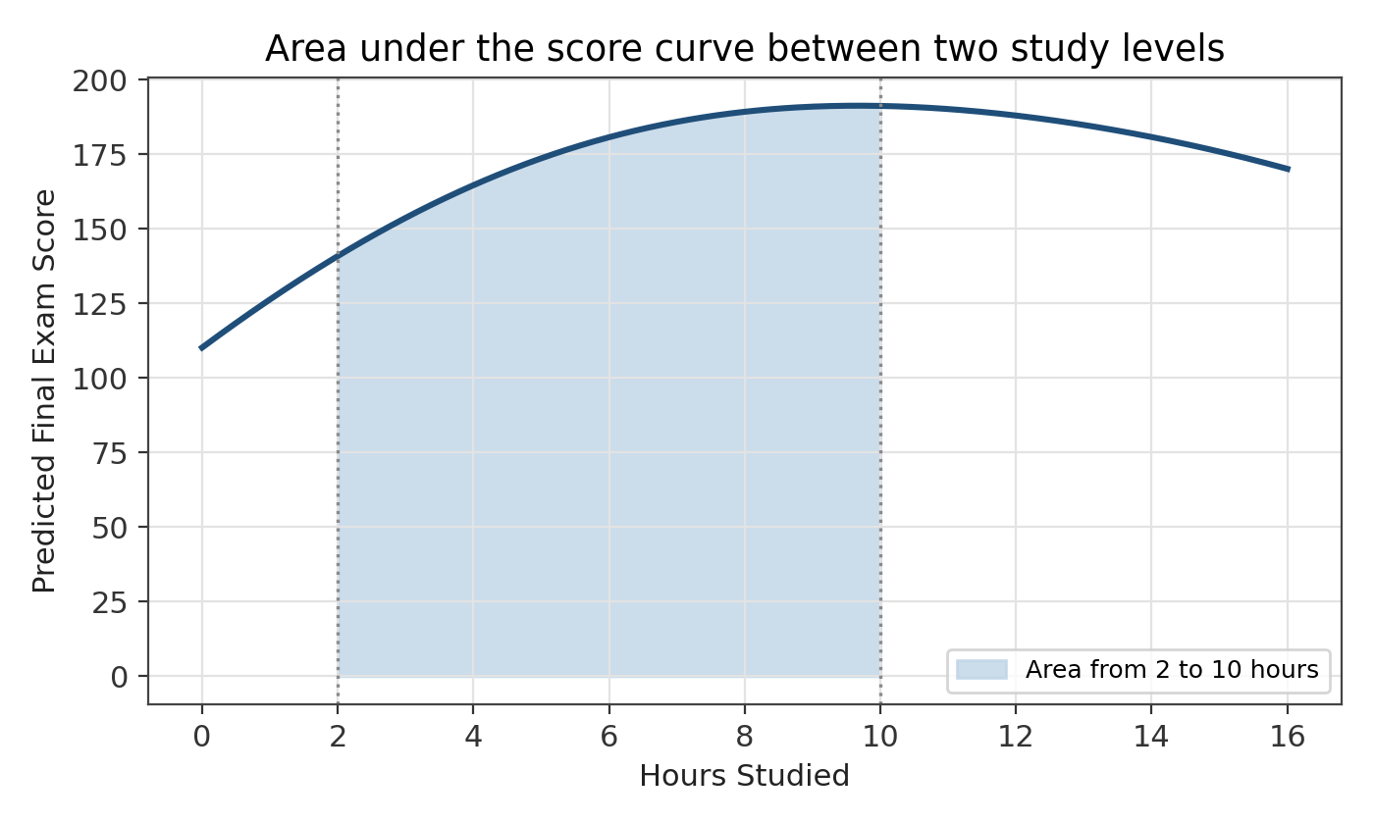
the same score curve. it climbs, flattens near 9 to 10 hours, then gently falls, exactly what a positive, then zero, then negative derivative looks like
It is worth being honest about what this particular curve does not do. If you check the second derivative of this slice of the formula, it never changes sign, the curve is bending downward everywhere along its length. That means this particular view of the data has exactly one peak and no inflection point at all. Not every function needs one. A simpler example like f(x) equals x cubed does have an inflection point, at x equals 0, where the curve switches from bending down to bending up, and it is a good shape to keep in the back of your mind for what an inflection point looks like.

Why this matters for machine learning
Training a model almost always means adjusting parameters to reduce a loss function, a measure of how wrong the model's predictions are. The derivative of that loss with respect to a parameter tells you exactly two things: which direction reduces the error, and how sensitive the error is to that parameter right now. A positive derivative means increasing the parameter increases the loss, so you should decrease it. A derivative of zero means you have reached a flat spot, which is either a good resting point or a saddle waiting to be investigated further. Every training loop you will ever run is, underneath the framework code, repeatedly asking this exact same slope question.
Try it yourself
1. Using the derivative formula above, is the score curve rising or falling at 4 hours of studying, and what does that tell a student about the value of one more hour at that point.
2. A critical point has zero slope. Explain in your own words why that alone does not tell you whether it is a peak, a valley, or neither.
3. Suppose a loss function has a derivative of negative 3 with respect to a particular weight. Should that weight be increased or decreased to reduce the loss, and why.
So far every derivative we have taken has treated Hours_Studied as the only variable that matters, freezing everything else in place. Real prediction problems almost never have just one input. The next section extends the derivative to functions of several variables at once, which is the natural setting for almost all of machine learning.

3. Partial derivatives
Our score depends on seven different features at once, not just Hours_Studied. To understand how the prediction responds to any single feature, we hold every other feature fixed and ask the same slope question as before, one variable at a time. The result is called a partial derivative, and the only new idea is the bookkeeping of what is being held constant.
Written with the curly d symbol, the partial derivative of the score with respect to Sleep_Hours asks: if we nudge sleep up slightly while keeping Hours_Studied, Attendance, and everything else exactly where they are, how much does the predicted score move.
$\frac{∂Score}{∂Sleep} = 3$
sleep contributes a constant 3 points of score per extra hour, regardless of how much studying happened
$\frac{∂Score}{∂Hours} = 4 + \frac{5}{3} cos(Hours/3) − 1.4(Hours − 8)$
this is the same expression from the derivatives section, now labeled explicitly as a partial derivative
Notice something important in comparing those two results. The partial derivative with respect to sleep is a flat constant, 3, no matter what value any other feature takes. The partial derivative with respect to hours studied depends on hours studied itself. Sleep affects the score in a simple straight line way in this dataset, while hours studied affects it in a curved way. Partial derivatives let us see that difference clearly, feature by feature, instead of guessing at it from the raw formula.

Seeing it in three dimensions
With two input variables and one output, we can actually draw the whole function as a surface, like a sheet stretched and bent over a table, rather than just a curve on a flat page. The picture below plots predicted score as a function of both Hours_Studied and Sleep_Hours together, with Attendance and Practice_Problems held at their average values.
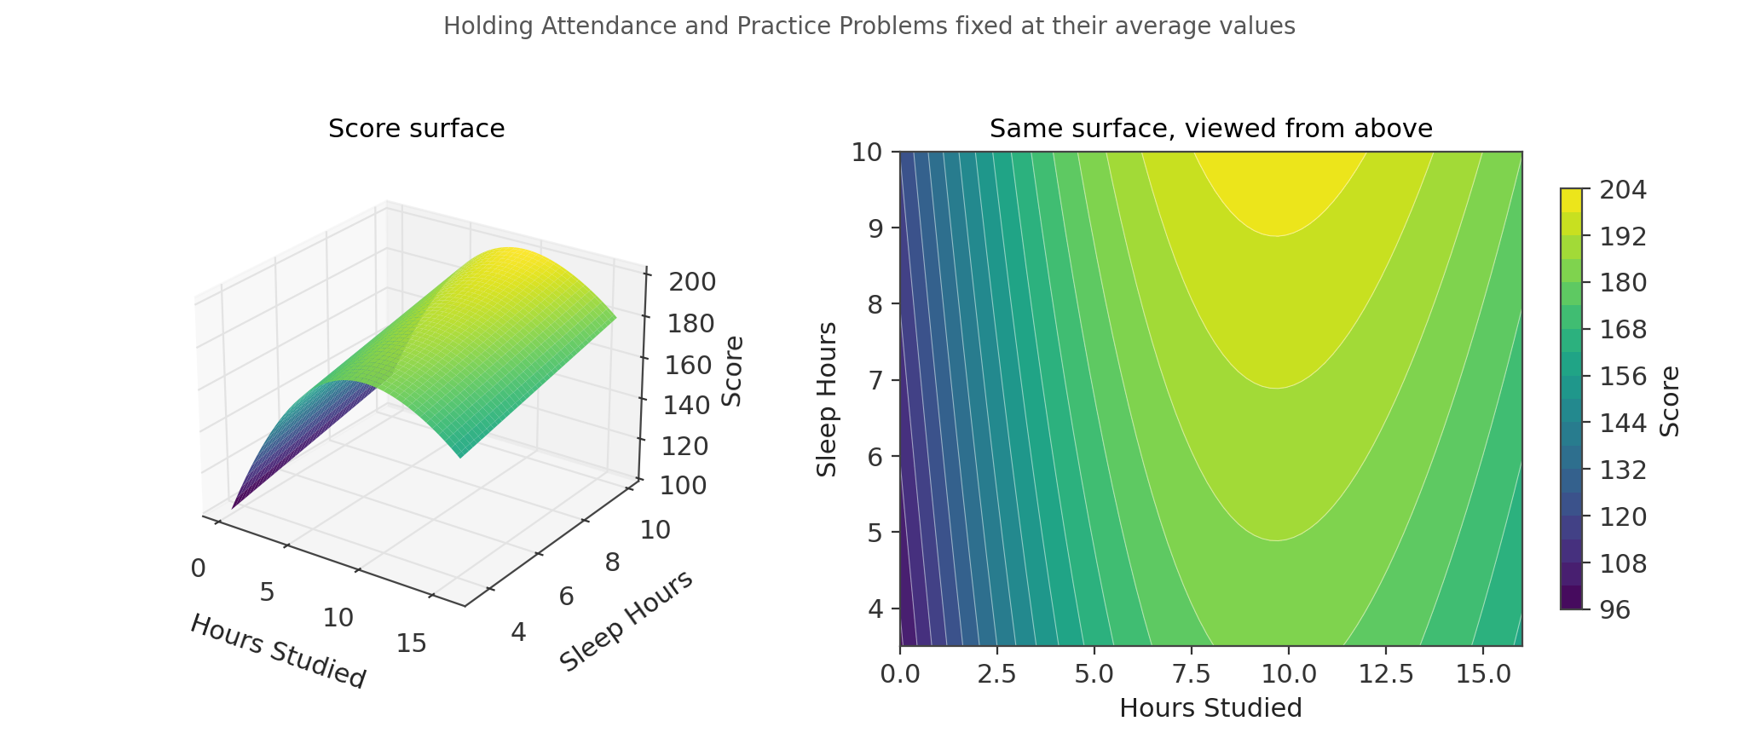
left, the score as a bent surface over the hours and sleep plane. right, the same surface viewed from directly above, where each curve traces out points of equal predicted score
The view from above is called a contour plot, and it is one of the most useful pictures in this whole subject. Each curve on it connects points that all produce the same predicted score, much like the elevation lines on a hiking map connect points at the same height. Where the contour lines are packed tightly together, the surface is changing quickly. Where they spread out, the surface is nearly flat. You can read the partial derivative with respect to hours directly off this picture as the steepness of the slope if you walked horizontally across it, and the partial derivative with respect to sleep as the steepness if you walked vertically.

Why this matters for machine learning
A neural network can easily have millions of individual weights, and every single one of them has its own partial derivative with respect to the loss. That huge collection of partial derivatives, one per parameter, is exactly what a training algorithm needs in order to know how to adjust each weight. Nobody computes these by hand. Frameworks like PyTorch and TensorFlow use a technique called automatic differentiation to compute every partial derivative of a large computational graph efficiently, but the underlying question each one is answering is precisely the question in this section: if I nudge this one input and freeze everything else, how much does the output move.
Try it yourself
1. Why is the partial derivative of the score with respect to Sleep_Hours a constant number, while the partial derivative with respect to Hours_Studied is not.
2. On the contour plot, describe what it would look like for a feature that had absolutely no effect on the score at all.
3. If you were standing on the score surface at a point where the contour lines are very close together, would a small step in the wrong direction be costly or harmless. Explain.
Partial derivatives treat each input as if it acted alone. But real models are built by stacking functions inside other functions, a prediction that depends on a transformed version of the data, which itself depends on the raw input. To handle that kind of nesting we need one more rule, arguably the single most important rule in all of deep learning.

4. The chain rule
Many useful functions are really two or more functions glued together, one feeding into the next. Suppose we first convert Hours_Studied into a rough effort score using some function g, and then feed that effort score into a second function f that produces the final predicted grade. The combined function is f of g of Hours_Studied, often written f(g(x)), and asking how the final output responds to the original input x means asking how a change ripples through both stages at once.
$\frac{d}{dx} f(g(x)) = f'(g(x)) · g'(x)$
the rate of change of the outer function at the inner value, multiplied by the rate of change of the inner function itself
Read in words, the chain rule says the total sensitivity is the sensitivity of the outer step multiplied by the sensitivity of the inner step. If a small change in x causes g to move quickly, and a small change in g causes f to move quickly as well, then the combined effect of x on f is the product of those two speeds, not just one or the other.

Why this matters for machine learning
A neural network is, from this point of view, nothing more than a long chain of functions. Raw input passes through a first layer, the result passes through a second layer, and so on until a final prediction comes out. Training the network means figuring out how the final error depends on every single weight buried deep inside that chain, including the very first layer, which is separated from the loss by every other layer in the network. The chain rule is what makes this possible. Starting from the output and working backward, layer by layer, you multiply local derivatives together to find out exactly how much each early weight contributed to the final mistake. This backward pass through the chain is called backpropagation, and it is, quite literally, the chain rule applied over and over in sequence.
You rarely compute these derivatives by hand for a real model. Symbolic tools such as SymPy in Python can differentiate an expression automatically and simplify the result, and this is a smaller scale version of exactly what deep learning frameworks do internally, just applied to a computational graph with potentially millions of connected pieces instead of one textbook formula.

A computational graph
It helps to picture the chain as a diagram of small boxes connected by arrows, each box representing one operation, such as a multiplication, an addition, or an activation function. Data flows forward through the boxes to produce a prediction. Once the loss is computed at the far end, gradient information flows backward through the same boxes, and at every box the chain rule combines the gradient arriving from downstream with that box's own local derivative before passing the result further upstream. Every modern deep learning framework builds exactly this kind of graph behind the scenes, whether or not the code ever mentions the words chain rule directly.
Try it yourself
1. If g'(x) equals 0 at some point, what does the chain rule say happens to the derivative of f(g(x)) there, no matter how sensitive f itself is.
2. Explain, in plain language, why a network with ten layers needs the chain rule applied ten times to find how the first layer's weights affect the final loss.
3. Why do you think it might cause problems for training if many of the local derivatives being multiplied together in a long chain are each less than one.
The chain rule tells us how to track a rate of change through a sequence of steps. The next section turns the idea around. Instead of asking how fast something is changing, we ask how much of something has built up in total, which turns out to be the natural partner to the derivative rather than something unrelated to it.

5. Integrals
Derivatives break a function down into how fast it is changing at each instant. Integrals do the reverse. They build a total back up out of many tiny pieces. If you knew, minute by minute, how much a student's understanding grew while studying, the integral of that rate over an entire session would tell you the total understanding gained. This is the idea of accumulation, and it turns out to be the mirror image of everything we did with derivatives.
Geometrically, the definite integral of a function between two points is the area trapped between the curve and the horizontal axis over that stretch. The picture below shades the area under our score curve between 2 and 10 hours of studying, which you can think of as a rough stand in for the total benefit accumulated over that whole range of effort, rather than just the benefit at any single hour.

the shaded region is the definite integral of the score curve from 2 to 10 hours, the total area trapped beneath it
Reversing a derivative gives you what is called an antiderivative. If F prime equals f, then F is an antiderivative of f. An indefinite integral is just an antiderivative written with a constant of integration added, since any constant disappears when you differentiate it back, so the reverse process cannot fully pin it down. A definite integral, by contrast, has fixed start and end points and produces one specific number, the exact area between those two points.
$\int{f(x) dx = F(x) + C}$
an indefinite integral: the family of all functions whose derivative is f
$\int_{a}^{b}{f(x) dx = F(b) − F(a)}$
the fundamental theorem of calculus: the definite integral is just the antiderivative evaluated at the two endpoints and subtracted
That second formula is worth sitting with, because it quietly connects the two halves of this subject. It says you never actually need to add up infinitely many tiny slices by brute force. If you can find any antiderivative, the whole area calculation collapses into evaluating that antiderivative at two points and subtracting. This link between accumulation and reversal is called the fundamental theorem of calculus, and it is the reason integrals and derivatives are taught together rather than as two unrelated topics.

When there is no clean formula
Real data rarely comes with a tidy formula attached. Often all you have is a set of points sampled from a curve, with no algebraic expression connecting them. The trapezoidal rule handles this by connecting each pair of neighboring points with a straight line, computing the area of the resulting thin trapezoid, and adding all of those small areas together. As you use more and thinner slices the approximation gets closer to the true area, and this simple idea is the starting point for most of the numerical integration methods used in scientific computing.

Why this matters for machine learning
Integrals show up constantly in probability, which underlies a large share of machine learning. When an outcome is described by a continuous probability density rather than a simple list of possibilities, the probability that the outcome falls in some range is literally the area under that density curve, an integral. Expected values, which describe the average outcome a model predicts over all possibilities, are also defined as integrals. Even outside probability, some loss functions and normalizing terms used in modern models are built directly from integrals or their numerical approximations.
Try it yourself
1. Why does adding an arbitrary constant to an antiderivative not change its derivative.
2. If you were only given ten scattered data points instead of a full formula, how could the trapezoidal rule still give you a reasonable estimate of the area underneath them.
3. Explain in your own words why the area under a probability density curve over its entire range must always equal exactly 1.
Integrals accumulate a single quantity along one direction. Our next tool goes the opposite way from a single derivative, expanding outward instead, by collecting every partial derivative of a multivariable function into one combined object that points us toward higher or lower values.

6. The gradient
Section 3 computed several partial derivatives of the score function, one feature at a time. The gradient simply gathers all of those partial derivatives into a single list, called a vector. For a function of Hours_Studied and Sleep_Hours, the gradient has two entries, one for each input, and in general a function of n variables has a gradient with n entries, one per input.
$∇f = ( \frac{∂f}{∂x₁} , \frac{∂f}{∂x₂} , … , \frac{∂f}{∂xₙ} )$
the gradient: every partial derivative of f, collected into one vector
The upside down triangle symbol is read as nabla or del, and the whole expression is read as the gradient of f. What makes the gradient more than just a convenient bundle is a genuinely useful geometric fact. At any given point, the gradient vector points in the exact direction that increases the function fastest. Turn it around, and the negative of the gradient points in the direction that decreases the function fastest. Every other direction you could step in increases or decreases the function more slowly than those two special directions.
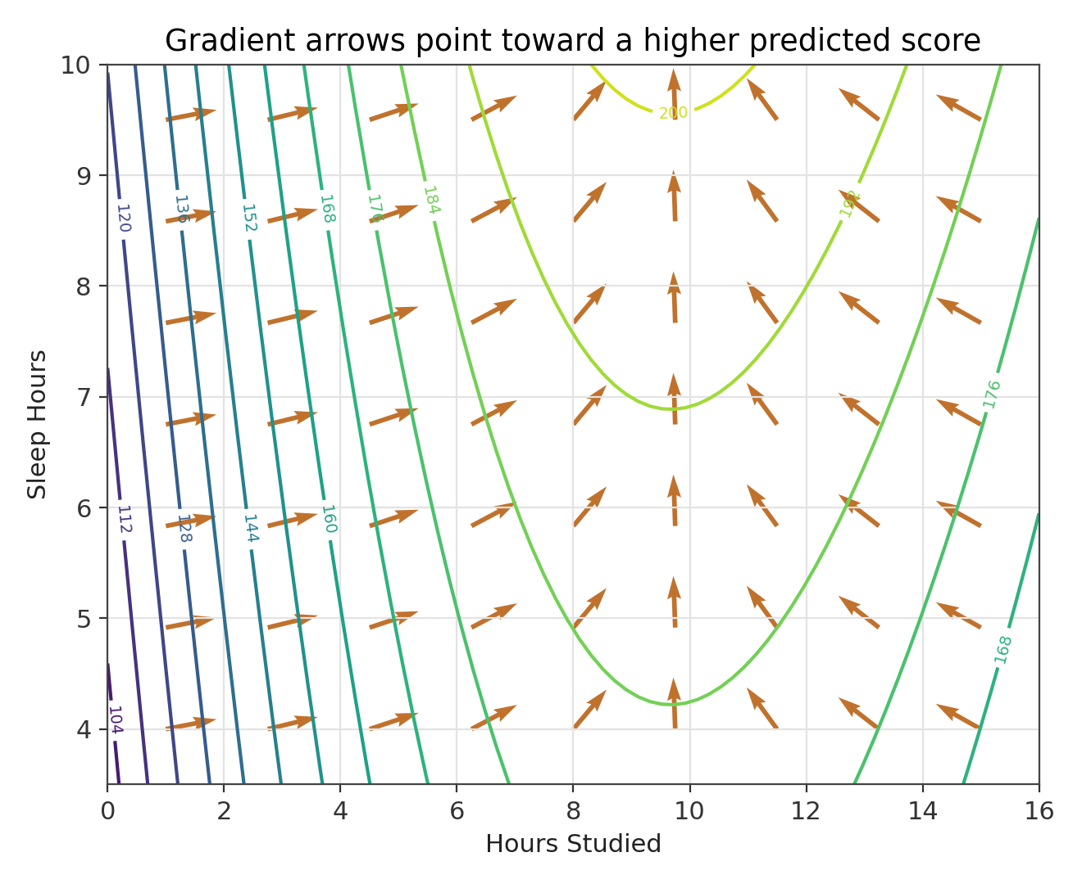
contour lines of the score surface with gradient arrows overlaid. every arrow points toward higher scores and crosses the contour lines at a right angle
Look at how the arrows behave in that picture. They always cross the contour lines at a right angle, never running alongside them. That is not a coincidence, it is a direct consequence of what a gradient is. Moving along a contour line keeps the function's value unchanged, so the direction of no change and the direction of fastest change must be perpendicular to each other. You can also see the arrows tilt as they pass different values of Hours_Studied, growing shorter and rotating near the peak in the middle of the picture, because the slope in that direction is close to zero right around there.

Why this matters for machine learning
A loss function used to train a model typically depends on thousands, millions, or even billions of parameters at once. The gradient of that loss, one entry per parameter, tells the training process exactly which direction in that enormous space makes the loss worse fastest. Since we want to make the loss smaller, not bigger, the natural move is to step in the opposite direction, along the negative gradient. That single observation is the entire idea behind the most important algorithm in modern machine learning, which gets a full section of its own next.
Try it yourself
1. Why must the gradient vector always be perpendicular to the contour line passing through the same point.
2. If the gradient of a function at a certain point is the zero vector, what does that tell you about moving in any direction from that point.
3. A gradient has one entry for every input variable. How many entries would the gradient of the loss function for a model with 50,000 parameters have.
Knowing which direction makes things worse fastest is only useful if you actually do something with that information. The next section turns the gradient into an algorithm, a repeated recipe for taking small steps that gradually walk a set of parameters toward values that make a model's predictions as accurate as possible.

7. Gradient descent
Training a machine learning model almost always comes down to the same task. You have some parameters, a starting guess for how the model should behave, and a loss function that scores how wrong those parameters currently are on the data you have. You want to find parameter values that make the loss as small as possible. Gradient descent is the simple, repeated procedure that gets you there.
The recipe has three ingredients. Start somewhere, often at random or at zero. Compute the gradient of the loss at the current parameters. Take a small step in the direction opposite the gradient, since that direction decreases the loss fastest. Then repeat the whole process from the new position, again and again, until the loss stops improving by any meaningful amount.
$θ_{new} = θ_{old} − α ∇f(θ_{old})$
the parameter update rule. theta stands for the parameters, and alpha is the learning rate
The Greek letter alpha in that formula is called the learning rate, and it controls the size of each step. Getting it right matters more than almost any other choice in the whole training process.

Choosing a learning rate
We can make this concrete using a plain linear regression fit to our dataset, predicting Final_Exam_Score from all seven standardized features at once, trained from scratch with gradient descent rather than a closed form solution. With a learning rate of about 0.01, progress is real but painfully slow. After the same number of steps that another setting would need to fully converge, the loss has barely started to fall. With a learning rate around 0.1, the loss drops sharply within the first ten or fifteen steps and then settles into a flat, low value, which is exactly the behavior you want to see. Push the learning rate up too far, past roughly 1.0 for this particular dataset, and the steps become so large that each one overshoots the bottom of the loss surface and lands somewhere worse than before, so the loss grows without bound instead of shrinking, doubling and redoubling every iteration.
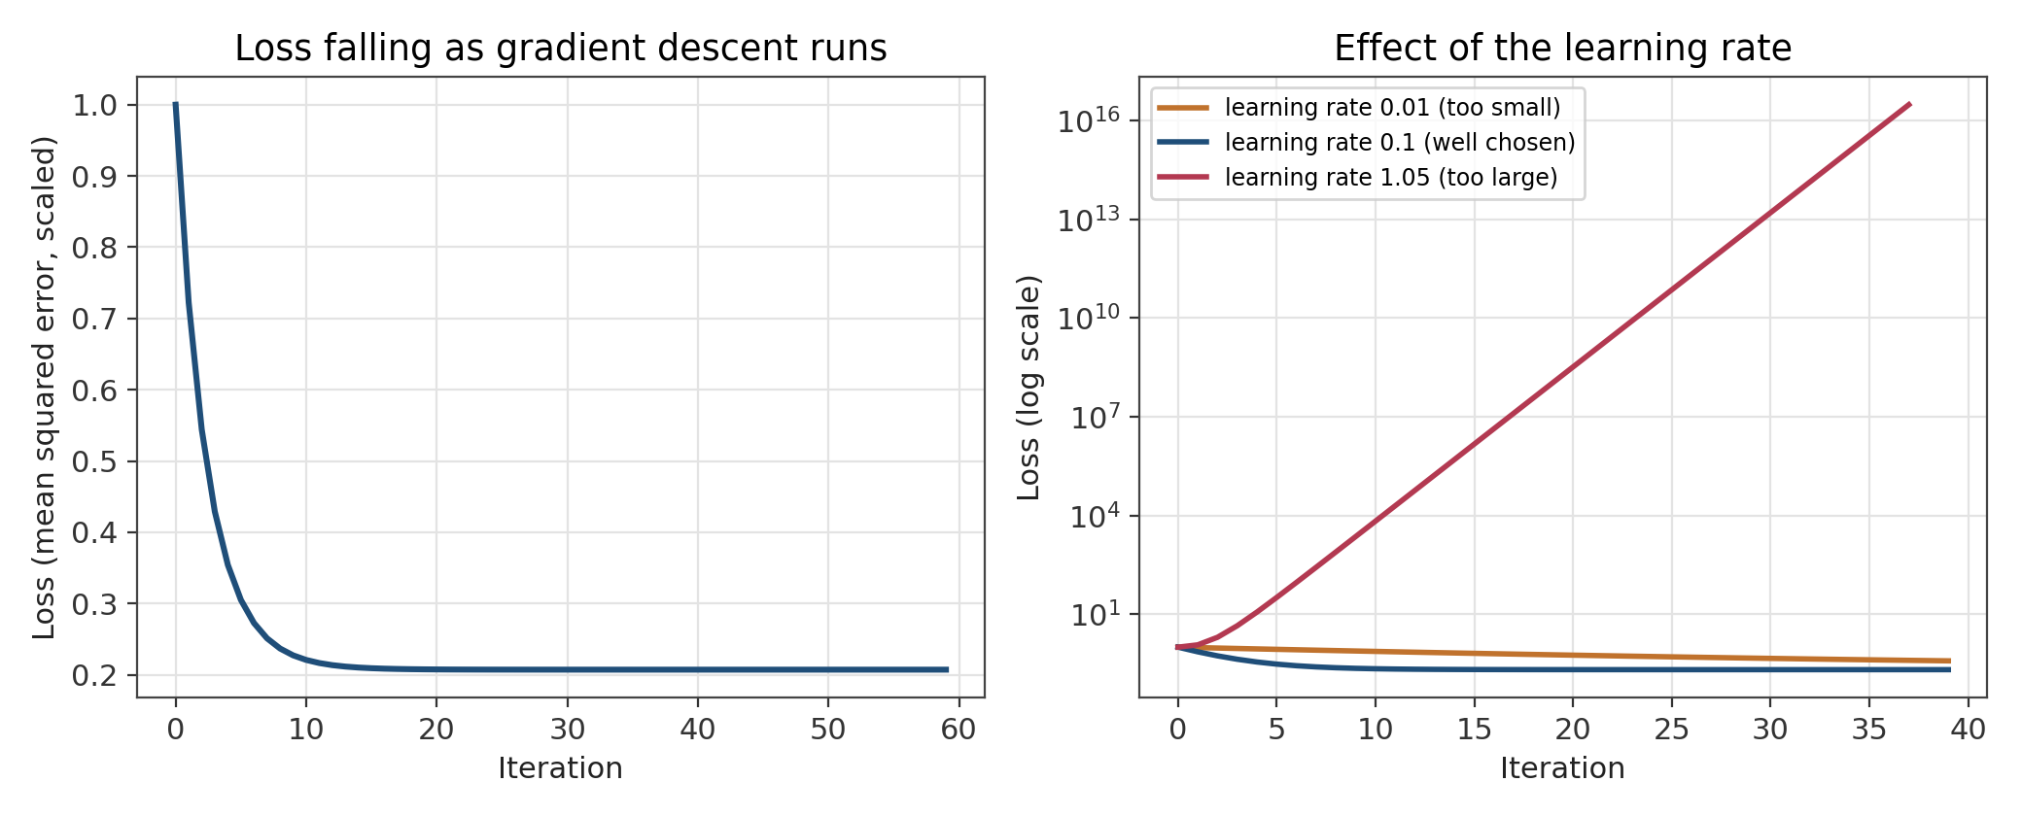
left, a well chosen learning rate drives the loss down quickly and then flattens out. right, comparing three learning rates on a log scale, the too small one crawls, the well chosen one settles low, and the too large one explodes
This gives a practical rule of thumb. If training loss is barely moving after many iterations, the learning rate is probably too small and progress will simply take longer than it needs to. If the loss is jumping around wildly or increasing, the learning rate is probably too large and needs to come down. Well tuned training usually looks like the left hand curve above, a fast initial drop that gradually flattens into a stable, low value.

Local minima and global minima
For a bowl shaped loss surface with a single low point, gradient descent reliably finds it. Real loss surfaces, especially for large neural networks, are far bumpier, with many valleys of different depths. Gradient descent only promises to walk downhill from wherever it starts, so it can easily settle into a local minimum, a valley that is the lowest point in its immediate neighborhood but not the lowest point anywhere on the entire surface, which would be the global minimum. In practice, modern training relies on tricks like randomized starting points, momentum that helps carry the search through small dips, and the sheer high dimensional shape of large networks, which research suggests makes many local minima nearly as good as the global one, rather than a fundamentally worse trap.
Once a model has been trained this way on our dataset, its learned weights are informative on their own. The features that end up with the largest weights are Practice_Problems, Hours_Studied, and Attendance, which matches the original formula that generated the data, since those are exactly the features with the biggest true influence on the score. The three features that were never actually part of the generating formula, Previous_Score, Study_Consistency, and Motivation_Level, end up with weights very close to zero, since gradient descent has no reason to lean on them once it has found the pattern that genuinely reduces error. This kind of check, comparing what the model learned against what you know to be true, is a healthy habit whenever you have the chance to do it.

Why this matters for machine learning
Gradient descent, along with faster relatives like stochastic gradient descent and Adam, is the algorithm that trains almost every modern machine learning model, from a simple linear regression like the one above to networks with billions of parameters. Every one of those more advanced methods is still fundamentally the same three step recipe from the top of this section. Compute the gradient, step against it, repeat, with smarter choices layered on top for how big each step should be and how much memory of past steps to keep.
Try it yourself
1. If the loss barely changes after a hundred iterations of gradient descent, what is the first setting you would try adjusting, and in which direction.
2. Explain why a step size that is too large can cause the loss to increase rather than decrease, even though the direction of the step is correct.
3. Why might a valley that is not the lowest point on the entire loss surface still count as a reasonable place for training to end up.

8. Jacobians
Every derivative we have taken so far has produced a single number or a single vector describing one output. But plenty of useful functions produce several outputs at once from the same inputs. Imagine a model that predicts not just Final_Exam_Score but also, from the same features, a second number such as how likely the student is to keep up their study habits next term. Now we have two outputs and several inputs, and asking how every output responds to every input at once calls for more structure than a single gradient can hold.
The Jacobian is that structure. It is a matrix, a grid of numbers, with one row per output and one column per input. The entry in row i and column j is the partial derivative of output i with respect to input j. For our two output, two input example, using just Hours_Studied and Sleep_Hours, and calling the two outputs f1 and f2, the Jacobian looks like this.
$\frac{∂f₁}{∂Hours}$ | $\frac{∂f₁}{∂Sleep}$
$\frac{∂f₂}{∂Hours}$ | $\frac{∂f₂}{∂Sleep}$

Every gradient we met in section 6 is really just a single row of a Jacobian, the special case where there is only one output. The Jacobian is what you need the moment a function has more than one output to track.

Thinking of it as a transformation
There is a second, more geometric way to read a Jacobian. If you think of the inputs as coordinates of a point and the outputs as where that point gets mapped to, the Jacobian at a point describes how a tiny neighborhood around that point gets stretched, squeezed, or rotated by the mapping. A Jacobian with large entries stretches space out in that region, one with small entries compresses it, and the pattern of positive and negative entries controls any rotation or flipping that happens along the way.

Why this matters for machine learning
Jacobians show up whenever a system has multiple outputs that all depend on the same inputs. In robotics, the Jacobian relates small changes in a robot arm's joint angles to small changes in the position of its hand, which is essential for smooth, precise motion. In computer vision, Jacobians describe how transformations like rotating or warping an image affect every pixel coordinate at once. In deep learning, layers that produce vector outputs, rather than a single number, pass Jacobians backward during training, and the same automatic differentiation systems mentioned in the chain rule section are, more precisely, Jacobian calculators as soon as more than one output is involved. Jacobians also come up in studying how sensitive a trained model's predictions are to small changes or small attacks on its input, an area of active interest for building models that behave reliably.
Try it yourself
1. If a function has 3 outputs and 5 inputs, what shape would its Jacobian matrix be.
2. Explain, using the robot arm example, why a single gradient would not be enough to describe how joint angles affect hand position.
3. How is a single row of a Jacobian matrix related to something you already learned in the gradient section.
The Jacobian tells us how a function stretches space in the first order sense, using only first derivatives. To understand curvature itself, whether a surface bends like a bowl, a dome, or a saddle, we need to go one derivative further.

9. Hessians
A first derivative tells you whether a function is rising or falling. A second derivative, the derivative of the derivative, tells you how the slope itself is changing, which is another way of describing curvature. A positive second derivative means the slope is increasing, which bends the curve upward like the inside of a bowl. A negative second derivative means the slope is decreasing, which bends the curve downward like the outside of a dome. For a function of several variables, gathering all of the second derivatives, including the mixed ones like how the slope in the hours direction changes as sleep varies, produces a matrix called the Hessian.
$\frac{∂²f}{∂x²}$ | $\frac{∂²f}{∂x∂y}$
$\frac{∂²f}{∂y∂x}$ | $\frac{∂²f}{∂y²}$

The Hessian lets us classify what kind of flat spot a critical point actually is, something a single derivative being zero could not tell us on its own back in section 2. If the Hessian behaves like a positive number in every direction, mathematicians call it positive definite, and the point sitting there is a local minimum, the bottom of a bowl. If it behaves like a negative number in every direction, it is negative definite, and the point is a local maximum, the top of a dome. If it is positive in some directions and negative in others, the point is a saddle, rising one way and falling another, neither a peak nor a valley.
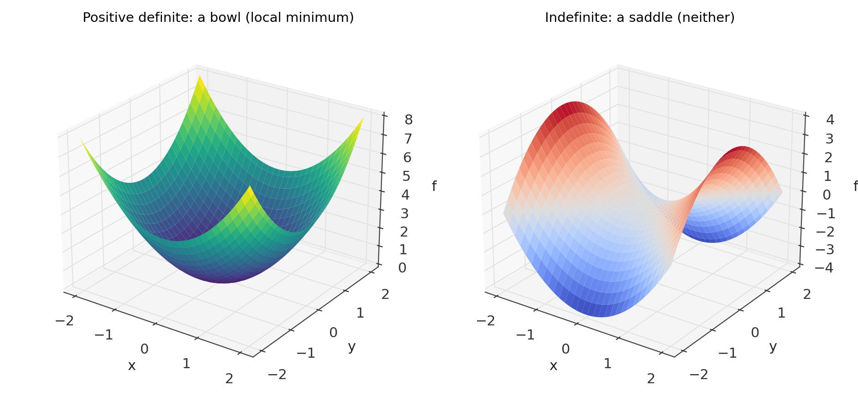
a positive definite surface curves upward in every direction, like the inside of a bowl. an indefinite surface curves upward in one direction and downward in another, a saddle
Recall from section 2 that our score curve, sliced along the hours studied direction, has a critical point at about 9.67 hours. Working out the second derivative there gives a negative value, which confirms mathematically what the picture already suggested, that point really is a peak and not a valley or a saddle in disguise.

Why this matters for machine learning
Plain gradient descent only ever looks at the slope, the first derivative, which is part of why it can be slow to settle down near a flat region. Newton's Method is a classic optimization technique that also uses the Hessian, the curvature information, to take a smarter step that accounts for how quickly the slope itself is changing. When it works, Newton's Method can reach a minimum in far fewer steps than gradient descent. The catch is cost. For a model with a million parameters the Hessian has a trillion entries, one for every pair of parameters, which is far too large to compute or store for most modern neural networks. This is exactly why gradient descent and its variants, which only ever need the much smaller gradient, remain the practical default for large scale training, while Hessian based methods are reserved for smaller problems or approximated only roughly for big ones.
Try it yourself
1. Why does a Hessian matrix need one entry for every pair of variables, rather than just one entry per variable like a gradient.
2. If the Hessian at a critical point is negative in one direction and positive in another, what kind of point is it, and can gradient descent get permanently stuck there.
3. Why might computing the full Hessian be impractical for a neural network with a million parameters, even though it is entirely practical for a function of two or three variables.
Second derivatives describe curvature at a single point. The next section shows what that curvature is actually good for, using it to build a simple, local approximation of a complicated function that is often just as useful as the real thing nearby.

10. Taylor series
Complicated functions are often hard to work with directly, but near any single point you can build a much simpler stand in for them using nothing but derivatives evaluated at that one point. This is the idea behind a Taylor series. Start with the function's value at the point. Add a correction based on the first derivative, which accounts for the slope. Add another correction based on the second derivative, which accounts for curvature. Keep going, and each additional term makes the approximation hug the true function more closely, at least near the point you built it around.
$f(x) = f(a) + f'(a)(x − a) + \frac{f''(a)}{2!}{(x − a)}^{2} + …$
the Taylor series of f, built around the point a
Stopping after the first two terms gives what is called a first order approximation, which is nothing more than the tangent line from section 2. Keeping the next term as well gives a second order approximation, a parabola that also matches the curvature of the original function at that point, not just its slope. Each further term brings in a higher derivative and buys a little more accuracy, usually over a slightly wider range around the center point.
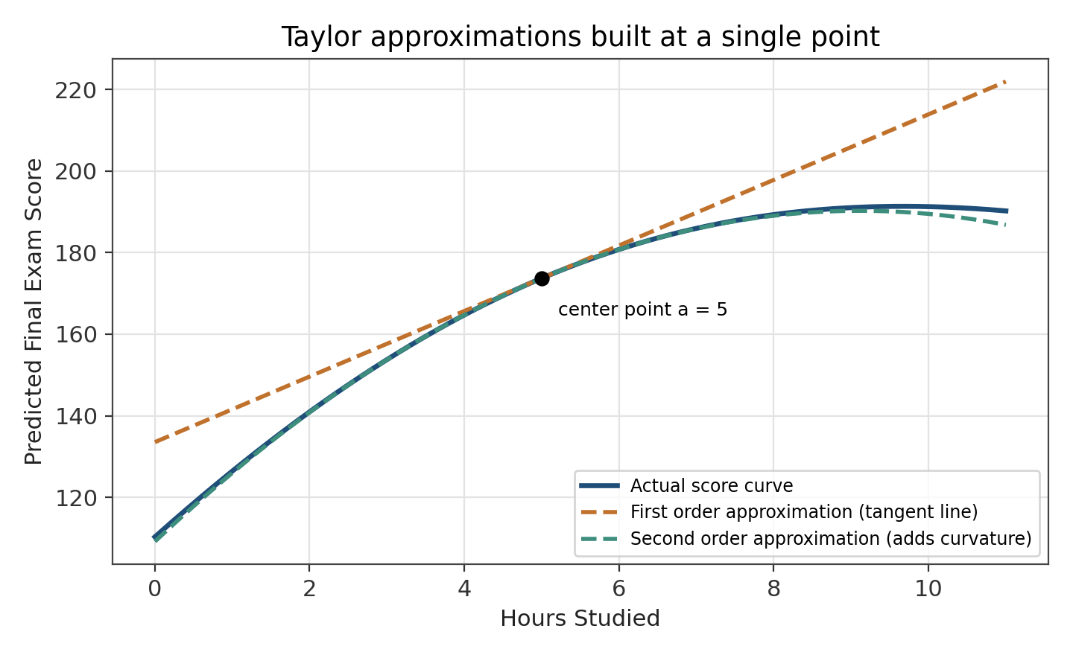
built around 5 hours of studying, the first order approximation is a straight line and drifts away quickly, while the second order approximation follows the true curve much longer before it too diverges
Notice how the straight line approximation peels away from the real curve fairly quickly, while the curved, second order approximation tracks the true score noticeably longer before it starts to drift, particularly past where the real curve bends over near its peak. This is the general pattern with Taylor approximations. They are built to be trustworthy close to their center point, and how far that trust extends depends on how many terms you keep and how sharply the true function bends further away.

Why this matters for machine learning
Taylor series are more than a textbook curiosity, they are the mathematical justification behind several tools we have already used. Newton's Method from the previous section is derived by building a second order Taylor approximation of the loss function at the current point and then jumping straight to the minimum of that simple parabola instead of the true, more complicated surface. More broadly, whenever an algorithm needs to reason about a complicated function using only a bit of local information, a Taylor approximation is very often lurking in the background, quietly turning a hard global problem into an easy local one.
Try it yourself
1. Why does a first order Taylor approximation match the original function's value and slope at the center point, but generally nothing else.
2. Looking at the picture above, why does the second order approximation eventually drift away from the true curve too, rather than matching it forever.
3. In your own words, explain the connection between a second order Taylor approximation and Newton's Method from the previous section.
We now have every tool needed to train a model from scratch. The final section puts them all to work together, following the same dataset from a raw table of numbers all the way through to a trained set of parameters.

11. A complete pipeline, start to finish
It is worth walking through, in order, how every idea in these notes fits into a single working pipeline, the same kind of pipeline that sits underneath any machine learning library you might use. Every step below has already appeared in an earlier section. Here they are simply lined up in the order a real training run would use them.
- Start with the dataset. Our 150 rows of features and the Final_Exam_Score target, standardized into X_std so that every feature is on a comparable scale, exactly as described in section 0.
- Choose a prediction function. A simple starting choice is a linear combination of the standardized features, each multiplied by its own weight and added together. More flexible models simply replace this with a chain of nested functions, which is where the chain rule from section 4 becomes essential.
- Choose a loss function. Mean squared error, the average of the squared difference between predicted and actual Final_Exam_Score, is a natural choice, and it is continuous and smooth everywhere, which section 1 showed us is exactly what makes derivative based training possible in the first place.
- Differentiate the loss. Using partial derivatives from section 3, and the chain rule from section 4 if the prediction function has any nested structure, work out how the loss responds to a small change in each individual weight.
- Collect those partial derivatives into a gradient. Section 6 showed that this single vector points toward the fastest increase in the loss, which tells us immediately which direction to avoid.
- Run gradient descent. Repeatedly step each weight a small amount, set by the learning rate, opposite the gradient, exactly as in section 7, tracking the loss after every step to confirm it is falling rather than stalling or exploding.
- Optionally use curvature. A Hessian based method from section 9, or a Taylor approximation from section 10, can sometimes reach a good answer in fewer steps, at the cost of more computation per step.
- Arrive at trained weights. Once the loss stops improving in any meaningful way, the current weights define your trained model, ready to make predictions on new students it has never seen.
When we actually ran this pipeline on our dataset back in section 7, using gradient descent on a linear model, the weights that came out gave the most credit to Practice_Problems, Hours_Studied, and Attendance, and almost none to Previous_Score, Study_Consistency, or Motivation_Level. That outcome was not luck. It fell directly out of the same three step loop, compute the gradient, step against it, repeat, applied patiently until it settled down. Every large model in production today, no matter how many layers or parameters it has, is running a more elaborate version of exactly this same loop.

Where a linear model falls short
It is worth being honest about the limits of the simple linear model we trained. Because it can only combine features in a straight line fashion, it cannot represent the sine wave or the squared peak baked into the true score formula, and no amount of additional gradient descent steps will fix that, since the model family itself is too limited. Capturing that curved behavior would mean choosing a more flexible prediction function, perhaps one with its own nested, chain rule friendly structure, and then handing it to the exact same training loop described above. The loop does not change. Only the function being trained does.

12. Summary table
Ten ideas, one dataset, and one continuous story connecting them. Here is the whole subject compressed into a single table, matching every mathematical idea to the machine learning job it actually does.

Limits | Instantaneous behavior | Makes derivatives possible
Derivatives | Rate of change | Optimization direction
Partial derivatives | Multivariable change | Neural network weights
Chain rule | Composite derivatives | Backpropagation
Integrals | Accumulation | Probability and expected value
Gradient | Direction of steepest change | Where optimization should step
Gradient descent | Repeated parameter updates | Training machine learning models
Jacobians | Derivatives of vector outputs | Deep learning, robotics, vision
Hessians | Curvature | Newton's Method, second order optimization
Taylor series | Local approximation | Numerical methods, deriving Newton's Method

Every row in that table is really the same small story told a different way. We started by asking what a function does as we approach a point, which gave us limits. Limits let us define a derivative, the rate of change at a single point, and a handful of rules let us compute derivatives quickly instead of by brute force. Multivariable functions needed partial derivatives, and nested functions needed the chain rule, which together make it possible to differentiate almost anything a real model can be built from. Integrals gave us the reverse operation, accumulation rather than instantaneous change. Collecting partial derivatives into a gradient gave us a direction, and gradient descent turned that direction into a repeated procedure for actually training a model. Jacobians extended that idea to functions with several outputs, and Hessians took us one derivative further, into curvature, which let us tell peaks, valleys, and saddles apart and gave us Newton's Method. Taylor series tied first and second derivatives together into a single local approximation, the same approximation that Newton's Method quietly relies on.
None of this required a new dataset for every new idea. The same 150 students and the same score formula carried every single topic, which is exactly the point. Calculus is not a collection of unrelated tricks to memorize. It is one connected way of asking how things change, and machine learning is, in large part, the practice of using that same question, asked millions of times over, to let a model find its own way toward better predictions.

