DSA Assignment 1 …………………………………………………………...
Muhammad Abubakar Rashid
459565

Task 1 :
Approach : I have used circular linked list class CPUscheldule
to manage the processes of System and each process is an obejct of Process class that is actually the node of circular linked list ,i have made a cycle function that iterates over every process in the System an subtract specified time from the remaining time of each, as soon as the remaining time of a process gets to 0 remove Process function gets called that removes that completed process

Assumptions No assumptions were taken in this task

GitHub Link
https://github.com/Abubakar-rashid/DSA

Challenges Faced initially it looked hard to implement a circular list and remove process as it gets completed but after some tries I figured it out and its now working fine

Output screenshots

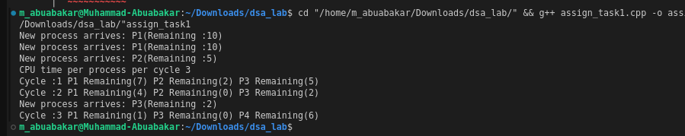


Task 2 :
Approach :
I have created a singly linked list and each of its node is capable of storing 64 bits and a large 1024 bit number can be broken down and store in the nodes of linked list
then I am using a primeMod function that calculates the x mod n where x is the
the large number stored in the linked list and n is any specified number
I have used this special function to achieve the remainder after dividing the x with any n
lastly, I am first checking that if that number is divisible by 2 , 3 ,5 , 7 and 11 this if statement clears most of the large numbers that are not prime after that I am using a while loop and increasing it by 2 starting from 3 and onwards till len gth of i*i get equal to the length of n

Assumptions
I have taken into account Prime Number Theorem that states that when the numbers start increasing the amount of prime numbers become less frequent
and ulimately gets very rare

so I am checking the number by dividing it with number i until i*i gets equal to the length of the original number if n is large and it is a prime then it will not be divisible by any number till len(i*i) = len of orig ,if it is not then it will be divisible by any number before len(i*i) , I am using len of (i*i) from concept of Miller Rabin as in miller rabin approach sqrt of the original number is taken but here instead of taking sqrt of original number I am using square of i
some demonstrations are attatched in the output screenshots

GitHub Link
https://github.com/Abubakar-rashid/DSA

Challenges Faced It was difficult to implement the logic of mod function I used traditional approach to calculate the mod such that remainder of one Node gets concatenated at the start of the other node value
other than that implementing the concept of Miller Rabin approach and Prime Number Theorem was confusing

Output Screenshots:
