QURIE
QUantum Radiotherapy Inverse-planning Engine
Choosing radiation beam angles that hit the tumour and spare the heart, with QAOA in Qiskit
Qiskit Fall Fest 2026 Hackathon · Domain: Healthcare
Team: [team member names] · FAST-NUCES Islamabad
GitHub: [repository link] · Video: [Google Drive link]

Summary
After breast-cancer surgery, radiotherapy fires X-ray beams at the chest wall from a few angles. Each extra beam costs machine time, and every angle trades target coverage against dose to the heart and lungs. QURIE formulates choosing k = 4 of 12 candidate beam angles as an exact QUBO built from a dose model of each real patient's CT slice, maps it to a 12-qubit Ising Hamiltonian, and solves it with QAOA using a constraint-preserving XY mixer, so every measurement is a valid 4-beam plan.
On 48 real patients (25 left-sided, 23 right-sided) from a public hospital dataset, and with circuit angles tuned on one patient only, QAOA at depth p = 10 returned the exact optimal plan (verified by brute force) in 100% of runs with 100 shots. A single shot hits the optimum 46% of the time on average, about 228× better than random guessing. The textbook penalty-QAOA reaches only 0.3% per shot and wastes 25% of shots on invalid plans. Without being told the hospital's plans, the optimiser chose angles within 15° of the doctors' main beams in 47 of 48 patients. There is no quantum speed-up at this size (brute force takes 2 ms); we use the exact answer as the referee.

1. Problem and who it serves
Radiotherapy is given to most breast-cancer patients after surgery. A linear accelerator rotates around the patient and delivers X-ray beams from a small number of gantry angles. The planner must decide which angles to use.
- Limited resource: every beam adds set-up and delivery time on a machine that treats dozens of patients a day, so the number of beams is capped (here k = 4).
- Competing objectives: the target (chest wall / breast) must receive the full, even dose, while the heart and lungs should receive as little as possible. For a left-sided target the heart lies directly behind it; radiation to the heart raises the long-term risk of heart disease, and radiation to the lung can cause lung damage. An angle that avoids the heart often crosses more lung, and the other way round.
- Who it serves: treatment planners and medical physicists (angle selection is still largely manual, by trial and error), patients (fewer side effects), and resource-limited hospitals such as those in Pakistan, where planning time and machine time are scarce.
Decision question: for this patient, which 4 of 12 candidate beam angles give the best balance of target coverage and organ sparing?

2. Formulation

2.1 Test instance (real patient data)
We use the public dataset of Rezaei et al. (Data in Brief, 2017): CT scans, doctor-drawn outlines and the hospital's own treatment plans for 52 breast-cancer patients. The team converted it into anonymised 2D axial slices on a 4 mm grid (one slice per patient, where the target-heart overlap is largest). 48 patients passed quality checks: 25 left-sided and 23 right-sided. Each slice has masks for the body, target (CTV), heart, left and right lung, the CT numbers, and the hospital's beam angles.
Candidate beams (one qubit each): 12 angles in two 75° arcs that face the treated side, every 15° (left-sided: 90, 105, ..., 165° and 285, 300, ..., 345, 0°; 0° = from the front, 90° = from the patient's left, IEC convention). For right-sided patients the list is mirrored automatically. Beams entering from the far side would have to cross the whole chest, so they are not offered.

2.2 Dose model
Each candidate beam b is modelled as a straight strip aimed at the target centre, as wide as the target plus a margin, with intensity falling as exp(−0.05 · depth). Depth is measured as radiological depth: tissue density from the CT scan (lung is mostly air, so it attenuates less). Each beam's dose map is normalised so the target receives 1.0 (100% of the prescription) on average. With k beams switched on, each delivers 1/k of the dose:
D_v(x) = Σ_b x_b · a_bv , a_bv = dose of beam b in pixel v, divided by k

2.3 Variables, objective and constraint
Element | Definition
Decision variables | x_b ∈ {0,1}, b = 1..12 (1 = use beam b) → 12 qubits
Objective (minimise) | f(x) = 10·mean_target (D−1)² + 5·mean_heart D² + 1.5·mean_lungL D² + 1.5·mean_lungR D² + 0.3·mean_other D²
Constraint | Σ_b x_b = k = 4 (limited machine time)
Search space | C(12,4) = 495 valid plans per patient; 2¹² = 4,096 bitstrings
Measurable outputs | objective value; mean heart / lung dose; target coverage V95 (share of target receiving ≥ 95% of the dose)

The first term asks for full and even target coverage; the others penalise dose to healthy organs. The weights express clinical priorities (heart highest) and can be changed; Section 6.4 shows how the optimal plan moves when they do.

2.4 Why this is an exact QUBO
Because the dose D is linear in x, every term of f is a quadratic polynomial in x. Expanding the squares gives f(x) = xᵀQx + cᵀx + const with Q_ij = Σ_organs w_o · mean_v(a_iv·a_jv). No approximation is needed. The off-diagonal terms have a clear physical meaning: two beams that cross the same healthy tissue are penalised together, which is exactly what a planner tries to avoid. A unit test confirms that the QUBO polynomial equals the dose-based objective for random plans to 10⁻⁹.

3. Quantum representation and algorithm

3.1 Mapping to qubits
Substituting x_i = (1 − Z_i)/2 turns f into a 12-qubit Ising Hamiltonian H_C = Σ h_i Z_i + Σ J_ij Z_i Z_j + const, built as a Qiskit SparsePauliOp. Its eigenvalue on each computational basis state equals the plan's cost; a test checks this on all 4,096 bitstrings (maximum error ~10⁻¹³). Qubit i corresponds to beam i (Qiskit little-endian ordering is handled explicitly).

3.2 Why QAOA
- The problem is natively a QUBO, the input QAOA is designed for, and the QAOA circuit is built directly from the problem Hamiltonian, so the quantum part does the actual optimisation.
- Its depth p gives a clear accuracy-versus-circuit-size knob that we study.
- 12 qubits are small enough for exact statevector simulation, so every quantum result can be checked against the true optimum.

3.3 Our extension: keeping the constraint inside the circuit (XY mixer)
Textbook QAOA starts in an equal superposition of all 4,096 bitstrings, uses an X mixer, and adds a penalty λ(Σx − k)² for plans with the wrong number of beams. Many measured bitstrings are then invalid, and the penalty distorts the cost landscape.
QURIE instead uses the Quantum Alternating Operator Ansatz (Hadfield et al., 2019):
- Start state: an equal superposition of only the 495 valid plans (a Dicke state |D⁽¹²⁾₄⟩).
- XY mixer: H_M = Σ_{i<j} (X_iX_j + Y_iY_j)/2. Each term swaps |01⟩ ↔ |10⟩ on a pair of qubits, i.e. moves a beam from one angle to another, so the number of beams never changes.
- Result: 100% of measurements are valid plans, by construction; no penalty term or penalty tuning is needed.
The penalty variant is kept as a baseline, with λ set to the spread of valid-plan costs (a test checks that the penalised minimum is still a valid plan; an ablation varies λ from 0.25× to 2×).

3.4 Choosing the circuit angles
For depth p the circuit is |ψ⟩ = Π_{l=1..p} e^{−iβ_l H_M} e^{−iγ_l H_C} |D⟩. Instead of optimising 2p free angles per patient, we use a linear-ramp schedule (a digitised quantum anneal): γ_l = Δγ·l/p, β_l = Δβ·(1 − (l−1)/p). Only two numbers (Δγ, Δβ) are tuned for each depth, by a grid search plus a short COBYLA polish that minimises the average measured cost on one patient (P01). They are then reused unchanged on all 48 patients. This avoids per-patient training, uses no knowledge of the true optimum, and tests whether the circuit generalises. The cost Hamiltonian is divided by the spread of valid-plan costs so the same angles suit every patient.

3.5 Measurement and output
The trained circuit is sampled with Qiskit's StatevectorSampler (V2 primitive): 100 shots per run, 5 independent runs per patient and depth. The cheapest valid plan in a run is QURIE's answer. We also record the exact output probabilities to report the chance that a single shot is the optimum.

4. Architecture
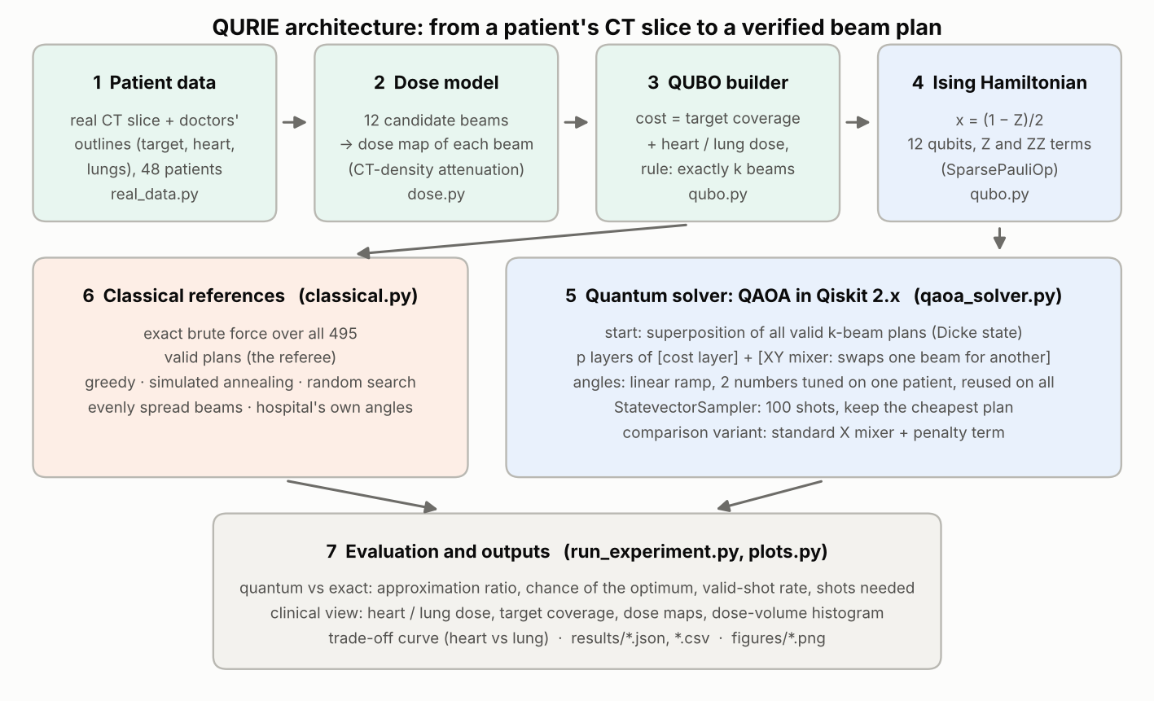
Figure 1. QURIE pipeline: from a patient's CT slice to a beam plan verified against the exact optimum.
Module | Role
real_data.py | loads the 48 anonymised patient slices and the hospital plans
dose.py | candidate angles (mirrored for right-sided targets) and per-beam dose maps
qubo.py | QUBO builder, brute force, Ising mapping, dose metrics
qaoa_solver.py | QAOA (XY-mixer and penalty variants), ramp tuning, sampling, scoring
classical.py | greedy, simulated annealing, random search, evenly spread, hospital angles
run_experiment.py | one command that runs everything and writes results/ and figures/

Software: Python 3.10–3.13, Qiskit 2.x (qaoa_ansatz, SparsePauliOp, Statevector, StatevectorSampler), NumPy, SciPy, Matplotlib. QURIE does not depend on qiskit-optimization, which IBM archived in July 2026; the QUBO and Ising mapping are written directly.

5. Classical and exact references
- Exact brute force: evaluates all 495 valid plans. This is the referee: it gives the true optimum and the worst plan for the approximation ratio.
- Greedy: adds the single beam that lowers the cost most, k times.
- Simulated annealing: swaps one beam in and one out, accepting worse swaps with a falling probability; 100 cost evaluations (the same budget as 100 quantum shots).
- Random search: best of 100 random valid plans.
- Evenly spread beams: a naive plan.
- Hospital's angles: the angles the hospital actually used, re-scored in our dose model with equal weights (a sanity check, not a like-for-like comparison: the real plans used wedges, unequal weights and 3D planning).
Metrics: approximation ratio r = (f_worst − ⟨f⟩)/(f_worst − f_best) over measured valid plans (1.0 = perfect), P(optimum) per shot, valid-shot rate, found-optimum rate (best of 100 shots equals the brute-force optimum), and shots needed for a 95% chance of the optimum.

6. Results

6.1 Every method against the exact answer
Method (48 patients) | Finds exact optimum | Avg. cost above optimum
Exact brute force (reference) | 100% | 0%
QURIE: XY-mixer QAOA, p = 10 (100 shots) | 100% of runs | 0.00%
QURIE: XY-mixer QAOA, p = 3 | 100% of runs | 0.00%
QURIE: XY-mixer QAOA, p = 1 | 93% of runs | 0.21%
Penalty QAOA, p = 20 | 41% of runs | 3.9%
Penalty QAOA, p = 10 | 25% of runs | 5.6%
Greedy | 38 / 48 patients | 0.62% (worst 8%)
Simulated annealing (100 evaluations) | 80% of runs | 0.75%
Random search (100 draws) | 17% of runs | 7.5%
Evenly spread beams | 0 / 48 | 83%
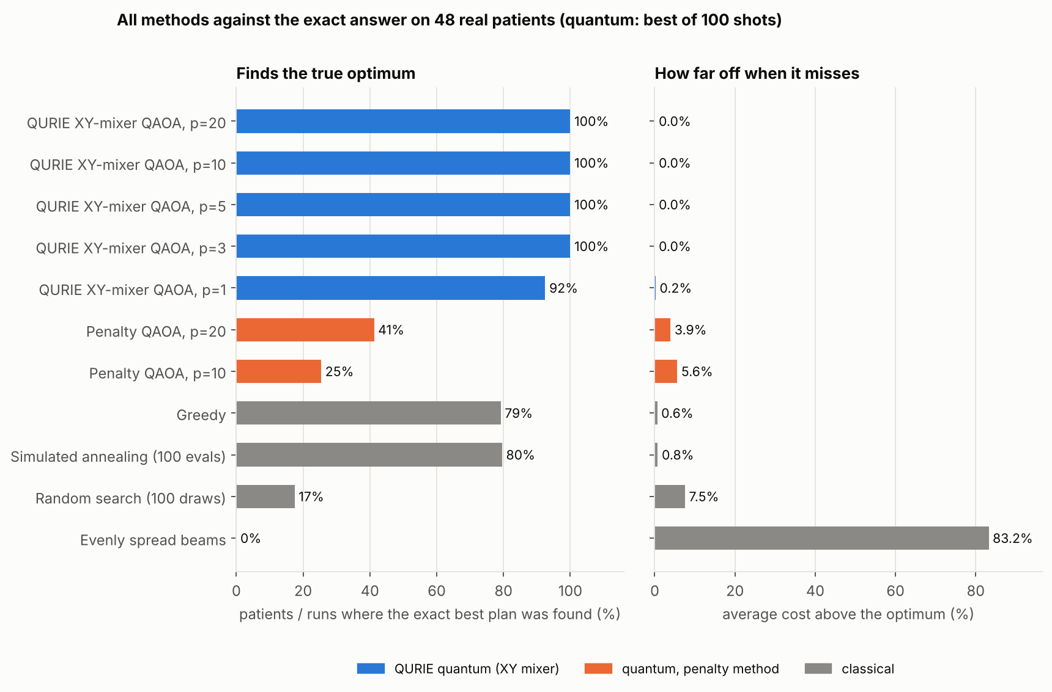
Figure 2. Share of runs that reach the exact optimum (left) and average cost above the optimum (right), 48 patients.
With a budget of 100 shots (or 100 cost evaluations), QAOA with the XY mixer was the only method that reached the exact optimum in every run on every patient at depth p ≥ 2. Greedy missed the optimum for 10 of 48 patients (up to 8% worse), because beams interact: the best single beam is not part of the best set. Simulated annealing with more evaluations would also reach 100%; at this size the problem is easy for classical computers, which is exactly why we can verify the quantum answer.

6.2 Quality of the quantum circuit itself
Depth p | 1 | 2 | 3 | 5 | 10 | 20
XY: P(optimum) per shot | 2.6% | 8.6% | 13.4% | 28.4% | 46.0% | 62.0%
XY: valid shots | 100% | 100% | 100% | 100% | 100% | 100%
XY: approximation ratio | 0.829 | 0.887 | 0.920 | 0.946 | 0.973 | 0.987
XY: shots for 95% chance of optimum | 117 | 36 | 22 | 9 | 5 | 3
Penalty: P(optimum) per shot | 0.1% | 0.1% | 0.1% | 0.2% | 0.3% | 0.5%
Penalty: valid shots | 40% | 46% | 57% | 58% | 75% | 89%
Penalty: approximation ratio | 0.615 | 0.619 | 0.617 | 0.636 | 0.668 | 0.700
Two-qubit gates (XY / penalty) | 198 / 66 | 396 / 132 | 594 / 198 | 990 / 330 | 1980 / 660 | 3960 / 1320

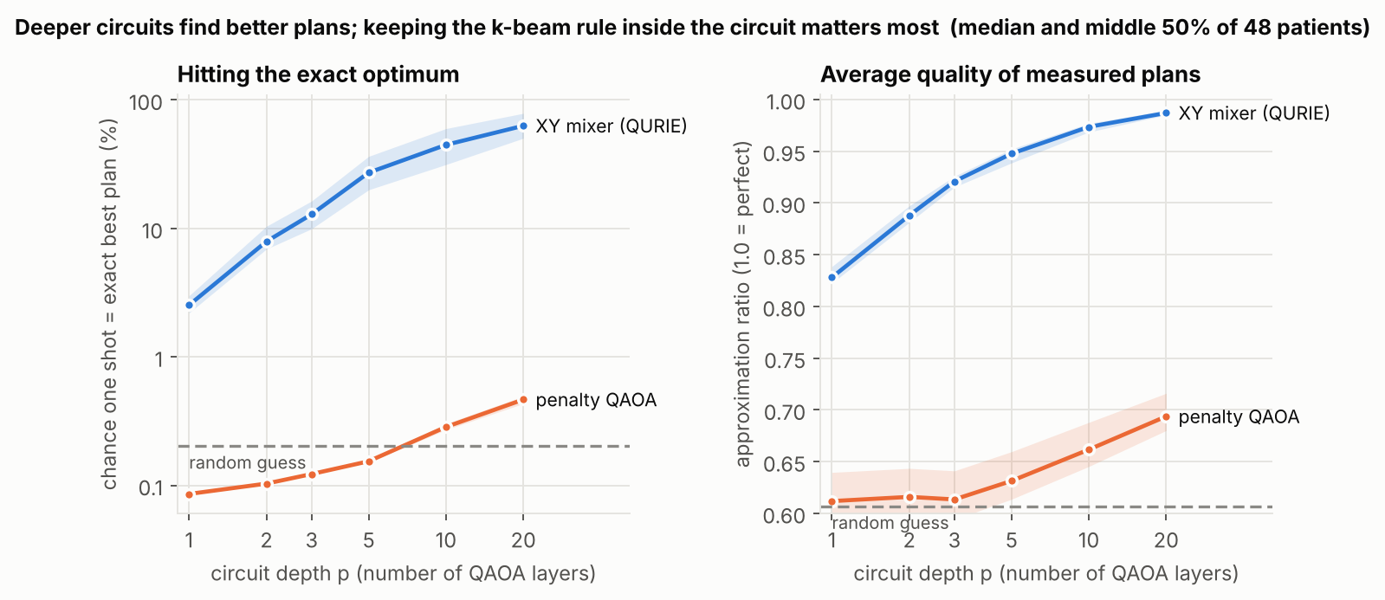
Figure 3. P(optimum) per shot (log scale) and approximation ratio against circuit depth; line = median, band = middle 50% of 48 patients.
A random guess finds the optimum 1 time in 495 (0.2%). With the XY mixer, P(optimum) rises steadily with depth to 46% at p = 10 (between 20% and 76% per patient), and the approximation ratio reaches 0.973 (lowest patient 0.962). The penalty variant stays near random level (≤ 0.5%) at every depth: much of its probability lands on plans with the wrong number of beams, and the large penalty compresses the real cost differences. The constraint-preserving mixer is the single most important design choice. The same two ramp numbers worked on all 48 patients, including 23 right-sided ones the tuning never saw.
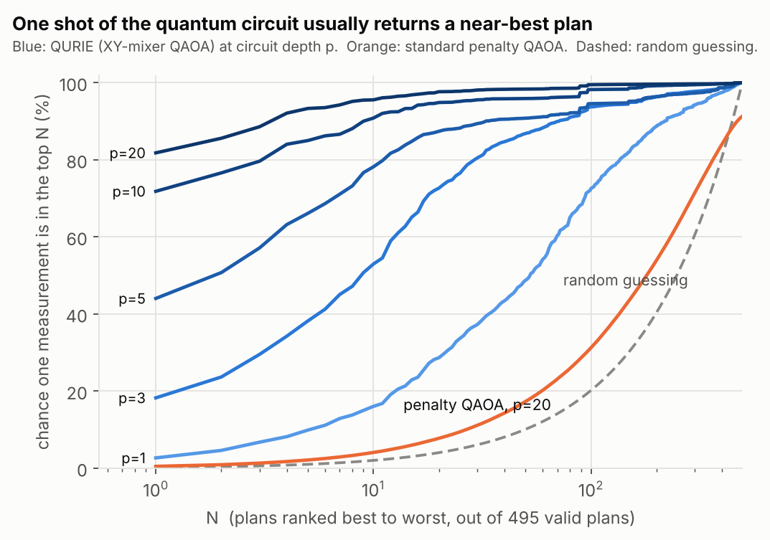
Figure 4. Patient P03: chance that one measurement lands in the best N plans, by depth.

6.3 What the plans look like
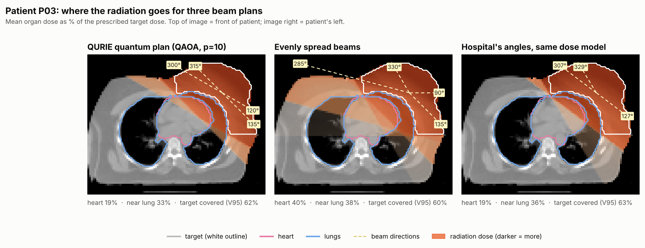
Figure 5. Patient P03 (left-sided). Dose maps for QURIE's plan, evenly spread beams and the hospital's angles in the same model.
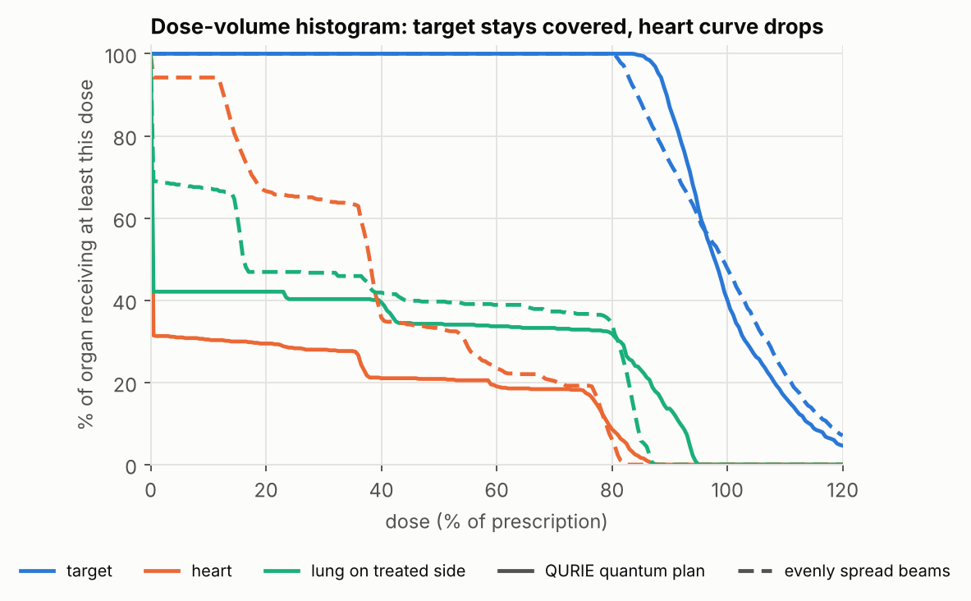
Figure 6. Dose-volume histogram for P03: solid = QURIE plan, dashed = evenly spread beams.
Evenly spread beams send radiation straight through the heart. QURIE's plan uses near-tangential beams that skim the chest wall, which is also what clinicians do. Across 48 patients the optimiser, never told the clinical angles, chose angles within 15° of the hospital's two main beams in 47 of 48 patients (Figure 7).
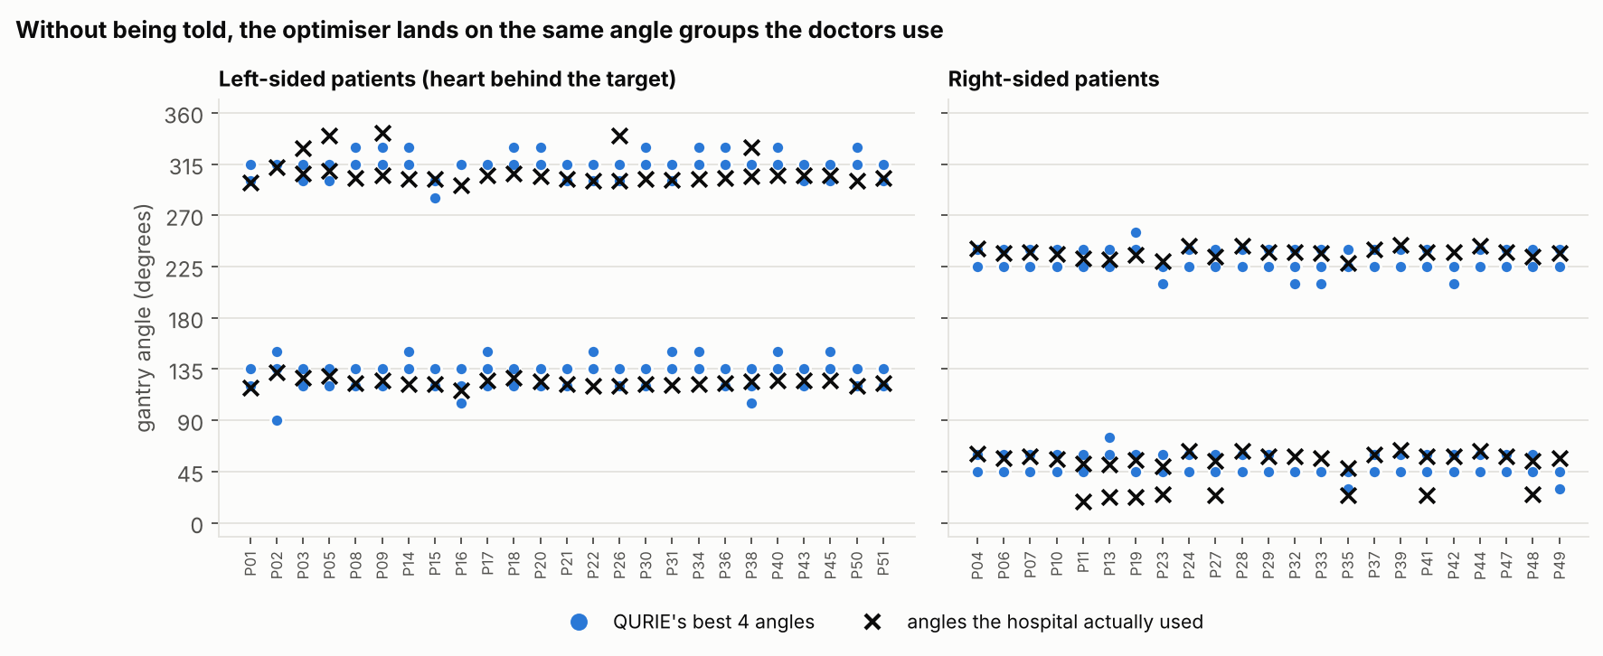
Figure 7. QURIE's 4 angles (blue) and the hospital's angles (×) for all 48 patients.
In our dose model (mean over patients) | QURIE plan | Hospital's angles
Heart dose, all 48 patients | 13.2% | 17.4%
Heart dose, left-sided (25) | 19.4% | 25.9%
Treated-side lung dose, all | 34.0% | 33.3%
Target coverage V95, all | 73.5% | 72.1%
Lower objective than the other | 41 / 48 | 7 / 48

This is a sanity check, not a claim to beat clinicians: QURIE uses 4 beams where most hospital plans used 2–3, and the hospital plans were optimised with wedges, beam weights and 3D information that our model leaves out.

6.4 Competing objectives: the heart–lung trade-off
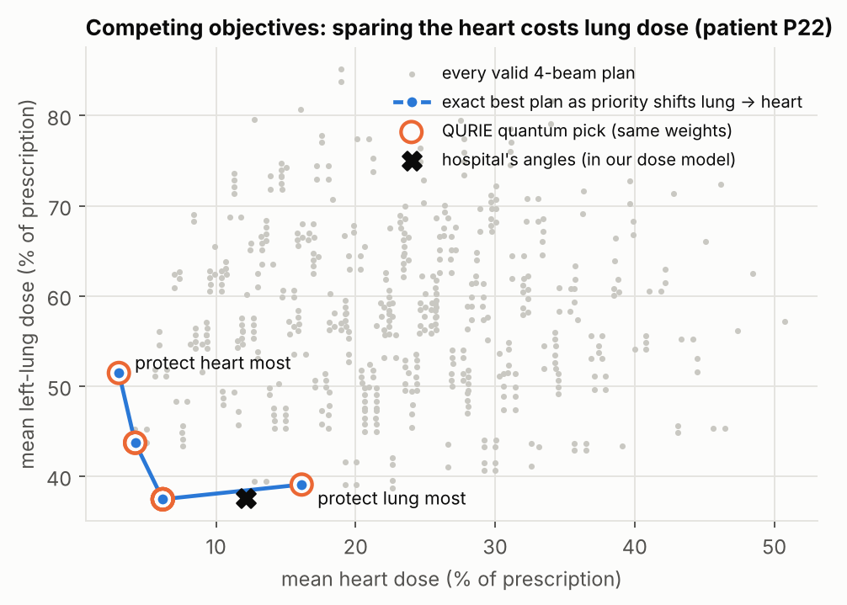
Figure 8. Patient P22: every valid plan (grey), the exact optimum as priority shifts from the left lung to the heart (blue), and QURIE's quantum pick (orange rings).
Moving the priority from the left lung to the heart moves the optimal plan along a clear front: from heart 16% / lung 39% to heart 3% / lung 51%. QAOA, with the same ramp angles, found the exact optimum at every setting (8 of 8). A clinician can therefore set priorities and let the optimiser return the matching plan.

6.5 Further checks
- Number of beams (patient P03): k = 2, 3, 4, 5 give 66, 220, 495 and 792 valid plans; with the same ramp angles QAOA (p = 10) found the optimum in every run for all four (P(optimum) per shot 29%, 40%, 72%, 43%).
- Free angle optimisation: letting COBYLA tune all 2p angles freely on the tuning patient barely helped at p = 1–2 and doubled P(optimum) at p = 3 (13% → 26%), but that requires per-patient training. The 2-number ramp is the cheap, transferable default; per-patient fine-tuning is a possible extension.
- Penalty strength: varying λ from 0.25× to 2× never lifted penalty-QAOA's P(optimum) above 0.6%, so its weakness is structural, not a tuning issue.
- Left versus right: results are similar for both sides (p = 10 found the optimum in 100% of runs for both; mean P(optimum) 42% left, 50% right). As expected, heart dose is much lower for right-sided patients (6.4% vs 19.4%).

7. Limitations and honest assessment
- No quantum advantage. Brute force over 495 plans takes 2 ms. We demonstrate a correct, verifiable quantum method, not a faster one. The motivation is scale: 36 candidate angles with 5 beams already gives 376,992 plans, 72 with 7 gives 1.5 billion, and adding couch rotations gives far more. Whether QAOA helps at that scale is an open research question.
- Noise-free simulation only. At p = 10 the XY circuit has about 2,000 two-qubit gates (≈ 470 layers), far beyond today's hardware without error mitigation. Lower depth is more hardware-friendly but less accurate (p = 1: 93% found rate, 2.6% per shot).
- Dicke state. In simulation the valid-plan start state is loaded directly. On hardware it needs a dedicated O(n·k) circuit (Bärtschi & Eidenbenz, 2019), which adds depth.
- Simplified physics. 2D, straight beams, density-weighted exponential attenuation, no scatter, equal beam weights, no wedges or multi-leaf collimators. Real planning is 3D IMRT/VMAT. Our dose percentages compare plans within the model; they are not clinical doses.
- Data. One axial slice per patient; the target is the post-mastectomy chest wall (CTV); there are no spinal-cord or contralateral-breast outlines. The patients come from one hospital.
- Objective weights were chosen by us. Section 6.4 shows how results move with them; clinicians would set them.
- Hospital comparison is scored in our model with equal weights and uses more beams than most clinical plans; it is a sanity check only.
- Ramp angles were tuned on one left-sided patient. They transferred well to all 48, but other planning problems would need re-tuning.

8. Originality and what we added
Our starting point was published student projects that use quantum machine learning to classify breast-cancer data (VQC/QSVM on the Wisconsin dataset). Those are classification tasks, not optimisation, and in each a classical model performed better. We kept the breast-cancer focus but moved to a genuine resource-constrained optimisation problem in treatment planning:
Aspect | Typical breast-cancer QML project | QURIE
Task | classify benign vs malignant | choose beam angles under a beam budget
Role of quantum | classifier, beaten by classical | QAOA solves the core decision
Proof of correctness | test accuracy (often one split) | exact brute-force optimum for every patient
Constraint handling | not applicable | XY mixer + Dicke state vs penalty, compared
Data | tabular features | 48 real CT slices with organ outlines and hospital plans
Clinical meaning | accuracy | heart / lung dose, coverage, DVH, trade-off curve

9. Reproducibility
pip install -r requirements.txt
python run_experiment.py --quick # one patient, about 30 s
python run_experiment.py # all 48 patients, about 11 min
python -m pytest -q # 9 sanity checks
All randomness is seeded. The two ramp numbers per depth are stored in results/ramp_params.json and re-created with --retune. Every number in this report is read from results/summary.json.

References
1. Rezaei M., Mohammadbeigi A., Khoshgard K., Haghparast A. CT images and radiotherapy treatment planning of patients with breast cancer: A dataset. Data in Brief 13 (2017) 390–395. doi:10.1016/j.dib.2017.06.002. Data: doi:10.17632/vj83jj6fvt.3.
2. Farhi E., Goldstone J., Gutmann S. A Quantum Approximate Optimization Algorithm. arXiv:1411.4028 (2014).
3. Hadfield S. et al. From the Quantum Approximate Optimization Algorithm to a Quantum Alternating Operator Ansatz. Algorithms 12(2):34 (2019).
4. Bärtschi A., Eidenbenz S. Deterministic Preparation of Dicke States. FCT 2019, LNCS 11651.
5. Montañez-Barrera J. A., Michielsen K. Towards a universal QAOA protocol: evidence of a scaling advantage in solving some combinatorial optimization problems. arXiv:2405.09169 (2024).
6. Craft D. et al. Shared data for intensity modulated radiation therapy (IMRT) optimization research: the CORT dataset. GigaScience 3:37 (2014).
7. Qiskit contributors. Qiskit: An Open-source Framework for Quantum Computing (version 2.x), 2026.

