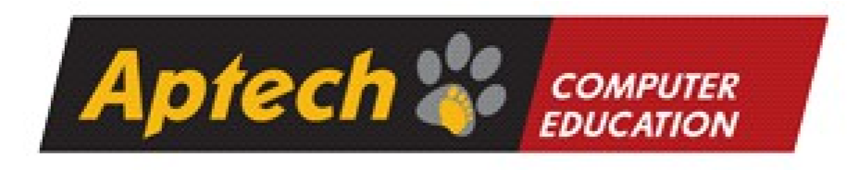

**Project Report on**

**Colligraphy Art**

**Table Of Contents**

1. **Acknowledgments**
2. **Information About Developers**
3. **Introduction About Project**
4. **Synopsis**
5. **Analysis**
6. **Screen Shots**
7. **Final Statement**

# Acknowledgments

The combine Study on this project is an honor for our group members.

We were eager to make such a dynamic and interesting project, which may provide us with a huge amount of practical knowledge and will help us use our skills efficiently.

My heartiest appreciation and gratitude towards our teachers, whose help, dedication and encouragement has helped me to successfully, achieve my goals.

I am grateful to Aptech for providing me necessary facilities and the support which I needed and also for providing me the opportunity to practically implement what we have learned, which will help, help me in future.

# Information About Developers

|  |  |
| --- | --- |
| Student1436269 | Abubakar baig |
| Student1436270 | Ahsan baig |
| Student1436269 | Ali shanwer |
| Student1436269 | Ali haider |

# Introduction About Project

Calligraphy is the art of forming beautiful symbols by hand and arranging them well.

It’s a set of skills and techniques for positioning and inscribing words so they show

integrity, harmony, some sort of ancestry, rhythm and creative fire.

Calligraphy can be taken to expert heights. Calligraphy skills are used in many areas

of art and graphics, from greetings card design to tattoo artistry. But you don’t have

to be a pro to express your creative self and have a pleasant effect on the viewer or

recipient of your efforts.

Essentially, there are three main types of calligraphy: Western, Arabic, and Oriental.

Within each style, there may be several lettering sub-styles or hands. Seeing

examples of these styles can help you perfect your art and get inspired to create

something amazing.

Here we are aiming to design a website “QuickCalligraphy” which will provide an easy

way to learn calligraphy and provide the basic other details about the art.

# Analysis

Purpose:

Calligraphy has a rich history in many cultures, including China, Japan, Arabic and Islamic traditions, and Western societies. It serves as a form of cultural expression, preserving and honoring traditional writing styles and techniques. It can also convey a sense of cultural identity and heritage.

Working:

Calligraphy encompasses a wide range of writing styles, each with its own characteristics and historical origins. Some well-known styles include Western calligraphy (such as Gothic, Italic, and Copperplate), Chinese calligraphy (such as Kaishu, Xingshu, and Caoshu), Arabic calligraphy (such as Naskh, Thuluth, and Diwani), and Japanese calligraphy (such as Kaisho, Gyosho, and Sosho).

Calligraphers use a variety of tools to create their artwork. Traditional tools include brushes, dip pens, fountain pens, and reed pens. Each tool produces different effects and line variations, allowing the calligrapher to experiment with different styles.

**Design**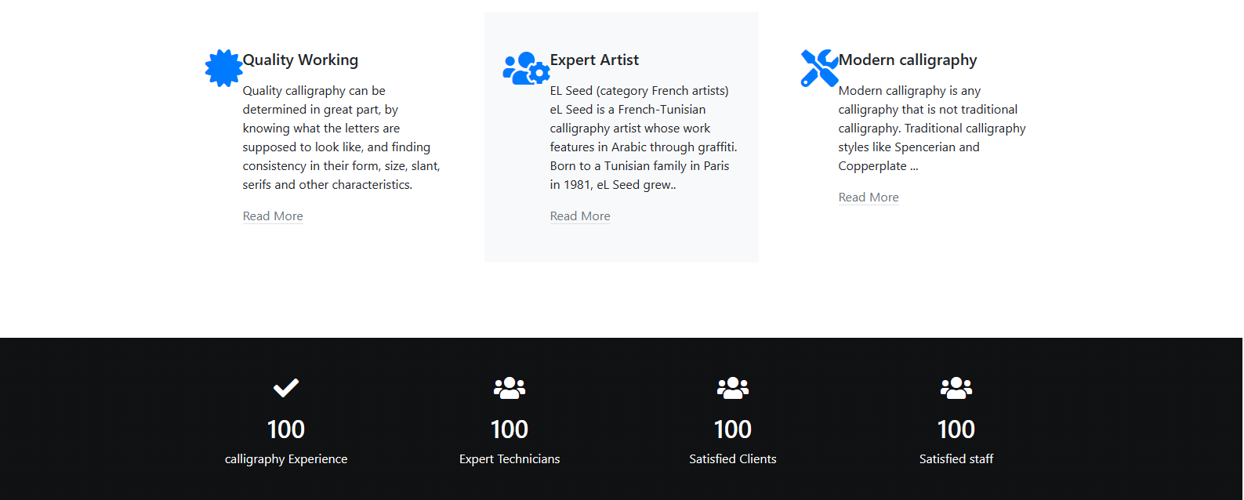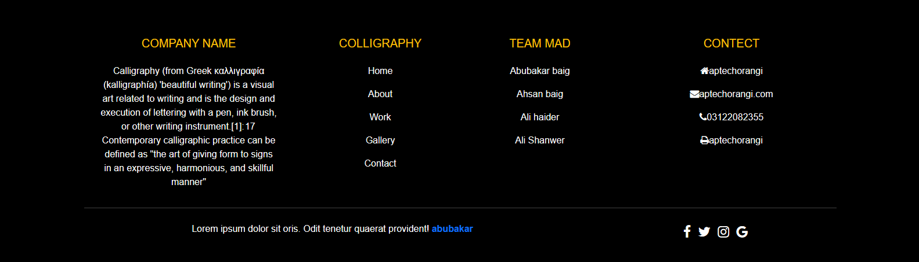

**Snap Shots**

Home Page:

This Is the Home Page of Website.

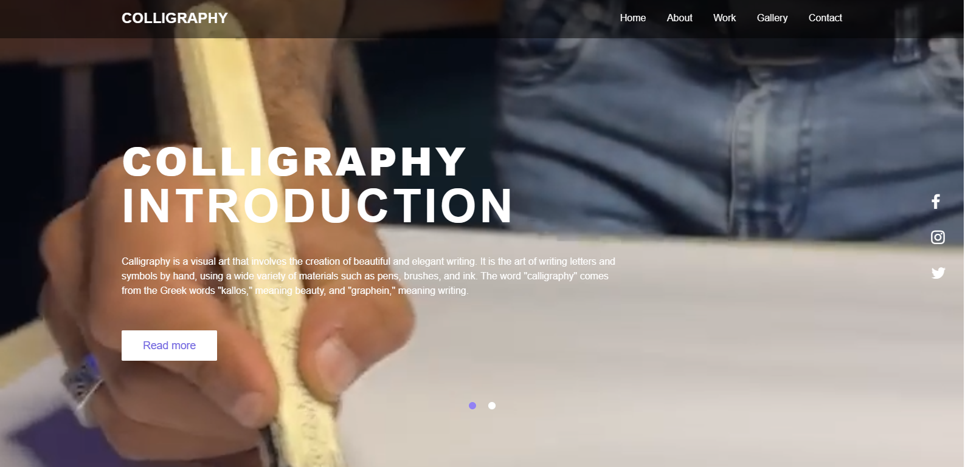

Details

You can contact us through this from. Through this form we get to know that some one wants talk to us.



Reservation

This map show where we live and where we work.

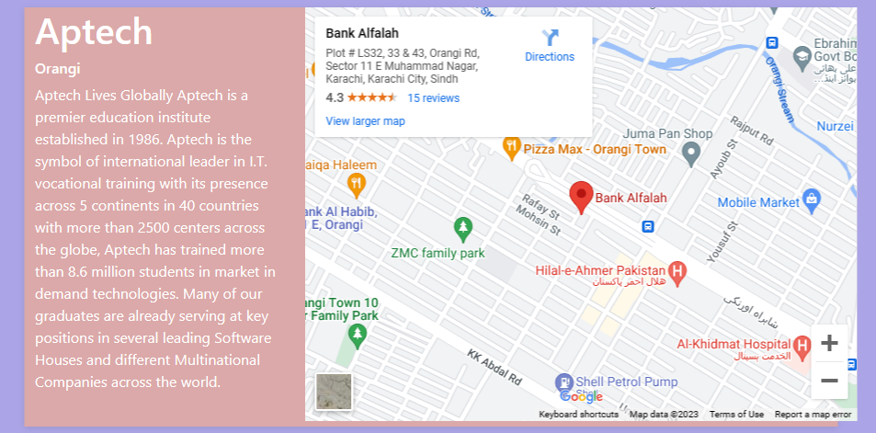

Our Team made ID cards

This ID card has images of our team mates and their data is written through which you can meet our team mates.

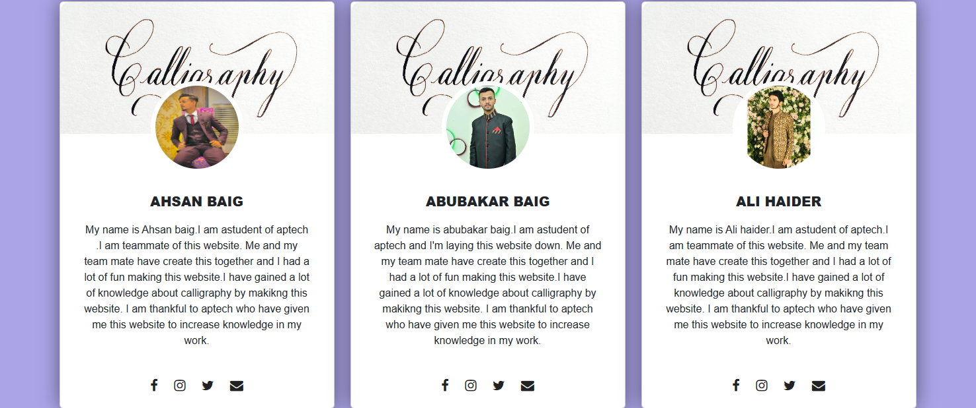

About Us

In the about page we have put pictures when you hover your mouse over the pictures you will give your opinion on different country calligraphy as you can see above screenshot.

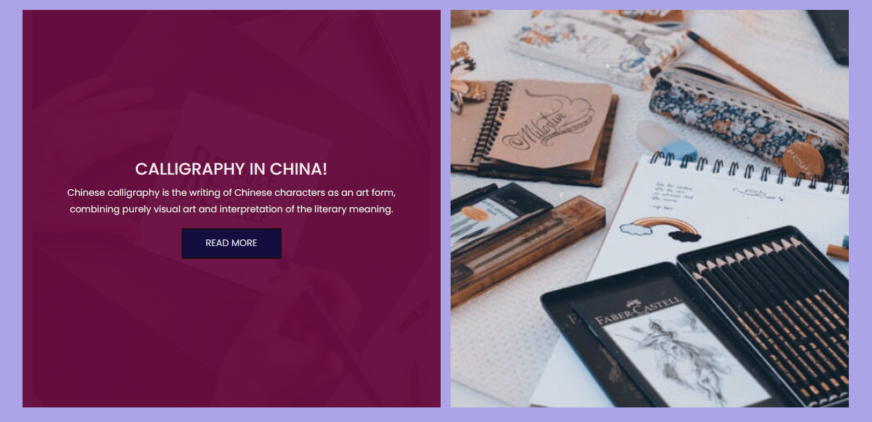

Final Statement

This E Project was created with Firm Determination. I did lot of hard work to complete this project on time.I did MY best to made this project perfect, work full, help full, easy to use and Qualified as much as possible. I Kept the future technologies and usage in MY mind while Making this project.

I hope That APTECH will like MY project and will appreciate MY hard work and Firm Determination.

THANK YOU!

**Documentation Created By Abubakar baig**