

***Semester Project***

House price prediction

***ABUBAKAR ASIF***

**#AbubakarAsif FA20-BCE-013**

**#abubakarasif3111@gmail.com**

**#https://github.com/Abubakar3111**

**#https://www.linkedin.com/in/abubakar-asif-b3b94021a/**

**Artificial Intelligence**

## 

Linear regression is a function that allows an analyst to make predictions about one variable based on the information that is known about another variable. Linear regression can only be used when one has two or more continuous variables—an independent variable and a dependent variable. The independent variable is the parameter that is used to calculate the dependent variable or outcome.

***Hypothesis:***

**h(x) = theta_0 + theta_1 * x1 + theta_2 * x2 .....theat_n * xn**

where x1, x2...xn are multiple input values

***Cost Function:***

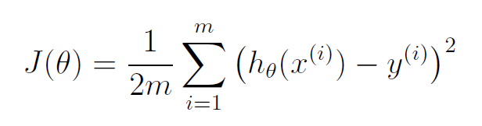

**Gradient Descent Algorithm:**

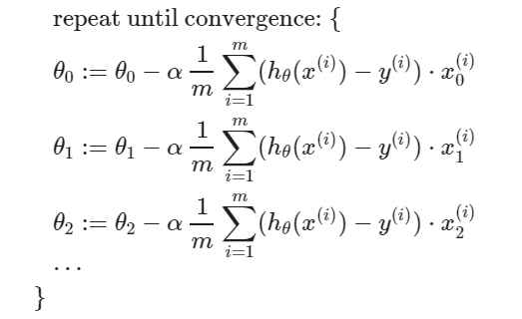

**House Price Prediction**

**Data Set:**

|  |  |  |  |  |  |  |  |  |
| --- | --- | --- | --- | --- | --- | --- | --- | --- |
| **Sample** | **Marla Price** | **Total Marla** | **Room** | **Floors** | **Washroom** | **Car Posh** | **Lawn** | **Final Price** |
| **1** | 730000 | 10 | 7 | 2 | 8 | 1 | 1 | **16200000** |
| **2** | 700000 | 7 | 6 | 2 | 4 | 0 | 0 | **10100000** |
| **3** | 1000000 | 10 | 8 | 2 | 10 | 1 | 1 | **19400000** |
| **4** | 1200000 | 5 | 5 | 2 | 4 | 1 | 0 | **13900000** |
| **5** | 350000 | 15 | 10 | 3 | 11 | 1 | 1 | **16850000** |
| **6** | 450000 | 5 | 5 | 2 | 4 | 0 | 0 | **7150000** |
| **7** | 850000 | 4.5 | 10 | 2 | 8 | 0 | 1 | **13625000** |
| **8** | 400000 | 12 | 6 | 3 | 6 | 1 | 0 | **14700000** |
| **9** | 515000 | 5 | 5 | 2 | 3 | 0 | 0 | **6875000** |
| **10** | 300000 | 6 | 3 | 1 | 2 | 0 | 0 | **4400000** |
| **11** | 525000 | 35 | 15 | 3 | 4 | 1 | 1 | **30775000** |
| **12** | 650000 | 4 | 3 | 1 | 8 | 0 | 0 | **5800000** |
| **13** | 630000 | 25 | 8 | 2 | 9 | 1 | 0 | **23550000** |
| **14** | 250000 | 12 | 6 | 2 | 6 | 1 | 1 | **11400000** |
| **15** | 200000 | 15 | 12 | 3 | 12 | 1 | 1 | **15300000** |
| **16** | 900000 | 13 | 10 | 3 | 7 | 1 | 1 | **22900000** |
| **17** | 950000 | 10 | 5 | 1 | 5 | 1 | 1 | **16000000** |
| **18** | 375000 | 5 | 4 | 1 | 3 | 0 | 0 | **4875000** |
| **19** | 550000 | 9 | 8 | 2 | 4 | 1 | 0 | **12750000** |
| **20** | 1250000 | 12 | 13 | 3 | 9 | 1 | 1 | **27300000** |
| **21** | 750000 | 8 | 7 | 2 | 4 | 1 | 1 | **14500000** |
| **22** | 575000 | 13 | 10 | 3 | 5 | 1 | 0 | **16975000** |
| **23** | 315000 | 7.5 | 6 | 2 | 1 | 0 | 0 | **7262500** |
| **24** | 875000 | 5 | 3 | 1 | 4 | 0 | 0 | **7175000** |
| **25** | 1050000 | 15 | 15 | 3 | 8 | 1 | 1 | **28550000** |

**Data Set REAL WORLD:**

|  |  |  |  |  |  |  |  |  |
| --- | --- | --- | --- | --- | --- | --- | --- | --- |
| Sample | MarlaPrice | TotalMarla | Room | Floors | Washroom | CarPosh | Lawn | FinalPrice |
| 1 | 1500000 | 10 | 6 | 2 | 6 | 1 | 1 | 45000000 |
| 2 | 1000000 | 5.5 | 6 | 2 | 6 | 1 | 0 | 14000000 |
| 3 | 1500000 | 6 | 6 | 2 | 6 | 1 | 1 | 22000000 |
| 4 | 1200000 | 11 | 6 | 2 | 6 | 1 | 1 | 35000000 |
| 5 | 450000 | 10 | 4 | 2 | 4 | 0 | 0 | 10500000 |
| 6 | 1500000 | 24 | 10 | 3 | 12 | 1 | 1 | 1.2E+08 |
| 7 | 1000000 | 7 | 5 | 2 | 6 | 1 | 0 | 14000000 |
| 8 | 1000000 | 10 | 7 | 2 | 3 | 1 | 1 | 13000000 |
| 9 | 1000000 | 20 | 7 | 2 | 7 | 1 | 1 | 70000000 |
| 10 | 525000 | 6 | 7 | 3 | 7 | 1 | 0 | 12500000 |
| 11 | 375000 | 3.5 | 3 | 1 | 2 | 1 | 0 | 3800000 |
| 12 | 575000 | 4 | 7 | 2 | 6 | 0 | 0 | 7500000 |
| 13 | 900000 | 7.5 | 7 | 2 | 4 | 1 | 0 | 14000000 |
| 14 | 250000 | 12 | 6 | 2 | 6 | 1 | 1 | 11400000 |
| 15 | 850000 | 6 | 12 | 2 | 12 | 1 | 1 | 14000000 |
| 16 | 650000 | 7 | 4 | 1 | 4 | 1 | 0 | 11000000 |
| 17 | 950000 | 10 | 6 | 2 | 6 | 1 | 1 | 45000000 |
| 18 | 575000 | 7 | 5 | 1 | 5 | 0 | 0 | 12000000 |
| 19 | 550000 | 9 | 8 | 2 | 4 | 1 | 0 | 12750000 |
| 20 | 450000 | 510 | 5 | 2 | 10 | 0 | 0 | 7000000 |
| 21 | 500000 | 7 | 3 | 1 | 3 | 0 | 0 | 4250000 |
| 22 | 575000 | 3 | 3 | 1 | 3 | 0 | 0 | 5700000 |
| 23 | 315000 | 4 | 5 | 2 | 3 | 0 | 0 | 4200000 |
| 24 | 475000 | 5 | 5 | 1 | 6 | 1 | 0 | 8200000 |
| 25 | 550000 | 4 | 3 | 1 | 3 | 0 | 0 | 4500000 |

**Program:**

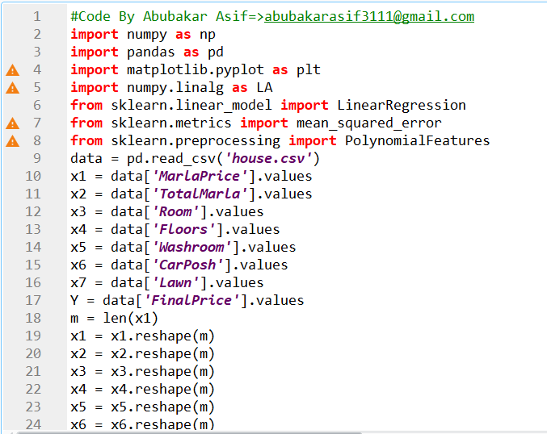

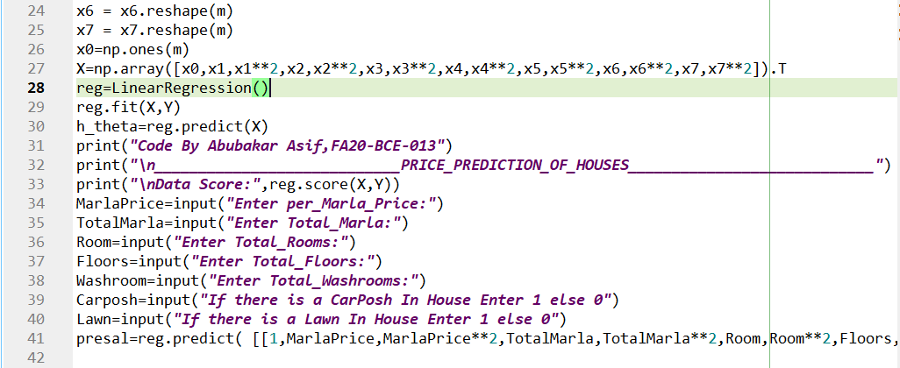

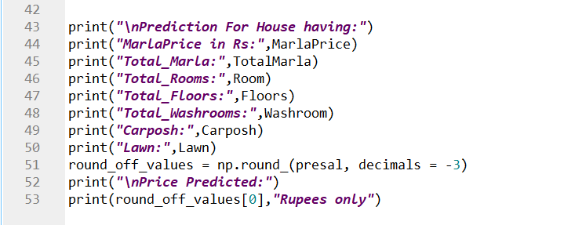

***#Code By Abubakar Asif=>abubakarasif3111@gmail.com***

***import numpy as np***

***import pandas as pd***

***import matplotlib.pyplot as plt***

***import numpy.linalg as LA***

***from sklearn.linear_model import LinearRegression***

***from sklearn.metrics import mean_squared_error***

***from sklearn.preprocessing import PolynomialFeatures***

*data = pd.read_csv('house.csv')*

*x1 = data['MarlaPrice'].values*

*x2 = data['TotalMarla'].values*

*x3 = data['Room'].values*

*x4 = data['Floors'].values*

*x5 = data['Washroom'].values*

*x6 = data['CarPosh'].values*

*x7 = data['Lawn'].values*

*Y = data['FinalPrice'].values*

*m = len(x1)*

*x1 = x1.reshape(m)*

*x2 = x2.reshape(m)*

*x3 = x3.reshape(m)*

*x4 = x4.reshape(m)*

*x5 = x5.reshape(m)*

*x6 = x6.reshape(m)*

*x7 = x7.reshape(m)*

*x0=np.ones(m)*

*X=np.array([x0,x1,x1**2,x2,x2**2,x3,x3**2,x4,x4**2,x5,x5**2,x6,x6**2,x7,x7**2]).T*

*reg=LinearRegression()*

*reg.fit(X,Y)*

*h_theta=reg.predict(X)*

*print("Code By Abubakar Asif,FA20-BCE-013")*

*print("\n____________________________PRICE_PREDICTION_OF_HOUSES____________________________")*

*print("\nData Score:",reg.score(X,Y))*

*MarlaPrice=input("Enter per_Marla_Price:")*

*TotalMarla=input("Enter Total_Marla:")*

*Room=input("Enter Total_Rooms:")*

*Floors=input("Enter Total_Floors:")*

*Washroom=input("Enter Total_Washrooms:")*

*Carposh=input("If there is a CarPosh In House Enter 1 else 0")*

*Lawn=input("If there is a Lawn In House Enter 1 else 0")*

*presal=reg.predict( [[1,MarlaPrice,MarlaPrice**2,TotalMarla,TotalMarla**2,Room,Room**2,Floors,Floors**2,Washroom,Washroom**2,Carposh,Carposh**2,Lawn,Lawn**2]])*

*print("\nPrediction For House having:")*

*print("MarlaPrice in Rs:",MarlaPrice)*

*print("Total_Marla:",TotalMarla)*

*print("Total_Rooms:",Room)*

*print("Total_Floors:",Floors)*

*print("Total_Washrooms:",Washroom)*

*print("Carposh:",Carposh)*

*print("Lawn:",Lawn)*

*round_off_values = np.round_(presal, decimals = -3)*

*print("\nPrice Predicted:")*

*print(round_off_values[0],"Rupees only")*

**Output:**

* ***Data Score: 0.990396***

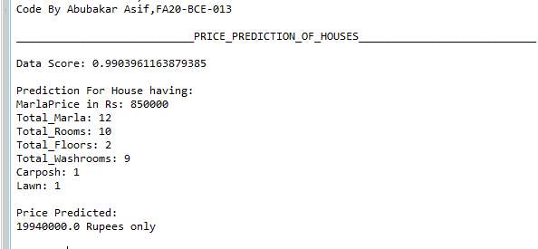

**Output REAL WORLD:**

***Data Score: 0.9392625418649234***

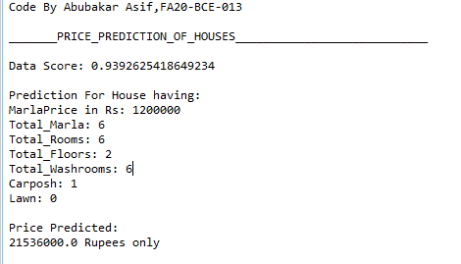

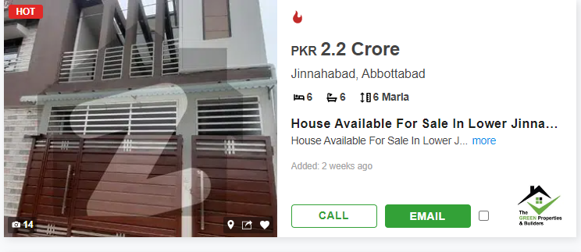

**2ND PREDICTION:**

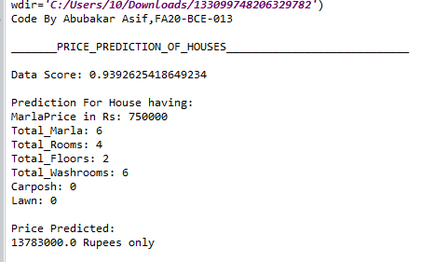

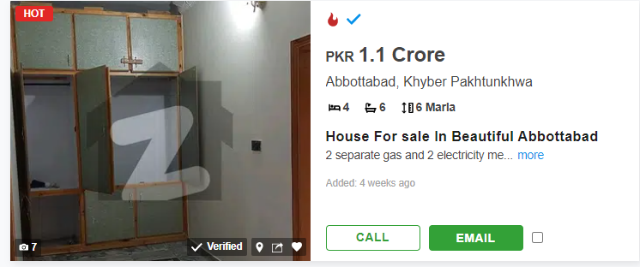

**3RD PREDICTION:**

 