Coffee_Shop_Sales:
MY SQL Queries:
Step 1;
Data Cleaning (Data types)
- UPDATE coffee_shop_sales
SET transaction_date=str_to_date(transaction_date,'%d/%m/%Y');
ALTER TABLE coffee_shop_sales
MODIFY COLUMN transaction_date DATE;
- UPDATE coffee_shop_sales
SET transaction_time=str_to_date(transaction_time,'%H:%i:%s');
ALTER TABLE coffee_shop_sales
MODIFY COLUMN transaction_time TIME;
- ALTER TABLE coffee_shop_sales
CHANGE COLUMN ï»¿transaction_id transaction_id INT;
Step 2;
Business Requirements (Queries)
- Total Sales Analysis:
SELECT CONCAT((ROUND(SUM(unit_price*transaction_qty)))/1000,"K") AS Total_sales
FROM coffee_shop_sales
WHERE
MONTH(transaction_date)=5 -- May Month

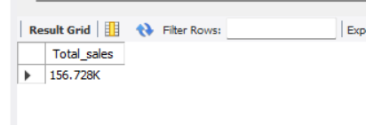
- TOTAL SALES KPI - MOM DIFFERENCE AND MOM GROWTH
SELECT
MONTH(transaction_date) AS month,
ROUND(SUM(unit_price * transaction_qty)) AS total_sales,
(SUM(unit_price * transaction_qty) - LAG(SUM(unit_price * transaction_qty), 1)
OVER (ORDER BY MONTH(transaction_date))) / LAG(SUM(unit_price * transaction_qty), 1)
OVER (ORDER BY MONTH(transaction_date)) * 100 AS mom_increase_percentage
FROM
coffee_shop_sales
WHERE
MONTH(transaction_date) IN (4, 5) -- for months of April and May
GROUP BY
MONTH(transaction_date)
ORDER BY
MONTH(transaction_date);
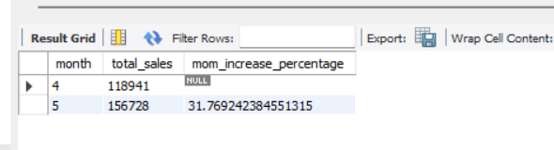

- TOTAL ORDERS:
SELECT COUNT(transaction_id) AS Total_Orders
FROM coffee_shop_sales
WHERE
MONTH(transaction_date)=3; -- March Month
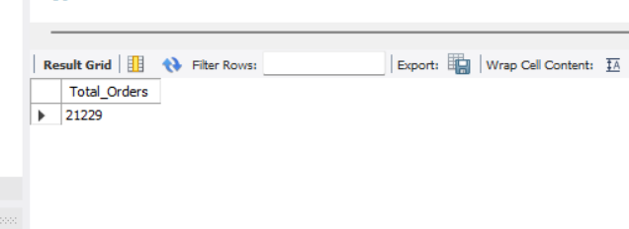
- TOTAL ORDERS KPI - MOM DIFFERENCE AND MOM GROWTH
SELECT
MONTH(transaction_date) AS month,
ROUND(COUNT(transaction_id)) AS total_orders,
(COUNT(transaction_id) - LAG(COUNT(transaction_id), 1)
OVER (ORDER BY MONTH(transaction_date))) / LAG(COUNT(transaction_id), 1)
OVER (ORDER BY MONTH(transaction_date)) * 100 AS mom_increase_percentage
FROM
coffee_shop_sales
WHERE
MONTH(transaction_date) IN (4, 5) -- for months of April and May
GROUP BY
MONTH(transaction_date)
ORDER BY
MONTH(transaction_date);
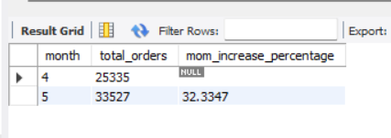
- TOTAL QUANTITY SOLD
SELECT SUM(transaction_qty) AS Total_quantity
FROM coffee_shop_sales
WHERE
MONTH(transaction_date)=5;
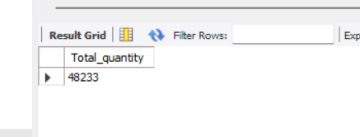
- TOTAL QUANTITY SOLD KPI - MOM DIFFERENCE AND MOM GROWTH
SELECT
MONTH(transaction_date) AS month,
ROUND(SUM(transaction_qty)) AS total_quantity_sold,
(SUM(transaction_qty) - LAG(SUM(transaction_qty), 1)
OVER (ORDER BY MONTH(transaction_date))) / LAG(SUM(transaction_qty), 1)
OVER (ORDER BY MONTH(transaction_date)) * 100 AS mom_increase_percentage
FROM
coffee_shop_sales
WHERE
MONTH(transaction_date) IN (4, 5) -- for April and May
GROUP BY
MONTH(transaction_date)
ORDER BY
MONTH(transaction_date);
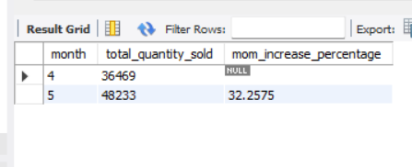
- CALENDAR TABLE – DAILY SALES, QUANTITY and TOTAL ORDERS
SELECT CONCAT(ROUND(SUM(unit_price*transaction_qty)/1000,1),'K') AS Total_Sales,
CONCAT(ROUND(SUM(transaction_qty)/1000,1),'K') AS Total_Quantity,
CONCAT(ROUND(COUNT(transaction_id)/1000,1),'K')AS Total_Orders
FROM coffee_shop_sales
WHERE transaction_date='2023-05-18'
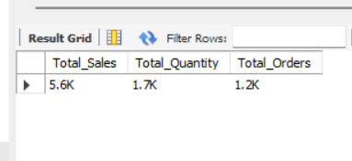
- SALES TREND OVER PERIOD
SELECT CASE
WHEN DAYOFWEEK(transaction_date) IN(1,7) THEN 'Weekends'
ELSE
'Weekdays'
END AS day_type,
CONCAT(ROUND(sum(unit_price*transaction_qty)/1000,1),'K') as total_sales
from coffee_shop_sales
where
MONTH(transaction_date) = 5
group by
case WHEN DAYOFWEEK(transaction_date) IN(1,7) THEN 'Weekends'
ELSE
'Weekdays'
END
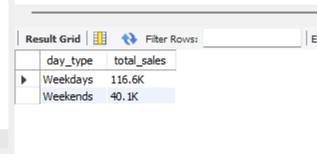
- SALES BY STORE LOCATION
SELECT store_location,
CONCAT(ROUND(SUM(unit_price*transaction_qty)/1000,1),'K') AS Total_Sales
FROM coffee_shop_sales
WHERE
MONTH(transaction_date)=5 -- May month
GROUP BY store_location
ORDER BY SUM(unit_price*transaction_qty) desc
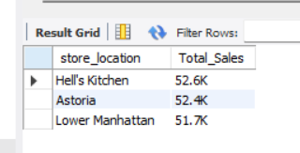
- SALES TREND OVER PERIOD
SELECT CONCAT(ROUND(AVG(Total_sales)/1000,1),'K') AS Avg_sales
from
(
SELECT SUM(unit_price*transaction_qty) AS Total_Sales
from coffee_shop_sales
where month(transaction_date)=5
group by transaction_date
) as internal_query
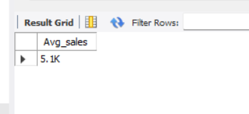
- DAILY SALES FOR MONTH SELECTED
SELECT
DAY(transaction_date) AS day_of_month,
CONCAT(ROUND(SUM(unit_price*transaction_qty)/1000,1),'K') AS Total_sales
from coffee_shop_sales
WHERE MONTH (transaction_date)= 5
GROUP BY DAY(transaction_date)
ORDER BY DAY(transaction_date)
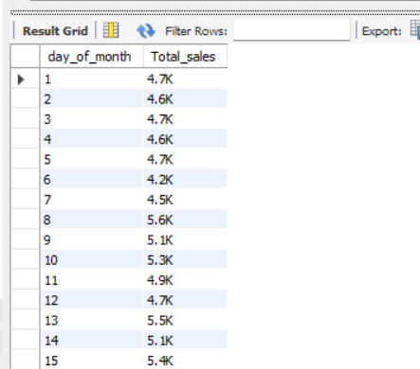
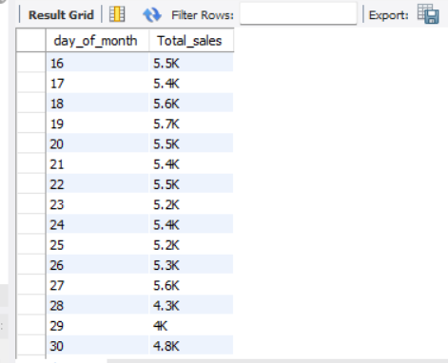
- Sales Analysis by Product Category:
SELECT
product_category,
CONCAT(ROUND(SUM(unit_price*transaction_qty)/1000,1),'K') AS Total_sales
from coffee_shop_sales
where month(transaction_date)=5
group by product_category
order by SUM(unit_price*transaction_qty) desc
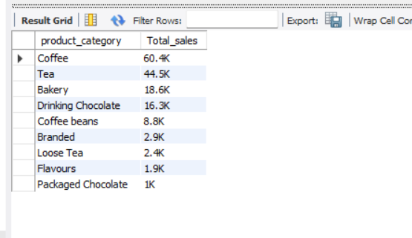

- SALES BY PRODUCTS (TOP 10)
SELECT product_type,
Round(SUM(unit_price*transaction_qty),1) AS Total_sales
from coffee_shop_sales
where month(transaction_date)=5
group by product_type
order by SUM(unit_price*transaction_qty) desc
limit 10
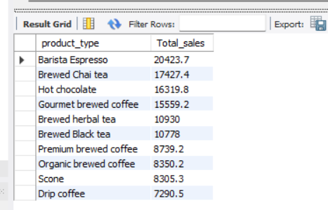
- SALES BY DAY | HOUR
SELECT
CONCAT(ROUND(SUM(unit_price*transaction_qty)/1000,1),'K') AS Total_sales,
SUM(transaction_qty) AS Total_quantity_sold,
count(*) AS Total_orders
from coffee_shop_sales
where month(transaction_date)=5 -- May Month
and DAYOFWEEK(transaction_date) = 2 -- Monday
and HOUR(transaction_time)=8 -- Hour no 8
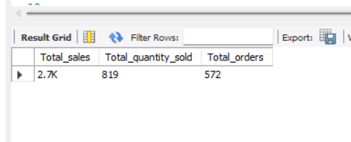
SELECT
HOUR(transaction_time),
CONCAT(ROUND(SUM(unit_price*transaction_qty)/1000,1),'K') AS Total_sales
from coffee_shop_sales
where month(transaction_date)=5
group by HOUR(transaction_time)
order by HOUR(transaction_time)
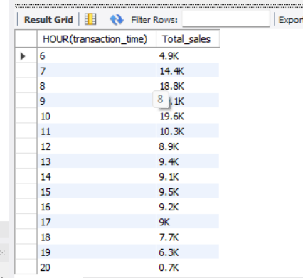
SELECT
CASE
WHEN DAYOFWEEK(transaction_date) = 2 THEN 'Monday'
WHEN DAYOFWEEK(transaction_date) = 3 THEN 'Tuesday'
WHEN DAYOFWEEK(transaction_date) = 4 THEN 'Wednesday'
WHEN DAYOFWEEK(transaction_date) = 5 THEN 'Thursday'
WHEN DAYOFWEEK(transaction_date) = 6 THEN 'Friday'
WHEN DAYOFWEEK(transaction_date) = 7 THEN 'Saturday'
ELSE 'Sunday'
END AS Day_of_Week,
ROUND(SUM(unit_price * transaction_qty)) AS Total_Sales
FROM
coffee_shop_sales
WHERE
MONTH(transaction_date) = 5 -- Filter for May (month number 5)
GROUP BY
CASE
WHEN DAYOFWEEK(transaction_date) = 2 THEN 'Monday'
WHEN DAYOFWEEK(transaction_date) = 3 THEN 'Tuesday'
WHEN DAYOFWEEK(transaction_date) = 4 THEN 'Wednesday'
WHEN DAYOFWEEK(transaction_date) = 5 THEN 'Thursday'
WHEN DAYOFWEEK(transaction_date) = 6 THEN 'Friday'
WHEN DAYOFWEEK(transaction_date) = 7 THEN 'Saturday'
ELSE 'Sunday'
END;

