CS312 – F2024 – Computer Simulations

Name: Mohammad Abubakar Atiq

ID: F2022031002

Department of Mechanical Engineering

Program: BS Industrial Engineering

Assignment 01

Instructor: Sir Syed Rehan Ashraf

Task 01:

1. Find the value of pi with the help of monte Carlo simulation (use excel or any computer program). Min. 500 cycle is required. Hint use random number from random number generator from desired computer program.

(Note in your submitted assignment each step must be mentioned clearly).

Solution:

Step 1:

Area of a unit square is 4.

Step 2:

Construct x and y values with random number generator from excel. To generator a random number between a and b, we will use this: a+(b-a) *rand ()

$$x, y values = 2*rand () = lower limit+ (upper limit – lower limit) *rand ()$$

See excel file sheet named as “Data_for_Pi” attached with the assignment.

Total number of trials are more than 3 lakhs. Or 0.3 million.

Total points inside the circle, area fraction of circle and estimated value of pi vary as we press “enter” on excel by default.

Step 3:

Find the distance from the center of the square and construct square plot as scatter chart.

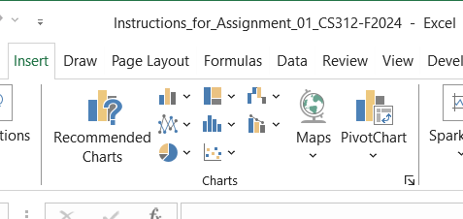go to excel, select “insert”>scatter chart

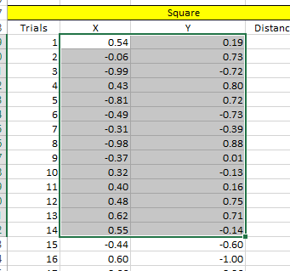Select range of $x,y.$

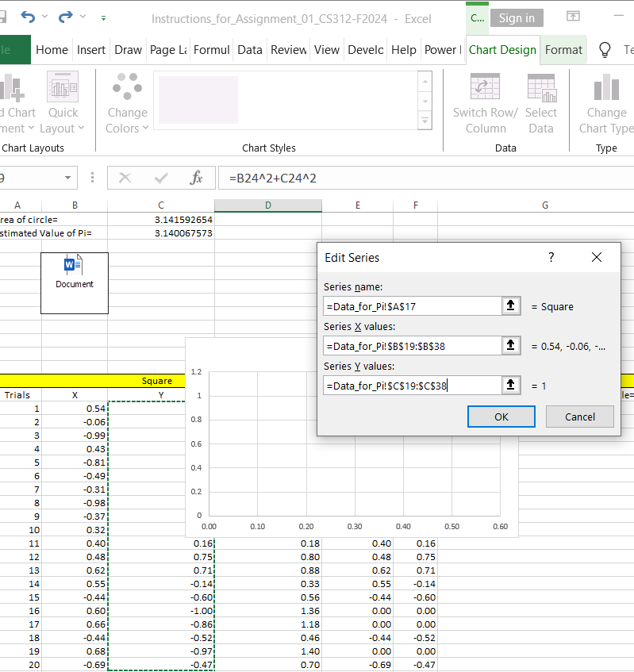Resulting square would be like this as below:

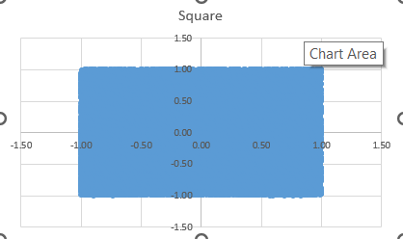

Resulting square. Note, select the values of x, y.

Step 4:

Construct the circle, based on the step 3. But this time calculation for x, y would be different such as.

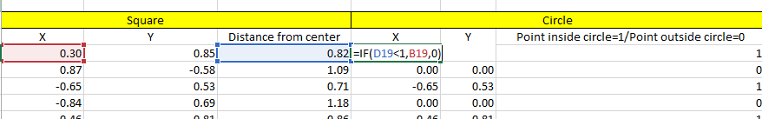Explanation, for x value of circle, if the distance of a square is less than 1 then select x value of square otherwise make it “0”. Vice versa for y value of circle.

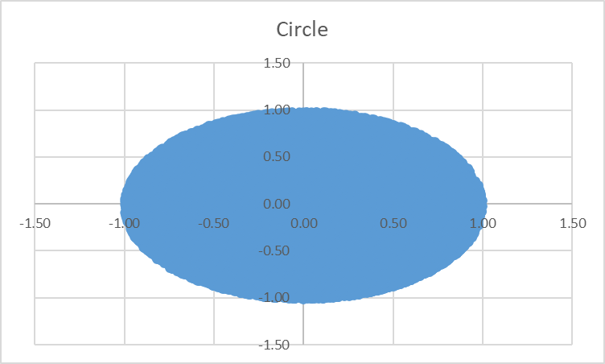

Step 5:

Find the total number of points inside the circle.

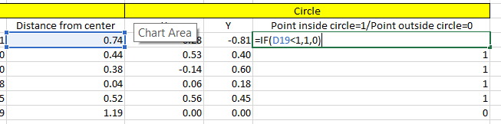

What this state? If distance from center of an unit square is less than 1, then set it to the “1” otherwise “0”.

Step 6: find the number of points lies with the circle.

In this case, it varies, which you can see on the excel file attach.

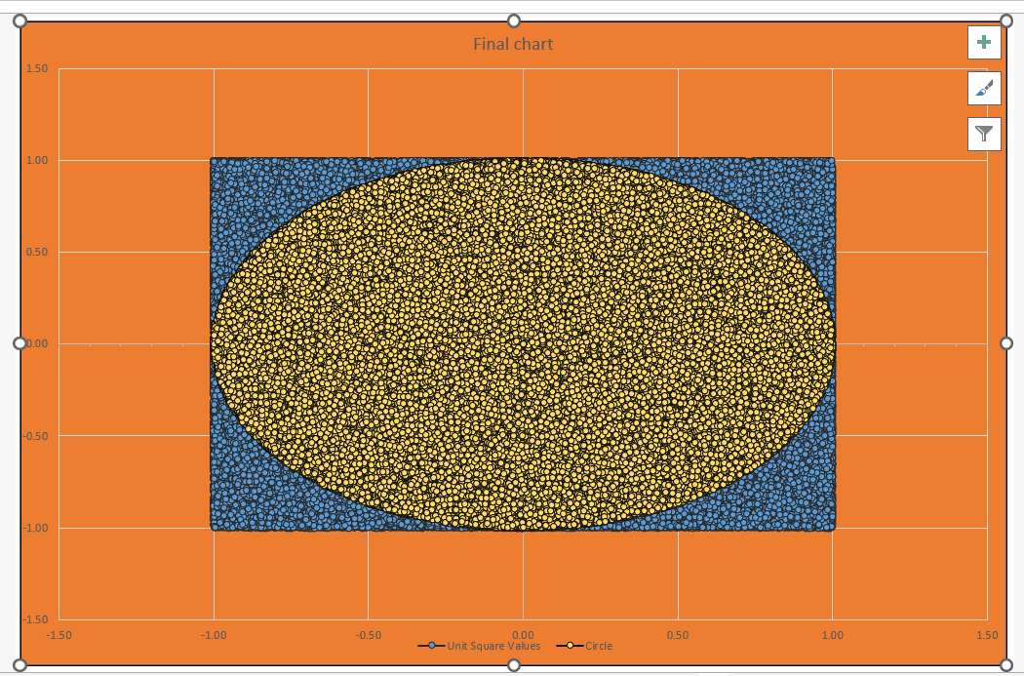

Task 02:

2. Use your own example to simulate any daily life activity. That simulation must contain at least three series and one parallel activity (Two activities at a time, minimum five activities) (More activities can be added). Explain each process and define the nature of the process (Type Probabilistic, deterministic, or stochastic) and the distribution going to be used in each activity. For a better explanation, a block diagram is recommended. (Use Arena for simulation, other Simulation Software can also be used) Last Date of submission is 10 Nov 2024. Link of Turnitin is will be on 4th week.

Solution:

**Simulation Example: My Typical Weekday Routine**

For this simulation, I’m going to model my typical weekday routine as an industrial engineering student. My day starts with waking up and getting ready. This process involves my morning hygiene routine, getting dressed, and eating breakfast. On average, this takes me around 45 minutes. Since it’s a fixed daily routine without much variation, I’m treating this as a deterministic process with a set time of 45 minutes.

After I’m ready, I usually commute to the university. The time it takes to get there can vary a lot depending on traffic, weather, and road conditions. On a good day, it might take about 20 minutes, but on a busy day, it can stretch to 45 minutes. Because of this unpredictability, I’m treating the commute as a stochastic process, using a normal distribution with an average of 30 minutes and a standard deviation of 10 minutes.

My morning classes usually start with Computer Simulation and Engineering Economics, which are fixed-duration classes (e.g., 9:30-10:45 AM and 11:00-12:30 PM). While the class duration is fixed, the time it takes for me to settle in and leave after class can vary slightly. I’m modeling this part of my day as a probabilistic process, using a uniform distribution to account for small variations in the time taken, ranging from 1 hour 15 minutes to 1 hour 30 minutes.

After my morning classes, I usually take a lunch break. The duration of my lunch break depends on how long I have to wait for food, how crowded the cafeteria is, and how fast I eat. Sometimes I can be done in 30 minutes, but other times it can take up to an hour. I’m treating this as a stochastic process with an exponential distribution, where the average time for lunch is about 45 minutes.

In the afternoons, I have labs, like the Computer Simulation Lab or the Mechanics of Materials Lab. These labs have scheduled times (e.g., 8:00-11:00 AM and 11:00-2:00 PM), but the actual time spent can vary depending on the experiment, technical issues, or other delays. I’m treating the labs as probabilistic processes and using a triangular distribution to account for these variations. While in the lab, there’s often some downtime while I wait for results or machines to become available. During this time, I usually review my notes, so I’ll treat this as a parallel activity. Reviewing notes is a deterministic activity (taking a fixed 30 minutes), while waiting for lab results is stochastic, modeled with an exponential distribution and a mean waiting time of 45 minutes.

After finishing my labs and classes, I commute home. Like the morning commute, the time it takes depends on traffic and other external factors, so I’m treating it as another stochastic process, using a normal distribution of an average of 45 minutes & standard deviation of 15 minutes.

Once I get home, I focus on homework and study. The time I spend on this depends on how much work I have, which can vary from 1 hour to 3 hours. On days when I have more assignments or upcoming exams, I’ll spend more time studying. I’m modeling this as a probabilistic process with a triangular distribution, where the most common time spent studying is around 2 hours.

This simulation models my daily routine with a mix of series and parallel activities, incorporating both deterministic and stochastic processes to account for the day-to-day variations in my schedule. This approach meets the requirement of having at least three series activities and one parallel activity.

Mathematical model:

This model will include a combination of deterministic, probabilistic, and stochastic processes, as described above. We will also include a representation of parallel activities during lab sessions.

# Wake up and get ready:

$$T_{ready}=45 \left(deterministic\right)$$

This is a fixed 45-minute process.

# Commute to university

$$T_{commute to}\sim N\left(μ=30, σ=10\right) (normal distribution)$$

This follows a normal distribution with a mean commute time of 30 minutes and a standard deviation of 10 minutes.

# Morning classes

$$T_{class1}\sim U\left(75,90\right) \left(uniform distribution\right)$$

$$T_{class2}\sim U\left(75,90\right) (uniform distribution)$$

These represent variations in the time spent settling in or leaving the classroom.

# Lunch break

$$T_{lunch}\sim Exp\left(λ=45\right) \left(exponential distribution\right)$$

This represents the varying duration of lunch, with an average of 45 minutes.

# Afternoon lab (e.g., Computer simulation lab) with Parallel Activity (Reviewing Notes)

The total time in the lab can be modeled using a triangular distribution:

$$T_{lab}\sim Triangular\left(150,180,210\right) \left(triangular distribution\right)$$

This assumes a minimum of 150 minutes, most likely 180 minutes, and a maximum of 210 minutes for lab completion.

In parallel, the time spent reviewing notes is a fixed 30 minutes:

$$T_{review notes}=30 (deterministic)$$

During waiting periods in the lab (e.g., waiting for machines), we model the waiting time as an exponential process:

$$T_{wait lab}\sim Exp\left(λ=45\right) (exponential distribution)$$

This represents the uncertain waiting time with an average of 45 minutes.

# Commute Home:

$$Tcommute_{home}∼N\left(μ=40,σ=15\right)\left(normal distribution\right)$$

$$Tcommute_home​∼N(μ=40,σ=15)(normal distribution)$$

The commute home also follows a normal distribution with an average time of 40 minutes and a standard deviation of 15 minutes.

# Homework and Study:

$$Tstudy∼Triangular(60,120,180)(triangular distribution)$$

This represents the time spent on homework or studying, with a minimum of 60 minutes, most likely 120 minutes, and a maximum of 180 minutes.

# Total Time Calculation

The **total time** spent on these activities during the day can be calculated as:

$$Ttotal=T_{(ready)}+Tcommute_to+Tclass1+Tclass2+Tlunch+Tlab+Tcommute_home+TstudyTtotal​=Tready​+Tcommute_to​+Tclass1​+Tclass2​+Tlunch​+Tlab​+Tcommute_home​+Tstudy​$$

For the parallel activities during the lab session, the total lab time will either be the lab duration or the time for reviewing notes, whichever is longer. Mathematically, this can be expressed as:

$$Tparallel_lab=max⁡(Tlab,Treview_notes)$$

Since reviewing notes is always 30 minutes and lab time varies, the lab duration will typically dominate.

# Block Diagram Representation

In a block diagram, each of these activities can be represented as separate blocks connected in series, with the lab activity having a parallel block for reviewing notes. The sequence would look like this:

1. **Wake Up and Get Ready** →
2. **Commute to University** →
3. **Morning Classes** →
4. **Lunch Break** →
5. **Afternoon Lab** (with parallel activity: reviewing notes) →
6. **Commute Home** →
7. **Homework and Study**

The **parallel activity** during the lab is depicted as two simultaneous processes: the main lab work and reviewing notes while waiting.

# Simulation with Arena

**Step 1: Open Arena**

Start by launching Arena simulation software. Create a new model to begin.

**Step 2: Define Variables and Distributions**

1. **Define Distributions**:
   * **Wake Up and Get Ready**: Use a constant value for this activity.
   * **Commute to University**: Use the **Normal Distribution** block.
   * **Morning Classes**: Use the **Uniform Distribution** block for each class.
   * **Lunch Break**: Use the **Exponential Distribution** block.
   * **Afternoon Lab**: Use the **Triangular Distribution** block.
   * **Reviewing Notes**: This is a constant value.
   * **Commute Home**: Use the **Normal Distribution** block.
   * **Homework and Study**: Use the **Triangular Distribution** block.

**Step 3: Set Up the Process Flow**

1. **Create a Process for Each Activity**:
   * Drag and drop **Process** modules for each activity.
   * Set the **Name** and **Duration** for each process according to the variables defined in your model.

**Example**:

* + **Wake Up and Get Ready**: Set the duration to 45 minutes.
  + **Commute to University**: Set the duration to the Normal distribution.
  + **Morning Classes**: Two separate processes for each class with Uniform distributions.
  + **Lunch Break**: Set the duration to the Exponential distribution.
  + **Afternoon Lab**: Set the duration to the Triangular distribution.
  + **Reviewing Notes**: Set a constant duration of 30 minutes.
  + **Commute Home**: Set the duration to the Normal distribution.
  + **Homework and Study**: Set the duration to the Triangular distribution.

1. **Parallel Activities**:
   * For the afternoon lab, use a **Decide** module to create a branching logic where one branch represents the lab activity and the other represents reviewing notes.
   * Use the **Maximum** module to determine which of the two activities takes longer during this parallel process.

**Step 4: Connect the Activities**

1. **Flow Connections**:
   * Connect each process in the order of your routine using the connectors provided in Arena.
   * Ensure that the output of one process flows into the next, following the sequence defined earlier.

**Step 5: Run the Simulation**

1. **Simulation Settings**:
   * Set up the simulation run length (e.g., run for a week’s worth of data).
   * Define the number of replications you want to perform for statistical significance.
2. **Run the Model**:
   * Execute the simulation to see how the model behaves over time.
   * Arena will generate outputs that you can analyze to understand the timing of each activity and the total time taken for your routine.

**Step 6: Analyze Results**

1. **Output Reports**:
   * Use Arena's reporting features to summarize the total time spent on each activity and the overall time for your routine.
   * Look for bottlenecks or areas where time is spent excessively.

